Hấp phụ Asen hiệu quả bằng vật liệu vỏ sò biến tính phosphate thân thiện môi trường

Cao Phương Anh¹, Lê Huỳnh Nhi², Lê Thị Phương Thảo³, Trịnh Thị Quế⁴, Nguyễn Bá Cường², Nguyễn Thị Hoài Phương^{1,*}

¹Trung tâm Nhiệt đới Việt-Nga, 63 Nguyễn Văn Huyên, Hà nội, Việt Nam
²Học viện Kỹ thuật Quân sự, 236 Hoàng Quốc Việt, Hà nội, Việt Nam
³Trường Đại học Mỏ-Địa chất, 18 Viên, Hà nội, Việt Nam
⁴Trường Trung học Phổ thông Lê Quý Đôn-Đống Đa, 195 Xã Đàn 2, Hà nội, Việt Nam

Received: dd/mm/yyyy; Revised: dd/mm/yyyy;
Accepted: dd/mm/yyyy; Published: dd/mm/yyyy

TÓM TẮT
Ô nhiễm asen trong các hệ thống nước, đặc biệt là từ nguồn nước thải mỏ axit (acid mine drainage), gây ra những rủi ro nghiêm trọng đối với môi trường và sức khỏe con người do độc tính và khả năng di động cao của arsenat (As(V)). Trong nghiên cứu này, vỏ sò được tái sử dụng và chuyển hóa thành vật liệu vỏ sò biến tính phosphate (PMOS) như một chất hấp phụ thân thiện với môi trường và có chi phí thấp để loại bỏ As(V). PMOS được chế tạo thông qua quá trình xử lý nhiệt-hóa học kết hợp với giai đoạn biến tính phosphate, và đặc tính hấp phụ của vật liệu được khảo sát có hệ thống dưới các điều kiện khác nhau. Kết quả cho thấy hiệu suất loại bỏ As(V) phụ thuộc mạnh vào pH, thời gian tiếp xúc, nồng độ ban đầu và liều lượng chất hấp phụ; hiệu suất tối ưu (~95%) đạt được trong khoảng pH từ 3 đến 7, với liều lượng 1,0 ÷ 1,5 g/L và đạt trạng thái cân bằng sau 100 phút. Phân tích động học xác nhận rằng quá trình hấp phụ tuân theo mô hình giả bậc hai (pseudo-second-order), cho thấy cơ chế hấp phụ hóa học chiếm ưu thế, trong khi các nghiên cứu đẳng nhiệt cho thấy mô hình Freundlich phù hợp nhất, với dung lượng hấp phụ cực đại đạt 46,34 mg/g. Kết quả đặc trưng cấu trúc xác nhận sự gắn kết thành công của các nhóm phosphate, giúp tăng cường ái lực đối với arsenat thông qua tương tác tĩnh điện, trao đổi ion và tạo phức bề mặt. Đáng chú ý, các thử nghiệm tái sử dụng cho thấy PMOS vẫn duy trì hơn 80% hiệu suất loại bỏ sau năm chu kỳ hấp phụ-giải hấp, chứng minh độ bền tái sinh tốt của vật liệu. Những phát hiện này cho thấy PMOS là vật liệu tiềm năng, bền vững và kinh tế cho quá trình xử lý asen trong nước bị ảnh hưởng bởi nước thải mỏ axit, đồng thời góp phần thúc đẩy chiến lược kinh tế tuần hoàn thông qua việc tái giá trị hóa chất thải nuôi trồng thủy sản.
Từ khóa: Asenat; vỏ sò biến tính photphat; hấp phụ; động học và đẳng nhiệt hấp phụ; khả năng tái sử dụng.

Email: hoaiphuong.vrtc@gmail.com
*Tác giả liên hệ.

Eco-friendly utilization of phosphate-modified oyster shell for efficient arsenic adsorption

Phuong Anh Cao¹, Huynh Nhi Le², Phuong Thao Le Thi³, Que Trinh Thi⁴, Ba Cuong Nguyen², Hoai Phuong Nguyen Thi^{1,}*

¹Joint Vietnam-Russia Tropical Science and Technology Research Center
²Le Quy Don University
³Hanoi University of Mining and Geology
⁴Le Quy Don High School

Received: dd/mm/yyyy; Revised: dd/mm/yyyy;
Accepted: dd/mm/yyyy; Published: dd/mm/yyyy

ABSTRACT
Arsenic contamination in aquatic systems, especially from acid mine drainage, poses severe environmental and health risks due to the toxicity and mobility of arsenate (As(V)). In this study, oyster shell waste was valorized into phosphate-modified oyster shells (PMOS) as an eco-friendly and low-cost adsorbent for As(V) removal. PMOS was prepared through thermochemical treatment followed by phosphate functionalization, and its adsorption behavior was systematically investigated under different conditions. The results showed that As(V) removal efficiency strongly depended on pH, contact time, initial concentration, and adsorbent dosage, with optimal performance (~95% removal) achieved at pH 3 ÷ 7, a dosage of 1,0 ÷ 1,5 g/L, and equilibrium reached within 100 min. Kinetic analysis confirmed that the process followed a pseudo-second-order model, indicating chemisorption as the dominant mechanism, while isotherm studies revealed the Freundlich model provided the best fit, with a maximum adsorption capacity (qmax) of 46,34 mg/g. Structural characterization confirmed the successful incorporation of phosphate groups, enhancing affinity for arsenate through electrostatic attraction, ion exchange, and surface complexation. Importantly, reusability tests demonstrated that PMOS maintained more than 80% of its removal efficiency even after five adsorption–desorption cycles, confirming its regeneration stability. These findings highlight PMOS as a promising, sustainable, and cost-effective material for arsenic remediation in acid mine drainage-impacted waters while simultaneously contributing to circular economy strategies through aquaculture waste valorization.
Keywords: Arsenate; Phosphate-modified oyster shell; Adsorption; Kinetic and Isotherm; Reusability.

1. INTRODUCTION
Arsenic contamination in aquatic systems has emerged as a critical global issue due to its extreme toxicity, persistence, and bioaccumulative character, with chronic exposure associated with severe health risks such as cancers, cardiovascular disorders, and dermatological lesions. Among arsenic species, arsenate (As(V)) predominates under oxic conditions and is of particular concern because of its high solubility and mobility in water. In mining regions, the oxidative dissolution of sulfide minerals produces acid mine drainage, an effluent characterized by low pH and high concentrations of Fe and Mn, while simultaneously releasing considerable amounts of As(V), thereby intensifying ecological hazards and human health risks.^{1–3} Although strict regulations have been established - such as the World Health Organization (WHO) provisional guideline of 0.01 mg/L and the Vietnamese national standard QCVN 01-1:2024/BYT - arsenic concentrations in acid mine drainage-impacted waters often exceed these limits by several orders of magnitude, underscoring the urgent need for efficient, robust, and affordable treatment technologies.^{3,4} Conventional remediation approaches, including precipitation, ion exchange, and membrane filtration, have been widely studied and applied but are constrained by high chemical and energy demands, secondary waste generation, and poor stability under the harsh and complex chemical conditions of acid mine drainage.⁵
In recent years, the development of eco-friendly, low-cost, and sustainable adsorbents has become an essential research direction. Biomass wastes, particularly shellfish residues such as oyster shells, have attracted attention owing to their abundance, low cost, and high calcium carbonate content.^{6–9} Transforming such residues into water treatment materials offers a dual environmental benefit: reducing aquaculture-derived waste and providing a renewable adsorbent for pollutant removal, in line with circular economy principles. Previous studies have demonstrated the potential of oyster shells and related derivatives for capturing heavy metals such as Pb(II), Cd(II), and Hg(II).^{8,9} However, their direct application to As(V) removal remains limited due to the scarcity of active binding sites and insufficient surface reactivity. To overcome these drawbacks, surface modification has been explored, with phosphate functionalization emerging as a highly effective strategy. By introducing phosphate groups onto calcium-rich matrices, active functional sites are created that enhance electrostatic interactions, ion exchange, surface complexation, and even co-precipitation with arsenate ions.^{10,11} This approach significantly improves the removal efficiency of arsenic compared to unmodified shells and provides a sustainable pathway for waste valorization in water treatment.
Despite these advances, the application of phosphate-modified oyster shells (PMOS) to arsenic remediation in acid mine drainage -related contexts remains underexplored. This knowledge gap is crucial, since acid mine drainage presents one of the most demanding scenarios for treatment technologies due to its extreme acidity and the presence of competing metal ions. Addressing this challenge, the present study aims to transform oyster shell waste into a phosphate-modified adsorbent and evaluate its potential for efficient As(V) removal. Specifically, the work pursues three objectives: (i) to investigate the adsorption behavior of As(V) under varying conditions and optimize operational parameters, (ii) to elucidate the adsorption mechanisms through kinetic and isotherm modeling, and (iii) to assess the regeneration and reusability of PMOS across multiple cycles to determine its long-term stability. By simultaneously addressing the urgent environmental challenge of arsenic pollution in acid mine drainage-impacted waters and the sustainable valorization of aquaculture waste, this research offers both a practical solution for water treatment and a contribution to eco-friendly resource utilization.
2. EXPERIMENT
2.1. Material
Raw oyster shells were collected from seafood processing waste in Quang Ninh. Analytical-grade Sodium arsenate dibasic heptahydrate (Na₂HAsO₄.7H₂O) were purchased. Other reagents, including hydrochloric acid (HCl), sodium hydroxide (NaOH), and phosphoric acid (H₃PO₄), were of analytical grade.
2.2. Preparation of Phosphate-modified oyster shells
The thermochemical modification of oyster shells followed the method outlined by Huong et al.¹² The collected oyster shells were thoroughly washed, dried at 105°C for 24 hours, and crushed into particles < 0,25 mm. The pretreated shells were then subjected to thermal activation in a muffle furnace at 500°C for 2 hours. Phosphate modification was performed by immersing the calcined shells in 0,5 M phosphoric acid solution at 65°C for 2 hours under agitation to induce partial phosphatization, forming a calcium phosphate-carbonate hybrid structure. The modified material was then filtered, rinsed with DI water until neutral pH, dried at 90 °C for 4 hours, and stored in airtight containers. The resulting material was labeled as PMOS.
2.3. Study on As(V) adsorption
As(V) adsorption was investigated in time periods of 15, 30, 45, 60, 90 and 120 minutes, at different concentrations from 5-30 mg/L with PMOS dosage varying from 0,25 ÷ 1,5 g/L and pH environment varying at 3, 5, 7, 9, 11, stirring continuously at 150 rpm. Then, the solution was filtered into 50 ml aldon and the remaining As(V) concentration was measured by ICP-MS method. Conduct adsorption kinetics studies and adsorption isotherm models. To investigate the regenerative properties of PMOS materials after adsorption by desorption with 50 ml of 0,1M HCl for 60 minutes. Then filter, wash, and dry at 90 degrees for 4 hours. Investigate the properties of purPMOS, desPMOS materials by FT-IR.
3. RESULTS AND DISCUSSION
3.1. Study on the adsorption conditions of As(V) in water by PMOS
Figure 1 shows that the As(V) ion removal efficiency strongly depends on the environmental conditions and the dosage of PMOS adsorbent. In graph (a), the adsorption efficiency reaches the highest value (~97,5%) at pH = 2 ÷ 4 and gradually decreases as the pH increases, especially at alkaline pH (>10). This phenomenon can be explained through two key factors: (i) the chemical transformation of As(V) with pH and (ii) the surface charge state of PMOS (pHpzc = 8,054).
At low pH, the main form is H₂AsO₄⁻; when pH increases to neutral and slightly alkaline, HAsO₄²⁻ predominates; and in strong alkaline environments, AsO₄³⁻ becomes the main form. On the material side, pHpzc = 8,054. When pH < pHpzc, the PMOS surface carries a positive charge, which is favorable for electrostatic attraction of arsenate anions. On the contrary, at pH > pHpzc, the surface turns to a negative charge, causing electrostatic repulsion of anions and is simultaneously competed by OH- in the solution. Therefore, in acidic environments (3 < pH < 7), when As(V) mainly exists in the form of HAsO₄²⁻ and the material surface is positively charged, the adsorption mechanism occurs strongly thanks to the combination of electrostatic interactions and ion exchange at the active phosphate groups on the brushite structure (CaPO₃(OH).2H₂O). Graph (b) shows that the adsorption rate of As(V) is fast, with an efficiency of over 80% after only 45 min and almost saturated (~95%) after 100 ÷ 120 min. This reflects the adsorption mechanism that combines surface interaction and intraparticle diffusion, and demonstrates that PMOS has the ability to process quickly and efficiently.
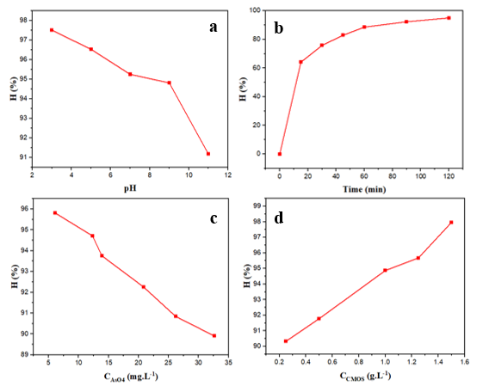
Figure 1. Graph of As(V) treatment efficiency at different environmental pH (a), time (b), As(V) concentration (c), PMOS dosage (d).
In graph (c), the efficiency decreases as the initial As(V) concentration increases. At low concentrations (5 ÷ 10 mg/L), the efficiency reaches over 94 ÷ 95%, but drops to about 90% when the concentration increases to 30 mg/L. The reason is that the number of adsorption sites is limited, when the pollutant concentration is too high, the material is saturated and the efficiency decreases.
From the obtained results, it can be concluded that the optimal conditions for As(V) treatment with PMOS materials are in the mildly acidic to neutral pH range (3 ÷ 7), when the material surface is favorable for the adsorption of arsenate anion. A contact time of about 100 min is sufficient to reach equilibrium with an efficiency of nearly 95%. The appropriate initial As(V) concentration to achieve a removal efficiency of over 95% is below 10 mg/L, while the optimal material dosage ranges from 1,0 ÷ 1,5 g/L. Under these conditions, PMOS exhibits high and stable treatment efficiency, demonstrating its potential application in the treatment of arsenic-containing wastewater.
3.2. Kinetic model and As(V) adsorption isotherm
Based on Figure 2 and the data in Table 1, it can be seen that the adsorption process of As(V) on PMOS materials is best described by the pseudo-second-order kinetic model, with a correlation coefficient R² of 0,99972 and a qe value (11,78 mg/g) that closely matches the experiment. This shows that the main mechanism of the process is chemisorption, in which the active hydroxyl and phosphate groups on the material surface play a central role, creating a strong interaction with arsenate ions. Meanwhile, the pseudo-first-order model also shows a certain level of agreement (R² = 0,97417) but the qe value is significantly different, indicating that it does not accurately reflect the actual kinetics. The Elovich model (R² = 0,98389) adds further evidence of the energy heterogeneity at the adsorption sites, indicating that the PMOS surface contains many active sites with different properties. In particular, the bangham model has a very high R² (0,99683), confirming the significant role of capillary diffusion in controlling the adsorption rate. In contrast, the intraparticle diffusion model with R² of only 0,77101 shows that intraparticle diffusion is not the decisive step but only contributes to support. Observation of the time survey curve (Figure 2f) shows that the adsorption rate is fast in the initial stage, the efficiency reaches more than 80% after only 45 minutes and approaches equilibrium at about 100 minutes with an efficiency of nearly 95%. This evolution reflects a multi-stage adsorption mechanism: initially, the rapid capture of As(V) ions on the surface, followed by a slow diffusion process into the pores inside the material
Thus, combining the data in Figure 2 and Table 1, it can be confirmed that the adsorption kinetics of As(V) on PMOS follows a pseudo-second-order model, which is typical for chemical adsorption, and is supported by the diffusion mechanism in the capillary. This is an important factor that helps the material achieve fast processing speed, high efficiency and potential for practical application in the treatment of arsenic in water.
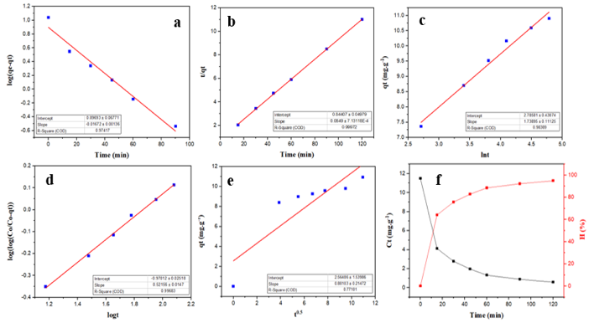
Figure 2. Kinetic model of As(V) adsorption by PMOS according to first-order kinetics (a), second-order kinetics (b), Elovich (c), Bangham (d), intrapartical diffusion (e), and time study (f) of the process.
Table 1. Parameters of As(V) adsorption kinetic models on phosphate-modified oyster shells (PMOS)
Kinetic model | Parameter | Value
Pseudo-first order | k₁ (min⁻¹) | 0,0385
Pseudo-first order | q_{e} (mg/g) | 7,8873
Pseudo-first order | R² | 0,97417
Pseudo-second order | k₂ (g/mg.min) | 0,00854
Pseudo-second order | q_{e} (mg/g) | 11,7786
Pseudo-second order | R² | 0,99972
Elovich | a (mg/g) | 2,78581
Elovich | b (g/mg) | 1,73895
Elovich | R² | 0,98389
Bangham | α | 0,157
Bangham | log(k_{o}m / 2.303V) | -0,97012
Bangham | R² | 0,99683
Intrapartical diffusion | k_{i} (mg/g.min^{0.5}) | 0,88103
Intrapartical diffusion | C (mg/g) | 2,56486
Intrapartical diffusion | R² | 0,77101
Based on Figure 3 and the data shown in Table 2, it can be seen that the adsorption process of As(V) on PMOS materials is best described by the Freundlich isotherm model, with a correlation coefficient R² of 0,98682, higher than other models. This shows that the PMOS surface is heterogeneous, there are many adsorption sites with different energies, and the adsorption process occurs according to a multilayer mechanism. The value of n = 1,56 > 1 also proves the favorable and good adsorption capacity of the material for As(V). The Langmuir model also gives a relatively good fit (R² = 0,98032), with a maximum adsorption capacity qmax = 46,34 mg/g, reflecting the ability to form a monomolecular coating on the material surface. This qmax value is significantly higher than that of many other biological materials, demonstrating the outstanding advantage of PMOS in arsenic treatment. The Temkin model (R² = 0,96495) shows that the adsorption energy gradually decreases as the surface coverage increases, consistent with the characteristics of materials rich in active phosphate groups.
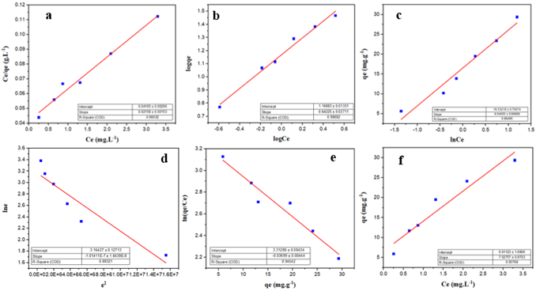
Figure 3. PMOS adsorption isotherm models of As(V) according to Langmuir (a), Freundlich (b), Temkin (c), Dubinin-Radushkevich (d), Elovich (e), Henry (f).
Table 2. Parameters of isotherm models for As(V) adsorption on phosphate-modified oyster shell (PMOS)
Isothermal model | Parameter | Value
Langmuir | K_{L} (L/mg) | 0,518
Langmuir | q_{max} (mg/g) | 46,34
Langmuir | R² | 0,98032
Freundlich | K_{F} (mg/g).(L/mg)^{1/n} | 14,75
Freundlich | n | 1,56
Freundlich | R² | 0,98682
Temkin | K_{T} | 5,657
Temkin | b_{T} (J/mol) | 9,540
Temkin | R² | 0,96495
Dubinin–Radushkevich | q_{max} (mg/g) | 23,67
Dubinin–Radushkevich | β (mol²/kJ²) | 1,01411.10⁻⁷
Dubinin–Radushkevich | E (kJ/mol) | 2220,46
Dubinin–Radushkevich | R² | 0,88321
Elovich | α (mg/g) | 27,463
Elovich | β (g/mg) | 0,0370
Elovich | R² | 0,94542
Henry | K_{H} | 7,5276
Henry | R² | 0,93768
In contrast, the Dubinin-Radushkevich model (R² = 0,88321) gives a qmax value of only 23,67mg/g,
much lower than Langmuir, while the adsorption energy E reaches 2,22 kJ/mol, typical of physical adsorption. Although the Elovich (R² = 0,94542) and Henry (R² = 0,93768) models have quite good correlation coefficients, they do not fully reflect the kinetic nature and complex interaction mechanism between As(V) and the material surface.
Thus, it can be concluded that the Freundlich model is the most suitable to describe the adsorption process of As(V) on PMOS, indicating the existence of a multilayer mechanism on a heterogeneous surface, while the Langmuir model still provides important information on the maximum capacity with qmax reaching 46,34 mg/g, confirming the high efficiency and application potential of the material in the treatment of arsenic in water environment.
The results in Table 3 show that the phosphate-modified oyster shell material (PMOS) achieved a maximum adsorption capacity of qmax = 46,34 mg/g for As(V), confirming its remarkable arsenate removal efficiency. Compared with natural and simply modified mineral materials, PMOS showed outstanding advantages. Specifically, the qmax value of PMOS was dozens of times higher than that of the kaolin mixture system (0,695 ÷ 4,17 mg/g), and nearly three times higher than that of ascorbic acid-coated Fe₃O₄ magnetic nanoparticles (16,56 mg/g). At the same time, PMOS also far surpassed other As(V) removal materials such as NaOH-modified electrolytic manganese sludge (23,96 mg/g), iron-modified concrete sludge (27,8 ÷ 41,7 mg/g), or GUT-3 metal-organic framework (33,91 mg/g). This demonstrates that the phosphate modification process significantly optimized the surface activity of oyster shells, helping to increase the density of phosphate and hydroxyl functional groups, thereby enhancing the ability to capture arsenate anions. In addition, when compared with more advanced material systems, PMOS continues to maintain its competitive position. The adsorption capacity of PMOS is higher than that of the metal-organic framework-chitosan- nanocellulose (CS-NC-MIL-53(Fe)) (36,76 mg/g), and only lower than some materials with more complex structures such as the polymer-Fe-Al hydroxide hybrid (49,6 mg/g) or amine-modified lignin (64,08 mg/g). This shows that PMOS, although developed from simple biological waste sources, can still achieve adsorption efficiency approaching or even surpassing some modern nano-composite materials which have complex manufacturing processes, high costs and are difficult to apply on a large scale.
Table 3. Comparison of maximum adsorption capacity (qmax) of PMOS and As(V) adsorbent tracks.
Adsorbent material | q_{max} (mg/g) | References
Kaolin mixed system | 0,695 ÷ 4,17 | ¹³
Ascorbic Acid Coated Superparamagnetic Fe₃O₄ Magnetic Nanoparticles | 16,56 | ⁴
NaOH modified electrolytic manganese residues (M-EMRs) | 23,96 | ¹⁴
Waste sludge from the production of iron-modified concrete (CWSFe) | 27,8 ÷ 41,7 | ¹⁵
Metal-organic framework - chitosan -nanocellulose (CS-NC-MIL-53(Fe)) | 36,76 | ¹⁶
GUT-3 metal organic framework | 33,91 | ¹¹
Phosphate - modified oyster shell | 46,34 | This study
Polymer-Fe-Al hydroxide hybrid material | 49,6 | ¹⁷
Amine-modified lignin (Lignin@N-X) | 64,08 | ¹⁸
3.3. Reuse of PMOS in As(V) adsorption
Figure 4 shows the FT-IR graphs of PMOS before adsorption (purPMOS) and after desorption (desPMOS). The PMOS sample before adsorption (purPMOS) exhibits the inherent absorption bands of CaCO₃, and the PMOS FT-IR spectrum shows many important new signals. The broad peaks at 3479 and 3160 cm⁻¹ reflect the O–H stretching vibrations, indicating the presence of hydroxyl groups or adsorbed water. The peak at 1646 cm⁻¹ is assigned to the bending vibration of H–O–H, further confirming the existence of water molecules in the newly formed structure. In particular, a series of bands at 1416, 1123, 1056 and 984 cm⁻¹ are characteristic of the valence and deformation vibrations of the phosphate group (PO₄³⁻/HPO₄²⁻). In addition, the peak at 522 cm⁻¹ is attributed to the Ca–O and P–O bond vibrations in the calcium phosphate salt structure. The appearance of these peaks shows that the denaturation process was successful in introducing phosphate groups into the CaCO₃ matrix, while forming the CaPO₃(OH).2H₂O (Brushite) phase.
It can be seen that after desorption with 0,1 M HCl (desPMOS), most of the main peaks were restored to almost the original spectrum, especially –OH and CO₃²⁻, indicating that the Ca²⁺– PO₄³⁻ – CO₃²⁻ framework structure of the material is still stable. However, the cluster intensity of 1123,09 ÷ 1056,19 cm⁻¹ and 522,64 cm⁻¹ is still lower than the original, indicating that a part of the metal ions are still tightly bound in the form of stable phosphate or carbonate, which is difficult to completely remove. This confirms that the adsorption mechanism of PMOS is based on the coordination between ion exchange, surface precipitation and strong chemical bonding, and the material has good regeneration ability after desorption.
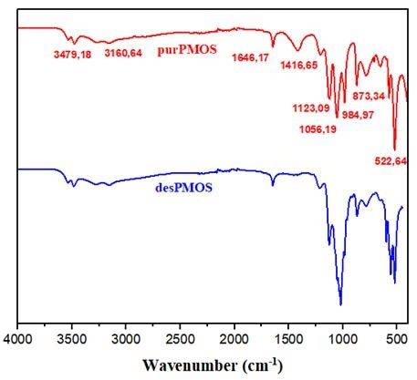
Figure 4. FT-IR graphs of the material before adsorption (purPMOS), and after desorption (desPMOS).
The results of the reusability evaluation (Figure 5) showed that PMOS exhibited stable and sustainable regeneration in the process of As(V) removal. In the first cycle, the adsorption efficiency reached 94,96%, reflecting the very high ability of the material to capture As(V) ions. During desorption and reuse, the efficiency slightly decreased but remained high through the following cycles, with a value of over 90% in the second cycle, about 88 ÷ 89% in the third cycle, and still reaching about 84% and 81% after the fourth and fifth cycles. This decrease is inevitable because a part of As(V) ions are tightly held at adsorption sites with high binding energy or due to local changes on the material surface after many treatments, however, the level of decrease is quite small compared to the total initial efficiency. It is noteworthy that the decreasing trend occurred gradually rather than abruptly, clearly reflecting the structural stability and the ability to preserve the active functional groups of PMOS during the repeated adsorption-desorption process. This shows that most of the active sites can still be effectively reactivated after the desorption process, and proves that the material is not destroyed or deactivated as quickly as many traditional adsorbents. Maintaining the As(V) removal efficiency above 80% even after 5 consecutive reuse cycles confirms that PMOS is a material with good regenerability, high durability and promise for practical implementation. With this characteristic, PMOS not only meets the requirements for treatment efficiency but also brings great economic and sustainability advantages, because the ability to regenerate many times will reduce operating costs, limit the need to replace new materials, and reduce the amount of solid waste generated during the water treatment process. Thus, the adsorption capacity combined with sustainable regeneration makes PMOS a promising adsorption candidate for As(V) removal in aquatic environments, serving long-term, safe and effective treatment solutions.
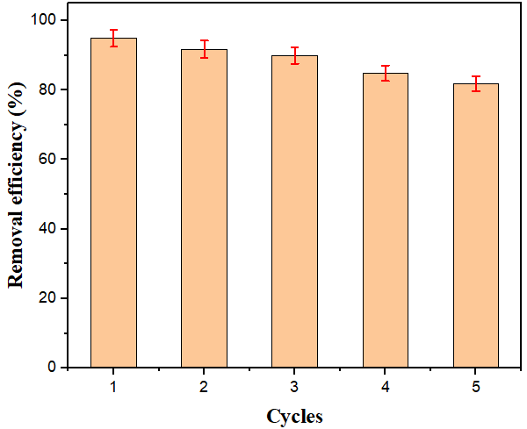 Figure 5. Reusability of PMOS for As(V) adsorption.
4. CONCLUSION
The present study demonstrated the successful development of phosphate-modified oyster shells (PMOS) as a sustainable and efficient adsorbent for arsenate [As(V)] removal from aqueous environments, with a particular focus on acid mine drainage conditions. PMOS achieved nearly complete removal efficiency (~95%) under optimal operational parameters (pH 3 ÷ 7, dosage 1,0 ÷ 1,5 g/L, equilibrium time 100 min), indicating its strong affinity for As(V). Kinetic modeling confirmed that the adsorption process followed a pseudo-second-order model, highlighting chemisorption as the dominant
mechanism supported by diffusion processes, while isotherm analyses showed that the Freundlich model best described multilayer adsorption on heterogeneous surfaces, with the maximum adsorption capacity (qmax) reaching 46,34 mg/g - significantly higher than many conventional biosorbents and competitive with advanced composite materials. Structural characterization further revealed the effective introduction of phosphate functional groups, which created active binding sites and accounted for the enhanced affinity toward oxyanions. Importantly, regeneration and reuse experiments demonstrated the durability of PMOS, as the material retained over 80% of its initial adsorption efficiency after five consecutive cycles, with only gradual declines in performance, reflecting the stability of its phosphate-calcium framework and the resilience of its active sites during repeated adsorption-desorption. Taken together, these results highlight PMOS not only as a highly effective and low-cost solution for arsenic removal in challenging acid mine drainage contexts but also as an eco-friendly approach to valorizing aquaculture waste in line with circular economy principles. By bridging pollutant remediation and biomass reuse, this work provides both mechanistic insights into As(V) adsorption and practical evidence of the potential of PMOS as a scalable, sustainable, and economically viable material for long-term water treatment applications.
Acknowledgments
This research was conducted at the Joint Vietnam-Russia Tropical Science and Technology Research Center. The authors gratefully acknowledge the experimental assistance provided by Nguyen Ngoc Minh Chau and Do Vu Duy, students of Le Quy Don High School.

REFERENCES
1. D. Núñez-Gómez, F. R. Lapolli, M. E. Nagel-Hassemer, M. Á. Lobo-Recio. Optimization of Fe and Mn removal from coal acid mine drainage (AMD) with waste biomaterials: Statistical modeling and kinetic study, Waste and Biomass Valorization, 2020, 11(3), 1143–1157.
2. T. T. Nguyen, H. Huang, T. A. H. Nguyen, S. Soda. Recycling clamshell as substrate in lab-scale constructed wetlands for heavy metal removal from simulated acid mine drainage, Process Safety and Environmental Protection, 2022, 165, 950–958.
3. K K. Khan, M. S. Khan, M. Younas, M. Yaseen, A. G. Al-Sehemi, Y. N. Kavil, C. Su, N. Ali, A. Maryam, R. Liang. Pathways and risk analysis of arsenic and heavy metal pollution in riverine water: Application of multivariate statistics and USEPA-recommended risk assessment models, Journal of Contaminant Hydrology, 2025, 269, 104483.
4. L. Feng, M. Cao, X. Ma, Y. Zhu, C. Hu. Superparamagnetic high-surface-area Fe₃O₄ nanoparticles as adsorbents for arsenic removal, Journal of Hazardous Materials, 2012, 217, 439–446.
5. M. Yadav, G. Singh, R. N. Jadeja. Physical and chemical methods for heavy metal removal, Pollutants and Water Management: Resources, Strategies and Scarcity, 2021, 377–397.
6. A. S. Ayangbenro, O. O. Babalola. A new strategy for heavy metal polluted environments: a review of microbial biosorbents, International Journal of Environmental Research and Public Health, 2017, 14(1), 94.
7. H. Qin, T. Hu, Y. Zhai, N. Lu, J. Aliyeva. The improved methods of heavy metals removal by biosorbents: A review, Environmental Pollution, 2020, 258, 113777.
8. G. Zhao, X. Wang, Q. Chen, J. Cheng. Efficacy of phosphorus loaded oyster shell in heavy metal removal: A combined study on adsorption behavior, structure characterization and comparative mechanism, Environmental Technology & Innovation, 2024, 33, 103484.
9. T.-T. Tran, N.-N. T. Tran, S. Sugiyama, J.-C. Liu. Enhanced phosphate removal by thermally pretreated waste oyster shells, Journal of Material Cycles and Waste Management, 2021, 23(1), 177–185.
10. H. Onoda, H. Nakanishi. Preparation of calcium phosphate with oyster shells, Natural Resources, 2012, 3(2), 71–77.
11. X. Zheng, M. Yi, Z. Chen, Z. Zhang, L. Ye, G. Cheng, & Y. Xiao. Efficient removal of As(V) from simulated arsenic-contaminated wastewater via a novel metal–organic framework material: Synthesis, structure, and response surface methodology, Applied Organometallic Chemistry, 2020, 34(5), e5584.
12. T. T. H. Nguyen, H. P. Nguyen Thi, N. H. Nguyen, M. T. Nguyen, M. C. Vu, D. D. Nguyen, & D. D. La. Biomass conversion of waste oyster shells into calcium phosphate/carbonate adsorbents for efficient manganese removal, Biofuels, Bioproducts and Biorefining, 2025, 19.4, 1044-1058.
13. B. Doušová, E. Bedrnová, K. Maxová, D. Koloušek, M. Lhotka, L. Pilař, & M. Angelis. Kaolin–fly ash composite for Pb²⁺ and AsO₄³⁻ adsorption from aqueous system, Applied Sciences, 2024, 14(12), 5358.
14. J. Lan, Y. Sun, L. Guo, Y. Du, D. Du, T. C. Zhang, J. Li, H. Ye. Highly efficient removal of As(V) with modified electrolytic manganese residues (M-EMRs) as a novel adsorbent, Journal of Alloys and Compounds, 2019, 811, 151973.
15. B. Doušová, E. Bedrnová, P. Reiterman, M. Keppert, D. Koloušek, M. Lhotka, & L. Mastný. Adsorption properties of waste building sludge for environmental protection, Minerals, 2021, 11, 309.
16. Y. Paisart. Nanocellulose-chitosan-metal organic framework composites for arsenic removal, Journal of Environmental Chemical Engineering, 2021, 9(5), 106075.
17. P. S. Kumar, R. Q. Flores, C. Sjöstedt, L. Önnby. Arsenic adsorption by iron–aluminium hydroxide coated onto macroporous supports: Insights from X-ray absorption spectroscopy and comparison with granular ferric hydroxides, Journal of Hazardous Materials, 2016, 302, 166–174.
18. Q. Wu, L. Gao, M. Huang, G. A. M. Mersal, M. M. Ibrahim, Z. M. El-Bahy, X. Shi, Q. Jiang. Aminated lignin by ultrasonic method with enhanced arsenic(V) adsorption from polluted water, Advanced Composites and Hybrid Materials, 2022, 5(2), 1044–1053.

Email: hoaiphuong.vrtc@gmail.com * Corresponding author.

