Tối ưu hóa hiệu suất phân hủy congo red trên xúc tác đất diatomite sử dụng thiết kế Box-Behnken

Phạm Đình Dũ^{1,}*

¹Trường Đại học Thủ Dầu Một, Thành phố Hồ Chí Minh, Việt Nam

*Tác giả liên hệ chính. Email: dupd@tdmu.edu.vn

Ngày nhận bài: dd/mm/yyyy; Ngày sửa bài: dd/mm/yyyy
Ngày nhận đăng: dd/mm/yyyy; Ngày xuất bản: dd/mm/yyyy

TÓM TẮT
Quá trình phân hủy congo red (CR) đã được khảo sát trong hệ phản ứng kiểu Fenton với sự hiện diện của đất diatomite (DE). Phương pháp bề mặt đáp ứng (RSM) dựa trên thiết kế Box-Behnken đã được ứng dụng để tối ưu hóa hiệu suất phân hủy. Trong những thiết kế thực nghiệm này, ba thông số quá trình ảnh hưởng đến hiệu suất phân hủy như nồng độ CR ban đầu (30−50 mg/L), nhiệt độ phản ứng (30−50 °C) và thời gian phân hủy (5−45 phút) đã được khảo sát. Dữ liệu thực nghiệm thu được được đưa vào phương trình đa thức bậc hai sử dụng phân tích hồi quy đa biến với giá trị hệ số tương quan cao (R² = 0,9999). Ở nồng độ CR ban đầu 40 mg/L, nhiệt độ phản ứng 40 °C, và thời gian phản ứng 14,2 phút, hiệu suất phân hủy đạt được 99% được dự đoán bởi mô hình (ở điều kiện: DE 1,2 g/L; pH 6; H₂O₂ 6,5 g/L). Kết quả này cũng được xác nhận thông qua các thí nghiệm xác thực, chỉ ra rằng RSM là một trong những phương pháp hiệu quả để tối ưu hóa các điều kiện vận hành trong nghiên cứu này.
Từ khóa: Congo red, đất diatomite, phân hủy, thiết kế Box-Behnken.

Optimization of congo red degradation performance on diatomaceous earth catalyst using Box-Behnken design

Pham Dinh Du^{1,}*

¹Thu Dau Mot University, Ho Chi Minh City, Vietnam

*Corresponding author. Email: dupd@tdmu.edu.vn

Received: dd/mm/yyyy; Revised: dd/mm/yyyy;
Accepted: dd/mm/yyyy; Published: dd/mm/yyyy

ABSTRACT
The degradation of congo red (CR) was investigated in a Fenton-type reaction system with the presence of diatomaceous earth (DE). Response surface methodology (RSM) based on Box-Behnken design was applied to optimize the degradation performance. In these experimental designs, three process parameters affecting the degradation performance, such as initial CR concentration (30−50 mg/L), reaction temperature (30−50 °C) and degradation time (5−45 min), were investigated. The obtained experimental data were fitted into a quadratic polynomial equation using multiple regression analysis with high correlation coefficient value (R² = 0.9999). At an initial CR concentration of 40 mg/L, a reaction temperature of 40 °C, and a reaction time of 14.2 min, the degradation efficiency of 99% was predicted by the model (under the conditions: DE 1.2 g/L, pH 6, H₂O₂ 6.5 g/L). This result was also confirmed through validation experiments, indicating that RSM is one of the effective methods to optimize the operating conditions in this study.
Keywords: Box-Behnken design, congo red, degradation, diatomaceous earth.

1. INTRODUCTION
Dyes are commonly used to color goods in many industries, including textiles, paper, leather, plastics, carpets, fruits, and cosmetics.¹ Dye residues in industrial wastewater are a major concern because their presence and accumulation can be harmful or carcinogenic to living organisms.^{1,2} It is impossible to remove dye compounds from water at low concentrations. Meanwhile, textile dyes are expected to be discharged in industrial waste at a rate of 280,000 tons per year.³ In many cases, color removal is very effective, but physical wastewater treatment methods simply move the pollutant to another environment, creating secondary waste.³ CR is known to be a highly toxic secondary diazo dye, with very small amounts of CR in the environment also being carcinogenic and mutagenic to aquatic organisms due to the conversion of CR to benzidine.⁴
In recent years, advanced oxidation processes (AOPs) have been identified as effective methods to achieve high oxidation efficiency for many organic compounds.^{1–3} Hydroxyl radicals (HO•) play an important role in AOPs, which can target a wide range of contaminants in a non-selective and efficient manner. The Fenton process is one of the AOPs that involves the reaction of Fe²⁺ species with H₂O₂ under strong acidic conditions to produce highly reactive hydroxyl radicals with an oxidation potential of 2.80 V and is known as the Fenton-like equation:³
Fe²⁺ + H₂O₂ → Fe³⁺ + HO⁻ + HO• (1)
Fe³⁺ + H₂O₂ → Fe²⁺ + H⁺ + HO• (2)
The Fenton reaction is a potential practical, cost-effective, and environmentally friendly wastewater treatment process.^{3,5} The Fenton method has received a lot of attention. The Fenton process is influenced by several factors, including temperature, H₂O₂ concentration, Fe²⁺ concentration, and pH. pH is a very important factor in AOPs, and especially in the Fenton process, as it directly affects the rate of pollutant degradation. Several studies on the Fenton process have shown that the pH should be between 2.8 and 3.0 for optimal degradation of organic pollutants.³ The main disadvantages of the homogeneous Fenton process are the formation of precipitated Fe³⁺ compounds (oxy-hydroxides) when the pH of the solution increases, the inability to reuse the catalyst, and the generation of Fe-containing sludge, which affects the environment and costs.^{2,5} To overcome the disadvantages of homogeneous Fenton, the heterogeneous Fenton process using solids as catalysts has been developed, in which iron and other active metals are incorporated into the structure of the material or immobilized on the solid support.
Xu et al.⁵ suggested that heterogeneous Fenton systems have great application prospects in the catalytic degradation of organic wastewater. However, these systems have not been widely used due to difficulties in catalyst preparation such as low efficiency and high production cost. These authors used iron-containing palygorskite clay as a Fenton catalyst reagent without any retreatment. Phenol degradation in water was carried out as a probe reaction for the palygorskite Fenton reagent. The effects of several factors, including palygorskite content, H₂O₂ concentration, and pH value, on the phenol degradation efficiency were studied by these authors. The optimal operating conditions were determined to be palygorskite content of 0.5 g/L, initial pH of 3, and hydrogen peroxide dosage of 30 mmol/L. Under this optimum operating condition, the chemical oxygen demand (COD) degradation efficiency of 100 mg/L phenol reached 94% in a reaction time of 15 min. The authors suggested that the degradation ability of palygorskite clay could be due to Fe₂O₃ on the palygorskite surface.
DE, also known as diatomite, is a naturally occurring soft siliceous sedimentary rock that consists primarily of the fossilized remains of diatoms, a type of unicellular algae. The main chemical composition of diatomite is silica (SiO₂), along with small amounts of aluminum oxide (Al₂O₃), iron oxide (Fe₂O₃), calcium oxide (CaO), magnesium oxide (MgO), and organic matter. Its unique properties, including high porosity, low density, and large specific surface area, make it a valuable material in many industrial applications.⁶ Furthermore, diatomite mineral deposits are quite abundant, making DE a potential candidate for heterogeneous Fenton catalysts.
The efficiency of Fenton-type catalytic degradation depends on the pollutant concentration, solution pH, catalyst dosage, residual H₂O₂ concentration, reaction temperature and time, etc. Therefore, optimization of these parameters is crucial to achieve catalytic degradation of the existing pollutant. One of the most widely used optimization techniques for this purpose is the RSM. By systematically varying all the variables simultaneously, this method has been recognized as the most reliable and empirical statistical method used to evaluate the impact of different process parameters on catalytic degradation. Furthermore, by developing a mathematical model (linear, square polynomial function, etc.), it is possible to determine the influence of each parameter on the process efficiency and study the interaction between them. The most important advantage of using RSM is that it provides a systematic method for designing experiments that often require fewer experiments and therefore less time.^{3,7,8} To design these experiments, the Box-Benkhen design is widely used for optimization.^{8,9} The Box-Behnken design is an independent, rotatable quadratic design with no embedded factorial or fractional factorial points where the variable combinations are at the midpoints of the edges of the variable space and at the center. The Box-Behnken design is only used when there are more than two factors.⁹
In this study, CR was considered as a model dye for removal from aqueous solution by the heterogeneous Fenton process on DE catalyst. The effects of operating parameters, including reaction temperature, CR concentration, and reaction time, on the degradation of CR in terms of degradation efficiency were evaluated. The aim of this study is to apply the RSM through Box-Behnken experimental design to optimize the parameters, at the same time allowing to analyze the influence of each parameter, the interaction of parameters, evaluate the influence level as well as the reliability of the optimization method for the degradation of CR by the heterogeneous Fenton process.
2. EXPERIMENTAL
2.1. Materials and characteristic methods
Raw DE was taken from Phu Yen province, Vietnam, washed several times with water, filtered, dried at 100 °C, sieved, and stored in closed containers for further tests.
The morphology of DE was observed by using a scanning electron microscopy (SEM, IMS-NKL) and a transmission electron microscopy (TEM, EMLab-NIHE). X-ray diffraction (XRD) pattern was recorded on a Bruker D8 Advance (Germany) powder diffractometer with a Cu Kα radiation source. Fourier-transform infrared (FT-IR) spectra were obtained on a Jasco FT/IR-4600 (Japan); the samples being dispersed on KBr pallets. Nitrogen adsorption-desorption isotherms were obtained by using a Tristar 3000 analyser; the samples were degassed by heat treatment at 250 °C in the N₂ for 5 h. The elemental composition was analyzed with an Energy-dispersive X-ray spectroscopy (EDX, Bruker) at 15 keV.
2.2. Degradation experiments
In each experiment, DE (0.06 g) is stirred with 50 mL of CR (Guangdong, China) solution at a specific concentration and pH (0.1 M HCl or 0.1 M NaOH was used to adjust the initial pH value) and 1.0 mL of H₂O₂ 30% (Fisher, Korea). The reaction is performed at a fixed temperature. At certain time intervals, about 3 mL of the solution is drawn, filtered to remove the catalyst, the remaining CR concentration in the solution is determined by the UV-Vis method on a Jasco V-770 (Japan) at λ_{max} 498 nm.
The CR degradation performance, D%, is calculated according to the Eq. (3).
$$D\%=\frac{C_{0}-C_{t}}{C_{0}}×100$$ | (3)
Where C₀ and C_{t} are the concentration of CR in the solution at the original and t time, respectively.
2.3. Box-Behnken design
In this study, the initial pH of the solution was fixed at 6 to investigate the effects of three process factors on the degradation efficiency of CR by H₂O₂ on DE catalyst (under the conditions: DE 1.2 g/L and H₂O₂ 6.5 g/L). The three factors investigated, including initial CR concentration, temperature and reaction time. The Box-Behnken design for the three process variables is shown in Table 1 at three experimental levels for each variable. Their allowable values ​​include {−1,0,+1} for low, medium and high levels, respectively. Minitab software (Version 16, Minitab Inc., Pennsylvania State, USA) was used to construct the experimental matrix for the multiple regression model using the RSM according to the Box-Behnken design with the number of experiments being 15, of which the number of experiments at the center is 3 (Table 2).
3. RESULTS AND DISCUSSION
3.1. Characteristics of DE
SEM and TEM images (Fig. 1a) show that natural DE contains cylindrical structures with a diameter of about 5−7 μm. The surface of these structures is quite smooth and has many pores with a diameter of about 50 nm. XRD diffraction (Fig. 1b) shows that the DE material has an amorphous structure; the broad peak of 2θ at 20−25° is characteristic of amorphous silica.¹
Table 1. Ranges and levels of independent variables for CR degradation on DE catalyst.
Independent variables (Unit) | Symbol | Level
Independent variables (Unit) | Symbol | −1 | 0 | +1
Initial CR concentration (mg/L) | A | 30 | 40 | 50
Reaction temperature (°C) | B | 30 | 40 | 50
Degradation time (min) | C | 5 | 25 | 45

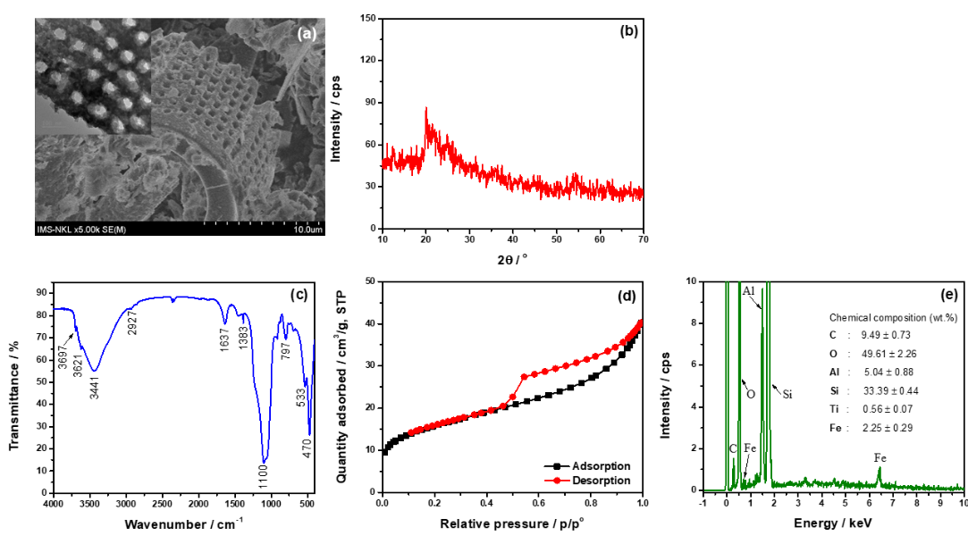
Fig. 1. SEM image and the inset presents TEM image (a), XRD pattern (b), FT-IR spectrum (c), nitrogen adsorption/desorption isotherms (d), EDX spectrum and the insert presents the chemical composition (e) of DE.

The FT-IR spectrum of DE is shown in Fig. 1c. The peaks in the 3700−3200 cm⁻¹ region and at 1637 cm⁻¹ are characteristic of the vibrations of the O−H bond, including Si−OH, Me−OH (Me is a metal) and freely adsorbed H₂O. The broad absorption band centered at 1100 cm⁻¹, and two bands at 797 and 470 cm⁻¹, are characteristic of the vibrations of the Si−O−Si bond. The peak at 533 cm⁻¹ is attributed to the bending vibration of the Me−O bond.¹ The weak vibrations at 2927 and 1383 cm⁻¹ are thought to be due to the existence of some organic matter.¹⁰
The nitrogen adsorption/desorption isotherms of DE is type II with a type H3 hysteresis loop (Fig. 1d), indicating the existence of macroporous structures with irregular sizes and shapes. DE has a large specific surface area (55.4 m²/g), which is similar to that reported by Son et al.¹¹. The chemical composition of DE was analyzed by EDX (Fig. 1e). It can be seen that Si is the main element in diatomite (33.39%) with some other impurities such as Al (5.04%), Ti (0.56%), Fe (2.25%) and some organic compounds with a C elemental content of 9.49%. With a large specific surface area, porous structure and the presence of metals, including iron, DE is a potential catalyst in the Fenton-type reaction system.
3.2. Degradation of CR in aqueous solution
3.2.1. Effect of solution pH
Figure 2 shows that CR is removed very quickly in the first 10 minutes of the reaction at all pH values ​​examined. After that, the concentration of CR in the solution do not change significantly in the pH range from 4 to 8, but tend to decrease gradually until 90 minutes of reaction. On the contrary, in the pH range of 9−11, the concentration of CR in the solution tend to increase with the reaction time. The reason for this problem can be explained by the fact that DE has a high affinity for adsorbing CR, so the concentration of CR decreases significantly at the first; over time, the desorption occurs making the concentration of CR in the solution increases again. But the oxidation of CR by H₂O₂ on the DE catalyst occurs favorably at pH 4−8, so the concentration of CR still decreases gradually with the reaction time.
3.2.2. Removal of CR under different conditions
The removal of CR in aqueous solution under different conditions is shown in Fig. 3. It can be seen that CR is quite stable under the effect of H₂O₂ (without catalyst), CR is only degraded about 7% after 90 minutes of reaction. In the presence of DE (without H₂O₂), CR is removed about 50% after 90 minutes of contact, proving that DE also has the ability to adsorb CR. Notably, when H₂O₂ and DE are present at the same time, CR is removed very quickly, the degradation efficiency reaches 85% after only 10 minutes of reaction and changes insignificantly during the remaining investigation time. Therefore, the degradation of CR in aqueous solution by H₂O₂ in the presence of DE continues to be studied.
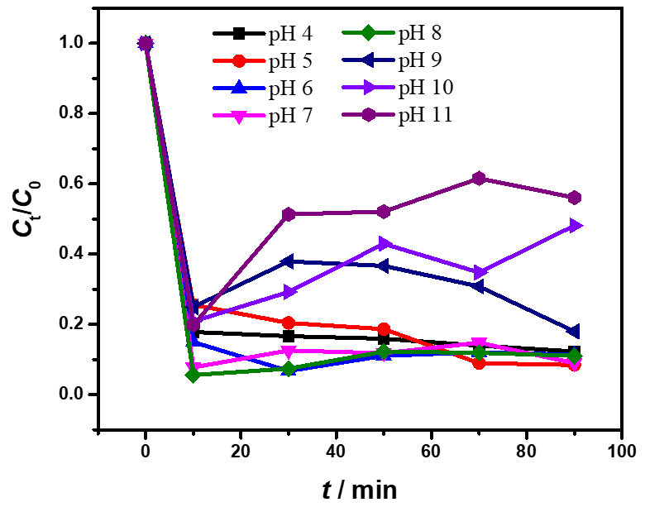
Fig. 2. Decomposition of CR by H₂O₂ on DE catalyst at different initial solution pHs (Experimental conditions: DE 1.2 g/L, CR 30 mg/L, H₂O₂ 6.5 g/L and ambient temperature).
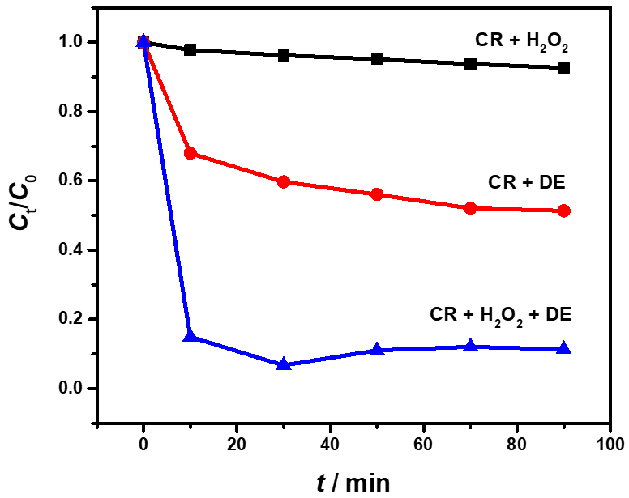
Fig. 3. CR removal under different conditions (Experimental conditions: DE 1.2 g/L, CR 30 mg/L, pH 6, H₂O₂ 6.5 g/L and ambient temperature).
3.2.3. Applying the Box-Behnken experimental design model
The results of the CR degradation performance determination of 15 experimental studies are given in Table 2. The experimental D% values ​​were found to be in the range of 80.82–99.74%. A multiple regression equation was derived using the experimental variable data and the experimental D% values ​​to express the relationship between D% and the process parameters according to the coded variables. Eq. (4) represents this relationship.
$$D\%=-18.3156+3.5972 A+3.0397 B-0.9453 C-0.0665 A^{2}-0.0500 B^{2}+0.0002 C^{2}+0.0250 AB+0.0201 AC+0.0004 BC$$ | (4)
Where A, B and C are the coded process variables.

The adequacy and significance of the proposed model were analyzed using analysis of variance, the results of which are shown in Table 3. Statistically, a low p-value (<0.05) indicates the significance of a model or parameter. Therefore, in the interpreting the results of the variance test, it is known that independent variables with p-values ​​less than 0.05 are effective in the obtained model. Whereas, p-values ​​greater than 0.1 indicate that the terms are non-significant.^{7,8} From Table 3, it can be seen that the interacting factors of C² and BC is non-significant, the remaining terms are all significant. The F-value of the regression model is 4747.62 indicating that the model is significant at p = 0.000 (< 0.001). The F-value of Lack-of-Fit is 1.36 and the associated p-value is 0.450 which is non-significant due to the pure relative error.⁹ Furthermore, there is a good agreement between the correlation coefficient (R² = 0.9999), the predicted R² (0.9987) and the adjusted R² (0.9997), between the theoretical and experimental values.⁷ Fig. 4 shows the predicted response compared to the actual response as well as the normal plot of residuals. The fact that the residuals lie around a straight line indicates that the errors are distributed reasonably (Fig. 4a).⁸ The plotted points almost lying on the first quadrant bisector in Fig. 4b also indicate that the predicted D% value is close to the experimental result. These demonstrate the adequacy of the proposed model.
As can be seen from Eq. (4), the parameters that are significant to the model are those with larger coefficients, so with small changes in this value, the reaction will undergo large changes. Furthermore, with Eq. (4), the effect of the variable on the process can be inferred. The combined effects of decomposition time, reaction temperature and initial CR concentration on D% are depicted in Fig. 5. These plots can be understood as graphical representations of the regression model equation used to solve the optimal conditions of the factors, and are often applied to demonstrate an understanding of the types of interactions between variables that can be used to improve the decomposition performance.⁸ The degradation efficiency of CR by H₂O₂ on DE catalyst with a target of about 99.0% was predicted by Minitab software (v. 16) for three process parameters found to be 40 (mg/L), 40 (°C), and 14.2 (min) corresponding to initial CR concentration, temperature and reaction time, respectively. Under these conditions, the experimental results showed that the D% value reached 98.6%. The experimental results, under the same conditions, are close to the software prediction results, which confirm the reliability of the mode.
Table 2. Experimental and predicted responses for different experimental runs.
Run | Coded variables |  |  | Experimental variables |  |  | Response values (D%)
Run | A | B | C | Initial CR concentration (mg/L) | Reaction temperature (°C) | Degradation time (min) | Exp. | Pred.
1 | +1 | 0 | +1 | 50 | 40 | 45 | 90.61 | 90.65
2 | +1 | 0 | −1 | 50 | 40 | 5 | 87.30 | 87.24
3 | −1 | 0 | +1 | 30 | 40 | 45 | 86.98 | 87.04
4 | −1 | 0 | −1 | 30 | 40 | 5 | 99.74 | 99.70
5 | 0 | +1 | +1 | 40 | 50 | 45 | 91.08 | 91.07
6 | 0 | +1 | −1 | 40 | 50 | 5 | 95.45 | 95.54
7 | 0 | −1 | +1 | 40 | 30 | 45 | 90.02 | 89.93
8 | 0 | −1 | −1 | 40 | 30 | 5 | 94.69 | 94.71
9 | +1 | +1 | 0 | 50 | 50 | 25 | 86.88 | 86.85
10 | +1 | −1 | 0 | 50 | 30 | 25 | 80.82 | 80.86
11 | −1 | +1 | 0 | 30 | 50 | 25 | 86.32 | 86.27
12 | −1 | −1 | 0 | 30 | 30 | 25 | 90.26 | 90.29
13 | 0 | 0 | 0 | 40 | 40 | 25 | 97.81 | 97.72
14 | 0 | 0 | 0 | 40 | 40 | 25 | 97.72 | 97.72
15 | 0 | 0 | 0 | 40 | 40 | 25 | 97.63 | 97.72
Table 3. Analysis of variance for D% of the CR degradation on DE catalyst.
Source | df | Seq SS | Adj SS | Adj MS | F-value | p-value | Remarks
Regression | 9 | 414.745 | 414.745 | 46.083 | 4747.62 | 0.000 | Significant
Linear | 3 | 83.839 | 136.875 | 45.625 | 4700.45 | 0.000 | Significant
A | 1 | 39.167 | 59.225 | 59.225 | 6101.57 | 0.000 | Significant
B | 1 | 1.933 | 42.290 | 42.290 | 4356.90 | 0.000 | Significant
C | 1 | 42.739 | 36.406 | 36.406 | 3750.66 | 0.000 | Significant
Square | 3 | 241.342 | 241.342 | 80.447 | 8288.00 | 0.000 | Significant
A² | 1 | 148.183 | 163.332 | 163.332 | 16827.08 | 0.000 | Significant
B² | 1 | 93.130 | 92.326 | 92.326 | 9511.81 | 0.000 | Significant
C² | 1 | 0.029 | 0.029 | 0.029 | 3.00 | 0.144 | Non-significant
Interaction | 3 | 89.563 | 89.563 | 29.854 | 3075.71 | 0.000 | Significant
AB | 1 | 25.013 | 25.013 | 25.013 | 2576.89 | 0.000 | Significant
AC | 1 | 64.527 | 64.527 | 64.527 | 6647.83 | 0.000 | Significant
BC | 1 | 0.023 | 0.023 | 0.023 | 2.42 | 0.181 | Non-significant
Residual Error | 5 | 0.049 | 0.049 | 0.010
Lack-of-Fit | 3 | 0.033 | 0.033 | 0.011 | 1.36 | 0.450 | Non-significant
Pure Error | 2 | 0.016 | 0.016 | 0.008
Total | 14 | 414.793

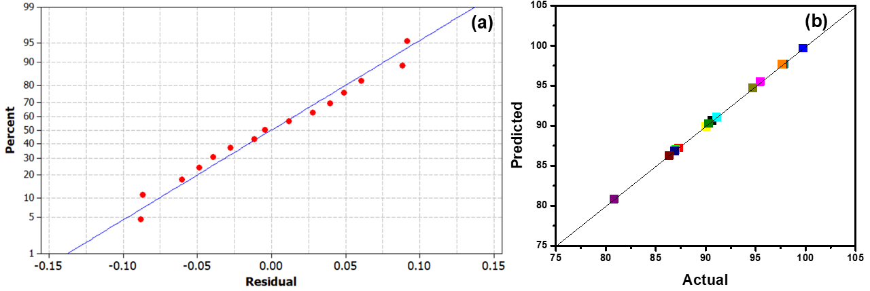
Fig. 4. Normal plot of residuals (a) and predicted vs. actual values (b) for CR degradation.
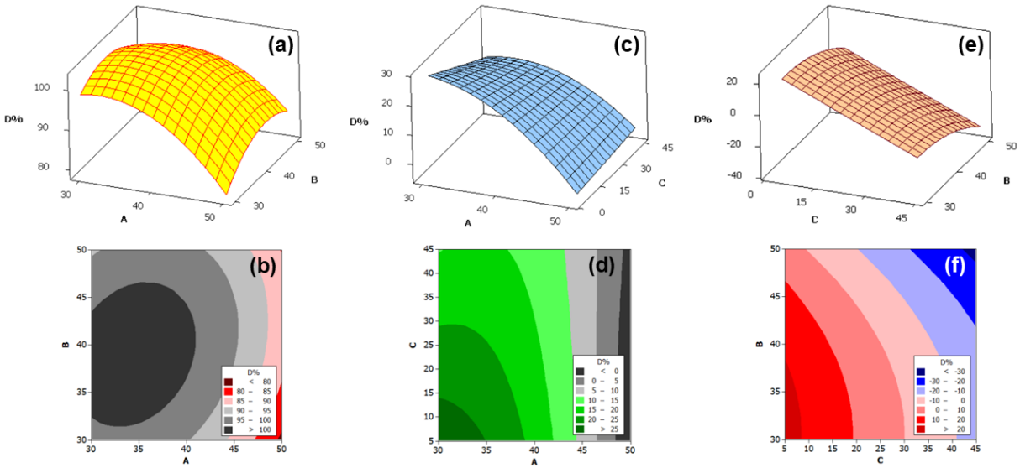
Fig. 5. Combined effects of independent variables: (a, b) Initial CR concentration and reaction temperature; (c, d) Initial CR concentration and degradation time; (e, f) Degradation time and reaction temperature.

Table 4 compares the degradation efficiency of CR by H₂O₂ oxidizing agent in the presence of different catalysts. Although the reaction conditions are different, it can be seen that DE is also an effective catalyst for CR oxidation reaction in aqueous solution.
3.3. Recyclability of DE
Used DE catalyst is recovered, washed with distilled water and reused. The catalytic activity of DE was evaluated over four cycles of use, and the results of the CR degradation efficiency are shown in Fig. 6. It can be seen that the D% value decreased sharply after the first use, from 99% to 76% in the second use. After that, the D% only decreased slightly until the fourth use. This shows that DE still maintained its catalytic activity after four cycles of use, so this catalyst can be used to degrade organic dyes in aqueous solution with hydrogen peroxide as an agent.
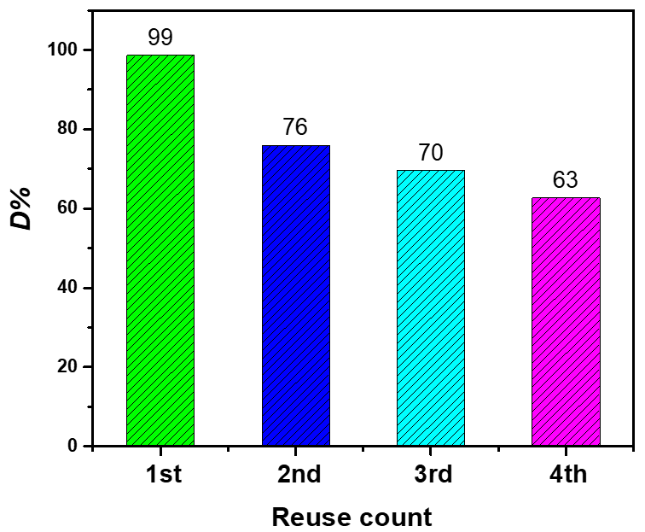
Fig. 6. CR degradation efficiency after four times of reusing DE (Experimental conditions: DE 1.2 g/L, CR 40 mg/L, pH 6, H₂O₂ 6.5 g/L, 40 °C, and reaction time of 14.2 min).
Table 4. Degradation of CR using H₂O₂ as oxidizing agent on different catalysts.
Catalyst | Degradation efficiency (%) | Experimental conditions | Ref.
DE | 98.6 | pH 6, catalyst dosage = 1.2 g/L, [H₂O₂] = 6.5 g/L, initial [CR] = 40 mg/L, temperature = 40 °C, time = 14.2 min | This work
Ag/ZnCo-ZIFs | 94 | pH 7.1, catalyst dosage = 150 mg/L, [H₂O₂] = 0.05 mol/L, initial [CR] = 30 mg/L, temperature = 30 °C, time = 45 min | ¹²
FeSO₄ (*) | 83 | pH 3.5, catalyst dosage = 25 mg/L, [H₂O₂] = 5 mM, initial [CR] = 25 mg/L, temperature = 30 °C, time = 60 min | ¹³
Fe²⁺ | 74.75 | pH 3, catalyst dosage = 1.03 mM, [H₂O₂] = 11.77 mM, initial [CR] = 50 mg/L, temperature = 25 °C, time = 120 min | ³
Fe₂O₃@CeO₂-ZrO₂/Palygorskite | 95 | pH 3.4, catalyst dosage = 4 g/L, [H₂O₂] = 40 mM, initial [CR] = 500 mg/L, temperature = 30 °C, time = 105 min | ¹⁴
*The sono-Fenton process.

4. CONCLUSION
DE material was used as a catalyst in a heterogeneous Fenton oxidation system to decompose CR in aqueous solution. DE has a large specific surface area (55.4 m²/g) with the main component being amorphous silica, and some impurities such as Al (5.04%), Ti (0.56%), Fe (2.25%) (by weight). In the initial solution pH range from 4 to 8, the decomposition occurred favorable and the decomposition efficiency did not change significantly. At the initial solution pH of 6, the experimental results were effectively modeled using Box-Behnken factorial design for three process variables affecting the CR decomposition efficiency, including initial CR concentration, temperature and reaction time. The model summary statistics showed that the developed model was adequate and accurate with the experimental data. The optimal operating conditions for the three process parameters were found to be 40 (mg/L), 40 (°C), and 14.2 (min) for the initial CR concentration, reaction temperature and decomposition time, respectively. Under these conditions, the CR decomposition efficiency was approximately 99% (at DE 1.2 g/L, pH 6, H₂O₂ 6.5 g/L).
REFERENCES
1. D. Dai, H. Liang, D. He, H. Potgieter, M. Li. Mn-doped Fe₂O₃/diatomite granular composite as an efficient Fenton catalyst for rapid degradation of an organic dye in solution, Journal of Sol-Gel Science and Technology, 2021, 97, 329-339.
2. W. Chen, M. Zeng, J. Yang. Preparation of Fenton Catalysts for Water Treatment, Catalysts, 2023, 13, 1407.
3. G. Afef, B. Mohamed. Removal of Congo Red and Rhodamine B Dyes from Aqueous Solution by Fenton Process: Optimization of Operational Parameters, Iranian Journal of Chemistry and Chemical Engineering, 2023, 42, 801-809.
4. P. O. Oladoye, M. O. Bamigboye, O. D. Ogunbiyi, M. T. Akano. Toxicity and decontamination strategies of Congo red dye, Groundwater for Sustainable Development, 2022, 19, 100844.
5. J. Xu, X. Yun, M. Li, Y. Tian, X. Lei, F. Zhang. Iron-containing palygorskite clay as Fenton reagent for the catalytic degradation of phenol in water, RSC Advances, 2021, 11, 29537-29542.
6. A. Przybek, M. Łach, M. Hebdowska-Krupa, K. Miernik, J. Mikuła. Research of the physical and chemical properties of diatomite as a carrier of phase change materials for use in advanced building materials, Frontiers in Materials, 2024, 11, 1507779.
7. A. Fdez-Sanromán, E. Rosales, M. Pazos, A. Sanromán. One-pot synthesis of bimetallic Fe–Cu metal–organic frameworks composite for the elimination of organic pollutants via peroxymonosulphate activation, Environmental Science and Pollution Research, 2023, 32, 10592-10607.
8. M. Seloglu, R. Orhan, V. Selen, G. Dursun. Analysis of Photocatalytic Degradation of Phenol by Zinc Oxide Using Response Surface Methodology, ChemistryOpen, 2024, 13, e202300238.
9. J. Prakash-Maran, S. Manikandan, K. Thirugnanasambandham, C. Vigna-Nivetha, R. Dinesh. Box–Behnken design based statistical modeling for ultrasound-assisted extraction of corn silk polysaccharide, Carbohydrate Polymers, 2013, 92, 604-611.
10. Y. Liu, J. Zhang, X. Sheng, N. Li, Q. Ping. Adsorption and Release Kinetics, Equilibrium, and Thermodynamic Studies of Hymexazol onto Diatomite, ACS Omega, 2020, 5, 29504-29512.
11. B. H. D. Son, V. Q. Mai, D. X. Du, N. H. Phong, N. D. Cuong, D. Q. Khieu. Catalytic wet peroxide oxidation of phenol solution over Fe–Mn binary oxides diatomite composite, Journal of Porous Materials, 2017, 24, 601-611.
12. G. H. Dang, T. T. A. Le , A. K. Ta , T. N. T. Ho , T. V. Pham , T. V. H. Doan, T. H. V. Luong. Removal of Congo red and malachite green from aqueous solution using heterogeneous Ag/ZnCo-ZIF catalyst in the presence of hydrogen peroxide. Green Processing and Synthesis, 2020, 9, 567-577.
13. S. Nawaz, M. Siddique, R. Khan, N. Riaz, U. Waheed, I. Shahzadi, A. Ali. Ultrasound-Assisted Hydrogen Peroxide and Iron Sulfate Mediated Fenton Process as an Efficient Advanced Oxidation Process for the Removal of Congo Red Dye. Polish Journal of Environmental Studies, 2022, 31, 2749-2761.
14. J. Ouyang, Z. Zhao, S. L. Suib, H. Yang. Degradation of Congo Red dye by a Fe₂O₃@CeO₂-ZrO₂/Palygorskite composite catalyst: Synergetic effects of Fe₂O₃. Journal of Colloid and Interface Science, 2019, 539, 135-145.

