Mô hình AI trên FPGA: Mô hình CNN gọn nhẹ thông lượng cao và công suất thấp cho bài toán nhận dạng chữ số

Phạm Văn Khoa*, La Công Lộc, Nguyễn Đức Trọng, Huỳnh Minh Quý, Hồ Gia Huyên, Võ Quang Huy, Phạm Bá Lộc, Huỳnh Thị Thu Hiền

Địa chỉ của tác giả: Trường Đại học Sư phạm Kỹ thuật Tp. Hồ Chí Minh
*Tác giả liên hệ chính. Email: khoapv@hcmute.edu.vn
Ngày nhận bài: dd/mm/yyyy; Ngày sửa bài: dd/mm/yyyy;
Ngày nhận đăng: dd/mm/yyyy; Ngày xuất bản: dd/mm/yyyy

TÓM TẮT
Nghiên cứu này trình bày việc thiết kế và triển khai một mạng nơ-ron tích chập trên nền tảng SoC–FPGA để phân loại chữ số viết tay sử dụng bộ dữ liệu MNIST. Mục tiêu là xây dựng một bộ gia tốc CNN gọn nhẹ và hiệu quả, có dưới 1,000 tham số, hoạt động tương thích với bộ xử lý ARM trên bo mạch PYNQ-Z2 thông qua các giao tiếp DMA và AXI. Bộ gia tốc được hiện thực ở mức RTL, với các giai đoạn mô phỏng, tổng hợp và tối ưu hóa tài nguyên, đồng thời vẫn duy trì được độ chính xác của quá trình suy luận. Trên 10,000 ảnh kiểm thử MNIST, hệ thống đạt độ chính xác 91.28%—thấp hơn khoảng 5% so với mô hình chạy trên CPU hai nhân ARM Cortex-A9 (96.26%)—nhưng lại mang lại tốc độ xử lý nhanh hơn 7 lần và giảm 36% mức tiêu thụ điện năng. Thiết kế cho thấy hiệu quả của việc song song hóa và pipeline hóa các phép tích chập trực tiếp trên FPGA, giúp giảm đáng kể mức sử dụng tài nguyên và công suất tiêu thụ. Những kết quả này cung cấp một nền tảng thực tiễn cho các ứng dụng AI nhúng thời gian thực—chẳng hạn như nhận dạng ký tự, giám sát hình ảnh, hệ thống IoT thông minh và tính toán biên—trên các nền tảng SoC–FPGA.
Từ khóa: Bộ tăng tốc Mạng Nơ-ron Tích chập (Convolutional Neural Networks Accelerator), FPGA, Hệ thống trên Chip (System on Chip), MNIST, Phân loại ảnh.

Practical Embedded AI on FPGA: A Compact CNN Achieving High Throughput and Low Power for Digit Recognition

Pham Van Khoa*, La Cong Loc, Nguyen Duc Trong, Huynh Minh Quy, Ho Gia Huyen, Vo Quang Huy, Pham Ba Loc, Huynh Thi Thu Hien

Author’s address: Ho Chi Minh City University of Technology and Education, Vietnam
*Corresponding author. Email: khoapv@hcmute.edu.vn
Received: dd/mm/yyyy; Revised: dd/mm/yyyy;
Accepted: dd/mm/yyyy; Published: dd/mm/yyyy

ABSTRACT
This work presents the design and deployment of a Convolutional Neural Network on an SoC–FPGA platform for handwritten digit classification using the MNIST dataset. The goal is a compact, efficient FPGA-based CNN accelerator with fewer than 1,000 parameters that integrates seamlessly with the ARM processor on the PYNQ-Z2 board via DMA and AXI interfaces. The accelerator is realized at the register-transfer level and undergoes simulation, synthesis, and resource-focused optimization while preserving inference accuracy. On 10,000 MNIST test images, the system attains 91.28% accuracy—about 5 percentage points below a CPU implementation on dual ARM Cortex-A9 cores (96.26%)—but delivers a 7–8× speedup and a 36% reduction in power consumption. The design highlights effective parallelization and pipelining of convolution operations directly on the FPGA, achieving low resource usage and power draw. These results provide a practical foundation for real-time embedded AI applications—such as character recognition, image monitoring, intelligent IoT systems, and edge computing—on SoC–FPGA platforms.
Keywords: Convolutional Neural Networks Accelerator, FPGA, System on Chip, MNIST, Image Classification.
- INTRODUCTION
In recent years, Convolutional Neural Networks (CNNs) have become the dominant approach for image recognition and classification owing to their efficient spatial feature extraction and high accuracy.¹ However, CNN models typically require substantial computation and memory, which makes deployment challenging on embedded systems with limited hardware resources.² Field-Programmable Gate Arrays (FPGAs)—with their flexibility, massive parallelism, and low power consumption—have proven to be effective platforms for accelerating CNNs in embedded applications.^{1,3} Implementing CNNs on FPGAs can reduce inference latency relative to CPU- or GPU-based software while efficiently utilizing hardware resources such as DSP slices, Lookup Tables (LUTs), and block RAM (BRAM). To achieve high performance on FPGAs, many studies quantize weights and activations to replace floating-point operations with integer arithmetic, thereby reducing hardware complexity while maintaining accuracy.² In addition, techniques such as parallelization, pipelining, and data reuse are commonly applied to increase throughput and optimize memory bandwidth.³ In SoC–FPGA architectures, the integration of FPGA Programmable Logic (PL) and the embedded ARM Processing System (PS) provides a balance between performance and flexibility.⁴ The PL handles computationally intensive kernels, while the PS manages control and data movement via direct memory access (DMA) over the Advanced eXtensible Interface (AXI) interconnect.^{5,6} On the PYNQ-Z2 platform, the Python Productivity for Zynq (PYNQ) framework enables direct control and testing of the CNN accelerator from Python, facilitating data transfer between Double Data Rate (DDR) memory and the FPGA and thereby simplifying system development and evaluation.^{6,7}This work presents the design and implementation of a lightweight CNN accelerator on an SoC–FPGA platform for handwritten-digit classification using the Modified National Institute of Standards and Technology (MNIST) dataset. The model is optimized to fewer than 1,000 parameters to balance accuracy, memory footprint, and hardware feasibility on the PYNQ-Z2. The system employs DMA/AXI for data exchange between the CPU and FPGA and integrates the PYNQ framework for control and real-time inference. Experimental results demonstrate that the proposed design delivers high performance, efficient resource utilization, and low power consumption, confirming the feasibility of FPGA-based real-time embedded AI systems.
- RELATED WORKS
MNIST inference on FPGA/SoC platforms has been extensively explored along two main directions: (i) extreme-quantization approaches (binary/ternary) that push hardware efficiency and throughput, and (ii) fixed-/integer-point CNN deployments (LeNet-5-based CNN) that target higher accuracy with moderate resource cost. In the first direction, FINN provides a representative toolflow for binarized neural networks on FPGAs and reports multi-million classifications per second on MNIST with sub-microsecond latency on a Zynq ZC706 platform, together with explicit performance and power reporting⁸. In the fixed-/integer-point CNN category, González et al. implement a LeNet-5 inference accelerator using an SW/HW co-processing scheme on a Zynq-7000 Arty Z7-20, reporting 97.59% MNIST accuracy with 12-bit fixed-point arithmetic and approximately 441 images/s at 100 MHz⁹. More recent full-network deployments using HLS on Zynq devices provide more complete reporting of model scale and system metrics; for example, Liang et al. detail LeNet-5 weight counts and report end-to-end inference time, power, and error rate (e.g., 1.07 ms, 2.193 W, and 0.99% error for their PIPELINE design)¹⁰. Complementary to binary networks, ternary models have also been proposed to improve efficiency while retaining more representational capacity than binarization; Alemdar et al. present ternary neural networks and discuss FPGA/ASIC realizations that leverage low-precision arithmetic and sparsity effects for energy-efficient inference¹¹. Beyond CNNs, compact fixed-point DNN implementations that keep weights entirely in on-chip memory have also been demonstrated to reduce external memory traffic; Park and Sung describe an FPGA-based DNN design using 3-bit weights with on-chip storage (no external DRAM access) and report <5 W full-speed power in their MNIST evaluation¹².

- DESIGN METHODOLOGY
As shown in Figure 1, the design process comprises four stages: first, we specify the MNIST classification task, target performance and accuracy, hardware resource constraints, and the PS–PL communication scheme within the Zynq SoC to guide subsequent decisions. Next, we design, train, and quantize the CNN in PyTorch, convert the quantized weights to 8-bit integers (int8), and export them as HEX files for the hardware stage. We then implement the CNN functional blocks at the Register-Transfer Level (RTL), perform simulation and synthesis to evaluate resource usage (LUTs, DSPs, BRAM), and integrate the accelerator into the Zynq SoC via the AXI4-Stream interface to enable high-throughput PS–PL data movement. Finally, we deploy the generated bitstream on the PYNQ-Z2, control execution through the PYNQ framework on the ARM Cortex-A9, and evaluate the system using 10,000 MNIST test images to measure performance, accuracy, and hardware resource utilization.
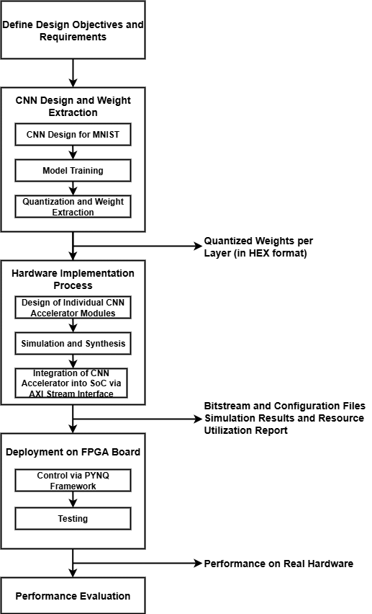
Figure 1. Design Implementation Flow

  - CNNs for Hand-written digit classification
Selecting an appropriate CNN model is pivotal to the overall system design because it directly influences accuracy, processing latency, and hardware resource utilization on the FPGA. On an SoC–FPGA platform constrained by DSP slices, LUTs, and BRAM, the model must balance computational complexity with hardware feasibility: an excessive parameter count can exceed on-chip storage, increase DDR access latency, and impede pipelining, whereas an overly simplified network may weaken feature extraction and reduce accuracy. Accordingly, the research team aims to develop a compact, efficient CNN architecture that enables high-throughput inference in a RTL implementation. As shown in Figure 2, the designed CNN model comprises two convolutional layers, two pooling layers with Rectified Linear Unit (ReLU) activation, and a single fully connected layer. The architecture follows the LeNet-5 paradigm but is simplified for FPGA deployment. A 5×5 kernel is employed to balance feature extraction quality with streamlined, pipelined Multiply–Accumulate (MAC) operations on DSP units. After the two convolution–pooling stages, the output is flattened into a 48×1 feature vector and passed to a fully connected layer that produces class scores over ten outputs corresponding to digits 0–9.
As shown in Figure 2, the proposed CNN contains a small number of parameters across all layers, reflecting its lightweight design for FPGA deployment. The CNN adopts a minimalist architecture with an optimized dataflow tailored to the FPGA’s bandwidth and buffering constraints. The pooling layers progressively reduce the spatial dimensions of the feature maps, which facilitates deep pipelining and lowers the computational load of subsequent layers. With a total of 796 parameters, the model attains approximately 96% accuracy in single-precision (float32), providing a robust foundation for quantization and hardware implementation.
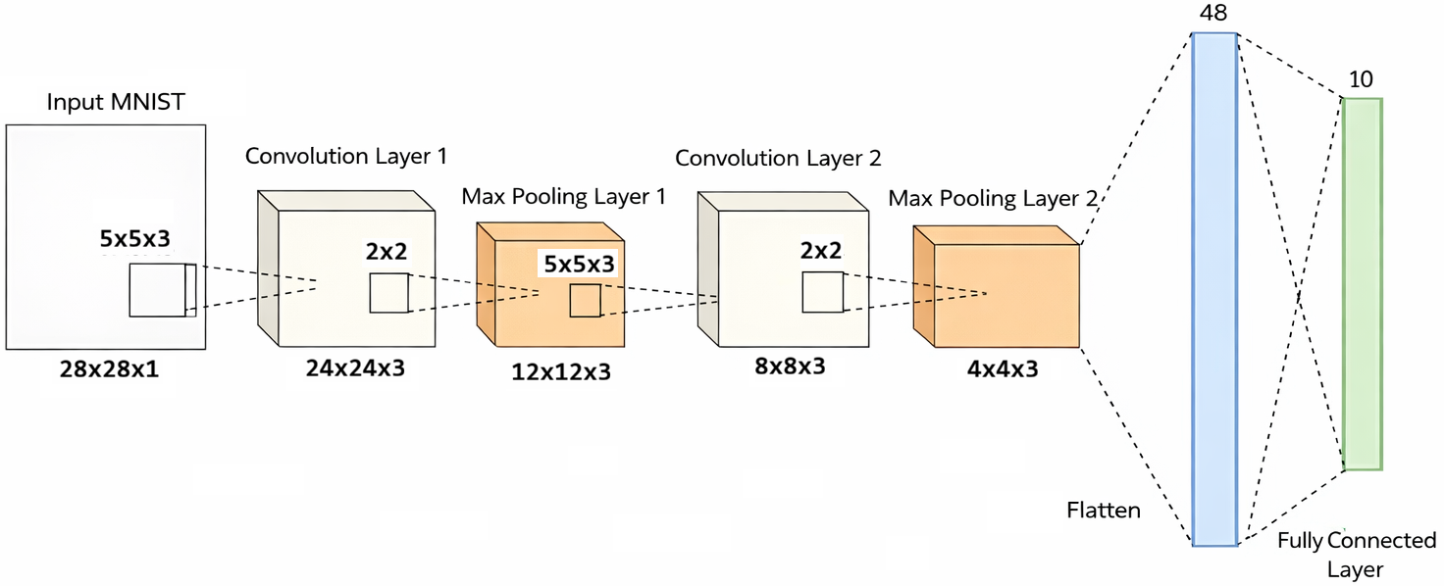
Figure 2. CNN Model Architecture for MNIST Classification
To reduce hardware cost and accelerate computation, we apply quantization-aware training (QAT) to convert the model to int8, reducing memory usage by approximately 4× while preserving accuracy close to the floating-point baseline. Quantized weights and biases are exported per layer to enable direct inference on the FPGA. The quantization pipeline consists of three steps: (1) normalize weights and biases to the range [−1, 1]; (2) scale by 128 to map values to the int8 range [−128, 127]; and (3) encode negative values in two’s-complement form for FPGA storage. The resulting quantized parameters are written as .mem files (one per layer) and loaded directly into BRAM or register files within the RTL design. This workflow yields a CNN optimized for both accuracy and hardware deployability and is ready for accelerator construction and on-FPGA inference. As shown in Figure 3, the quantization process follows a structured three-step pipeline that ensures numerical consistency between software simulation and hardware implementation.
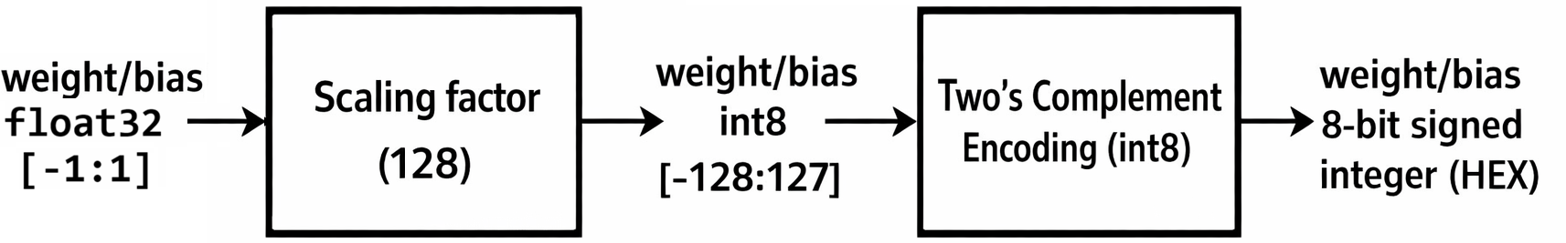
Figure 3. Quantization Process of the CNN Model
  - Implementation of CNN Accelerator Core on FPGA
After completing the CNN model, the next step is the design of the RTL module. A CNN architecture can be implemented using various approaches, including Naive Convolution, Matrix Multiplication, or Winograd Convolution. In this work, the basic Naive Convolution method is adopted to construct the CNN hardware architecture.
Figure 4 illustrates the overall system architecture, in which the Buffer, Conv Calc, Maxpooling, ReLU, Fully Connected, and Comparator modules are independently designed and then integrated into a complete CNN block.
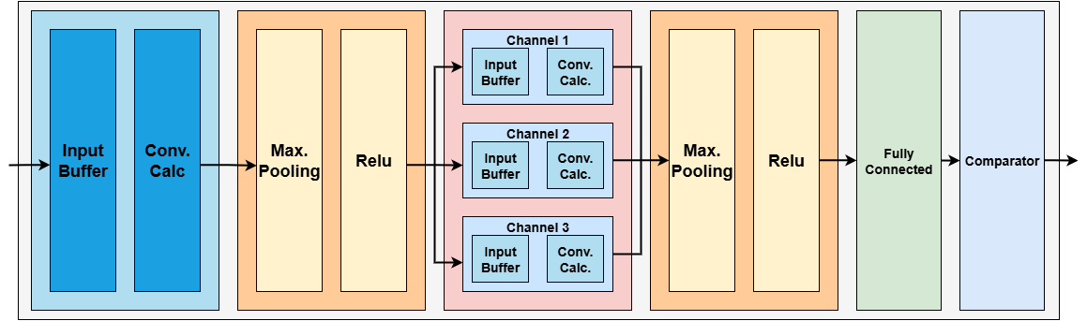
Figure 4. Block Diagram of the CNN Accelerator

The Input Buffer Block stores incoming image pixels. The accelerator ingests a 28×28 MNIST bitmap (784 pixels), with each pixel represented in 8 bits. Pixels arrive as a stream—one pixel per clock cycle—in raster-scan order from the top-left corner, proceeding left-to-right and top-to-bottom. This serial loading scheme avoids allocating on-chip memory for the entire image and allows computation to begin immediately, without waiting for full-frame capture. The line buffer holds 140 entries of 8 bits each (corresponding to 5 rows × 28 columns). After a row is processed, the buffer is overwritten with the next row until the entire image is consumed. For convolution, 5×5 pixel windows are extracted from the buffer and shifted by one pixel horizontally at each cycle, repeating until the end of the row. In every clock cycle, one 5×5 window is emitted and forwarded to the convolution stage. With a 5×5, stride-1, valid convolution on a 28×28 input, the first layer produces 24×24 = 576 windows (each containing 25 pixels), matching the output feature-map dimensions of the layer.

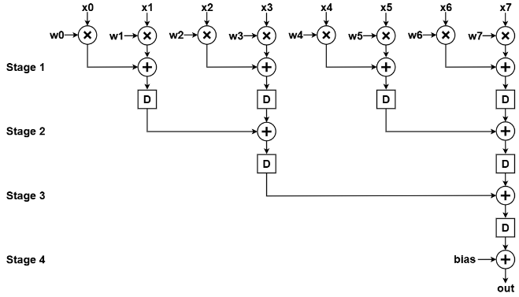
Figure 5. Pipeline Stages of the Convolution Module

The Convolution Calculation Module performs the convolution between the input data stream from the buffer block and the 5×5 kernel weights. Its input is a stream of 576 windows, each containing 25 parallel pixels, supplied by the buffer. At each clock cycle, one 5×5 window is consumed to compute a dot product with the 5×5 kernel, followed by addition of the bias term. Because arithmetic operations on the FPGA incur propagation delay, the datapath is pipelined to sustain high throughput. Figure 5 illustrates the pipelined structure, realized by inserting registers to partition the computation into multiple stages, thereby shortening the critical path and increasing the achievable clock frequency. With a four-stage pipeline, the first valid output appears four cycles after the corresponding input window is received; thereafter, the module produces one output per cycle.
For Max-Pooling and ReLU Modules, the first convolution layer yields a 24×24 feature map, emitted as 576 sequential values in a continuous stream, which serves as the input to the MaxPooling and ReLU modules. The 2×2 MaxPooling unit processes pixels in pairs of rows (two from the first row and two from the second row), outputs the maximum among the four, and advances by one pooling stride. The result is then passed to the ReLU activation, which preserves non-negative values and sets negative values to zero. A line buffer stores 12 elements—one output row of the resulting 12×12 feature map from the MaxPooling–ReLU stage. For each 2×2 cell, the running maximum is updated in the buffer when the current value exceeds the stored value; otherwise, the stored value is retained. The buffered value is then compared with zero to apply ReLU. Pointers and control flags step through the buffer in sync with the 576-pixel input stream, producing a 12×12 feature map with 144 outputs.
The Fully Connected and Comparator Module Block receives input from the second convolution and MaxPooling layers. The 4×4 feature maps with three channels are flattened into a 48×1 vector, multiplied by the corresponding weights, and summed with bias terms to produce ten output neurons. Arithmetic operations in the Fully Connected module are pipelined similarly to the convolution module to optimize performance. After computing the ten neuron outputs, the Comparator identifies the neuron with the highest value (argmax). A ten-element line buffer temporarily stores the neuron values from the Fully Connected module, and the index of the maximum value is emitted as the predicted class (digits 0–9).
  - Integration of CNN Accelerator Core into Zynq SoC
After completing the CNN accelerator hardware core, we integrated it into the Zynq SoC so that the ARM processing system (PS) can drive the programmable-logic (PL) inference engine through a standard memory-to-stream pipeline. Input images are stored in off-chip DDR, and a Xilinx IP block (AXI DMA) bridges the DDR-based memory subsystem and the streaming accelerator, as depicted in Figure 6. To make the accelerator compatible with the SoC interconnect, we wrapped the RTL core with a lightweight top-level module that presents a compliant AXI4-Stream slave interface for input pixels and an AXI4-Stream master interface for output results. Since the CNN core natively consumes data as a stream, the AXI-Stream handshake signals (e.g., TVALID/TREADY and frame delimiting) map naturally onto the existing streaming datapath and ensure reliable backpressure handling. The end-to-end dataflow proceeds as follows. (1) The PS configures the AXI DMA through the S_AXI_LITE control port, programming the base DDR addresses and transfer lengths for the input image buffer and the output result buffer. (2) For the MM2S (memory-mapped-to-stream) direction, the DMA fetches pixel data from DDR via M_AXI_MM2S and packetizes it into an AXI4-Stream on M_AXIS_MM2S. (3) The outgoing stream is optionally decoupled using axis_data_fifo_0, which absorbs burstiness from DDR reads and provides elastic buffering so the accelerator can run smoothly even if memory traffic momentarily stalls. (4) The buffered stream is then consumed by the CNN accelerator (axis_cnn_mnist_0), which performs inference in the PL and emits classification outputs as an AXI4-Stream. (5) On the output side, axis_data_fifo_1 buffers the accelerator’s result stream and handles any backpressure from the downstream DMA. (6) For the S2MM (stream-to-memory-mapped) direction, the DMA receives the output stream on S_AXIS_S2MM and writes the results back to DDR via M_AXI_S2MM. (7) Finally, the PS reads the result buffer from DDR and uses it for reporting (e.g., predicted digit) or for subsequent software-side processing. Overall, this PS–PL integration turns DDR-resident images into a continuous AXI stream for the accelerator and returns inference outputs back to DDR using the same standardized AXI infrastructure. The two FIFOs isolate the accelerator from memory timing variability, while the AXI-Lite control path lets software orchestrate transfers without modifying the RTL datapath, yielding a reusable and scalable integration pattern for streaming CNN inference on Zynq.
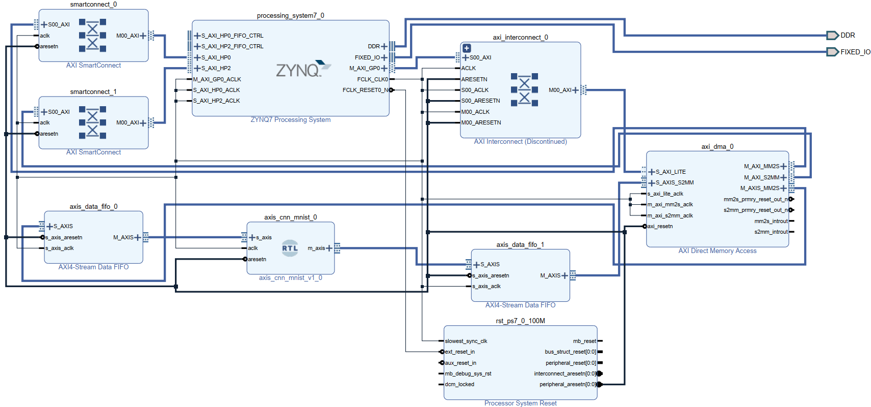
Figure 6. System Block Diagram for implementation in Xilinx Vivado
- RESULTS AND DISCUSSION
This work implements a CNN hardware accelerator on the PYNQ-Z2 board operating at 100 MHz. As summarized in Table 1, after simulating the accelerator with 10,000 MNIST test images, the classification accuracy reached approximately 91%. The implementation on the PYNQ-Z2 utilized 37.48% of LUTs, 100% of DSPs, and 2.5% of BRAM. Full utilization of DSP slices reflects the dominance of multiply–accumulate (MAC) operations in the convolutional layers, whereas the moderate LUT usage and minimal BRAM consumption indicate an efficient architecture with well-optimized data reuse and pipelining. To evaluate performance, we executed the classification function on both the PL-based accelerator and the dual-core ARM Cortex-A9 CPU (650 MHz) for comparison. Power consumption was measured as total board power during continuous inference on 10,000 MNIST test images over a 15-minute interval to ensure stable operating conditions. The baseline (idle) power was recorded with the board powered on and no inference running; the average processing power was then computed by subtracting this idle power from the total measured power.
Table 1. CNN Accelerator Hardware Synthesis Results
Hardware | LUT | DSP | BRAM
CNN core | 17052 (32.05%) | 220 (100%) | 0
PL | 19942 (37.48%) | 220 (100%) | 3.5 (2.5%)
To reduce the DSP utilization on XC7Z020 to a more reasonable level, the accelerator can be re-architected to trade a small amount of throughput for substantially lower multiplier parallelism. First, the 5×5 convolution dot-products can be implemented with partial unrolling (e.g., 1/5/10-way) and time-multiplexed MAC accumulation, reusing a smaller set of multipliers over multiple cycles instead of instantiating all products in parallel. Second, layer folding can be applied so that a single shared MAC engine is reused sequentially across Conv1, Conv2, and the FC layer, allocating DSPs to the maximum requirement of one layer rather than the combined peak across layers. Third, because operands are int8, DSP48 packing/SIMD can be exploited to compute multiple 8-bit multiplications within one DSP block, further reducing the number of DSP instances required. Finally, where beneficial, fixed inference weights enable replacing some multipliers with LUT-based constant-coefficient arithmetic (e.g., shift-add or distributed arithmetic) and/or applying structured pruning with zero-skipping to reduce the effective MAC count. Collectively, these modifications can significantly lower DSP usage while preserving the AXI-streaming integration and maintaining sufficient throughput for MNIST inference.
Figure 7(a) presents the time-resolved (instantaneous) PYNQ-Z2 board power during single-image inference, clearly capturing the transient transition from the idle baseline to the active computation phase. Figure 7(b)–(d) then compares the corresponding average power across three operating modes: (b) idle (baseline), (c) inference executed on the ARM CPU, and (d) inference executed on the PL-based SoC accelerator.
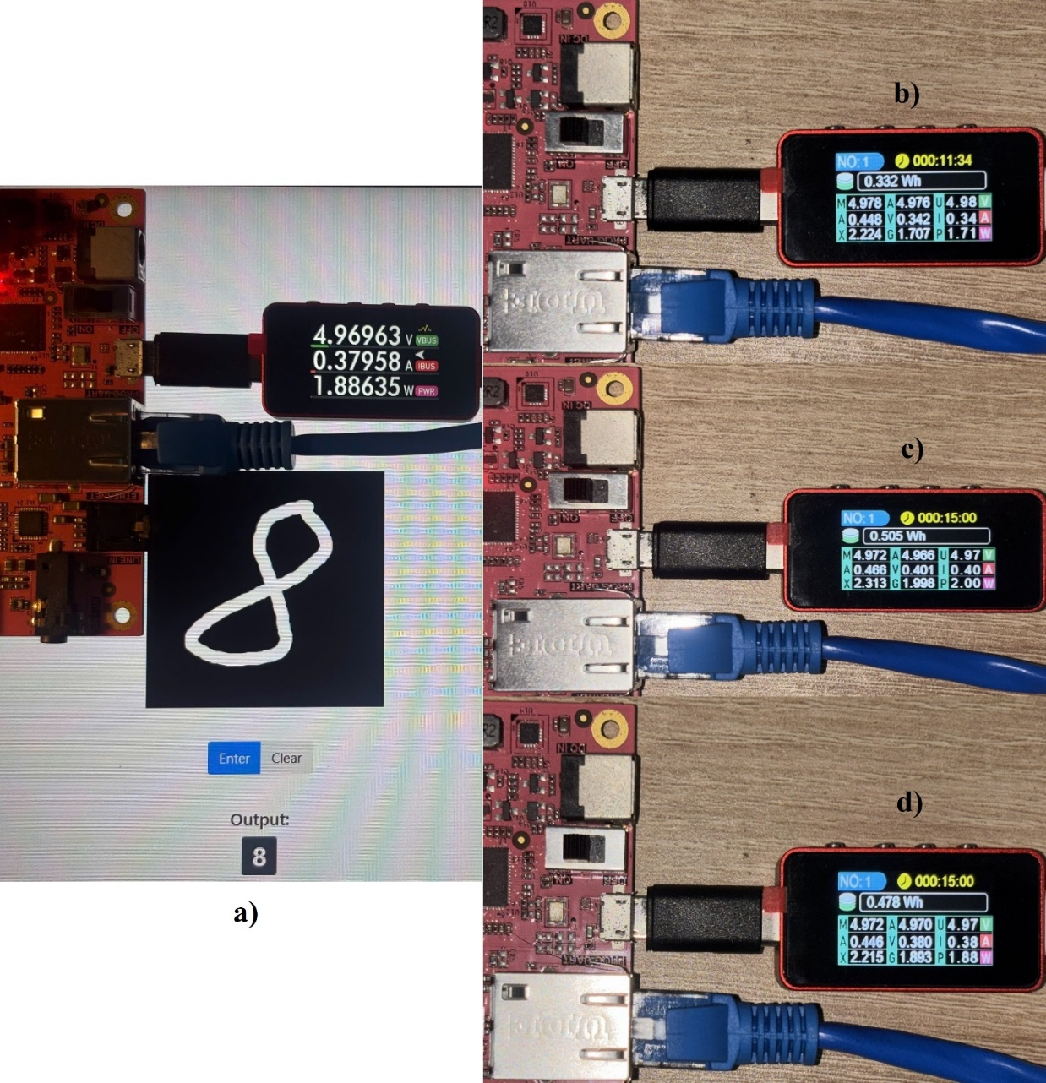
Figure 7. Measurement of instantaneous and average power consumption during CNN inference on the PYNQ-Z2 platform. (a) Instantaneous power profile for a single input image, illustrating the transition from idle to active operation. (b)–(d) Comparison of average power consumption under idle conditions, CPU-based inference, and PL/SoC accelerator-based inference.

Table 2 presents the summarized results—including classification accuracy, frame rate, and average power. The proposed CNN accelerator achieves a classification accuracy of 91.28%, which is approximately 5% lower than the CPU implementation (96.26%). However, processing latency is significantly reduced—from 4.25 ms on the CPU to 0.54 ms on the FPGA—representing a 7–8× speedup, despite the FPGA operating at a much lower frequency (100 MHz vs. 650 MHz). This improvement highlights the benefits of parallel computation and deep pipelining inherent in FPGA-based architectures. In terms of power efficiency, the FPGA implementation consumes 186 mW on average, compared with 291 mW for the CPU, resulting in an overall 36% reduction in power consumption. The corresponding energy per inference decreases from 1.234 mJ per image on the CPU to 0.102 mJ per image on the FPGA, demonstrating a substantial improvement in energy efficiency. Overall, these results indicate that the proposed CNN accelerator offers a favorable balance between performance and energy consumption, making it well suited for real-time embedded AI applications on resource-constrained edge devices.

Table 2. Experimental results and performance comparison
Hardware  Platform | Latency  (ms) | Accuracy  (%) | FPS | Power  (mW) | Efficiency  (mJ/frame)
FPGA  (100 MHz) | 0.54 | 91.28 | 1852 | 186 | 0.102
CPU ARM Cortex A9  (650 MHz) | 4.25 | 96.26 | 235 | 291 | 1.234

Table 3 shows that prior FPGA MNIST accelerators typically emphasize either higher accuracy using larger LeNet-5–class models ^{9,10} or extremely high throughput via aggressive quantization such as binary or ternary networks^{8,11,12}. In contrast, our work targets a different operating point by implementing a very small int8 CNN (2 conv + 1 FC) with only 796 parameters directly in RTL and integrating it on the low-cost PYNQ-Z2 (XC7Z020) using an AXI-DMA streaming flow; on 10,000 test images it achieves 91.28% accuracy, 0.54 ms/image latency (1,852 FPS), and 186 mW incremental power (0.102 mJ/image). Compared with earlier studies, the primary strength is model compactness, since the parameter count is far smaller than the larger LeNet-5 implementations and the 3-layer FC network with substantial parameter storage^{8,9,10}. However, the compact model yields lower accuracy than all other works reporting accuracy (≈95.83%–≈99.01%)^{8–11}. In throughput, our design exceeds slower FPGA results such as 441 FPS and 934.6 FPS^{9,10} but remains well below the ultra-high-throughput designs reporting 61,035–70,000 FPS or even multi-mega FPS enabled by extreme quantization and heavy parallelism^{8,11,12}. Finally, while our absolute power is low compared to watt-level implementations^{9,10}, the energy per image is not best-in-class because 0.102 mJ/image (~102 µJ/image) is higher than the best reported µJ/image figures^{11,12}.

Table 3. Comparison of FPGA-based MNIST inference accelerators
Work | Precision | Platform | Model | Accuracy | Throughput | Power
This work | int8 | PYNQ-Z2 (Zynq XC7Z020) | Compact CNN  (2 conv. + 1 FC.)  796 params | 91.28% | 1,852 FPS  0.54 ms/img | 186 mW,  0.102 mJ/img
Umuroglu et al. [8] | 1-bit | ZC706  (Zynq Z7045) | 3-layer FC,  256 neurons/layer; 0.3 Mbits params | 95.83% | 12.361 M-FPS,  0.31 µs/img | Pchip 7.3 W,  Pwall 21.2 W
González et al. [9] | fixed-point  (12-bit) | Arty Z7-20 (Zynq-7000) | LeNet-5  (params N/R) | 97.59% | 441 FPS  2.27 ms/img | 1.72 W
Liang et al.  [10] | Integer / fixed-point variants | Zynq platform | LeNet-5 | ≈99.01% | 934.6 FPS  1.07 ms/img | 2.19 W
Alemdar et al. [11] | Ternary NN | Kintex-7 (XC7K160T) | not reported | 98.14% | 61,035 FPS, 8.09 µs/img | 3.63 µJ/img
Park  et al. [12] | 3-bit weights, 8-bit signals | ZC706  (Zynq Z7045) | not reported | not reported | 70,000 FPS | 71 µJ/img

- CONCLUSION
This work delivers a deployable, end-to-end SoC–FPGA inference pipeline that goes beyond demonstrating MNIST classification by integrating model design with a practical embedded hardware realization. We (i) design a minimalist int8 CNN (2 conv + pooling/ReLU + 1 FC) with only 796 parameters and export FPGA-ready quantized weights, (ii) implement a fully RTL streaming accelerator that processes input pixels at one pixel per clock using lightweight line buffering and a pipelined datapath, and (iii) integrate the core on the low-cost PYNQ-Z2 (XC7Z020) via AXI4-Stream and AXI-DMA for complete PS–PL deployment. On 10,000 MNIST test images, the PL implementation achieves 91.28% accuracy—about five percentage points below the dual ARM Cortex-A9 CPU baseline—while providing a 7–8× throughput improvement (0.54 ms/image, 1,852 FPS vs. 4.25 ms/image, 235 FPS) and lower incremental power, resulting in markedly better energy per inference. These results highlight the advantages of FPGA-based CNN acceleration for deterministic low-latency and energy-efficient edge inference on resource-constrained platforms, and the presented workflow offers a reproducible template spanning quantization, RTL development, pipelining, resource-aware design, and PYNQ-based system integration. Although accuracy is limited by the intentionally compact model and int8 quantization, and the XC7Z020 imposes tight DSP/BRAM constraints, the proposed system establishes a solid foundation for future improvements such as layer folding and time-multiplexed MACs to reduce DSP usage, refined quantization-aware training to recover accuracy, and scaling to larger FPGAs or modestly larger networks while preserving the same streaming integration methodology. Overall, the paper demonstrates a practical and extensible approach to embedded FPGA inference suitable for real-time edge applications including digit/character recognition and low-power intelligent sensing in IoT systems.
Acknowledgments
This work belongs to the project in 2026 funded by HoChiMinh City University of Technology and Engineering, Vietnam.
REFERENCES
- A. Shawahna, S. Sait, A. El-Maleh. “FPGA-based accelerators of deep learning networks for learning and classification: A review,” IEEE Access, 2019, 7, 7823-7859.
- V. K. Pham, N. Q. Tran, N. L. Nguyen. “Optimizing the convolutional neural networks for resource-constrained hardwares,” Science & Technology Development Journal – Engineering and Technology, 2022, 4(4), 906.
- S. Bouguezzi, H. B. Fredj, T. Belabed, C. Valderrama, H. Faiedh, C. Souani. “An efficient FPGA-based convolutional neural network for classification: Ad-MobileNet,” Electronics, 2021, 10(18), 2272.
- M. Faizan, I. Intzes, I. Cretu, H. Meng. “Implementation of deep learning models on an SoC-FPGA device for real-time music genre classification,” Technologies, 2023, 11(4), 91.
- Anjali, J. P. Anita. “AXI based DMA Memory System Testbench Architecture Using UVM Harness Technique,” The 9th International Conference on Advances in Computing and Communication, ICACC 2019, Kochi, India, 2019.
- A. Sharma. “Evaluation of AXI-Interfaces for Hardware Software Communication,” Master’s thesis, Technische Universität Chemnitz, Chemnitz, 2019.
- S. Sun, J. Zou, Z. Zou, S. Wang (eds.). “Experience of PYNQ: Tutorials for PYNQ-Z2,” Springer Nature Singapore, Singapore, 2023.
- Y. Umuroglu, N. J. Fraser, G. Gambardella, M. Blott, P. H. W. Leong, M. Jahre, K. A. Vissers. “FINN: A Framework for Fast, Scalable Binarized Neural Network Inference,” Proceedings of the 2017 ACM/SIGDA International Symposium on Field-Programmable Gate Arrays, FPGA 2017, Monterey, CA, USA, 2017, 65-74.
- E. González, W. D. Villamizar Luna, C. A. Fajardo Ariza. “A Hardware Accelerator for the Inference of a Convolutional Neural Network,” Ciencia e Ingeniería Neogranadina, 2020, 30(1), 107-116.
- Y. Liang, J. Tan, Z. Xie, Z. Chen, D. Lin, Z. Yang. “Research on Convolutional Neural Network Inference Acceleration and Performance Optimization for Edge Intelligence,” Sensors, 2024, 24(1), 240.
- H. Alemdar, V. Leroy, A. Prost-Boucle, F. Pétrot. “Ternary Neural Networks for Resource-Efficient AI Applications,” 2017 International Joint Conference on Neural Networks, IJCNN 2017, Anchorage, AK, USA, 2017, 2547-2554.
- J. Park, W. Sung. “FPGA Based Implementation of Deep Neural Networks Using On-Chip Memory Only,” 2016 IEEE International Conference on Acoustics, Speech and Signal Processing, ICASSP 2016, Shanghai, China, 2016, 1011-1015.

BLACK: the review comments
BLUE: the author responses
RED: the added and modified sentences in the revised manuscript

Reviewer 1
Question 1: The hardware acceleration techniques applied such as pipeline, parallel processing are standard.
[Reply]
We thank the reviewer for this important comment. We acknowledge that an accuracy of 91.28% on MNIST is not competitive with conventional MNIST CNN baselines. However, our work intentionally targets a highly compact network for RTL deployment on a resource-constrained SoC–FPGA platform: the proposed CNN contains 796 parameters and is deployed with an int8 fixed-point flow (QAT + parameter export to FPGA memory files), which prioritizes hardware simplicity and streaming throughput over peak accuracy. To properly contextualize the result, we emphasize that the main contribution of this manuscript is the end-to-end embedded deployment and measured efficiency on real hardware: compared with the ARM Cortex-A9 CPU implementation, the FPGA design reduces latency from 4.25 ms to 0.54 ms (≈7–8× faster), increases throughput from 235 FPS to 1852 FPS, and reduces energy per inference from 1.234 mJ/image to 0.102 mJ/image (≈12× lower), while operating at a much lower clock frequency (100 MHz vs. 650 MHz). In response to the reviewer’s request, we have expanded the manuscript with a new “Related Work” and “Discussion” subsections and added a comparison table that positions our design against representative FPGA/SoC MNIST accelerators reported in the literature. The table compares precision (e.g., int8/fixed-point), platform/device, model complexity, accuracy, throughput/latency, and power/energy reporting. This shows our results fairly under the specific constraints of an RTL streaming design and a <1,000-parameter model. To reflect your comment in the revision, we added the following sentences in the revised manuscript

MNIST inference on FPGA/SoC platforms has been extensively explored along two main directions: (i) extreme-quantization approaches (binary/ternary) that push hardware efficiency and throughput, and (ii) fixed-/integer-point CNN deployments (LeNet-5-based CNN) that target higher accuracy with moderate resource cost. In the first direction, FINN provides a representative toolflow for binarized neural networks on FPGAs and reports multi-million classifications per second on MNIST with sub-microsecond latency on a Zynq ZC706 platform, together with explicit performance and power reporting8. In the fixed-/integer-point CNN category, González et al. implement a LeNet-5 inference accelerator using an SW/HW co-processing scheme on a Zynq-7000 Arty Z7-20, reporting 97.59% MNIST accuracy with 12-bit fixed-point arithmetic and approximately 441 images/s at 100 MHz9. More recent full-network deployments using HLS on Zynq devices provide more complete reporting of model scale and system metrics; for example, Liang et al. detail LeNet-5 weight counts and report end-to-end inference time, power, and error rate (e.g., 1.07 ms, 2.193 W, and 0.99% error for their PIPELINE design)10. Complementary to binary networks, ternary models have also been proposed to improve efficiency while retaining more representational capacity than binarization; Alemdar et al. present ternary neural networks and discuss FPGA/ASIC realizations that leverage low-precision arithmetic and sparsity effects for energy-efficient inference11. Beyond CNNs, compact fixed-point DNN implementations that keep weights entirely in on-chip memory have also been demonstrated to reduce external memory traffic; Park and Sung describe an FPGA-based DNN design using 3-bit weights with on-chip storage (no external DRAM access) and report <5 W full-speed power in their MNIST evaluation12.

Work | Precision | Platform | Model | Accuracy | Throughput | Power
This work | int8 | PYNQ-Z2 (Zynq XC7Z020) | Compact CNN  (2 conv. + 1 FC.)  796 params | 91.28% | 1,852 FPS  0.54 ms/img | 186 mW,  0.102 mJ/img
Umuroglu et al. [8] | 1-bit | ZC706  (Zynq Z7045) | 3-layer FC,  256 neurons/layer; 0.3 Mbits params | 95.83% | 12.361 M-FPS,  0.31 µs/img | Pchip 7.3 W,  Pwall 21.2 W
González et al. [9] | fixed-point  (12-bit) | Arty Z7-20 (Zynq-7000) | LeNet-5  (params N/R) | 97.59% | 441 FPS  2.27 ms/img | 1.72 W
Liang et al.  [10] | Integer / fixed-point variants | Zynq platform | LeNet-5 | ≈99% | 934.6 FPS  1.07 ms/img | 2.19 W
Alemdar et al. [11] | Ternary NN | Kintex-7 (XC7K160T) | not reported | 98.14% | 255102 FPS, 8.09 µs/img | 3.63 µJ/img
Park  et al. [12] | 3-bit weights, 8-bit signals | ZC706  (Zynq Z7045) | not reported | not reported | 70,000 FPS | 71 µJ/img

Table 3 shows that prior FPGA MNIST accelerators typically emphasize either higher accuracy using larger LeNet-5–class models ^{9,10} or extremely high throughput via aggressive quantization such as binary or ternary networks^{8,11,12}. In contrast, our work targets a different operating point by implementing a very small int8 CNN (2 conv + 1 FC) with only 796 parameters directly in RTL and integrating it on the low-cost PYNQ-Z2 (XC7Z020) using an AXI-DMA streaming flow; on 10,000 test images it achieves 91.28% accuracy, 0.54 ms/image latency (1,852 FPS), and 186 mW incremental power (0.102 mJ/image). Compared with earlier studies, the primary strength is model compactness, since the parameter count is far smaller than the larger LeNet-5 implementations and the 3-layer FC network with substantial parameter storage^{8,9,10}. However, the compact model yields lower accuracy than all other works reporting accuracy (≈95.83% – ≈99%)^{8–11}. In throughput, our design exceeds slower FPGA results such as 441 FPS and 934.6 FPS^{9,10} but remains well below the ultra-high-throughput designs reporting 61,035–70,000 FPS or even multi-mega FPS enabled by extreme quantization and heavy parallelism^{8,11,12}. Finally, while our absolute power is low compared to watt-level implementations^{9,10}, the energy per image is not best-in-class because 0.102 mJ/image (~102 µJ/image) is higher than the best reported µJ/image figures^{11,12}

8. Y. Umuroglu, N. J. Fraser, G. Gambardella, M. Blott, P. H. W. Leong, M. Jahre, K. A. Vissers. “FINN: A Framework for Fast, Scalable Binarized Neural Network Inference,” Proceedings of the 2017 ACM/SIGDA International Symposium on Field-Programmable Gate Arrays, FPGA 2017, Monterey, CA, USA, 2017, 65-74.
9. E. González, W. D. Villamizar Luna, C. A. Fajardo Ariza. “A Hardware Accelerator for the Inference of a Convolutional Neural Network,” Ciencia e Ingeniería Neogranadina, 2020, 30(1), 107-116.
10. Y. Liang, J. Tan, Z. Xie, Z. Chen, D. Lin, Z. Yang. “Research on Convolutional Neural Network Inference Acceleration and Performance Optimization for Edge Intelligence,” Sensors, 2024, 24(1), 240.
11. H. Alemdar, V. Leroy, A. Prost-Boucle, F. Pétrot. “Ternary Neural Networks for Resource-Efficient AI Applications,” 2017 International Joint Conference on Neural Networks, IJCNN 2017, Anchorage, AK, USA, 2017, 2547-2554.
12. J. Park, W. Sung. “FPGA Based Implementation of Deep Neural Networks Using On-Chip Memory Only,” 2016 IEEE International Conference on Acoustics, Speech and Signal Processing, ICASSP 2016, Shanghai, China, 2016, 1011-1015.

Question 2: The accuracy of 91.28% on the MNIST dataset is not high, the author should compare your results to others works
[Reply]
We thank the reviewer for the comment. We agree that 91.28% MNIST accuracy is below typical CNN baselines; however, our goal is efficient RTL deployment on a low-cost PYNQ-Z2 (XC7Z020) with a fully streaming datapath, using an intentionally compact CNN (796 parameters) to enable deep pipelining and minimal buffering. To address the reviewer’s concern about the relatively modest MNIST accuracy (91.28%), we added an explicit comparison to prior FPGA MNIST accelerators and clarified the design trade-offs in the manuscript. As reported in our Results and Discussion section, the proposed RTL-based int8 accelerator on PYNQ-Z2 achieves 91.28% accuracy on 10,000 MNIST test images (with 0.54 ms/image, 1,852 FPS, and 186 mW incremental power, i.e., 0.102 mJ/image), while a CPU baseline on the same board reaches 96.26% accuracy but is slower and less energy efficient. We now compare these results against representative prior FPGA works in Table 3. We can see that the prior studies typically pursue either higher accuracy using larger LeNet-5–class models [9,10] or ultra-high throughput through aggressive quantization such as binary/ternary networks [8,11,12]. In contrast, our work intentionally targets a different operating point—a very compact int8 CNN (2 conv + 1 FC) with only 796 parameters—which makes it superior in model compactness compared to LeNet-5 implementations and a 3-layer FC network with much larger parameter storage [8–10]. This compactness, however, comes with an expected accuracy trade-off: 91.28% is lower than other reported accuracies (≈95.83%–≈99.01%) [8–11]. For throughput, our design outperforms slower FPGA results such as 441 FPS and 934.6 FPS [9,10], but remains below the 61,035–70,000 FPS and multi-M FPS class enabled by extreme quantization and heavy parallelism [8,11,12]. Finally, while our absolute power (186 mW incremental) is lower than several watt-level implementations [9,10], our energy per image (0.102 mJ/image ≈102 µJ/image) is not the best compared with the lowest reported µJ/image figures [11,12]. This new table-and-discussion explicitly positions our contribution as a compact, low-cost, RTL-streaming accelerator emphasizing footprint and practical integration, rather than maximizing MNIST accuracy.

Question 3: The experimental results show a utilization of 100% DSP resources of the hardware for a tiny model (<1,000 parameters) is inefficient. Provide some modifications in order to reduce DSP usage to a reasonable level.
[Reply]

We agree that reporting 220/220 DSPs (100%) on XC7Z020 can appear inefficient for a <1,000-parameter network; however, DSP usage is driven mainly by how aggressively the MAC operations are parallelized rather than by parameter count. In our current RTL design, the convolution datapath is heavily unrolled and pipelined to sustain a high-rate streaming flow, so Vivado maps most multipliers into DSP48s, leading to full DSP utilization. To reduce DSP usage to a more reasonable level, the design can be modified by (i) partial unrolling/time-multiplexing the 5×5 MACs so fewer multipliers are reused over multiple cycles, (ii) folding the layers to reuse a shared MAC array across Conv1/Conv2/FC instead of allocating peak resources for each, (iii) applying int8 packing/SIMD in DSP48 blocks to perform multiple 8-bit multiplies per DSP, (iv) moving some multiplications to LUT-based constant-coefficient implementations (e.g., shift-add/DA), and (v) using structured pruning/zero-skipping to reduce the effective number of MACs; these changes trade a modest increase in latency/throughput for a large reduction in DSP consumption while keeping the accelerator practical on PYNQ-Z2. To reflect your comment in the revision, we added the following sentences in the revised manuscript.

To reduce the DSP utilization on XC7Z020 to a more reasonable level, the accelerator can be re-architected to trade a small amount of throughput for substantially lower multiplier parallelism. First, the 5×5 convolution dot-products can be implemented with partial unrolling (e.g., 1/5/10-way) and time-multiplexed MAC accumulation, reusing a smaller set of multipliers over multiple cycles instead of instantiating all products in parallel. Second, layer folding can be applied so that a single shared MAC engine is reused sequentially across Conv1, Conv2, and the FC layer, allocating DSPs to the maximum requirement of one layer rather than the combined peak across layers. Third, because operands are int8, DSP48 packing/SIMD can be exploited to compute multiple 8-bit multiplications within one DSP block, further reducing the number of DSP instances required. Finally, where beneficial, fixed inference weights enable replacing some multipliers with LUT-based constant-coefficient arithmetic (e.g., shift-add or distributed arithmetic) and/or applying structured pruning with zero-skipping to reduce the effective MAC count. Collectively, these modifications can significantly lower DSP usage while preserving the AXI-streaming integration and maintaining sufficient throughput for MNIST inference.

Question 4: There are some typos (e.g., "ASTRACT" missing the 'B') and check the terminology of Figure 2
[Reply]
Thank you for pointing this out. We have carefully proofread the manuscript and corrected the typo “ASTRACT” → “ABSTRACT”. We also reviewed Figure 2 and revised its terminology for consistency with the rest of the manuscript and standard SoC/AXI naming conventions—e.g., ensuring the labels clearly distinguish PS vs. PL, using AXI4-Stream and AXI-Lite terms correctly, and aligning module/interface names with those used in the system-integration description.

Question 5: The authour should compare your results with other similar works and suggest ways to improve the accuracy of your model
[Reply]
We thank the reviewer for this constructive suggestion. We acknowledge that the FPGA accuracy (91.28%) on MNIST is below typical CNN baselines; however, our work intentionally targets a very compact network (796 parameters) and an int8, RTL-friendly deployment flow on a low-cost PYNQ-Z2 (XC7Z020), prioritizing streaming hardware feasibility and efficiency over peak accuracy. In response to the reviewer’s request, we have expanded the manuscript with a new “Discussion” subsections and added a comparison table that positions our design against representative FPGA/SoC MNIST accelerators reported in the literature. To reflect your comment in the revision, we added the following sentences in the revised manuscript.

Table 3 shows that prior FPGA MNIST accelerators typically emphasize either higher accuracy using larger LeNet-5–class models ^{9,10} or extremely high throughput via aggressive quantization such as binary or ternary networks^{8,11,12}. In contrast, our work targets a different operating point by implementing a very small int8 CNN (2 conv + 1 FC) with only 796 parameters directly in RTL and integrating it on the low-cost PYNQ-Z2 (XC7Z020) using an AXI-DMA streaming flow; on 10,000 test images it achieves 91.28% accuracy, 0.54 ms/image latency (1,852 FPS), and 186 mW incremental power (0.102 mJ/image). Compared with earlier studies, the primary strength is model compactness, since the parameter count is far smaller than the larger LeNet-5 implementations and the 3-layer FC network with substantial parameter storage^{8,9,10}. However, the compact model yields lower accuracy than all other works reporting accuracy (≈95.83%–≈99.01%)^{8–11}. In throughput, our design exceeds slower FPGA results such as 441 FPS and 934.6 FPS^{9,10} but remains well below the ultra-high-throughput designs reporting 61,035–70,000 FPS or even multi-mega FPS enabled by extreme quantization and heavy parallelism^{8,11,12}. Finally, while our absolute power is low compared to watt-level implementations^{9,10}, the energy per image is not best-in-class because 0.102 mJ/image (~102 µJ/image) is higher than the best reported µJ/image figures^{11,12}

REVIEWER 2
Question 1: The authors deployed a lighweight CNN model to recognize handwritten digit on FPGA board. Howerver, the authors did not show the contributions and the advantages of the proposed systems. The content seems to be reworked or updated the existing or previous research.
[Reply]
Thank you for the comment; in the revised manuscript we explicitly state that the contribution is not simply re-implementing MNIST on FPGA, but demonstrating an end-to-end, deployable low-cost SoC–FPGA inference system at a different operating point. Our work combines (i) an ultra-compact int8 CNN (2 conv + pooling/ReLU + 1 FC) with only 796 parameters trained with quantization-aware steps for direct fixed-point inference, (ii) a fully RTL streaming accelerator that processes MNIST pixels as a one-pixel/clock stream using lightweight line buffering and a pipelined convolution datapath with deterministic latency, and (iii) complete PS–PL integration on PYNQ-Z2 (XC7Z020) via AXI4-Stream and AXI-DMA for practical deployment. We also provide measured on-board results and a CPU baseline: the PL accelerator achieves 0.54 ms/image (1,852 FPS) versus 4.25 ms/image (235 FPS) on ARM, with lower incremental power (186 mW vs. 291 mW) and much lower energy per image (0.102 mJ vs. 1.234 mJ). Finally, we add Table 3 and discussion to position our design against prior FPGA MNIST studies, showing the main advantage is compactness and low-cost integration while acknowledging the accuracy trade-off.

Question 2: the English grammar and words should double-checked again. Some figures are small and the letters in those figures are not clear (Fig. 3, 5, 6).
[Reply]
Thank you for the comments. We have double-checked the English grammar and wording across the entire manuscript and revised multiple sentences for clarity, consistency of tense/voice, and technical precision. We also corrected typographical issues and standardized terminology/notation so that the text, figure captions, and tables use consistent naming and symbols. Regarding Fig. 3, Fig. 5, and Fig. 6, we regenerated these figures to improve readability: we increased the font size, adjusted label placement, and exported the figures in higher resolution to ensure the text and signals remain clear when printed or viewed at journal zoom levels. We also revised the corresponding captions to better explain what each figure conveys. In addition, we expanded the reference list by adding more closely related works on FPGA/SoC-based neural network acceleration and low-precision deployment.

Question 3: The authors should add a comparison results with other works.
[Reply]
We thank the reviewer for this constructive suggestion. In response to the reviewer’s request, we have expanded the manuscript with a new “Discussion” subsections and added a comparison table that positions our design against representative FPGA/SoC MNIST accelerators reported in the literature. To reflect your comment in the revision, we added the following sentences in the revised manuscript.

Table 3 shows that prior FPGA MNIST accelerators typically emphasize either higher accuracy using larger LeNet-5–class models ^{9,10} or extremely high throughput via aggressive quantization such as binary or ternary networks^{8,11,12}. In contrast, our work targets a different operating point by implementing a very small int8 CNN (2 conv + 1 FC) with only 796 parameters directly in RTL and integrating it on the low-cost PYNQ-Z2 (XC7Z020) using an AXI-DMA streaming flow; on 10,000 test images it achieves 91.28% accuracy, 0.54 ms/image latency (1,852 FPS), and 186 mW incremental power (0.102 mJ/image). Compared with earlier studies, the primary strength is model compactness, since the parameter count is far smaller than the larger LeNet-5 implementations and the 3-layer FC network with substantial parameter storage^{8,9,10}. However, the compact model yields lower accuracy than all other works reporting accuracy (≈95.83%–≈99.01%)^{8–11}. In throughput, our design exceeds slower FPGA results such as 441 FPS and 934.6 FPS^{9,10} but remains well below the ultra-high-throughput designs reporting 61,035–70,000 FPS or even multi-mega FPS enabled by extreme quantization and heavy parallelism^{8,11,12}. Finally, while our absolute power is low compared to watt-level implementations^{9,10}, the energy per image is not best-in-class because 0.102 mJ/image (~102 µJ/image) is higher than the best reported µJ/image figures^{11,12}
Question 4: Table 2 is in the middle of Page 8, you should relocate it on the top of this page. Check Table I also again.
[Reply]
Thank you for pointing out the formatting issue. We have revised the manuscript layout to ensure Table 1 and Table 2 is relocated to the top of the page (and positioned close to its first in-text citation) in accordance with the journal’s presentation guidelines.

Question 5: Check English written carefully.
[Reply]
We thank the reviewer for this helpful comment. We carefully revised the manuscript to improve English grammar, wording, and technical clarity throughout. In particular, we corrected typographical errors (e.g., “ASTRACT” → “ABSTRACT”), standardized terminology and notation across the text and figures (especially the CNN architecture description and Figure 2), and rewrote several sentences for clearer technical expression and consistent tense/voice. In addition, we improved figure captions and table descriptions to better match the reported methodology and results.

Question 6: Add more papers in references.
[Reply]
Thank you for the comment; in the revised manuscript we add Table 3 and discussion to position our design against prior FPGA MNIST studies, showing the main advantage is compactness and low-cost integration while acknowledging the accuracy trade-off.
8. Y. Umuroglu, N. J. Fraser, G. Gambardella, M. Blott, P. H. W. Leong, M. Jahre, K. A. Vissers. “FINN: A Framework for Fast, Scalable Binarized Neural Network Inference,” Proceedings of the 2017 ACM/SIGDA International Symposium on Field-Programmable Gate Arrays, FPGA 2017, Monterey, CA, USA, 2017, 65-74.
9. E. González, W. D. Villamizar Luna, C. A. Fajardo Ariza. “A Hardware Accelerator for the Inference of a Convolutional Neural Network,” Ciencia e Ingeniería Neogranadina, 2020, 30(1), 107-116.
10. Y. Liang, J. Tan, Z. Xie, Z. Chen, D. Lin, Z. Yang. “Research on Convolutional Neural Network Inference Acceleration and Performance Optimization for Edge Intelligence,” Sensors, 2024, 24(1), 240.
11. H. Alemdar, V. Leroy, A. Prost-Boucle, F. Pétrot. “Ternary Neural Networks for Resource-Efficient AI Applications,” 2017 International Joint Conference on Neural Networks, IJCNN 2017, Anchorage, AK, USA, 2017, 2547-2554.
12. J. Park, W. Sung. “FPGA Based Implementation of Deep Neural Networks Using On-Chip Memory Only,” 2016 IEEE International Conference on Acoustics, Speech and Signal Processing, ICASSP 2016, Shanghai, China, 2016, 1011-1015.

Question 7: Describe the novelty and main contributions to this paper.
[Reply]
We thank the reviewer for this constructive comment. The novelty of this paper lies not in using MNIST itself, but in presenting an end-to-end, deployable SoC–FPGA inference system that targets a compact-model and low-cost-board operating point and reports measured latency, power, and energy on real hardware. Specifically, we (i) design and quantize a minimalist int8 CNN (2 conv + pooling/ReLU + 1 FC) with only 796 parameters and export FPGA-ready weights for direct inference, (ii) implement a fully RTL streaming accelerator that consumes MNIST pixels at one pixel per clock using a lightweight 5-row line buffer to form 5×5 windows on-the-fly and a pipelined datapath that sustains one output per cycle after pipeline fill, and (iii) integrate the core on a low-cost PYNQ-Z2 (XC7Z020) using AXI4-Stream + AXI-DMA to realize a complete PS–PL pipeline. We also provide on-board measurements with a CPU baseline and a defined incremental-power protocol, showing 0.54 ms/image (1,852 FPS) on PL versus 4.25 ms/image (235 FPS) on ARM, with lower incremental power (186 mW vs. 291 mW) and energy (0.102 mJ/image vs. 1.234 mJ/image). To reflect your comment in the revision, we modified the Conclusion section in the revised manuscript.

This work delivers a deployable, end-to-end SoC–FPGA inference pipeline that goes beyond demonstrating MNIST classification by integrating model design with a practical embedded hardware realization. We (i) design a minimalist int8 CNN (2 conv + pooling/ReLU + 1 FC) with only 796 parameters and export FPGA-ready quantized weights, (ii) implement a fully RTL streaming accelerator that processes input pixels at one pixel per clock using lightweight line buffering and a pipelined datapath, and (iii) integrate the core on the low-cost PYNQ-Z2 (XC7Z020) via AXI4-Stream and AXI-DMA for complete PS–PL deployment. On 10,000 MNIST test images, the PL implementation achieves 91.28% accuracy—about five percentage points below the dual ARM Cortex-A9 CPU baseline—while providing a 7–8× throughput improvement (0.54 ms/image, 1,852 FPS vs. 4.25 ms/image, 235 FPS) and lower incremental power, resulting in markedly better energy per inference. These results highlight the advantages of FPGA-based CNN acceleration for deterministic low-latency and energy-efficient edge inference on resource-constrained platforms, and the presented workflow offers a reproducible template spanning quantization, RTL development, pipelining, resource-aware design, and PYNQ-based system integration. Although accuracy is limited by the intentionally compact model and int8 quantization, and the XC7Z020 imposes tight DSP/BRAM constraints, the proposed system establishes a solid foundation for future improvements such as layer folding and time-multiplexed MACs to reduce DSP usage, refined quantization-aware training to recover accuracy, and scaling to larger FPGAs or modestly larger networks while preserving the same streaming integration methodology. Overall, the paper demonstrates a practical and extensible approach to embedded FPGA inference suitable for real-time edge applications including digit/character recognition and low-power intelligent sensing in IoT systems.

Question 8: The authors should present a block diagram of the SoC integrated with the CNN accelerator on FPGA and theirs results in more detail.

[Reply]

Thank you for this helpful comment. In the revised manuscript, we have revised the manuscript to address this comment by adding a complete SoC-level block diagram and a more detailed reporting of results. First, we now include Fig. 6 that shows the integrated Zynq PS–PL data path: MNIST images are stored in DDR, the ARM PS programs the AXI-DMA via S_AXI_LITE, the DMA reads the input buffer from DDR through M_AXI_MM2S and converts it to an AXI4-Stream (M_AXIS_MM2S), which is buffered by axis_data_fifo_0 and then processed by the CNN accelerator IP (axis_cnn_mnist_0). The accelerator’s output stream passes through axis_data_fifo_1 into the DMA (S_AXIS_S2MM), and the DMA writes results back to DDR via M_AXI_S2MM, after which the PS reads the output buffer for display or post-processing. Second, we report the experimental results in more detail by adding Table 1 (post-synthesis resource utilization: LUT/DSP/BRAM) and Table 2 (accuracy, latency, FPS, incremental power, and energy per image) and by clarifying the measurement protocol: power is measured as total board power during sustained inference on 10,000 images over a 15-minute interval, and incremental “processing power” is computed by subtracting the idle baseline. Finally, we add Fig. 7 to visualize both the instantaneous power transient (idle→active) and the average power under idle/CPU/PL modes, supporting the quantitative comparison (FPGA: 0.54 ms/image, 1,852 FPS, 186 mW, 0.102 mJ/image; CPU: 4.25 ms/image, 235 FPS, 291 mW, 1.234 mJ/image).

