Response to the reviewers and editor’s comments:

Original Manuscript ID: QNUJS-B2553
Original Article Title: “Thermal Analysis of Low-Voltage Power Cables Considering the Presence of Current Harmonics”
Submitted to: Journal of Science - Quy Nhon University
We would like to sincerely thank the Editor-in-Chief and the Reviewer#1 for the continued evaluation of our revised manuscript. Following the first-round review, we have carefully revised the manuscript and provided a detailed point-by-point response. In this second round (minor revision), we have addressed the additional comment raised during the re-evaluation by adding a clear description of the MATLAB/Simulink model used in the study, together with the relevant simulation settings to improve clarity and reproducibility.
We hope that this minor revision satisfactorily resolves the remaining concern and that the manuscript is now suitable for publication in the Journal of Science – Quy Nhon University. The detailed response is provided below.
- A more explicit and structured description of the MATLAB/Simulink implementation has been added for all investigated cases (Cases 1–3).
- A clear distinction has been made between the parametric MATLAB-based calculations (Cases 1 and 2) and the Simulink-based electrical system simulation (Case 3).
- A schematic diagram of the Simulink model has been included to visually illustrate the modeling workflow, from the rectifier–motor system simulation to harmonic extraction using FFT and subsequent thermal calculations.
- The data flow between the Simulink model and the MATLAB thermal model has been clarified, showing how the extracted harmonic components are used as inputs to the theoretical thermal formulation.
In the revised manuscript, all the changes are marked in a yellow background.

Reviewer #1:
R1-1. Cần nói rõ mô hình MATLAB/Simulink mà tác giả sử dụng trong bài báo
Answer:
We thank the reviewer for requesting a clearer and more explicit description of the MATLAB/Simulink model employed in this study. In response, we have clarified the modeling approach and computational workflow and provided an illustrative explanation to improve transparency and reproducibility.
For clarity and presentation purposes, we have additionally included a simplified schematic figure in the revised manuscript to illustrate the overall modeling framework for all three investigated cases. This figure is intended to provide a conceptual overview of the data flow between the electrical modeling and thermal calculation stages, rather than to present a detailed Simulink block-level representation. The corresponding explanations have been added to Section 3.2.3 and the related figure in the revised manuscript. (see the top of page 7 in the revised version):
Figure 2. Overview of the three harmonic case studies and the MATLAB/Simulink computational workflow.
Specifically, in Case 1 and Case 2, the analysis is carried out entirely in MATLAB using custom .m files. In these cases, the harmonic current components (harmonic orders and magnitudes) are defined parametrically and directly applied to the theoretical cable thermal model described by Eq. (19) to evaluate the conductor temperature.
In Case 3, the electrical system is implemented in MATLAB/Simulink to represent a practical nonlinear load scenario. The Simulink model consists of a three-phase low-voltage power supply, a fully controlled bridge rectifier, and a DC motor. A screenshot of the actual Simulink implementation for Case 3 in Figure R1 is provided here to illustrate the modeling structure. The AC-side current waveforms obtained from the Simulink simulation are processed using Fast Fourier Transform (FFT) analysis to extract the dominant characteristic harmonic components . The extracted harmonic magnitudes are then transferred to MATLAB and used as inputs to the same thermal model applied in Cases 1 and 2.
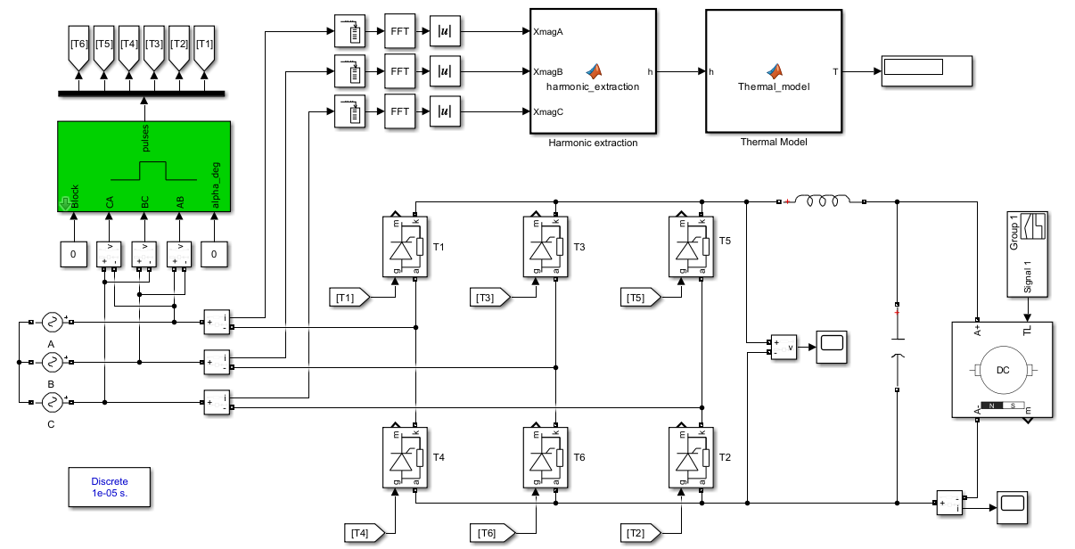
Figure R1. A screenshot of the actual Simulink implementation for Case 3

