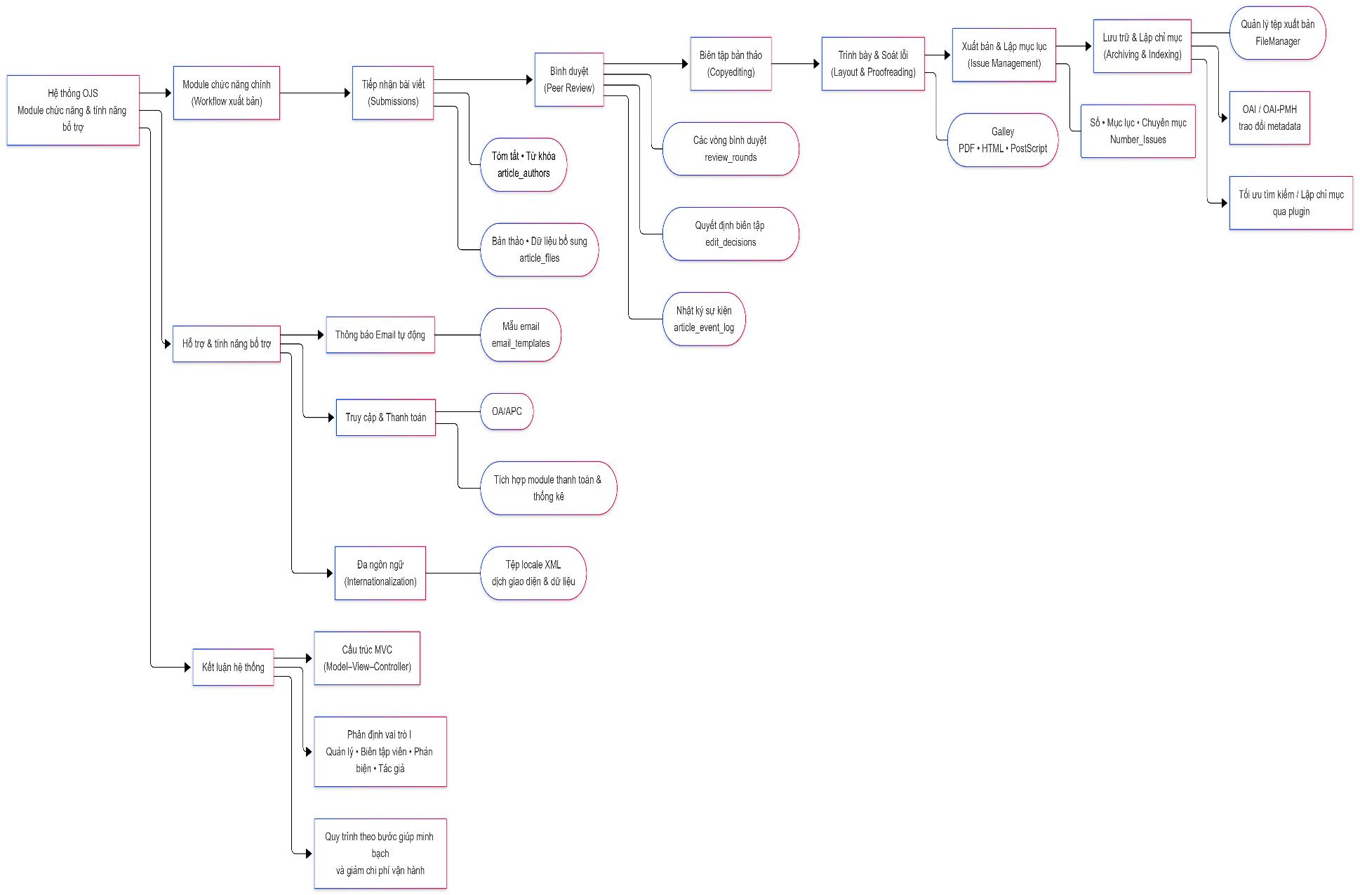Figure 1 Scholarly Publication Process and Add-on Features of OJS
(Source: Compiled from the technical documentation of the Public Knowledge Project (n.d.-c)

