Response to Reviewers
Dear Editor and Reviewers,
We sincerely thank the Editor and both reviewers for their careful reading of our manuscript and for their valuable comments and suggestions. These comments have helped us improve the clarity, structure, and academic value of the paper. We have carefully revised the manuscript accordingly. All revisions have been incorporated in the revised version of the manuscript.
Below we provide a summary of the major revisions made in response to each reviewer’s comments.
Response to Reviewer 1 | Response to Reviewer 2
We appreciate the reviewer’s constructive comments regarding the methodological clarity and the interpretation of the dataset. | We are grateful for the reviewer’s helpful comments on the conceptual framework and theoretical discussion.
- Comments on the manuscript organization  Response:  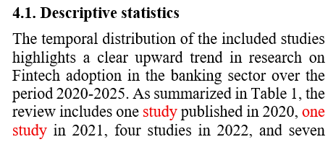  - Minor language issues have been carefully corrected throughout the manuscript (e.g., “one studies” has been revised to “one study”): section 4.1.  - Regarding the inclusion of the Technology Acceptance Model (TAM) by Davis (1989), this reference was retained because it is cited in one of the reviewed studies (Alzghoul and Al-kasasbeh [27]). Therefore, the reference is included to accurately reflect the theoretical frameworks used in the existing literature on FinTech adoption. | - Revise the topic to more comprehensively cover the contribution results.  Response: Thank you for the reviewer’s suggestion. The title has been revised to better reflect the main contributions of the study. Minor adjustments were also made to improve academic clarity and grammatical accuracy: “External and bank-specific determinants of Fintech adoption and its impacts: A systematic review”
2. Comments and suggestions | 2. Add section 2.3. Impacts of Fintech adoption.
a. Clarification of the dataset and geographical distribution  Response: Following the reviewer’s suggestion, we have clarified the geographical coverage of the reviewed studies. In particular, we added an explanation regarding the concentration of studies conducted in China and the limited number of studies from other emerging economies. The revised manuscript now explains that this distribution largely reflects the study’s selection criteria, which include only peer-reviewed journal articles published between 2020 and 2025 that examine Fintech adoption at the bank level.  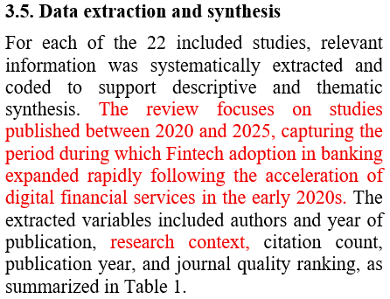  4.1. Descriptive statistics  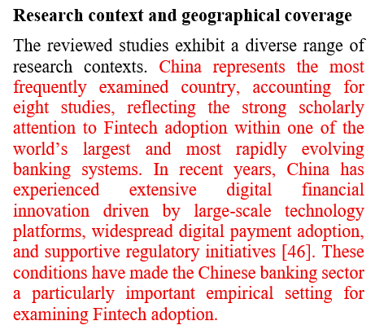 | Response: Thank you for the reviewer’s suggestion. A new subsection 2.3. Impacts of Fintech adoption has been added
b. Explanation of the time period of the dataset  Response: We have clarified the rationale for focusing on studies published between 2020 and 2025. This period reflects the phase in which FinTech adoption in banking accelerated significantly, particularly after the expansion of digital financial services during the early 2020s (section 3.5) | 3.Restructure Figure 2.  Response:  Following the reviewer’s suggestion, we revised Figure 2 to better reflect the relationships between external determinants, bank-specific determinants, FinTech adoption, and its impacts. In addition, the description of the conceptual framework has been refined to ensure consistency with the revised figure.  Section 4.2 has also been revised to improve the discussion of the theoretical frameworks used in the literature, including TOE, RBV, agency theory, and institutional theory. The revised section now aligns more closely with the classification presented in Table 2.
c. Consider incorporating quantitative synthesis methods (e.g., meta-analysis) to strengthen the robustness of the findings.  Response: We appreciate the reviewer’s valuable suggestion. However, the number of eligible studies included in the review remains relatively limited, which does not yet meet the conditions required for applying quantitative synthesis methods such as meta-analysis. We have therefore incorporated this suggestion as a potential direction for future research in the revised manuscript. | 4. Correct Table 2, row 2  Response: Thank you very much. The information in Table 2 has been carefully reviewed and corrected.
d. Minor revisions: Standardize table captions; ensure high resolution for all figures (including the PRISMA flow diagram and conceptual framework); maintain consistency in the Vietnamese abstract translation.
Response: We have standardized the table captions across the manuscript, improved the resolution of all figures (including the PRISMA flow diagram and the conceptual framework), and revised the Vietnamese abstract to ensure consistency with the English abstract.

