Thiết kế và triển khai robot di động tự hành dựa trên ROS với giao diện hỗ trợ điều hướng theo lộ trình.

Phan Gia Trí*, Trần Xuân Khoa, Trần Lê Minh Trưởng, Bùi Quốc Cường

Faculty of Engineering and Technology, Quy Nhon University, Vietnam

Email: phangiatri@qnu.edu.vn

Ngày nhận bài: dd/mm/yyyy; Ngày sửa bài: dd/mm/yyyy;
Ngày nhận đăng: dd/mm/yyyy; Ngày xuất bản: dd/mm/yyyy

TÓM TẮT
Robot tự hành ngày càng được ứng dụng rộng rãi trong các môi trường công nghiệp logistics trong nhà, nơi yêu cầu phải bảo đảm khả năng lập bản đồ, định vị và điều hướng tin cậy. Nghiên cứu này tập trung vào thiết kế một robot tự hành thực thi các tác vụ định vị và lập kế hoạch đường đi theo lộ trình đặt trước. Với mục tiêu tăng tính thân thiện với người dùng, một giao diện đồ họa tùy chỉnh, cho phép người vận hành thiết lập lộ trình đa điểm và giám sát trạng thái robot theo thời gian thực mà không cần sử dụng các công cụ chuyên sâu như Rviz. Về mặt thuật toán, nghiên cứu tích hợp Gmapping để lập bản đồ, thuật toán AMCL để định vị xác suất và bộ điều khiển DWA để điều hướng cục bộ kết hợp tránh vật cản động. Kết quả thực nghiệm trong môi trường nội khu cho thấy hệ thống đạt độ ổn định vận hành cao. Sai số đo khoảng cách của LiDAR duy trì dưới 3% trong phạm vi 10m, trong khi bản đồ 2D đảm bảo sai số từ 0,81% đến 1,29%. Việc tối ưu hóa bộ lọc hạt trong thuật toán AMCL giúp robot tự hiệu chỉnh sai số tích lũy từ encoder (dao động từ 5,8–7,0%), khả năng tiếp cận đích chính xác với tỷ lệ cao nhất đạt 95%. Đặc biệt, nền tảng điều hướng ổn định này tạo tiền đề cho việc tích hợp hệ thống thị giác máy tính nhằm tự động hóa công tác kiểm tra định kỳ, tiêu biểu là ứng dụng đọc chỉ số đồng hồ analog trong các nhà máy.
Từ khoá: ROS, AMR, SLAM, AMCL, DWA.

Design and Implementation of a ROS-Based Autonomous
Mobile Robot with a GUI-Assisted Route Navigation Interface

Phan Gia Trí*, Trần Xuân Khoa, Trần Lê Minh Trưởng, Bùi Quốc Cường

Faculty of Engineering and Technology, Quy Nhon University, Vietnam

*Email: phangiatri@qnu.edu.vn

Received: dd/mm/yyyy; Revised: dd/mm/yyyy;
Accepted: dd/mm/yyyy; Published: dd/mm/yyyy

ABSTRACT
Autonomous Mobile Robots are increasingly deployed in indoor industrial logistics environments, where reliable mapping, localization, and navigation are essential. This study focuses on the design and development of an autonomous robot capable of performing localization and path planning tasks along predefined routes. To enhance user accessibility, a custom graphical user interface is developed, enabling operators to configure multi-waypoint trajectories and monitor the robot’s real-time status without requiring specialized tools such as RViz.From an algorithmic perspective, the system integrates Gmapping for map generation, the Adaptive Monte Carlo Localization algorithm for probabilistic localization, and the Dynamic Window Approach for local navigation with dynamic obstacle avoidance. Experimental results conducted in indoor environments demonstrate high operational stability. The LiDAR-based distance measurement error remains below 3% within a range of 10 meters, while the generated 2D maps achieve accuracy levels with errors ranging from 0.81% to 1.29%.Furthermore, optimization of the particle filter in the AMCL algorithm enables effective compensation for accumulated encoder errors, which fluctuate between 5.8% and 7.0%. As a result, the robot achieves a high target-reaching accuracy, with a maximum success rate of 95%. Notably, this robust navigation framework establishes a foundation for integrating computer vision systems to support automated periodic inspection tasks, such as reading analog gauge values in industrial operation stations.
Keywords: ROS, AMR, SLAM, AMCL, DWA.

1. INTRODUCTION
Currently, autonomous mobile robots are extensively deployed across various domains, including logistics systems, cargo transportation, surveillance, and quality inspection, as well as navigation tasks in complex environments. These applications facilitate operational process optimization, minimize human intervention, and enhance overall productivity. In robotics research, robot localization and navigation are pivotal domains; terms such as SLAM, path planning, and motion control play crucial roles in enabling robots to operate effectively in unknown environments ¹⁻².
The field of autonomous robotics can be traced back to the work of Leonard in 1990, which introduced foundational approaches for 2D mapping and robot localization in three-dimensional space. This research direction established the foundation for SLAM, subsequently developed by Durrant-Whyte and Bailey, providing essential tools for localization and mapping in unknown environments ³⁻⁴. These contributions have significantly influenced the development of modern autonomous robot technology, particularly the application of Robot Operating Systems (ROS) and SLAM algorithms for mobile robots.
Modern SLAM algorithms—especially methods leveraging LiDAR and IMU sensors—have demonstrated robust capabilities in accurate 2D map reconstruction and efficient robot localization in three-dimensional space. However, implementing these SLAM approaches in real-world environments poses significant challenges, particularly when constrained by simple, low-cost hardware platforms. Several recent studies have addressed this issue by proposing cost-effective solutions while maintaining high performance, particularly for small and medium-scale autonomous robot applications⁵⁻⁷
Currently, many studies on mobile robots utilize ROS to simulate SLAM algorithms or rely on off-the-shelf commercial robot platforms such as Pioneer and Turtlebot. However, these platforms are often incompatible with the financial constraints and research infrastructure commonly found in Vietnam, where funding for autonomous robotics remains limited ⁸. Furthermore, solutions utilizing sensors such as LiDAR and cameras for mapping and navigation often entail challenges related to cost and computational resources ⁹.
In Vietnam, mobile robotics remains a key research topic. Current studies predominantly focus on developing control systems for mobile robots operating in known environments, typically based on two-wheeled differential drive structures and fixed kinematic models. However, such approaches may not fulfill maneuverability requirements in complex environments with dense obstacles and continuously changing spatial configurations ¹⁰. Consequently, recent studies have shifted towards path planning and motion control, aiming to optimize trajectories for autonomous robots in environments lacking pre-existing detailed maps, supported by algorithms such as A* and DWA ¹¹⁻¹².
With the objective of providing a low-cost solution while maintaining high performance, this paper presents a ROS-based system for navigation and mapping, alongside the DWA algorithm for local path planning. Both real-world experimental and simulation results are reported, demonstrating that our robotic platform can transport goods to user-selected target locations on the map with high precision, thereby fulfilling the requirements of autonomous robotic applications ¹³⁻¹⁴.
The remainder of the paper is organized as follows. Section 2 describes the system architecture and hardware design, followed by the differential drive kinematic model and software implementation on the ROS platform. Section 3 reports the experimental procedures and quantitative results regarding sensor evaluation, map accuracy, localization calibration, and navigation performance. Section 5 concludes the paper and outlines future improvements.
2. METHODS
2.1. Design methodology
The overview diagram of the proposed system is illustrated in Figure 1. The user operates a workstation to monitor the mapping process and command the robot to navigate to target locations via the Raspberry Pi 4 embedded computer. Both the workstation and Raspberry Pi 4 run the ROS platform on the Ubuntu 20.04 operating system, communicating through a shared Wi-Fi network; the Raspberry Pi is configured with a static IP address. The embedded computer collects measurement data from the LiDAR sensor for map construction. Meanwhile, the microcontroller collects inertial data from the IMU sensor to transmit to the embedded computer, while simultaneously controlling the actuators—including two DC motors—via a motor driver module.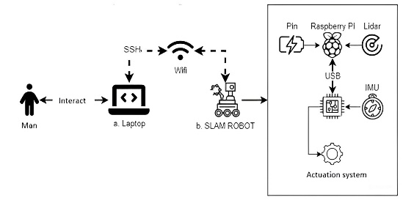
Figure 1. Overview of the proposed system
2.1.1. Hardware design
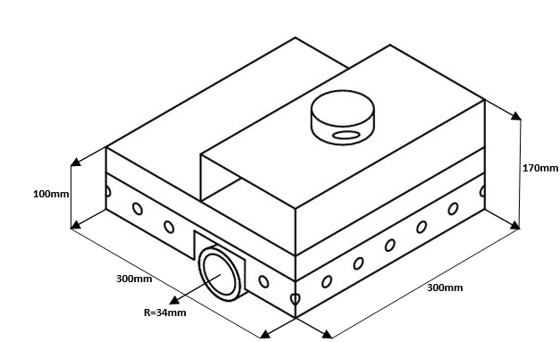
Figure 2. Dimensional drawing of the robot
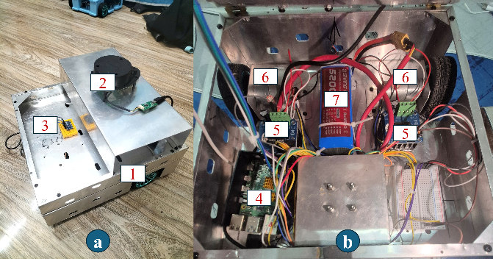
Figure 3. Robot prototype:
(a) external view, (b) internal layout.
The robot chassis is fabricated from aluminum alloy with overall dimensions of 300x300x170mm to optimize weight while ensuring structural rigidity and space for component distribution. Given the requirements for indoor operation on flat surfaces, the differential drive system utilizes standard wheels (Fig. 3a-1). The robot frame is designed to integrate a top cover where the RPLidar A1 sensor is mounted (Fig. 3a-2). A 9-axis Inertial Measurement Unit (IMU) sensor (MPU-9250) enables motion tracking along three spatial axes, improving localization capabilities and motion stability (Fig. 3a-3). As illustrated in Fig. 3b, the robot body houses a Raspberry Pi 4 embedded computer (Fig. 3b-4) for sensor data processing and communication with the control board. Two BTS7960 motor driver modules (Fig. 3b-5) control hai GA-25 geared DC motors (Fig. 3b-6) with integrated dual-channel A/B encoders, allowing for precise motion execution and motor velocity feedback. The system is powered by a 12V battery pack (Fig. 3b-7).
The installation positions of the components are calculated to optimize the sensors' field of view and the robot's center of gravity. The RPLidar A1 and MPU-9250 sensor cluster are positioned on the top surface (Fig. 3a) to collect spatial data with minimal noise. During operation, to compute precise internal odometry, the Raspberry Pi embedded computer collects and fuses feedback signals from the encoders of the two GA-25 motors with orientation data from the IMU. Based on this localization data and the LiDAR-generated map, interpolated velocity commands from the Navigation Stack are transmitted to the low-level microcontroller and subsequently converted into Pulse Width Modulation signals via the BTS7960 modules for trajectory tracking. The entire system is independently powered by a 12V battery block located on the lower platform (Fig. 3b-7).
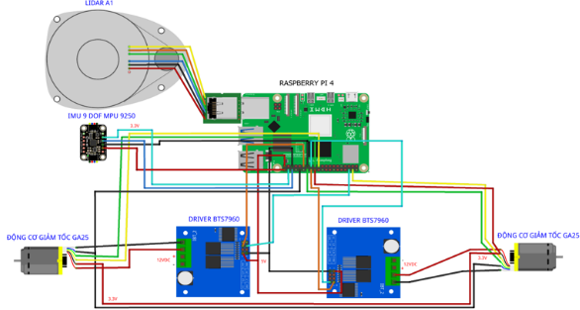
Figure 4. Hardware wiring diagram.
Figure 4 presents the hardware connection diagram, illustrating how the primary modules are integrated into a comprehensive control system.
2.2. Kinematic Model
A differential drive autonomous mobile robot consists of two independent driving wheels installed on both sides of the robot body, combined with a passive caster wheel to ensure mechanical stability.
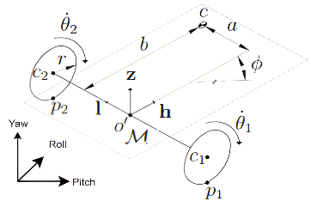
Figure 5. Kinematic model of a two-wheel differential-drive mobile robot
The linear velocity of each wheel is proportional to its radius and angular velocity:
- Right wheel: $v_{1}=r⋅\dot{θ_{1}}$
- Left wheel:$v_{2}=r⋅\dot{θ_{2}}$
Robot linear velocity $v$:
This is the forward speed of the robot, calculated as the average velocity of the two wheels:
$$v=\frac{v_{1}+v_{2}}{2}=\frac{r\left({\dot{θ}}_{1}+{\dot{θ}}_{2}\right)}{2}$$ | (1)

Robot angular velocity $ω$:
The rotational velocity of the robot depends on the velocity difference between the two wheels and the wheelbase $L = l+h$
$$ω=\frac{v_{1}-v_{2}}{L}=\frac{r\left({\dot{θ}}_{1}-{\dot{θ}}_{2}\right)}{l+h}$$ | (2)
- $r$ : Radius of each wheel.
- $l$ and $h$: Distance from the robot center $o'$ to each wheel. The total distance between the two wheels is $L = l + h$ (in this symmetrical model, $l = h$ thus $L = 2l$).
- ${\dot{θ}}_{1},{\dot{θ}}_{2}$ Angular velocities of the right and left wheels, respectively.
- $v_{1}, v_{2}$: Linear velocities at the contact points of the right and left wheels.
- $v$: Linear velocity of the robot at the center $o'$.
- $ω$: Angular velocity (rotational speed) of the robot around the $z-axis$
2.3. Navigation Algorithms
The robot's navigation system is built upon the ROS Navigation Stack architecture, comprising three core capabilities: mapping, localization, and navigation. In this study, the focus is on optimizing configuration parameters to ensure stable robot operation on the actual hardware platform.
2.3.1. Localization and Mapping
The slam_gmapping package is utilized for map construction, and the AMCL algorithm is employed for localization. To enhance accuracy, data from the encoders and IMU are fused using an Extended Kalman Filter (EKF). In the AMCL configuration, particle parameters were fine-tuned to address sensor noise:
- Number of particles (min_particles: 1000, max_particles: 7000): Increasing the maximum number of particles allows the robot to relocalize more effectively in cases of LiDAR noise or sudden disorientation.
- KLD Error (kld_err: 0.01, kld_z: 0.99): This configuration allows a particle distribution error of 1% with a 99% confidence level, ensuring the highest precision in pose estimation.
2.3.2. Global & Local Planning
The navigation process is divided into two planning layers:
Global Path Planning:
The Dijkstra algorithm is utilized to find the shortest path on the costmap. Through experiments, the cost_factor parameter in global_planner.yaml was adjusted between 1.0 and 1.5. A larger cost_factor increases the cost around obstacles, forcing the robot to select safer detours. Conversely, a smaller value allows the robot to travel closer to obstacles but may lead to becoming stuck in narrow environments.
Local Path Planning
We apply the Dynamic Window Approach (DWA) to generate reactive trajectories, enabling the robot to avoid unexpected obstacles. The operational parameters were fine-tuned as follows:
- Velocity Limits: max_vel_x is limited to 0.25 m/s to ensure that LiDAR and IMU sensors have sufficient time to update positional data on the map without latency. The backward velocity min_vel_x is set to -0.4 m/s, allowing the robot to maneuver out of tight spaces flexibly.
- Angular Velocity: max_vel_theta is set at 1.0 rad/s for stable rotation, while min_vel_theta is -1.6 rad/s, allowing for wide turns without stopping.
- Goal Tolerance: xy_goal_tolerance is 0.10 m and yaw_goal_tolerance is 0.30 rad. Setting latch_xy_goal_tolerance: false enables the system to continuously verify the goal status, ensuring the robot stops at the correct position and orientation.
- Trajectory Simulation: sim_time is set to 1.0s. This is the optimal duration for the planner to generate the best obstacle avoidance path without causing discontinuities in the global path due to high computational costs.
2.2.3. Costmap Configuration
To enable safe yet flexible movement, inflation parameters are distinctively separated:
- Local Costmap: inflation_radius: 0.15 and cost_scaling_factor: 5.0, allowing the robot to navigate through narrow passages slightly larger than the chassis.
- Global Costmap: inflation_radius: 0.3 and cost_scaling_factor: 10.0 are established to prioritize clear routes on a map-wide scale.
- Physical Dimensions (Footprint): We accurately declare the robot's shape as [[-0.14, -0.14], ..., [0.14, -0.14]] so the system can calculate collision distances as realistically as possible.
In addition, a Graphical User Interface (GUI) was developed to convert complex navigation tasks into standard commands, facilitating operator management of waypoints and real-time monitoring of the robot's execution status.
2.2.4 Sensor Fusion with EKF
To enhance the accuracy of mobile robot positioning and orientation, this study implements a sensor fusion algorithm for encoder and IMU data using the EKF. Specifically, the ekf_se_odom node from the robot_localization package in the Robot Operating System (ROS) is utilized for this task.
The EKF algorithm operates based on a continuous real-time prediction and correction mechanism. The structure of the filter is illustrated in Figure 6, consisting of two primary stages:
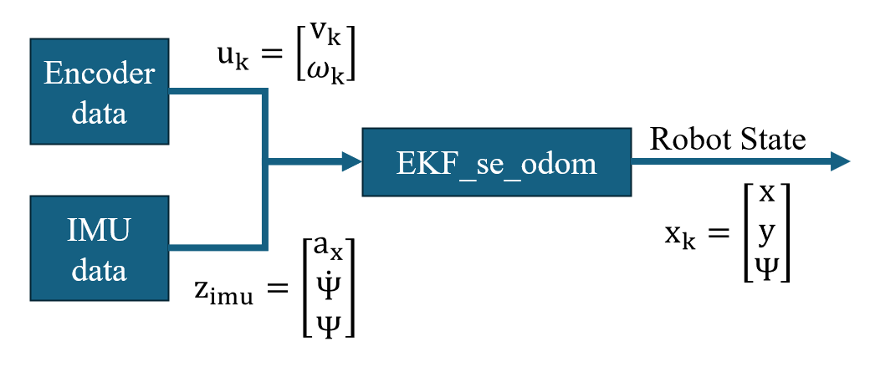
Figure 6. Sensor fusion architecture for robot state estimation using EKF
Prediction Stage
The robot state at time $k$ is predicted from the state at the previous time step $k-1$ based on the differential drive kinematics model. The control input $u_{k}$ includes the linear velocity $v_{k}$and angular velocity $ω_{k}$extracted from the encoders. The system of state equations is described as follows:
$$\left\{\begin{aligned}x_{k}=x_{k-1}+v_{k}cos(Ψ_{k-1})Δt \\ y_{k}=y_{k-1}+v_{k}sin(Ψ_{k-1})Δt \\ Ψ_{k}=Ψ_{k-1}+ω_{k}Δt\end{aligned}\right.$$ | (3)
Where $(x, y)$ are position coordinates and $Ψ$ is the orientation angle (Yaw) of the robot in the internal coordinate system (odom frame).
Update and Correction Stage
The observation vector $z_{imu}={\left[\begin{matrix}a_{x} & \dot{Ψ} & Ψ\end{matrix}\right]}^{T}$ from the IMU, comprising linear acceleration $a_{x}$, angular velocity $\dot{Ψ}$, and orientation angle $Ψ$, is used to compensate for accumulated errors (drift) from the encoders. The filter calculates weights based on the measurement noise covariance matrix to provide the most optimal state estimation for the system.
The ekf_se_odom node plays a central role in the robot's localization architecture. The data processing workflow is as follows:
- Input Data: Subscribes to raw data topics from encoders and the IMU. Data is time-synchronized before being processed by the filter.
- Output Data: Publishes processed state information to the /odometry/filtered topic.
The result of this fusion process provides a stable, low-noise, and highly reliable odometry data source, directly supporting subsequent tasks.
3. EXPERIMENTS AND EVALUATION
3.1. Encoder evaluation
To evaluate the precision of the encoder sensors, experiments were conducted on a flat floor surface. Actual distance markers, were measured against a tape measure (Ground Truth) to determine the actual distance traveled by the robot.
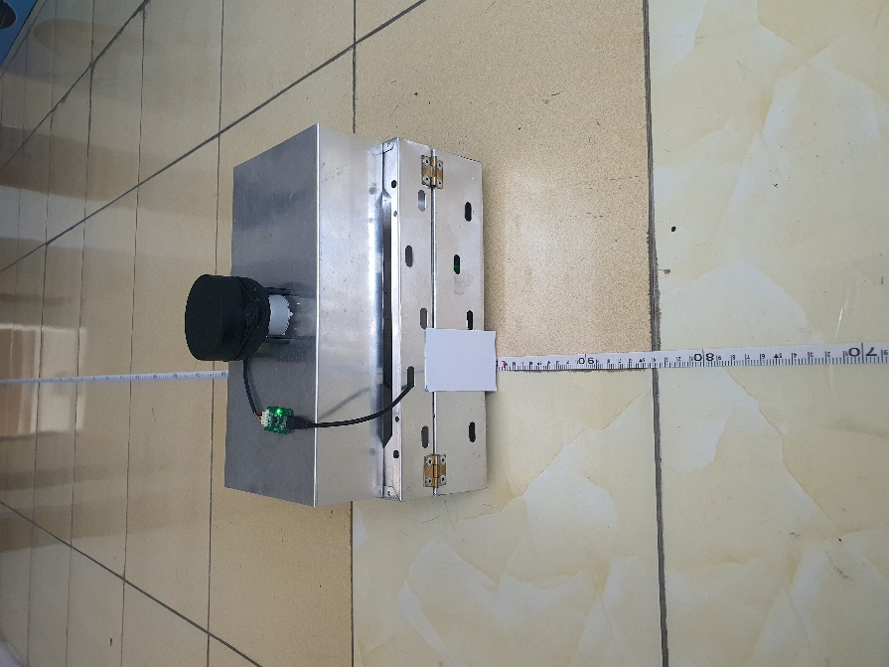
Figure 7. Evaluation of robot positioning accuracy with ground truth measurement
As shown in Figure 8, a physical indicator is attached to the robot chassis to align with a tape measure on the floor, providing a ground truth reference for distance measurement. Pulse counts from the left and right wheel encoders are recorded and stored. Each measurement is performed with 20 iterations at each distance marker to minimize the influence of random errors. After collecting the actual pulse data from the encoders, these values are compared with the theoretical pulse counts to determine the standard deviation and calculate the relative error.
To calculate the theoretical number of encoder pulses per distance traveled, the wheel circumference is determined by the formula:
$$C= π × D$$ | (4)
The theoretical number of pulses $N$ is calculated based on the hardware characteristics of the robot's encoders:
$$N=\frac{actual distance}{C} × 514$$ | (5)
Where 514 is the number of pulses generated by each wheel per full revolution.
Relative error, which determines the percentage deviation between the actual measured distance and the estimated distance, is calculated using the following formula:
$$E_{rel}=\frac{\left|N_{measured}-N_{theory}\right|}{N_{theory}}×100$$ | (6)
Where:
- $N_{measured}$ is the actual pulse count measured from the encoder
- $N_{theory}$ is the theoretical pulse count calculated from the above formula.
Standard deviation calculation:
$$σ=\sqrt{\frac{1}{n}\sum_{i=1}^{n}{{\left(x_{i}-\overline{x}\right)}^{2}}}$$ | (7)
- $x_{i}$ is the pulse value measured from the $i$ measurement.
- $\overline{x}$ is the average measured pulse value.
- $n$ is the number of measurements.
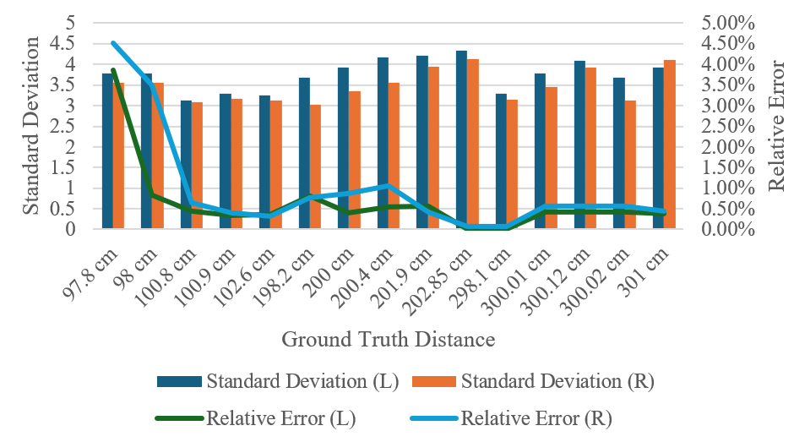
Figure 8. Encoder evaluation results
The relative error for both wheels consistently remains at a low level. Notably, the error tends to decrease inversely with the distance traveled. At the 300 cm mark, the error reaches its minimum (approximately 0.01% - 0.4%), indicating that the system operates with extreme precision during long-distance movement tasks. The highest error recorded at a short distance (97.8 cm) is 4.51%, which may be attributed to slight slippage during startup or the resolution error accounting for a larger proportion at shorter distances.
Stability: The standard deviation $σ$ fluctuates within a narrow range from 3.02 to 4.34 pulses. The low and stable $σ$ values across various measurement marks demonstrate the high repeatability of the sensors, ensuring reliable input data for the EKF filter.
Experimental results reveal a slight asymmetry, as the average pulse count for the right wheel is consistently higher than that of the left wheel, leading to a relative error deviation of approximately 0.1% - 0.7%. This may be caused by non-homogeneous mechanical properties of the motors or differences in actual slip coefficients. However, this error remains within the allowable threshold of < 5%. This lack of synchronization provides a practical basis for applying the EKF filter, combining IMU data to correct heading drift and optimize the robot's navigation accuracy.
3.2. IMU sensor evaluation
The performance of the IMU is evaluated through the measurement of the yaw angle, representing the rotational motion of the robot around the vertical z-axis. The yaw angle is used to determine the robot's heading during movement, and therefore plays a pivotal role in localization and navigation tasks.
3.2.1. Experimental scenario setup
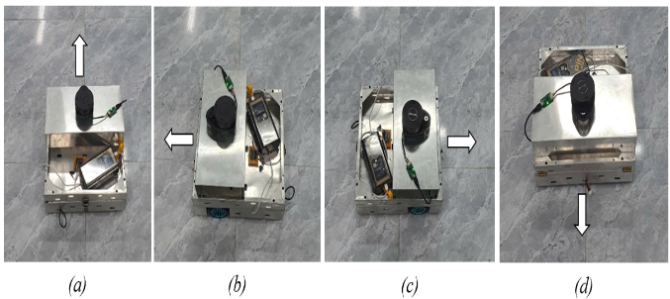
Figure 9. IMU evaluation: (a) initial yaw angle, (b) −90°, (c) 90°, and (d) 180°.
The experiment was implemented through three rotational motion scenarios with target angles of −90°, 180°, 90° (corresponding to an absolute heading of 270°) respectively, as described in Figure 9.
The robot was aligned at the 0° reference mark before executing rotation commands. Output data includes the raw heading angle (Raw Yaw) and the processed heading angle (Filtered Yaw) to evaluate two criteria: (i) the sensor's characteristic error under actual operating conditions and (ii) the correction capability of the filtering algorithm. The measurement procedure complies with the right-hand rule, ensuring consistency within the robot coordinate system.
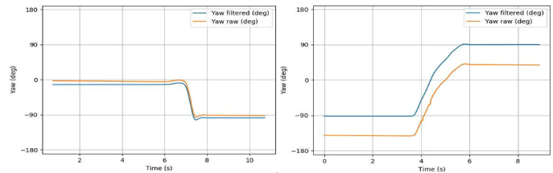
Figure 10. Raw and filtered yaw profiles for rotations 1 and 2.
Initially, the robot was aligned at a fixed heading of 0° (Figure 9a), then controlled to rotate to the target heading of 90° (Figure 9b). Next, the robot was commanded to rotate to the 180° angle (Figure 9d). The corresponding yaw measurement values, including raw and filtered data, are presented in Figure 10.
Finally, the robot was operated to rotate to the target heading of 270° (Figure 10c).
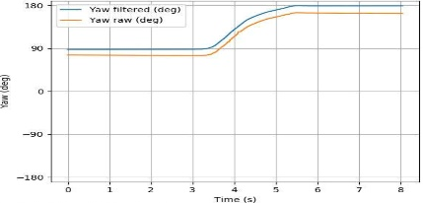
Figure 11. Raw and filtered yaw profiles for rotation 3.
The raw and filtered yaw signals for this third motion scenario are presented in Figure 11.
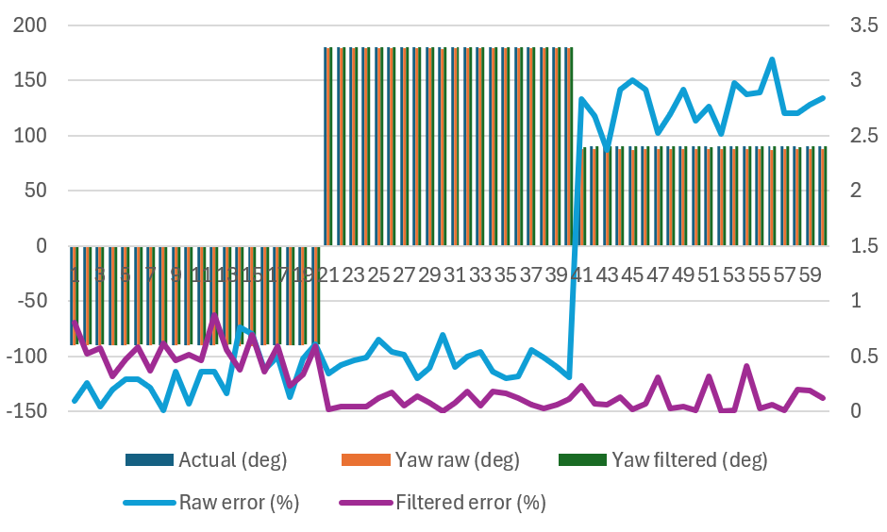
Figure 12. Comparison of raw and filtered yaw measurements.
Based on the experimental scenarios, the yaw measurement results are synthesized and presented in the corresponding graphs. Analysis of the Graph in Figure 12 illustrates the comparison between the actual rotation value (Actual), raw sensor data (Yaw raw), and filtered data (Yaw filtered), along with the corresponding error values, showing that:
- Noise Suppression and Signal Stability of the raw yaw signal exhibits significant stochastic fluctuations, whereas the filtered signal demonstrates high smoothness and precise alignment with the ground truth. This confirms the filter's efficacy in eliminating white noise and random interference inherent in IMU operations.
- The error analysis reveals that while the raw error exhibits significant variations between 2.5% and 3.2% during the third rotation scenario (samples 41–60) due to characteristic MEMS sensor drift, the filtered error remains remarkably stable within a range of 0.1%–0.5%, effectively maintaining high precision and substantially reducing deviations compared to the original data even at peak error points.
Dynamic Response: The filter demonstrates excellent instantaneous error compensation capability. At the transition points between the rotation markers (-90°, 180°, 90°), the filtered signal shows no significant overshoot or phase lag, ensuring real-time performance for the robot's navigation system.
In general, the IMU sensor provides relatively accurate raw yaw estimates; however, errors can increase during sudden heading changes or large-angle rotations. The applied filter has significantly reduced errors and improved the accuracy of the heading angle under the aforementioned operating conditions.
3.3. LiDAR sensor evaluation
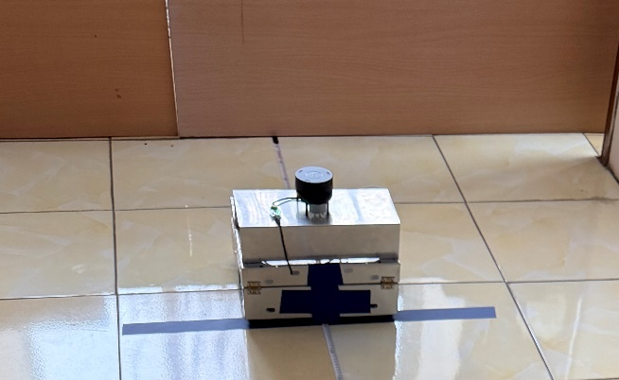
Figure 13. Experimental setup for LiDAR evaluation.
To evaluate the distance measurement accuracy of the LiDAR sensor, this study utilizes a 15 m tape measure as the ground truth reference. Target obstacles were positioned at distances ranging from 500 mm to 15,000 mm from the sensor, with a displacement step of 500 mm between consecutive measurements. At each position, the distance recorded by the sensor was compared with the corresponding ground truth value to determine the measurement error. To mitigate the effects of random fluctuations, each distance mark was measured independently 20 times, and the mean value was subsequently calculated to represent the measurement result at that position.
Mean value of 20 measurements:
$$\overline{x}=\frac{1}{n}\sum_{i=1}^{n}{x_{i}}$$ | (8)
Furthermore, to quantify the sensor's stability, the study calculated the standard deviation and relative error.
Standard deviation:
$$s= \sqrt{\frac{1}{n-1}\sum_{i=1}^{n}{{\left(x_{i}-\overline{x}\right)}^{2}}}$$ | (9)
Relative error:
$$E_{rel}= \frac{\left|\overline{x}-d_{gt}\right|}{d_{gt}}×100\%$$ | (10)

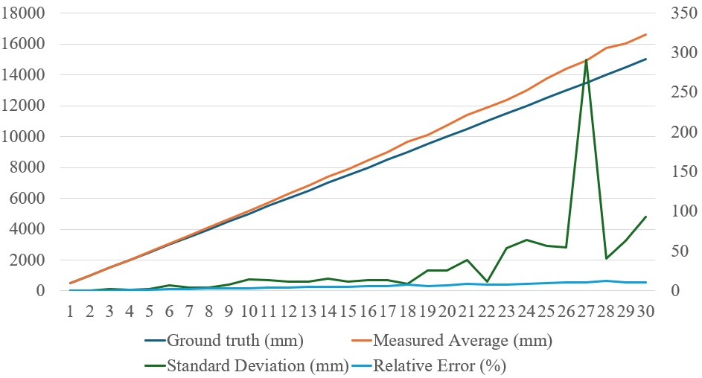
Figure 14. Experimental evaluation of LiDAR distance measurement accuracy
Experimental results indicate that the LiDAR sensor performs efficiently at short and medium ranges, whereas the error gradually increases at longer distances. Within the range of 500 mm to 6,500 mm, the mean measured values were close to the ground truth, with a small relative error of less than 5%, indicating high repeatability and stability of the acquired data. As the distance increased from 7,000 mm to 12,500 mm, the relative error began to rise but remained within acceptable limits for various indoor environment navigation tasks. At this range, the standard deviation between measurements remained low, suggesting that the sensor maintains operational stability. From 13,000 mm to 15,000 mm, the measurement results remained relatively consistent; however, the deviation trend from the actual values became more pronounced, resulting in lower accuracy compared to the near range. When the distance exceeded 9,000 mm, the error increased significantly, and the phenomenon of measurements exceeding the actual values became more apparent. In particular, at distant markers from 12,000 mm and above, the relative error reached a high level, reflecting a decrease in measurement reliability in the far range. Technically, this phenomenon may stem from signal reflection attenuation, the influence of obstacle surface characteristics, and noise during signal acquisition. Based on these results, a distance of less than 7,000 mm can be considered the optimal operating range for the sensor under the experimental conditions, as it ensures both relative accuracy and stability across measurements.
3.4. Mapping accuracy evaluation
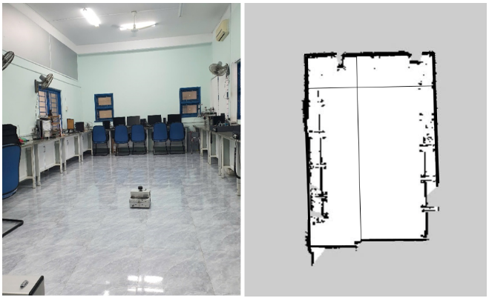
Figure 15. 2D map construction results.
We conducted 2D map construction in an indoor environment. The objective was to evaluate the mapping accuracy by comparing the dimensions of the reconstructed map with the actual environment dimensions (ground truth), thereby quantifying the resulting errors. On the map, black areas represent obstacles, while white areas denote free space through which the robot can navigate.

Table 1. Comparison between ground-truth and map-measured environment dimensions.
Dimension | Actual (m) | Measured  on map (m) | Absolute error (m) | Error (%)
Length | 10.6 | 10.46336 | 0.13664 | 1.29%
Width | 4.08 | 4.04712 | 0.03288 | 0.81%
The reconstructed map demonstrates a close alignment with the physical environment. The error in length was 1.29%, which is acceptable, while the width error was only 0.81%. Error levels below 2% confirm that the proposed system provides reliable measurement and mapping performance. It should be noted that obstacles are only detected if they are at the same height as the LiDAR sensor and within the scanning range; therefore, environmental and system noise may generate virtual map components (artifacts). Nevertheless, the observed errors remain within permissible limits for the target application.
3.5. AMCL localization performance evaluation
First, the AMCL filter is evaluated with different particle set sizes to determine the optimal configuration, ensuring a balance between accuracy and computational efficiency. AMCL utilizes a particle filter to estimate the robot's pose in the environment. The number of particles is a key factor, directly affecting both the estimation accuracy and computational cost. In this experiment, three particle counts (1000, 5000, and 7000) were tested to evaluate the performance of the AMCL algorithm.
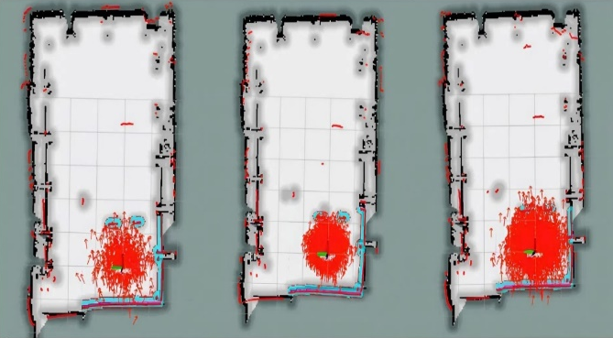
Figure 16. AMCL particle filter initialization with 1000, 5000, and 7000 particles.
Table 2. Impact of particle count on AMCL performance.
Particles | Performance  (%) | Final position error (m) | Error  (%) | Computation time (s)
1000 | 70 | 1.45 | 10.25 | 0.5
5000 | 90 | 0.93 | 6.75 | 1.2
7000 | 95 | 0.75 | 5.31 | 2.3
With 1000 particles, AMCL can estimate the robot's pose, but the accuracy is limited, leading to a relatively large error of 10.25%, despite low computation time. Increasing the particle count to 5000 improves the pose estimation accuracy and reduces the error to 6.75%; however, this accuracy remains at an intermediate level. The 7000-particle configuration achieves the best localization accuracy with the error reduced to 5.31%, albeit at the expense of longer computation time.
The definition of "Performance (%)" here refers to the percentage of successful pose estimations performed by the system within the allowable error range. This value is calculated by dividing the number of accurately estimated robot poses by the total number of evaluated poses throughout the testing process, then multiplying by 100. Based on these results, the 7000-particle configuration is selected as optimal, providing the best balance between localization accuracy and overall system performance. After the robot moves for a period, the particle set converges, and the estimated pose best matches the given map.
3.6. Navigation performance evaluation
The navigation performance of the robot was evaluated in two types of environmental configurations:
- Obstacle-free environment with a straight trajectory.
- Complex environment with obstacles.
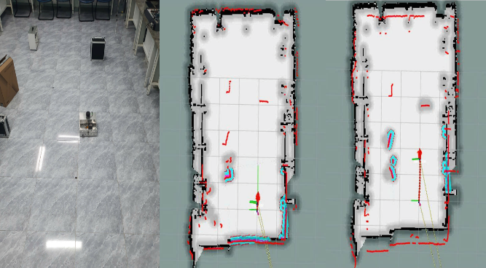
Figure 17. Robot navigation in an obstacle-free environment (straight trajectory).
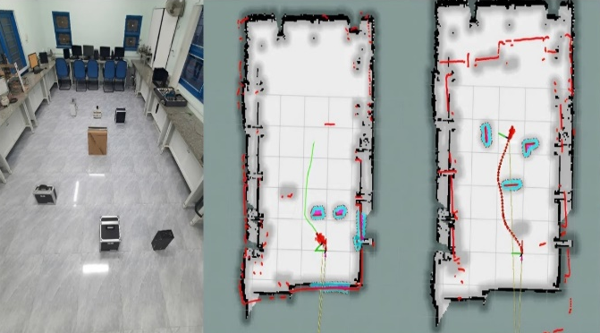
Figure 18. Robot navigation in a complex environment with obstacles.
The table below summarizes the navigation performance in both experimental scenarios. The particle count was fixed at 7000 for all navigation tests.
Table 3. Navigation performance under obstacle-free and obstacle-rich environments
 | Time to goal  (s) | Travel distance  (m) | Error  (%)
No obstacles | 4.5s | 4.0m | 0
Obstacles  (cost factor= 1.5) | 6.5s | 4.2m | 1.0
Obstacles  (cost factor = 1.2) | 5.8s | 4.3m | 0.7
Obstacles  (cost factor = 1.0) | 5.1s | 4.5m | 0.4
The cost_factor parameter relates to the costmap configuration within the ROS Navigation Stack. This parameter adjusts the cost associated with obstacle avoidance during robot navigation. Specifically, this factor influences the calculation of regions surrounding the robot, helping determine the distance to be maintained to avoid obstacles in the environment. The inflation radius is the radius around an obstacle where the cost increases to encourage the robot to stay away from that obstacle. The cost scaling factor is a parameter that adjusts the rate of cost increase according to the distance from the obstacle. A higher cost scaling factor causes the cost for obstacle avoidance to increase more sharply as the robot approaches the obstacle.
In the obstacle-free environment scenario, the robot reached the destination with short travel time and distance, achieving accurate motion without significant deviation. In the obstacle-rich environment, setting a high cost factor (cost factor = 1.5) caused the robot to exhibit overly conservative obstacle avoidance behaviors, increasing the time to goal despite maintaining acceptable accuracy. Reducing the cost factor to 1.0 significantly decreased the time to goal by minimizing unnecessary detours, while the error was reduced to 0.4%, indicating robust navigation behavior. Consequently, a cost factor of 1.0 was selected as the most suitable setting for our system, achieving faster navigation speeds while preserving reliable performance.
3.7. Navigation to predefined target locations
To realize the autonomous navigation capability to predefined locations, we developed an intuitive GUI, serving as a "Master Node" within the ROS ecosystem. The interface was built using Python with an event-driven architecture, closely integrated with the Navigation Stack via the Publish/Subscribe model. Specifically, the system encapsulates target coordinates into geometry_msgs/PoseStamped messages to be sent to the /move_base_simple/goal topic, while simultaneously monitoring feedback status from the /move_base/status topic. This mechanism allows the operator to select preset goal locations (Positions 1 to 4) and monitor the AMR's trajectory in real-time on the Occupancy Grid map.
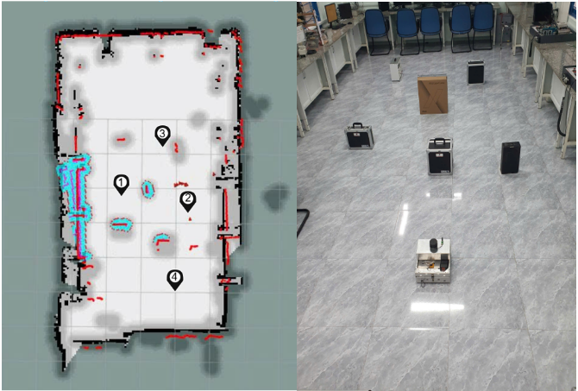
Figure 17. UI screenshot during experiment and robot trajectory overlay.
The interface provides real-time updates on the robot's current status, enabling convenient monitoring of the navigation process. The preset target locations represent key mission positions. During navigation, the robot must traverse narrow areas, requiring precise and flexible motion control. The control system and interface support continuous observation and performance verification throughout the mission.
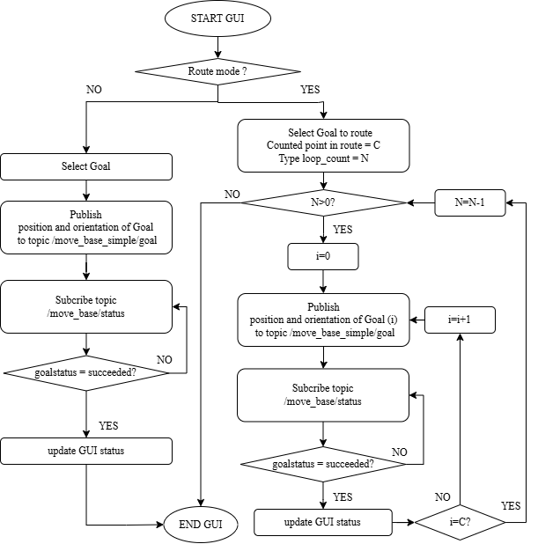
Figure 19. General algorithm flowchart
of Graphical User Interface
The GUI is designed as a central command station, serving as a "Master Node" within the ROS ecosystem to optimize human-machine interaction. Technically, the GUI is built using Python with an event-driven architecture, closely integrated with the Navigation Stack via the Publish/Subscribe model. Specifically, the system transmits target coordinates (position and orientation) to the /move_base_simple/goal topic while establishing a continuous feedback monitoring mechanism by subscribing to the /move_base/status topic.
The control system is designed to allow flexible execution between two modes: Single-point Navigation and Route Patrol (Multi-goal Sequence).
In Single-point Navigation mode, the process begins by extracting the target coordinate vector from the GUI. This data is encapsulated into a geometry_msgs/PoseStamped message and sent to the path planner via the /move_base_simple/goal topic. The system maintains a state monitor process by subscribing to the /move_base/status topic. The control algorithm enters a blocking state until a completion confirmation (Success) is received before updating data to the application layer.
For Route Patrol mode (Route Mode), the system operates based on nested loops to optimize continuous autonomy. The outer loop manages the parameter $N$ (total patrol cycles), while the inner loop iterates through the array list of target locations $C$. At each waypoint $i$, the system executes a handshaking mechanism with the navigation module: only when the status at point $i$ returns a convergence value does the index variable increment to $i+1$. When the index $i$ reaches the limit $C$, the system automatically decrements the cycle counter $N$ and restarts the route from the starting point. This process ensures high cyclicity and reliability in logistics or automated security surveillance robotic tasks. This mechanism ensures a high level of automation in long-term patrol missions, where the robot must automatically reset state parameters and restart a new cycle without manual intervention, while always maintaining an interrupt capability via emergency stop or reset commands.
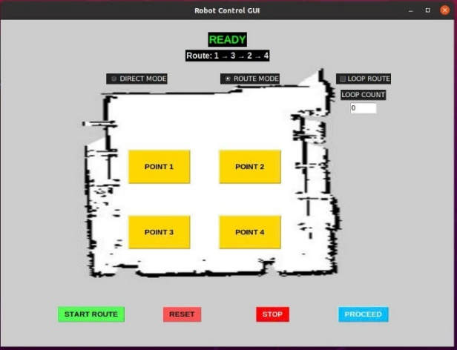
Figure 20. Robot navigation user interface.
We evaluated a multi-goal mission in which the robot starts at Position 4, then navigates sequentially through Position 1, Position 3, Position 2, and finally returns to Position 4.
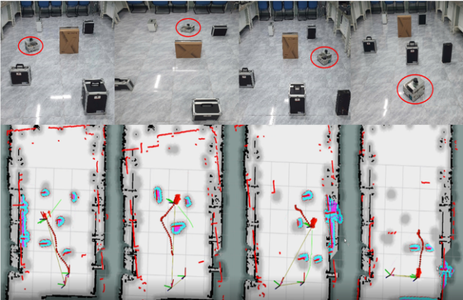
Figure 21. Robot navigation in real-world environment.
Table 4. Navigation performance for predefined goal locations.
Goal | Avg Accuracy (%) | Avg total_Time (s)
Position 1 | 95 | 25
Position 3 | 85 | 21
Position 2 | 92 | 13
Position 4 | 90 | 20
Accuracy (%) is calculated based on the ratio between the actual coordinates and orientation when the robot stops compared to the target coordinates and orientation upon completing the navigation. A higher value for this metric indicates that the robot is navigating closely along the planned trajectory with minimal deviation throughout the movement.
Subsequently, to evaluate accuracy, we performed a system performance assessment through five different trajectories $R1 to R5$ Each trajectory consists of a sequence of target points configured directly from the control interface.
Table 5. Performance evaluation of the navigation system across different trajectories
ID | Avg  Accuracy  (%) | Avg  Total_Time  (s)
R1 | 1 -> 2 -> 3 -> 4
R1 | 93.5 | 82.4
R2 | 4 -> 3 -> 2 -> 1
R2 | 91.2 | 85.1
R3 | 1 -> 3 -> 2 -> 4
R3 | 82.7 | 165.6
R4 | 2 -> 4 -> 1 -> 3
R4 | 89.5 | 88.3
R5 | 1 -> 2 -> 4 -> 3
R5 | 92 | 84.8
Based on the statistical data from Table 5, the navigation system's performance exhibits distinct variations depending on the geometric characteristics of the trajectory. Although the mission completion rate reached an absolute 100% across all scenarios, a deep analysis of the metrics for trajectory R3 highlighted the system's risk-handling mechanisms in complex environments. The specific continuous zigzag movement in this trajectory causes mechanical wheel slippage (encoder slip) and sensor drift (IMU drift), resulting in the tracking accuracy dropping to its lowest level (82.7%).
However, the abnormally extended operation time for R3 (165.6s) serves as evidence of the system's effective self-recovery mechanism. When the localization error exceeds the threshold and enters a local deadlock, the robot automatically activates a "Rotate Recovery" state to allow the LiDAR sensor to rescan the entire environment, update the costmap, and recalibrate pose estimation. These results affirm the excellent robustness and fault tolerance of the proposed GUI-ROS control architecture, enabling the robot to self-diagnose and escape localization blind spots without any manual intervention from the operator.
4. DISCUSSION
Experimental results demonstrate that the autonomous robot system developed on the ROS platform effectively fulfills the requirements for mapping, localization, and navigation in real-world environments. The highlight of this study lies in the optimization of the coordination between low-cost hardware and reliable processing algorithms.
The integration of data from LiDAR, IMU, and Encoders through the EKF has effectively resolved the issue of accumulated errors. Although the distance error from the Encoders still fluctuates between 5.8% and 7.0%, thanks to the configuration of 7000 particles in the AMCL algorithm with 99% confidence, the system is capable of self-correcting positional errors and preventing map drift—a common challenge in low-cost mobile robot systems.
Compared to the studies by Zhou et al. (2022) [17] or systems based on RBPF-SLAM (2023) [18], our solution demonstrates superiority in terms of practical deployment. While previous studies required high-end computing infrastructure and expensive sensors, the proposed system proves that with a minimal configuration based on Raspberry Pi 4, the robot still achieves comparable accuracy in complex indoor environments. In particular, unlike works focused purely on algorithms [19], this study has bridged the gap between technology and users through the development of a custom GUI, simplifying the operation and route monitoring process without relying on specialized tools such as Rviz.
5. CONCLUSIONS AND FUTURE WORK
5.1. Conclusion
The study has successfully designed and implemented a multi-sensor integrated autonomous mobile robot (AMR) system based on the ROS operating system. The primary contributions of this work include:
- Developing a differential drive motion model and a feedback control mechanism from Encoders combined with an IMU for accurate trajectory estimation.
- Executing the 2D SLAM process and AMCL probabilistic localization with an optimal trade-off between the particle count (7000 particles) and computing resources on Raspberry Pi 4.
- eveloping a GUI supporting multi-point navigation (waypoints), enhancing interactivity and practical application.
Quantitatively, the system achieved an overall stability of 95% in navigation scenarios. LiDAR distance measurement error remained low (<3% within a 10m range), and the geometric error of the map compared to the ground truth only fluctuated from 0.81% to 1.29%. Fine-tuning the cost factor (cost_factor = 1.0) helped optimize the travel trajectory, minimize unnecessary detours, and improve the time to goal.
5.2. Future Work
Despite promising results, the system still exhibits limitations regarding encoder drift during long-distance traversal and LiDAR sensitivity to low-reflectivity surfaces. To further advance the system's capabilities, future research will focus on the following directions:
- Enhancing Robustness and Navigation: Implementing advanced sensor fusion techniques to further mitigate wheel slippage and yaw drift during rapid maneuvers. Additionally, we aim to automate the parameter tuning process and explore deep reinforcement learning for more fluid navigation in highly dynamic environments.
- Integration of Industrial Inspection Vision: A primary focus of upcoming research is the integration of a computer vision system to transform the AMR into an intelligent inspection platform. We plan to develop image processing algorithms specifically designed to automatically read and record analog meter indices during autonomous patrol cycles. This will enable the robot to perform routine monitoring in industrial substations or plant rooms without human intervention.
- System Expansion and Health Monitoring: Developing multi-target task management and comprehensive system health monitoring features. This will support large-scale deployment in complex environments such as smart factories, logistics warehouses, or healthcare facilities, ensuring long-term operational reliability.
Acknowledgments
This research is conducted within the framework of science and technology projects at institutional level of Quy Nhon University under the project code T2024.847.18.

REFERENCES
- H. Durrant-Whyte, T. Bailey. Simultaneous Localization and Mapping: Part I, IEEE Robotics & Automation Magazine, 2006, 13, 99-110.
- Feder, H. J. S., Leonard, J. J., & Smith, C. M. Adaptive mobile robot navigation and mapping, The International Journal of Robotics Research, 1999, 18, 650-668.
- J. J. Leonard and H. F. Durrant-Whyte. Simultaneous map building and localization for an autonomous mobile robot, in Proceedings of the IEEE/RSJ International Workshop on Intelligent Robots and Systems, Osaka, Japan, 1991.
- S. Thrun, W. Burgard, and D. Fox. Probabilistic Robotics, MIT Press, 2005.
- J. Zhu, J. et al., Camera, LiDAR, and IMU Based Multi-Sensor Fusion SLAM: A Survey, IEEE Transactions on Instrumentation and Measurement, 2024, 73, 1-22.
- X. Yue, Y. Zhang, J. Chen, J. Chen, X. Zhou, and M. He. LiDAR-based SLAM for robotic mapping: state of the art and new frontiers, Industrial Robot: the international journal of robotics research and application, 2024, 51, 196-205.
- W. Chen, W. Chi, S. Ji, H. Ye, J. Liu, Y. Jia, J. Yu and J. Cheng. A survey of autonomous robots and multi-robot navigation: Perception, planning and collaboration, Biomimetic Intelligence and Robotics, 2025, 5, 100203.
- N. AbuJabal, M. Baziyad, R. Fareh, B. Brahmi, T. Rabie, and M. Bettayeb. A Comprehensive Study of Recent Path‑Planning Techniques in Dynamic Environments for Autonomous Robots, Sensors, 2024, 24, 8089.
- P. Chen, H. Liu and Z. Qiao. A review of research on SLAM technology based on the fusion of LiDAR and vision, Sensors, 2025, 25, 1447.
- Y. Bai, Z. Wang, and H. Xu. Path planning for mobile robots based on A* algorithm, Journal of Robotics and Automation, 2017, 34, 169-177.
- K. Cai, C. Wang, J. Cheng, C. W. De Silva, and M. Q.-H. Meng. Mobile Robot Path Planning in Dynamic Environments: A Survey, arXiv, 2021.
- K. Trejos, L. Rincón, M. Bolaños, J. Fallas and L. Marín. 2D SLAM algorithms characterization, calibration, and comparison considering pose error, map accuracy as well as CPU and memory usage, Sensors, 2022, 22, 6903.
- F. G. Sayyad and D. Salunke. Autonomous mobile robot base: cost effective solution for ROS-based navigation, in Proceedings of the Advances in Robotics (AIR) Conference, New York, NY, USA, 2023.
- Z. Wang, H. Tu, S. Chan, C. Huang and Y. Zhao. Vision-based initial localization of AGV and path planning with PO-JPS algorithm, Egyptian Informatics Journal, 2024, 27, 100527.
- W. Xu, Y. Cai, D. He, J. Lin and F. Zhang. FAST‑LIO2: Fast Direct LiDAR‑Inertial Odometry, IEEE Transactions on Robotics, 2022, 38, 2053-2073.
- Y. Hu, F. Xie, J. Yang, J. Zhao, Q. Mao, F. Zhao, and X. Liu. Efficient Path Planning Algorithm Based on Laser SLAM and an Optimized Visibility Graph for Robots, Remote Sensing, 2024, 16, 2938.
- J. Sun, J. Zhao, X. Hu, H. Gao and J. Yu. Autonomous Navigation System of Indoor Mobile Robots Using 2D LiDAR, Mathematics, 2023, 11, 1455.
- Zhang, J., Wang, Y., & Li, H. Autonomous Navigation System for Indoor Mobile Robots Using 2D LiDAR and Raspberry Pi. Journal of Robotics and Automation, 2021, 15(3), 120-128.
- J. M. Santos, D. Portugal and R. P. Rocha. An Evaluation of 2D SLAM Techniques Available in Robot Operating System, in IEEE Int. Symp. Safety, Security, and Rescue Robotics (SSRR), 2013.

