The Effects of Teacher Feedback on English Writing Development among Fourth-Year English Majors at Quy Nhon University
Nguyen Tran Yen Nhi*, Le Nhan Thanh

Department of Foreign Language, Quy Nhon University, Binh Dinh, Vietnam

*Corresponding author. Email: nhi4557510172@st.qnu.edu.vn

ABSTRACT
This research investigates the influence of teacher feedback on the English writing skills of fourth-year English majors at Quy Nhon University. Specifically, the study evaluates the extent to which feedback improves grammatical accuracy, coherence, and task achievement, while comparing the effectiveness of direct and indirect feedback. Using a mixed-methods approach, the author collected quantitative data from 100 students through survey questionnaires and qualitative data via in-depth interviews with both lecturers and students. The findings indicate that most students regard teacher feedback as a pivotal factor in skill development; furthermore, timely and constructive comments enhance students' confidence during the revision process. However, a segment of the student population still encounters barriers in perceiving and applying these suggestions. Despite limitations regarding the sample size at a single institution, the study proposes practical pedagogical implications and suggests directions for long-term research on the impact of feedback on advanced writing competence.
Keywords: teacher feedback, English writing skills, fourth-year English majors, writing development.
1. INTRODUCTION

In the contemporary landscape of higher education, particularly within the framework of English as a Foreign Language (EFL) instruction, the development of academic writing proficiency is no longer a peripheral goal but a core academic necessity. At Quy Nhon University, fourth-year English majors find themselves at a critical academic juncture. As they transition from foundational language learning to advanced research-oriented tasks such as graduation theses and professional internships, the pressure to produce high-quality, coherent, and academically rigorous texts becomes paramount. Despite years of formal instruction, many seniors continue to struggle with the complexities of the writing process. This persistent gap between student performance and academic expectations highlights an urgent need to investigate the most vital bridge in the pedagogical process: Teacher Feedback. This study seeks to explore how fourth-year students perceive and utilize this feedback, as their engagement with instructor comments is the primary driver of their writing development.
In an increasingly globalized world, English has solidified its position as the dominant international language, playing an essential role in various domains such as science, technology, business, and diplomacy. Hyland asserts that a learner’s overall language development is intrinsically linked to the improvement of their writing skills [1]. Similarly, Crystal underscores English as the world’s lingua franca, serving as a crucial tool for communication across borders [2]. In Vietnam, the demand for proficiency in English, particularly in formal and academic contexts, has never been higher. Among the four macro-skills, writing is widely regarded as the most challenging to master. It is a multifaceted cognitive process that involves not just the command of grammatical structures, but also the ability to organize ideas logically, employ sophisticated vocabulary, and adhere to specific genre conventions. For English majors at Quy Nhon University, writing is not merely a subject; it is a professional tool that determines their future success in a competitive global job market.
Teacher feedback, often referred to as Written Corrective Feedback (WCF), is arguably the most powerful tool in the writing classroom. Harmer argues that feedback is far more than a simple correction of errors; it is a fundamental cognitive process that aids in consolidating language acquisition [3]. Through feedback, learners receive the necessary "scaffold" to navigate linguistic and cultural barriers, allowing them to internalize complex patterns and apply them in meaningful ways. However, the effectiveness of feedback is not solely determined by the teacher’s expertise, but rather by the student's perception and subsequent "uptake." For senior students, the choice between Direct Feedback (explicitly providing the correct form) and Indirect Feedback (using codes or symbols to prompt self-correction) is not just a matter of preference but a strategic decision that affects their long-term learning and memory retention.
The role of feedback is particularly relevant for fourth-year English majors at Quy Nhon University. These students are in a critical "transitional phase" where the focus shifts from general language proficiency to specialized academic production. At this level, the ability to engage with critique is a hallmark of Learner Autonomy. Little emphasizes that students who take active responsibility for their learning through reflective practice and revision are significantly more likely to achieve long-term success [4]. Autonomy in writing allows students to process feedback at their own pace, experiment with different styles, and develop a critical eye for their own work. For these seniors, receiving and acting upon feedback is a rehearsal for their professional lives, where they must constantly adapt their work based on peer or supervisor critique.
Despite its importance, the feedback process often faces practical and psychological barriers. Vague comments, illegible handwriting, or the emotional stress associated with extensive error correction can lead to frustration and disengagement among students, particularly in contexts with large class sizes and limited instructional time. Previous studies have also noted that when feedback is perceived as unclear or overly critical, students may ignore or avoid it altogether, resulting in missed learning opportunities for revision and language development [8], [9]. The present study, "The Effects of Teacher Feedback on English Writing Development among Fourth-Year English Majors at Quy Nhon University," was designed to fill this gap by prioritizing the "student voice." It seeks to examine how seniors value feedback, which types they find most beneficial, and the specific obstacles preventing effective revisions.
Furthermore, this study provides a localized perspective on the feedback-revision cycle. As noted by Dörnyei, understanding learner attitudes is essential for designing effective pedagogical interventions [5]. The findings offer practical implications for educators at Quy Nhon University to move toward more efficient methods, such as Digital Feedback, aligning with modern personalized learning environments.
In conclusion, teacher feedback serves as the primary engine for progress in an English major’s academic journey. However, its success depends on a nuanced understanding of student perceptions and practical constraints. As Hyland points out, successful writing involves more than linguistic competence; it requires critical thinking and clear communication through an iterative process of revision [1]. This investigation aims to help students navigate the challenges of academic writing to become more autonomous and proficient writers.
Research questions
Based on the background discussed above, the study addresses the following research questions:
- What are Quy Nhon University’s fourth-year English majors’ perceptions of the importance and role of teacher feedback in their writing process?
- How do these students receive and apply teacher feedback during the revision and improvement of their writing?
2. THEORETICAL BACKGROUND
2.1. Theoretical background
2.1.1. Concepts of Teacher Feedback
Teacher feedback is a fundamental pedagogical tool that bridges instruction and the refinement of writing skills. According to Hyland and Hyland, feedback encompasses any teacher reaction to a student’s performance intended to provide information for improvement, empowering learners to bridge the gap between their current ability and academic standards [6].
Theoretically, this process is rooted in Vygotsky’s Socio-cultural Theory, specifically the concept of "Scaffolding." [7] Within the Zone of Proximal Development (ZPD), feedback serves as expert guidance that enables learners to tackle tasks beyond their independent reach, shifting the focus from simple error correction to a collaborative dialogue that fosters cognitive development.
Furthermore, Ferris asserts that writing acquisition is not a one-size-fits-all process; effective feedback must address specific student needs, from surface-level linguistic forms to deeper structural content [8]. For senior students, indirect feedback is particularly effective as it encourages self-correction and builds critical thinking skills. Bitchener and Ferris also highlight that feedback effectiveness is significantly enhanced when it is timely, clear, and focused, allowing students to engage in metacognitive reflection and self-regulation [9].
In the context of English majors at Quy Nhon University, teacher feedback is critical for high-stakes assignments such as graduation theses. However, challenges such as vague comments or excessive “red ink” may overwhelm students and reduce their motivation to revise their work. Previous research has shown that unclear or overly critical feedback can negatively influence learners’ engagement with the revision process [8]. Therefore, understanding how students perceive and utilize feedback is essential for optimizing writing instruction at the tertiary level and supporting students in achieving academic proficiency [6], [9].
2.1.2. Direct and Indirect Feedback
In this study, teacher feedback is categorized into two primary dimensions to provide a comprehensive view of how it influences student writing: the mode of delivery (Direct vs. Indirect) and the focus of feedback (Content-related vs. Form-related). This classification provides a comprehensive insight into the impact of feedback on the students' writing process.
2.1.2.1. Direct Feedback
Direct feedback (also known as explicit correction) involves the teacher identifying an error and providing the correct linguistic form or the precise solution for the student. This can take various forms, such as crossing out a superfluous word, inserting a missing morpheme, or rewriting a confusing sentence to improve clarity. According to Bitchener and Knoch, direct feedback is particularly effective because it reduces the ambiguity that students might face when encountering complex linguistic errors that are beyond their current level of competence [10].
For senior students, such as those in their fourth year at Quy Nhon University, direct feedback remains essential in specific contexts. When students deal with high-stakes academic writing-such as the Literature Review or Methodology sections of a graduation thesis-direct feedback provides immediate "treatable" solutions for idiomatic expressions or complex academic collocations that are not easily self-corrected. Ferris argues that direct feedback is highly beneficial for learners with lower linguistic proficiency or when the errors are "untreatable" (e.g., word choice or idiosyncratic sentence structures), as it prevents the reinforcement of incorrect patterns and provides a clear model for future writing tasks [11].
2.1.2.2. Indirect Feedback
Unlike direct correction, indirect feedback involves indicating an error's presence while requiring students to perform the actual correction through underlining, coding, or marginal comments. According to Ferris and Roberts [12], this approach is pedagogically valuable as it engages students in profound cognitive challenges, forcing them to utilize their linguistic knowledge for problem-solving.
For fourth-year students at Quy Nhon University, indirect feedback is particularly valuable for developing the self-editing skills required for advanced academic writing tasks such as graduation theses. By prompting students to identify and correct their own errors, this form of feedback encourages deeper cognitive engagement with language structures and promotes greater learner autonomy [12]. Research has also indicated that when students actively participate in the correction process, they tend to retain grammatical rules more effectively and apply them more accurately in future writing tasks [13]. This method promotes "guided discovery," leading to better retention of grammatical rules and structural conventions compared to direct correction. Lalande [13]. By reflecting on coded errors (e.g., “T” for Tense), senior students reinforce their metalinguistic awareness.
Furthermore, indirect feedback effectively addresses "treatable" errors like subject-verb agreement or verb tense. When prompted to resolve these issues independently, students develop greater autonomy and writing confidence. Bitchener [14]. However, its success depends on the student's proficiency and the clarity of the teacher’s hints, particularly for complex organizational or logical issues.
2.1.3. Feedback by Focus: Content-related vs. Form-related Feedback
Beside the mode of delivery, feedback can also be categorized based on its focus. Content-related feedback concerns the quality of ideas, logical organization, and coherence of the writing. For fourth-year students, this is crucial for meeting academic standards in graduation theses. In contrast, Form-related feedback (or linguistic feedback) targets technical accuracy, such as grammar, syntax, and mechanics. This study examines both dimensions to evaluate how each focus influences the revision process of senior English majors.
2.2. Previous studies
Teacher feedback is a universal element in language pedagogy and an indispensable aspect of the writing process. A vast body of research has been conducted under the umbrella of Written Corrective Feedback (WCF) to explore its effectiveness in human communication and academic development. In recent years, studies have recorded impressive achievements, helping researchers gain insights into the mechanisms of how feedback is formed by teachers and realized by students. However, much remains to be done to understand specific nuances, particularly the impact of academic level and gender on how students process these comments.
Studies on language and feedback have long indicated that students’ perceptions can differ based on various factors, including gender and proficiency level. Specifically, to elaborate on how learners engage with different strategies of feedback, Lee conducted an extensive study entitled "Classroom Writing Assessment and Feedback in L2 School Contexts." [15]. This research aimed to point out the differences in how students react to direct versus indirect corrections. The corpus contained writing samples and student interviews, which were contrastively studied to identify patterns of distribution in feedback uptake. The findings revealed that while most students valued teacher intervention, there was a significant gender-based trend: female students tended to be more reflective and attentive to indirect coded feedback, whereas male students often preferred direct corrections to minimize the time spent on revisions.
Among the considerable number of research works on the speech act of giving and receiving feedback is the work by Ferris, titled "Treatment of Error in Second Language Student Writing." [16]. This study aimed to shed light on the politeness and effectiveness of feedback used by EFL learners. Ferris investigated the effect of participants' backgrounds on their perception of "red ink" and direct criticism. Gathering data from a large pool of university students, the study utilized a mix of quantitative and qualitative techniques. The findings revealed that gender was an important factor in the emotional rating of feedback. Male learners were often more direct and focused on the "result" of the correction, while female learners exhibited more sensitivity to the "tone" of the teacher's comments, often perceiving harsh red marks as more stressful than their male counterparts.
Another study by Kadir et al. explored how students engage with digital feedback in online environments such as Google Docs [17]. Using a qualitative approach, the study found that students often employ various strategies to seek clarification and respond to teacher comments during the revision process.
In the Vietnamese context, Nguyen investigated the speech act of responding to teacher feedback among native Vietnamese speakers [18]. The study aimed to find similarities and differences in how male and female students perceive "vague feedback" (e.g., "Check grammar"). Using an open-ended questionnaire in the form of a discourse completion task with 60 university students, the findings revealed that Thai and Vietnamese males tended to voice their confusion directly to the instructor. In contrast, female students tended to use "hinting strategies" or discuss the feedback with peers before approaching the teacher. This suggests that gender-related cultural influences play a role in how feedback is negotiated in the EFL classroom.
The investigation into how learners perceive and respond to teacher feedback remains a highly relevant field in applied linguistics. Although there have been numerous studies focusing on written corrective feedback in general English writing courses, there is a notable scarcity of research specifically targeting fourth-year English majors. This group of students is at a critical academic juncture, where they must transition from classroom exercises to high-stakes writing tasks such as graduation theses and professional reports.
Therefore, the present study, entitled " The Effects of Teacher Feedback on English Writing Development among Fourth-Year English Majors at Quy Nhon University," was designed to fill this gap. Instead of looking at general communication, this research focuses on the academic interaction between instructors and seniors within the local context of Quy Nhon University. The study aims to explore how teacher feedback influences the actual writing process of these students - how they interpret comments, the emotional impact of such feedback, and the extent to which they incorporate these suggestions into their final drafts.
By focusing on this specific demographic, the researcher aims to identify the most effective feedback strategies that can bridge the gap between student's current writing abilities and the rigorous demands of graduation. Ultimately, the findings are expected to help both teachers and students at Quy Nhon University maximize the effectiveness of the feedback-revision cycle, fostering greater learner autonomy and confidence as students prepare to enter the professional world.
3. METHODOLOGY
3.1. Participant
The participants of this study were 100 fourth-year students from the English Language and English Teaching programs at Quy Nhon University. The group consisted of approximately 70% female and 30% male students, all of whom have been studying English as their major for four years, with a total English learning background of over seven years. The participants were selected using convenience sampling due to their accessibility, their enrollment in advanced writing modules, and their willingness to participate in the study.
3.2. Research method
This research employs a mixed-methods approach, integrating both quantitative and qualitative research paradigms. According to Creswell and Creswell, a mixed-methods design is particularly effective as it allows the researcher to provide a more comprehensive understanding of the research problem than either approach alone [19]. While quantitative data offers a broad overview of trends, qualitative data provides the necessary depth to explore the nuances of student experiences.
In this study, a sequential explanatory design is adopted. First, the quantitative method is implemented through a questionnaire survey distributed to approximately 100 fourth-year English majors. This tool, as suggested by Dörnyei and Taguchi, is an efficient way to collect large-scale data regarding students' perceptions and reported practices of utilizing teacher feedback [20]. The questionnaire is designed to measure students’ perceptions of four main types of feedback: (1) Direct feedback, (2) Indirect feedback, (3) Content-focused feedback, and (4) Form-focused feedback.
Following the survey, the qualitative method is conducted via focus group discussions with five small groups of students (4-6 participants per group). As noted by Vaughn et al., focus groups are highly effective in stimulating interaction among participants, which helps uncover collective insights and detailed explanations that statistical data might not fully capture [21]. This combination ensures that the findings regarding the effects of teacher feedback are both statistically grounded and contextually rich.
3.3. Data collection
a) Quantitative Data Collection:
The quantitative data were collected through an online survey administered via Google Forms, which allowed for efficient distribution and systematic data management. The questionnaire was specifically designed to investigate students' perceptions, preferences, and practices regarding teacher feedback in academic writing. The instrument was developed by the researcher following an extensive review of established frameworks in written corrective feedback, particularly drawing upon the works of Hyland and Hyland and Ferris [6], [9].
The questionnaire was structured into four core sections to ensure a comprehensive capture of the required data:
The questionnaire consisted of 10 items designed to investigate students’ perceptions, preferences, and practices regarding teacher feedback in English writing. Among these, five items measuring students’ perceptions were rated using a five-point Likert scale ranging from 1 (strongly disagree) to 5 (strongly agree). The internal reliability of the Likert-scale items was assessed using Cronbach’s alpha, which yielded a coefficient of 0.84, indicating good reliability of the instrument.
Demographic Information: Collecting participants' academic backgrounds and their experience with English writing courses at the tertiary level.
Perceptions of Teacher Feedback: Assessing students' attitudes and beliefs concerning the role of instructor comments in their writing development.
Preferences and Practices: Exploring students’ inclination toward different feedback types (direct vs. indirect) and their reported routines for incorporating feedback into revised drafts.
The survey was distributed to 100 fourth-year students majoring in English Language and English Teaching at Quy Nhon University. This cohort was selected due to their extensive exposure to academic writing requirements and their current engagement with high-stakes writing tasks, such as graduation theses. Participants were given one week to complete the questionnaire, and a follow-up reminder was sent mid-week to ensure a high response rate and data reliability.
b) Qualitative Data Collection:
To complement and elaborate on the survey results, Focus Group Discussions (FGD) were conducted with approximately 25 to 30 fourth-year English majors. This method was chosen over individual interviews to foster a dynamic environment where students could interact, debate, and share collective experiences regarding teacher feedback. As noted by Morgan, the synergy of a group discussion often uncovers deeper layers of student perceptions and shared challenges that might remain hidden in a one-on-one setting [22].
The participants were divided into five small groups (each consisting of 5-6 students) to ensure that every individual had sufficient opportunity to contribute. Each session followed the Focus Group Discussion Protocol (see Appendix B), which was structured into five thematic phases: (1) Attitudes and perceptions, (2) Preferences for feedback types, (3) Practices and uptake, (4) Barriers to revision, and (5) Recommendations for improvement. These sessions, lasting approximately 45 to 60 minutes each, were conducted in a neutral and comfortable setting to encourage open and honest communication.
With the participants' prior consent, all discussions were audio-recorded to ensure the accuracy of the data and to facilitate the subsequent transcription process. The researcher also took field notes to capture non-verbal cues and group dynamics that might be significant during the analysis phase. By integrating both the broad-scale survey data and the nuanced insights from the focus groups, this study ensures a comprehensive and well-rounded examination of the feedback-revision cycle among advanced EFL learners at Quy Nhon University.
3.4. Data analysis
This section describes the analysis of both quantitative and qualitative data. Quantitative data were analyzed using descriptive statistics, including frequencies, percentages, and mean scores, to identify patterns in students’ perceptions and preferences regarding teacher feedback. Qualitative data from the focus group discussions were analyzed to explore students' deep-seated attitudes and the specific challenges they face during the revision process. These findings offer insights into how students engage with feedback and the factors influencing their writing development.
4. RESULT AND DISCUSSION
4.1. Result
4.1.1. Demographic Information
Based on the analysis of the collected survey data, the researchers obtained quantitative findings regarding the demographic characteristics of 100 fourth-year English Language majors at Quy Nhon University, including their gender distribution and self-assessed English writing proficiency
4.1.1.1. Participants' gender

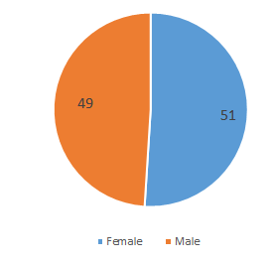
Figure 1. Student’s gender.
Figure 1 presents the gender distribution of 100 fourth-year English Language students at Quy Nhon University who participated in the survey. The data from the chart shows that the study sample is relatively balanced in terms of gender, specifically: female students account for 51% (51 students) and male students account for 49% (49 students).

4.1.1.2 English writing proficiency assessment

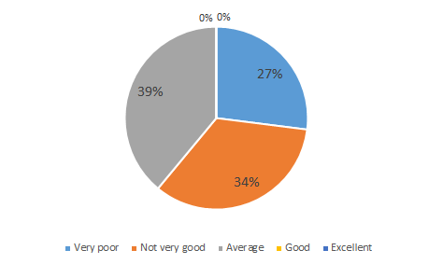

Figure 2. English writing proficiency assessment.

Figure 2 presents the self-assessment results of English writing competence among 100 fourth-year English Language majors at Quy Nhon University who participated in the survey. The data reveal a clear variation in students’ perceptions of their current writing ability. Specifically, the Average level accounts for the largest proportion, representing 39% (39 students). This is followed by the Not very good category, which comprises 34% (34 students), while 27% (27 students) evaluate their writing competence as Good. These findings suggest that although a certain proportion of final-year students have developed a degree of confidence and consider their writing skills to be at a good level, the majority still perceive their competence as average or below average. In fact, the combined percentage of students rating themselves as average or not very good reaches 73%, indicating that writing remains a challenging skill for a considerable number of learners even at the end of their undergraduate program.

4.1.2. Students' Perceptions of Feedback
4.1.2.1 Types of teacher feedback received by students

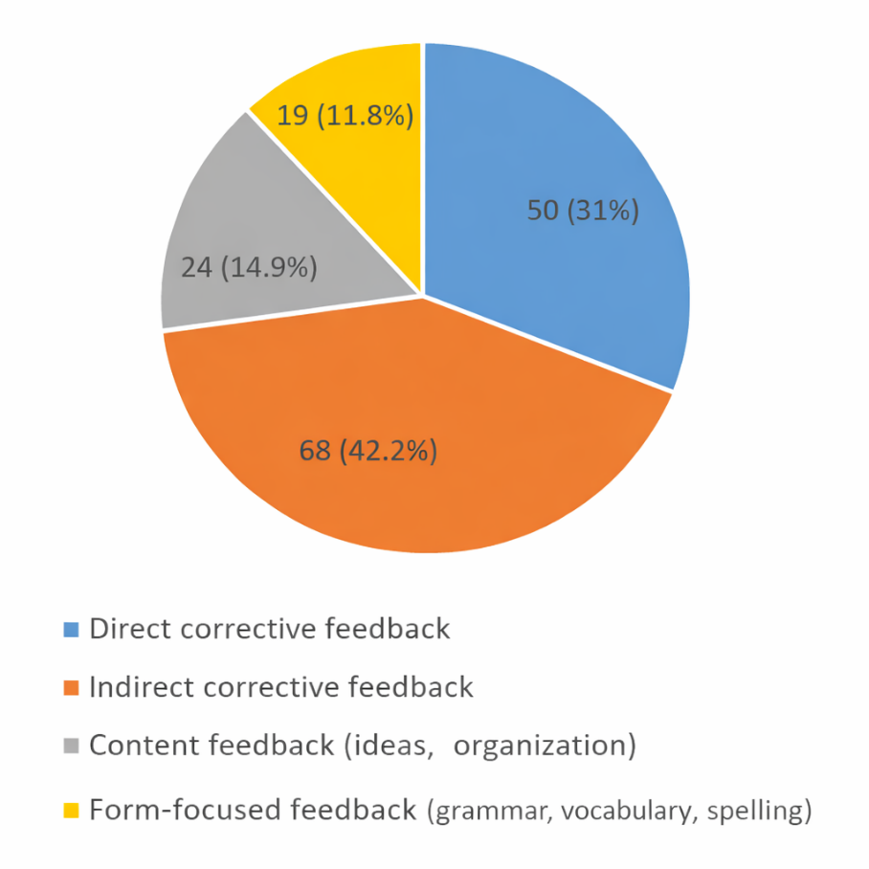
Figure 3. Types of teacher feedback received by students.

Figure 3 presents the distribution of different types of teacher feedback reported by students. Because respondents were allowed to select more than one option, the total number of responses exceeds the number of participants. Indirect corrective feedback accounts for the largest proportion (42.2%, 68 responses), followed by direct corrective feedback (31%, 50 responses). Feedback focusing on content represents 14.9% (24 responses), while form-focused feedback accounts for 11.8% (19 responses).

4.1.2.2. Perception of Feedback's Impact

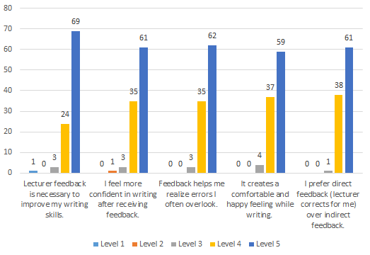
Figure 4. Perception of feedback's impact.
Figure 4 illustrates students’ perceptions of the impact of lecturer feedback on their English writing development. Overall, the results show a strongly positive attitude toward teacher feedback, as the majority of responses fall into Level 4 and Level 5 across all statements. Specifically, for the statement “Lecturer feedback is necessary to improve my writing skills,” 69 students selected Level 5, while 24 chose Level 4, indicating that nearly all participants consider feedback essential for writing improvement. Similarly, regarding confidence, 61 students reported Level 5 and 35 selected Level 4 for the statement “I feel more confident in writing after receiving feedback.” This suggests that feedback not only supports skill development but also enhances learners’ self-assurance. In addition, lecturer feedback was perceived as helpful in identifying errors that students often overlook, with 62 responses at Level 5 and 35 at Level 4. The emotional benefits of feedback were also evident, as 59 students strongly agreed (Level 5) and 37 agreed (Level 4) that feedback creates a comfortable and positive feeling while writing.
Finally, students expressed a preference for direct corrective feedback over indirect feedback, with 61 participants selecting Level 5 and 38 selecting Level 4. Notably, very few respondents chose the lower levels (Level 1–3), confirming that students generally recognize lecturer feedback as a crucial and beneficial factor in improving their writing performance.

4.1.3. Feedback Uptake and Application
4.1.3.1. Frequency of Carefully Reading Feedback from Instructors
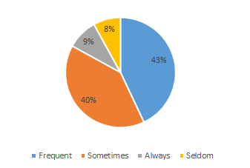
Figure 5. Frequency of carefully reading feedback from instructors.
Figure 5 illustrates the frequency with which students carefully read the feedback provided by their instructors. Overall, the results indicate that most participants pay considerable attention to lecturer feedback, as a large proportion reported reading feedback either frequently or sometimes.
Specifically, 43% of the students stated that they frequently read feedback carefully, representing the largest group in the sample. In addition, 40% reported that they sometimes review feedback in detail. Together, these two categories account for 83% of the responses, suggesting that the majority of fourth-year English majors recognize the importance of teacher feedback in improving their writing performance.
However, only a smaller proportion of students indicated a consistently high level of engagement, with 9% selecting always. Meanwhile, 8% of the participants reported seldom reading feedback carefully. Although this percentage is relatively low, it may imply that a minority of students do not fully utilize feedback as a learning resource. Overall, the findings highlight that while most students demonstrate positive feedback uptake, there remains room to encourage more consistent and thorough engagement with instructor comments.

4.1.3.2. Student Actions After Receiving Feedback

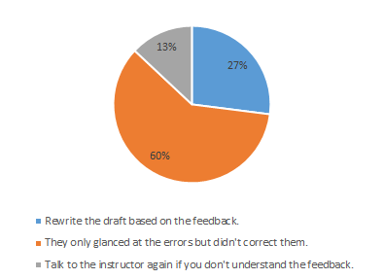
Figure 6. Students’ actions after receiving teacher feedback.

Figure 6 presents students’ actions after receiving feedback from instructors in the writing process. Overall, the findings reveal noticeable differences in how students respond to lecturer comments, ranging from active revision to more passive engagement. The largest proportion of participants (60%) reported that they only glanced at the errors pointed out by instructors but did not make corrections. This suggests that although students may be aware of the feedback provided, many do not fully utilize it to improve their drafts, possibly due to time constraints, limited motivation, or difficulties in applying corrections independently.
In contrast, 27% of the students stated that they rewrite their drafts based on the feedback, indicating a more active approach to revising and learning from teacher input. Additionally, 13% reported that they would talk to the instructor again when they do not understand the feedback. This reflects a smaller yet important group of learners who seek clarification to ensure effective revision.

4.1.3.3. Challenges in Implementing Feedback
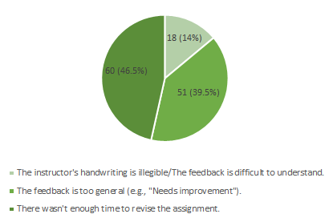
Figure 7. Challenges in implementing feedback.
Figure 7 provides an overview of the difficulties encountered by students when attempting to apply lecturer feedback to their writing revisions. Among the reported challenges, insufficient time to revise assignments emerges as the most dominant issue, with 60 responses (46.5%). Specifically, 51 students (39.5%) indicated that feedback is sometimes too general, such as brief remarks like “Needs improvement,” which may leave learners uncertain about how to make meaningful changes.
Furthermore, 18 participants (14%) pointed out that the instructor’s handwriting is unclear or that the feedback is difficult to interpret.

4.2. Discussion

4.2.1. Students’ Perceptions of Teacher Feedback
The findings indicate that fourth-year English majors at Quy Nhon University generally hold positive perceptions of lecturer feedback, although emotional reactions may vary. These findings suggest that students clearly recognize the importance of teacher feedback in improving their writing skills. The high level of agreement indicates that feedback plays a significant role in helping learners identify weaknesses and refine their writing. This perception is particularly important for final-year students, as they are required to produce more complex academic writing tasks. These results suggest that students recognize teacher feedback as an essential component of writing development.
This finding is consistent with the perspective of Hyland and Hyland, who argue that teacher feedback functions as an essential mechanism that guides learners in closing the gap between their current writing performance and academic expectations [6]. Similarly, Ferris emphasizes that effective feedback can help learners notice recurring errors and gradually improve their writing accuracy through continuous revision and reflection [8].
Overall, these findings demonstrate that while feedback may create short-term pressure, students tend to perceive it as valuable and supportive in the long term, especially as they approach graduation and academic writing demands become more serious.
4.2.2 Feedback Impact on Writing Skills
The findings of this study highlight the important role of lecturer feedback in supporting the writing development of EFL students. Students generally perceive feedback as a valuable resource that helps them identify common linguistic errors and improve the quality of their written work. Through lecturer comments, learners become more aware of grammatical problems, vocabulary limitations, and organizational weaknesses that may otherwise go unnoticed.
In addition to its corrective function, feedback also appears to influence students’ confidence in writing. Constructive comments from lecturers can create a more supportive learning environment, encouraging students to express their ideas more freely and engage more actively in the writing process. This suggests that feedback not only contributes to linguistic accuracy but also plays an important psychological role in reducing students’ anxiety when producing academic texts.
The predominance of indirect feedback is particularly noteworthy. According to Ferris and Roberts, indirect feedback encourages learners to engage in deeper cognitive processing because students must actively identify and correct their own errors [12]. This process promotes greater learner autonomy and helps students develop long-term self-editing abilities. Therefore, the preference for indirect feedback observed in this study suggests that lecturers may intentionally encourage students to become more independent writers.
The findings also indicate that lecturers tend to rely on corrective feedback strategies when responding to students’ writing. Such practices reflect a pedagogical emphasis on language accuracy and error reduction, which remains an important objective in EFL contexts such as Vietnamese universities. In particular, the use of indirect feedback may encourage students to participate more actively in the revision process, prompting them to reflect on their mistakes and engage in self-correction. This process can help learners develop independent editing skills that are essential for completing more advanced academic writing tasks, including graduation theses.
4.2.3. Factors Influencing Engagement
Although students acknowledge the value of lecturer feedback, their actual engagement with this feedback is influenced by several practical and contextual factors. Many students report that they read the comments provided by their lecturers; however, this does not always lead to active revision of their writing. This gap between awareness and action suggests that feedback is sometimes received passively rather than being fully integrated into the revision process.
This phenomenon has also been observed in previous research on written corrective feedback. Ferris notes that although students generally appreciate teacher comments, they do not always apply them effectively during revision, especially when time or motivation is limited [8].
One major factor affecting students’ engagement is the limited time available for revising assignments. Heavy academic workloads and tight submission deadlines may prevent students from carefully reviewing lecturer comments and applying them to improve their drafts. Without sufficient time for reflection and rewriting, the feedback process becomes less effective, and opportunities for deeper learning may be lost.
Another challenge relates to the clarity and specificity of feedback. Some students perceive certain comments as too general or lacking detailed guidance. When feedback does not clearly explain how to improve a specific aspect of writing, students may feel uncertain about how to revise their work effectively. As a result, they may ignore or only partially address the comments provided. These findings highlight the importance of providing clear, specific, and actionable feedback that guides students toward meaningful revisions.
5. CONCLUSION
This study investigated the effects of teacher feedback on the learning of English writing among fourth-year English Language majors at Quy Nhon University. By combining quantitative data from questionnaires with qualitative insights from focus group discussions, the research provides a comprehensive understanding of students’ perceptions, attitudes, and engagement with lecturer feedback in academic writing courses.
Overall, the findings indicate that teacher feedback is widely perceived as necessary and beneficial for improving writing performance. Most students reported positive attitudes toward feedback, recognizing its role in increasing confidence, identifying errors, and supporting writing development. In particular, indirect and direct corrective feedback were the most frequently received forms, suggesting that lecturers mainly emphasize error correction to help students revise their written work.
However, the study also reveals that feedback uptake does not always result in active revision. Although many students stated that they read feedback carefully, a large proportion admitted that they only glanced at teacher comments without making corrections. The challenges in implementing feedback were largely related to limited time for revision, vague or general remarks, and difficulties in interpreting handwritten comments. These barriers may reduce the effectiveness of feedback and prevent students from fully benefiting from instructor guidance.
In conclusion, teacher feedback plays an essential role in supporting fourth-year students’ writing development, yet its impact depends not only on the feedback provided but also on students’ ability and willingness to engage with it. Therefore, improving the clarity, specificity, and practicality of feedback, along with encouraging more active student revision practices, may enhance the overall effectiveness of feedback in university writing instruction.
Limitations and Future Research
Despite the contributions of this study, several limitations should be acknowledged. First, the participants were limited to fourth-year English majors at Quy Nhon University, which may limit the generalizability of the findings to other academic contexts or student populations. Since the research was conducted within a single institutional setting, the results may reflect specific teaching practices and learning environments that may not represent other universities.
In addition, the study relied primarily on self-reported data collected through questionnaires and focus group discussions. While these methods provide useful insights into students’ perceptions, they may not fully capture how students actually apply feedback in their writing revision process. Future research could involve larger and more diverse samples from multiple institutions and employ additional methods such as classroom observations or analysis of students’ revised drafts to better examine the long-term effects of teacher feedback on writing development.
Conflict of interest
The author(s) declare no competing interests.

REFERENCES
[1] K. Hyland, Second Language Writing, 2nd ed. New York: Cambridge University Press, 2019.
[2] D. Crystal, English as a Global Language, 2nd ed. New York: Cambridge University Press, 2003.
[3]J. Harmer, The Practice of English Language Teaching, 4th ed. London: Pearson Longman, 2007.
[4] D. Little, “Language learner autonomy: Some fundamental considerations revisited,” Innovation in Language Learning and Teaching, vol. 1, no. 1, pp. 14–29, 2007.
[5] Z. Dörnyei, Motivational Strategies in the Language Classroom. New York: Cambridge University Press, 2001.
[6] K. Hyland and F. Hyland. Feedback in Second Language Writing: Contexts and Issues, Cambridge University Press, New York, 2006.
[7] L. S. Vygotsky, Mind in Society: The Development of Higher Psychological Processes. Cambridge, MA: Harvard University Press, 1978.
[8] D. R. Ferris, Response to Student Writing: Implications for Second Language Students. Mahwah, NJ: Lawrence Erlbaum Associates, 2003.
[9] J. Bitchener and D. R. Ferris, Written Corrective Feedback in Second Language Acquisition and Writing. New York: Routledge, 2012.
[10] J. Bitchener and U. Knoch, “The contribution of written corrective feedback to language development: A ten-month investigation,” Applied Linguistics, vol. 31, no. 2, pp. 193–214, 2010.
[11] D. R. Ferris, “Does error feedback help student writers? New evidence on the short- and long-term effects of written error correction,” in Feedback in Second Language Writing: Contexts and Issues, K. Hyland and F. Hyland, Eds. New York: Cambridge University Press, 2006, pp. 81-104.
[12] D. R. Ferris and B. Roberts, “Error feedback in L2 writing classes: How explicit does it need to be?” Journal of Second Language Writing, vol. 10, no. 3, pp. 161–184, 2001.
[13] J. F. Lalande, “Reducing composition errors: An experiment,” The Modern Language Journal, vol. 66, no. 2, pp. 140–149, 1982.
[14] J. Bitchener, “Evidence in support of written corrective feedback,” Journal of Second Language Writing, vol. 17, no. 2, pp. 102–118, 2008.
[15] I. Lee, Classroom Writing Assessment and Feedback in L2 School Contexts. Singapore: Springer, 2017.
[16] D. R. Ferris, Treatment of Error in Second Language Student Writing, 2nd ed. Ann Arbor, MI: University of Michigan Press, 2011.
[17] S. A. Kadir, N. I. Adnan, and P. Abdull, “Gender differences in Twitter complaints,” Journal of Humanities and Social Sciences, vol. 3, no. 1, pp. 15–28, 2021.
[18] T. M. Nguyen, “Challenges in teaching academic writing to EFL students in Vietnamese universities,” Journal of Language and Life, vol. 5, no. 2, pp. 45–58, 2020.
[19] J. W. Creswell and J. D. Creswell, Research Design: Qualitative, Quantitative, and Mixed Methods Approaches, 5th ed. Los Angeles, CA: SAGE Publications, 2018.
[20] Z. Dörnyei and T. Taguchi, Questionnaires in Second Language Research: Construction, Administration, and Processing, 2nd ed. New York: Routledge, 2009.
[21] S. Vaughn, J. S. Schumm, and J. Sinagub, Focus Group Interviews in Education and Psychology. Thousand Oaks, CA: SAGE Publications, 1996.
[22] D. L. Morgan, Focus Groups as Qualitative Research, 2nd ed. Thousand Oaks, CA: SAGE Publications, 1997.

Ảnh hưởng của phản hồi từ giảng viên đối với sự phát triển kỹ năng viết tiếng Anh của sinh viên năm thứ tư chuyên ngành tiếng Anh tại Trường Đại học Quy Nhơn

Nguyễn Trần Yến Nhi*, Lê Nhân Thành

Khoa Ngoại ngữ, Trường Đại học Quy Nhơn, Bình Định, Việt Nam

*Tác giả liên hệ chính. Email: nhi4557510172@st.qnu.edu.vn

TÓM TẮT
Nghiên cứu này khảo sát ảnh hưởng của phản hồi từ giảng viên đối với kỹ năng viết tiếng Anh của sinh viên năm thứ tư ngành Ngôn ngữ Anh tại Đại học Quy Nhơn. Cụ thể, đề tài đánh giá mức độ cải thiện của phản hồi tới tính chính xác ngữ pháp, sự mạch lạc và khả năng hoàn thành văn bản, đồng thời so sánh hiệu quả giữa phản hồi trực tiếp và gián tiếp. Bằng phương pháp nghiên cứu hỗn hợp, tác giả đã thu thập dữ liệu định lượng từ 100 sinh viên qua phiếu khảo sát và dữ liệu định tính thông qua phỏng vấn sâu giảng viên cùng sinh viên. Kết quả chỉ ra rằng hầu hết sinh viên đều coi trọng phản hồi của giảng viên như một yếu tố then chốt để phát triển kỹ năng; trong đó, những phản hồi kịp thời và mang tính xây dựng giúp sinh viên tự tin hơn khi chỉnh sửa bài viết. Tuy nhiên, một bộ phận sinh viên vẫn gặp rào cản trong việc tiếp nhận và áp dụng các góp ý này. Dù còn hạn chế về quy mô khảo sát tại một đơn vị đơn lẻ, nghiên cứu đã đề xuất các hàm ý sư phạm thiết thực và gợi mở hướng nghiên cứu dài hạn về tác động của phản hồi đối với năng lực viết chuyên sâu.
Keywords: phản hồi từ giảng viên, kỹ năng viết tiếng Anh, sinh viên năm thứ tư chuyên ngành tiếng Anh, phát triển kỹ năng viết.

