Personalized Product Recommendation Model Using a Parallel Hybrid Coati–Kepler Algorithm

Hua Vinh Khang, Ho Nguyen Linh Chi,
Nguyen Thi Ngoc, Nguyen The Huu, Dinh Nguyen Trong Nghia *

Faculty of Information Technology, Ho Chi Minh City University of Industry and Trade, Vietnam

* Corresponding author. Email: nghiadnt@huit.edu.vn

Received: dd/mm/yyyy; Revised: dd/mm/yyyy;
Accepted: dd/mm/yyyy; Published: dd/mm/yyyy

ABSTRACT
This study proposes a parallel hybrid co-evolutionary optimization model integrating the Coati Optimization Algorithm (COA) and the Kepler Optimization Algorithm (KOA) to address premature convergence in product recommender systems. By deploying a parallel population topology where COA and KOA evolve simultaneously in logically independent subpopulations, the model synergizes local exploitation with global exploration. This architecture aims to optimize a complex multi-objective function balancing user relevance, commercial incentives, and stock constraints. The framework was evaluated on the Amazon Product Reviews dataset and benchmarked against Genetic Algorithm (GA), Particle Swarm Optimization (PSO), and Ant Colony Optimization (ACO). Experimental results demonstrate that the parallel hybrid approach achieves superior solution quality and enhanced convergence stability compared to both constituent and traditional metaheuristic algorithms. Furthermore, rigorous statistical analysis confirms the significance of these performance improvements, supporting the model’s stable and consistent optimization performance for solving constrained problems in offline recommender pipelines.
Keywords: Coati Optimization Algorithm (COA), Kepler Optimization Algorithm (KOA), metaheuristic optimization, recommender system, e-commerce.

1. PROBLEM STATEMENT
In the digital era, e-commerce has experienced rapid growth, accompanied by an increasing demand for personalized shopping experiences through product recommendation systems.^{1,2} These systems play a crucial role in helping users identify suitable products while supporting businesses in improving operational efficiency.
However, traditional algorithms such as Genetic Algorithm (GA)³, Particle Swarm Optimization (PSO)⁴, and Ant Colony Optimization (ACO)⁵ although effectively applied to parameter optimization in recommendation systems still exhibit several limitations in terms of convergence speed, accuracy, and scalability to large-scale data.⁶ These shortcomings often cause the models to suffer from premature convergence and limit their ability to effectively explore promising regions within complex search spaces.
In response to these challenges, next-generation metaheuristic algorithms have been introduced as a promising research direction. Among them, COA and KOA stand out due to their ability to simulate natural behaviors to balance local exploitation and global exploration. COA reproduces the cooperative hunting and survival behaviors of coatis, providing strong local exploitation capabilities in promising regions; meanwhile, KOA is inspired by Kepler’s laws of planetary motion and demonstrates high effectiveness in maintaining global search ability and avoiding local optima.
In addition, several studies have applied metaheuristic approaches to recommendation systems, such as models using the Grey Wolf Optimizer (GWO) combined with Fuzzy C-Means to optimize user and product clustering,⁷ or deep hybrid recommender systems based on autoencoders and collaborative filtering.² Although encouraging results have been reported, these models have not yet fully exploited the synergistic potential of bio-inspired algorithms in nonlinear optimization.
Based on these premises, this study proposes a hybrid COA–KOA model that integrates the strong local exploitation capability of COA with the superior global exploration ability of KOA, aiming to enhance performance and accuracy in product recommendation system optimization. The proposed model was experimentally evaluated on real-world recommendation datasets to verify its optimization capability in comparison with traditional algorithms.
The main contributions of this study are as follows: (1) a hybrid COA–KOA optimization model is proposed for the product recommendation problem; (2) the convergence behavior and stability of the proposed model are analyzed in comparison with single metaheuristic algorithms; and (3) experimental performance is evaluated in terms of accuracy and optimization speed, thereby clarifying the application potential of hybrid models in intelligent recommendation systems.
2. CONTENT
2.1. Coati Optimization Algorithm (COA)
The Coati Optimization Algorithm (COA) models survival strategies through two primary phases: exploration and exploitation. The optimization initiates with a population of N candidate solutions $X = \left\{X_{1}, X_{2}, ..., X_{N}\right\}$ randomly distributed in an m-dimensional space bounded by $\left[lb_{j}, ub_{j}\right]$. The initial positions are determined using the following equation:
$$x_{i,j} = lb_{j} + r⋅ \left(ub_{j} - lb_{j}\right)$$
Where $lb_{j}$ and $ub_{j}$ denote the lower and upper bounds of the $j$-th dimension, and$r∈ [0,1]$ is a random number.
2.1.1. Phase 1: Exploration
his phase simulates hunting behavior to explore the search space. The population is divided into two halves. The first half (1 to $\frac{N}{2}$) updates positions by approaching the current best individual (denoted as $Igua$):
$X_{i}^{P1} :x_{i,j}^{p1}$= $x_{I,j}+r∙\left( {Igua}_{j}-I ·x_{I,j} \right)$
$$\begin{aligned} i=1,2, …, \left\lfloor \frac{N}{2} \right\rfloor , j=1, 2, …,m\#\left(2\right)\end{aligned}$$
where $I∈ \left\{1, 2\right\}$ is a random factor representing movement variability.
The second half ($\frac{N}{2}+ 1 to N$) reacts to a random position ($Igua^{G}$). If the fitness of $Igua^{G}$ is superior to the current position, the individual moves towards it; otherwise, it diverges to search elsewhere . This mechanism is defined as:
$$\begin{aligned}X_{i}^{P1}: {x }_{i,j}^{P1}\left\{\begin{aligned} x_{i,j}+r· \left( {Igua}_{j}^{G} -I ·x_{i,j }\right), \\ F_{{Igua}^{G}}< F_{i} \\ x_{i,j}+ r·\left(x_{i,j}- {Igua}_{j}^{G}\right), \\ otherwise\end{aligned}\right.\#\left(3\right)\end{aligned}$$
A greedy selection mechanism is applied post-update, retaining the new position $X_{i}^{P1}$ only if it improves the objective function value.
2.1.2. Phase 2: Exploitation
To refine solutions, individuals perform a local search within a dynamically shrinking neighborhood $\left[lb_{j}^{local}, ub_{j}^{local}\right]$. The position is updated as follows:
$$X_{i}^{P2} : x_{i,j}^{P2}=x_{i,j}+\left(1-2r\right)∙\left({lb}_{j}^{local}+r∙\left({ub}_{j}^{local}-{lb}_{j}^{local}\right)\right)$$
$$\begin{aligned}i=1,2,…,N ;j=1,2,…,m\#\left(4\right)\end{aligned}$$
Similar to the previous phase, the algorithm retains the solution with the better fitness value for the next iteration.
2.2. Kepler Optimization Algorithm (KOA)
The Kepler Optimization Algorithm (KOA) simulates planetary physics to update candidate solutions. Each individual (planet) is defined by its position, velocity, orbital eccentricity ($e_{i}∈ \left[0,1\right]$), and orbital period ($T_{i}$). Similar to COA, the initial positions of the population are generated using Equation 1. However, to establish orbital dynamics, KOA additionally assigns $e_{i}$ randomly and $T_{i}$ based on a normal distribution:
2.2.1. Phase 1: Orbital Motion
This phase simulates the motion of planets revolving around the sun (the global best solution G). The velocity and position are updated based on gravitational force and inertia, as follows:
$$\begin{aligned}v_{i}^{t+1}=ω∙v_{i}^{t}+ϕ_{1}∙r_{1}∙\left(P_{i}-X_{i}^{t}\right) \\ +ϕ_{2}∙r_{2}∙\left(G-X_{i}^{t}\right)\#\left(5\right)\end{aligned}$$
$$\begin{aligned}X_{i}\left(t+1\right)=X_{i}\left(t\right)+v_{i}\left(t+1\right)\#\left(6\right)\end{aligned}$$
Where $ω$ is the inertia weight, $P_{i}$ denotes the personal best position, $ϕ_{1}, ϕ_{2}$ are acceleration coefficients, and $r_{1}, r_{2}∈ \left[0,1\right]$ are random variables.
2.2.2. Phase 2 Eccentricity Mechanism
This mechanism serves as a refinement strategy to balance exploration and exploitation based on the orbital eccentricity $e_{i}$:
$$\begin{aligned}X_{i}^{new}=X_{i}+e_{i}∙rand\left[0,1\right]∙\left(X_{i}-G\right)\#\left(7\right)\end{aligned}$$
The orbital eccentricity $e_{i}$​ acts as a stochastic control parameter: a large value of e_{i} promotes exploration of distant regions, whereas a small value of e_{i} encourages exploitation in the neighborhood of the best solution.
2.3. Hybrid COA-KOA algorithm
2.3.1. Hybrid Architecture and Rationale for Selection
This study proposes a Parallel Hybrid Co-evolutionary Architecture based on the island model topology, designed to fully exploit the complementary strengths of both algorithms through a logically simultaneous evolution strategy. The selection of COA and KOA is grounded in the principle of algorithmic orthogonality, distinguishing this approach from traditional hybrids that combine homologous bio-inspired methods with similar convergence biases. In this framework, the Coati Optimization Algorithm (COA) operates on the first sub-population to provide a bio-inspired exploitation mechanism; by simulating the deterministic "Iguana-hunting" strategy, it intensively refines solutions within promising regions to ensure precision. Concurrently, the Kepler Optimization Algorithm (KOA) governs the second sub-population as a physics-inspired exploration mechanism. By applying stochastic orbital dynamics and eccentricity adjustments, KOA introduces high-trajectory variance to the search process. This integration of directed biological instincts with stochastic physical laws creates a synergistic balance, effectively preventing the system from stagnating in local optima while maintaining population diversity throughout the evolutionary cycle.
2.3.2. Information exchange and collaborative methods
Parallel information exchange: To ensure population diversity and allow the subpopulations to independently develop distinct characteristics, the exchange mechanism is not performed continuously but is activated periodically after every k iterations (with k=3 in this study). At each exchange stage, the COA and KOA populations perform a parallel sharing of elite individuals to disseminate global optimal information throughout the entire system. Specifically, the solutions with the highest fitness values from each algorithm are shared and inserted into the population of the other algorithm. As a result, COA can benefit from the effective global search guidance of KOA, while KOA can learn from the strong local exploitation capability of COA. This mechanism enables the two algorithms to complement each other, simultaneously preventing premature convergence and accelerating the evolutionary process toward the global optimum.
Parallel hybrid integration: This approach allows the COA–KOA model to maintain a dynamic balance between exploitation and exploration within the search space, ensuring a high convergence speed while preserving population diversity. The synchronized information exchange facilitates the rapid propagation of promising individuals across the population, thereby enhancing the adaptability of the algorithm to nonlinear and multimodal objective function landscapes. Consequently, the hybrid model demonstrates superior performance in complex optimization problems, where both high solution quality and stable, robust convergence are required.
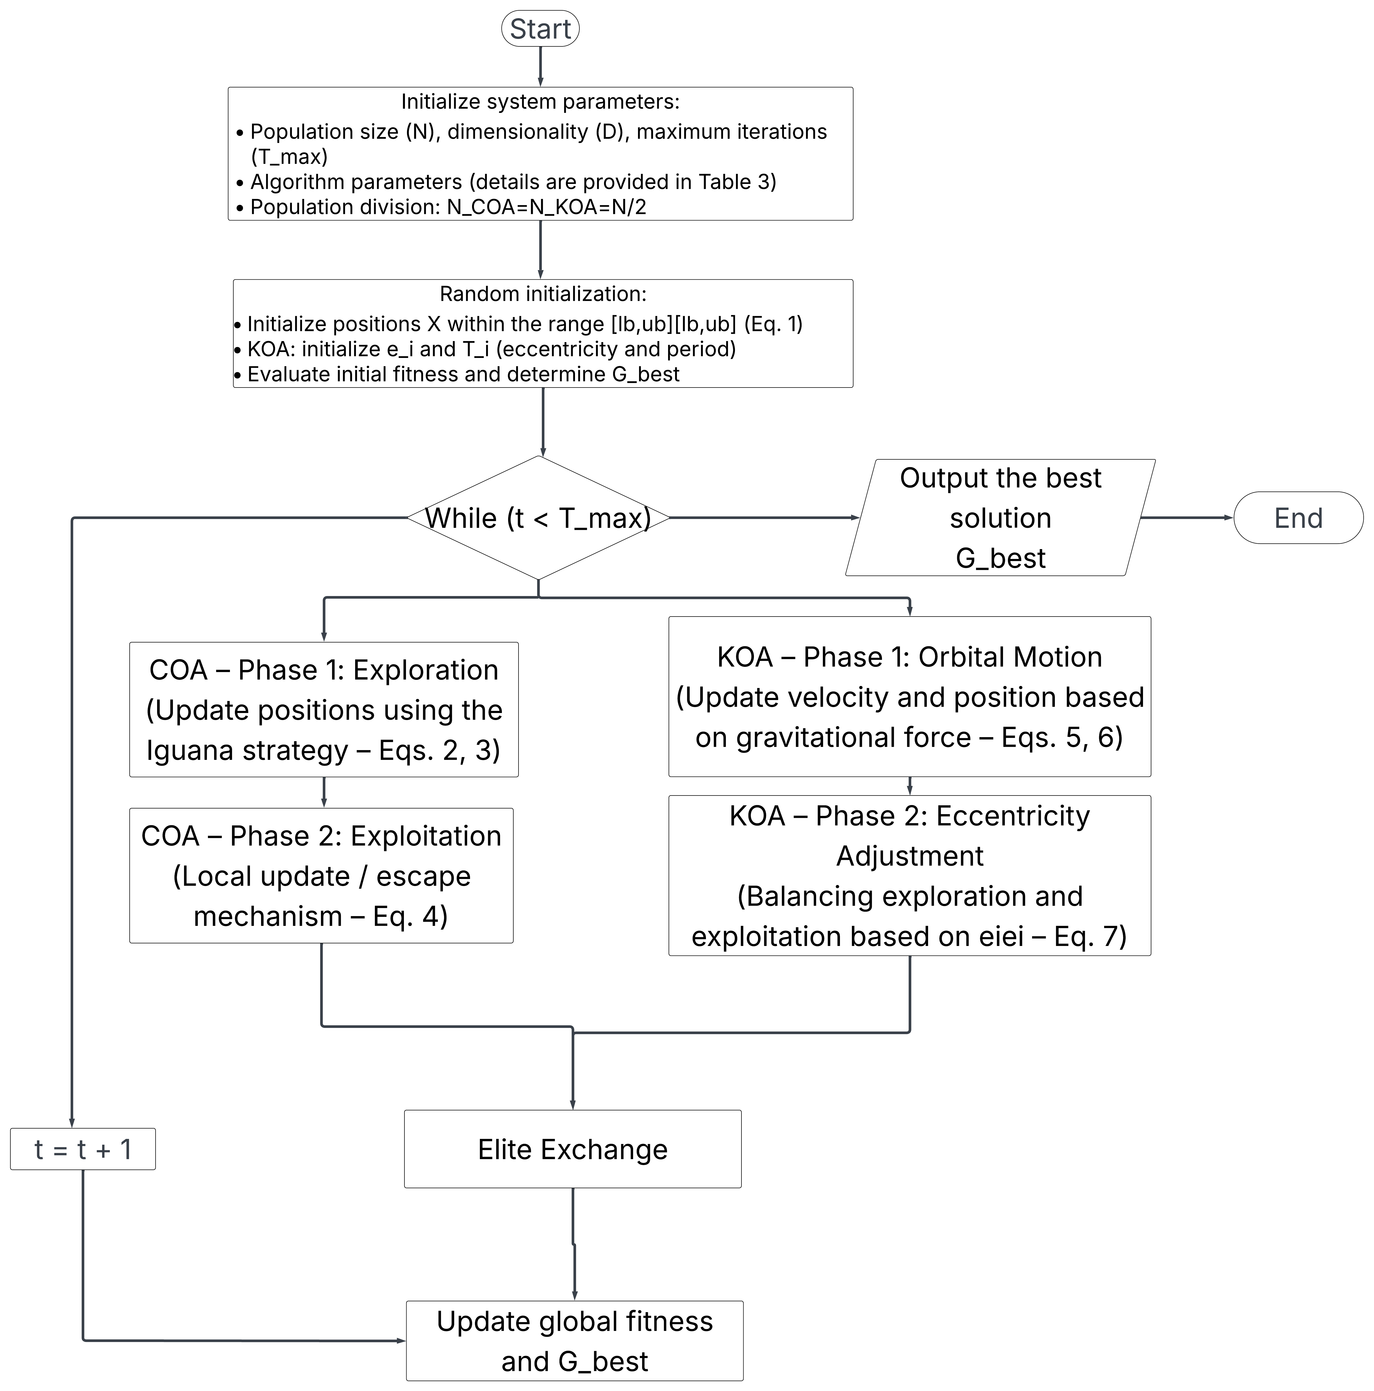
Figure 1. COA-KOA algorithm flowchart
2.4. Product recommendation model
2.4.1. Defining the problem and representing the data
The personalized product recommendation optimization problem is formulated based on two fundamental datasets: the product set P and the user interaction event set E. Each product $p∈ P$ is characterized by identification attributes and category information, while user data are modeled as sequences of behavioral events over time.
To quantify user interest, this study establishes a weighting mechanism $w_{e}$ for each type of interaction event, reflecting increasing levels of preference: product view (w = 2), related search (w = 4), add to favorites (w = 15), add to cart (w = 30) and purchase (w = 60). The cumulative scores derived from these weights are used to construct the user preference feature vector $u = (u_{1}, u_{2}, …, u_{n})$, where $u_{i}$ represents the degree of interest in the iii-th product category. To reduce the search space and focus on practical user demand, only the priority category groups accounting for at least 80% of the total accumulated score are extracted and used as input for the hybrid optimization algorithm.
2.4.2. Problem modeling
From a mathematical perspective, the problem can be modeled as follows. Let $P=\left\{p_{1},p_{2},…,p_{m}\right\}$ denote the set of all products in the system, and let $U=\left\{u_{1},u_{2},…,u_{n}\right\}$ represent the user preference vector, in which each element $u_{i}$ indicates the user’s level of interest in the i-th product category.
The objective is to identify a subset $R⊆ P$ consisting of k products such that the fitness function $f\left(R,U\right)$ attains its maximum value, reflecting the degree of relevance between the recommended products and the user’s preferences:
$$\max{f\left(R,U\right)}$$
Where $f\left(R,U\right)$ is defined based on criteria such as similarity, diversity, and the user’s accumulated preference score for each product.
Each solution (or individual) in the search space represents a product recommendation scheme and is described by the vector:
$$X=\left\{x_{1},x_{2},…,x_{d}\right\}$$
Where each element $x_{i}$ corresponds to a selected product in the recommendation list, and the vector dimension d = k represents the number of products recommended to the user.
2.4.3. Modeling of adaptive functions and optimization criteria
To evaluate recommendation quality, a fitness function $F(X)$ is constructed to balance user relevance maximization and constraint minimization. The maximization component integrates three core benefits: Similarity ($sim$) representing the relevance between product features and user profiles; Discount reflecting price incentives; and Popularity based on community ratings. Conversely, the function applies penalties for Diversity regulation $\left(P_{div}\right)$ to mitigate redundancy (Eq. 8) and Supply capacity $(P_{cap})$ to filter out-of-stock items (Eq. 9):
2.5. Performance Evaluation on Benchmark Functions
Prior to application in real-world product recommendation problems, the optimization capability of the hybrid COA-KOA algorithm required verification on standardized mathematical problems. This section details the environmental setup and analyzes the algorithm's efficiency on a set of 9 benchmark functions (F1–F9).
2.5.1. Experimental Setup and Objective Functions
To perform a comprehensive and objective evaluation of the proposed hybrid algorithm's performance, a set of 9 benchmark functions classified into two characteristic groups was utilized to verify different aspects of the optimization process. Specifically, the group of unimodal functions (denoted as F1–F7), possessing a single global optimum, was used to measure convergence speed and precise exploitation capability. Conversely, the group of multimodal functions (denoted as F8–F9) possesses complex surface structures with multiple local optima, serving as a measure of exploration capability and the ability to escape local optimum traps. Details regarding the mathematical formulas and search ranges for each function are presented in Table 1.¹¹
Experiments were conducted on an Intel Core i7-1165G7, 64GB RAM, Python 3.12 environment.. To ensure fairness in comparison, the algorithms (including COA-KOA, COA, and KOA) strictly adhered to the same initialization mechanism and operational parameter settings: a fixed population size of $N = 50$ and a maximum number of iterations of $T_{max} = 1000$. Notably, the experiments were conducted in parallel on two different dimensional spaces: $D=30$ and $D=100$. Expanding the experiment to the 100-dimensional space served as a critical verification step to assess scalability and performance stability when addressing problems with substantially higher computational complexity than the baseline setting.

Table 1. Mathematical formulas of experimental benchmark functions

Function | Formula | Range | Dimension
F1 | $$f\left(x\right)=\sum_{i=1}^{n}{x_{i}^{2}}$$ | [-5, 5] | 30, 100
F2 | $$f\left(x\right)=\sum_{i=1}^{n}{\left|x_{i}\right|}+\prod_{i=1}^{n}{\left|x_{i}\right|}$$ | [-10,10] | 30, 100
F3 | $$f\left(x\right)=\sum_{i=1}^{n}{{(\sum_{j=1}^{i}{x_{j}})}^{2}}$$ | [-100, 100] | 30, 100
F4 | $$f\left(x\right)=\max_{1≤i≤n}\left|x_{i}\right|$$ | [-100, 100] | 30, 100
F5 | $$f\left(x\right)=\sum_{i=1}^{n}{{\left|x_{i}\right|}^{i}}$$ | [-2, 2] | 30, 100
F6 | $$f\left(x\right)=\sum_{i=1}^{n}{i.x_{i}^{2}}$$ | [-100, 100] | 30, 100
F7 | $$f\left(x\right)=\sum_{i=1}^{n}{(x_{i}^{2}+\frac{D}{2}×}x_{i}^{2}+\frac{D}{2}×x_{i}^{4}$$ | [-100, 100] | 30, 100
F8 | $$f\left(x\right)=-20exp-0.2\sqrt{\frac{1}{n}\sum{x_{i}^{2}}}-exp\frac{1}{n}\sum{cos2πx_{i}}+20+exp1$$ | [-32, 32] | 30, 100
F9 | $$f\left(x\right)=\sum_{i=1}^{n}{\left|x_{i}.\sin\left(x_{i}\right)+0.1x_{i}\right|}$$ | [-100, 100] | 30, 100
2.5.2. Results and Discussion
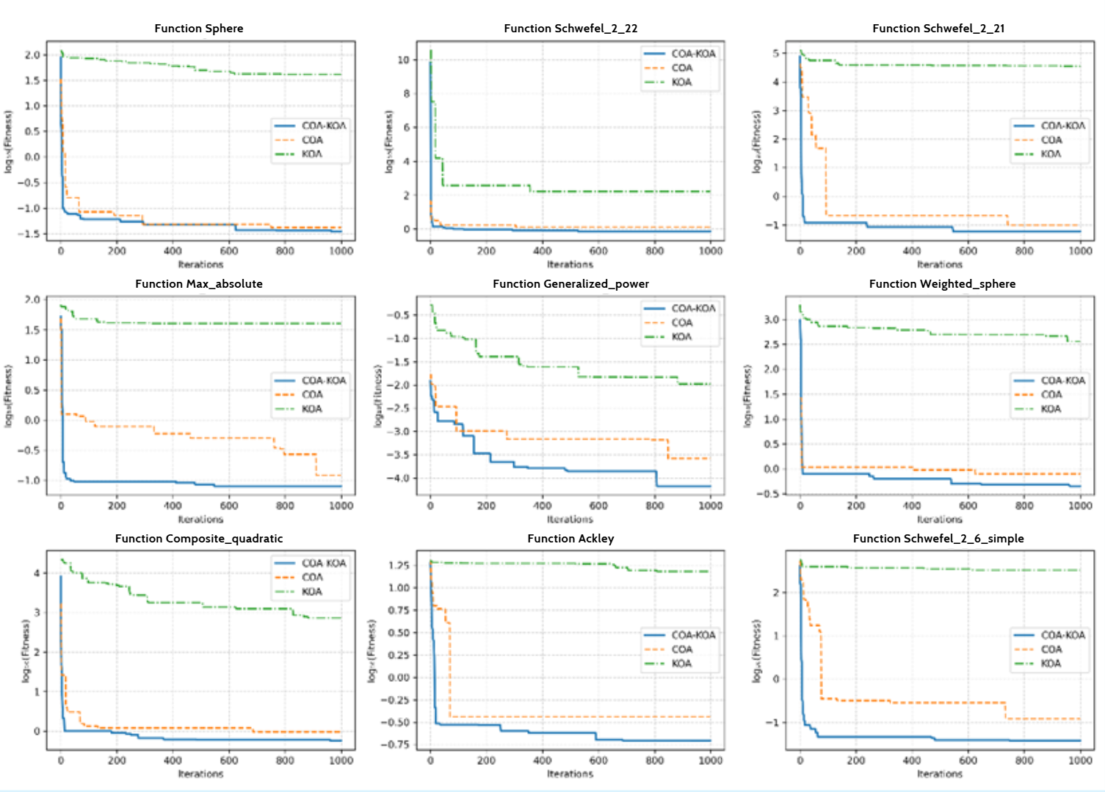
Figure 2. Experimental results with 30 dimensions

Figure 2 illustrates the comparison of convergence capabilities among the three algorithms—COA-KOA, COA, and KOA—on nine benchmark functions (F1–F9) in a 30-dimensional space. It can be observed that the hybrid COA-KOA algorithm consistently demonstrates superior optimization capability in terms of both convergence speed and the achieved log-fitness value compared to the two original algorithms. For functions F1, F2, and F3, COA-KOA rapidly reduces log-fitness to the lowest level after approximately 100 iterations, whereas COA and KOA converge more slowly and tend to fluctuate around higher values. For functions F4, F5, and F6, COA-KOA maintains a fast and stable convergence rate, avoiding the phenomenon of being trapped in local optima often encountered by the single algorithms. Notably, in functions with complex structures such as F7, F8, and F9, the hybrid algorithm retains high optimization efficiency, achieving the lowest log-fitness and converging steadily throughout the testing process. Overall, these results confirm that the combination of KOA's search space exploration and COA's local exploitation enabled COA-KOA to achieve an effective balance between exploration and exploitation, thereby not only improving the quality of the optimal solution but also ensuring stability in convergence. This performance indicates the strong potential of COA-KOA for application in multi-dimensional optimization problems and large-scale data.

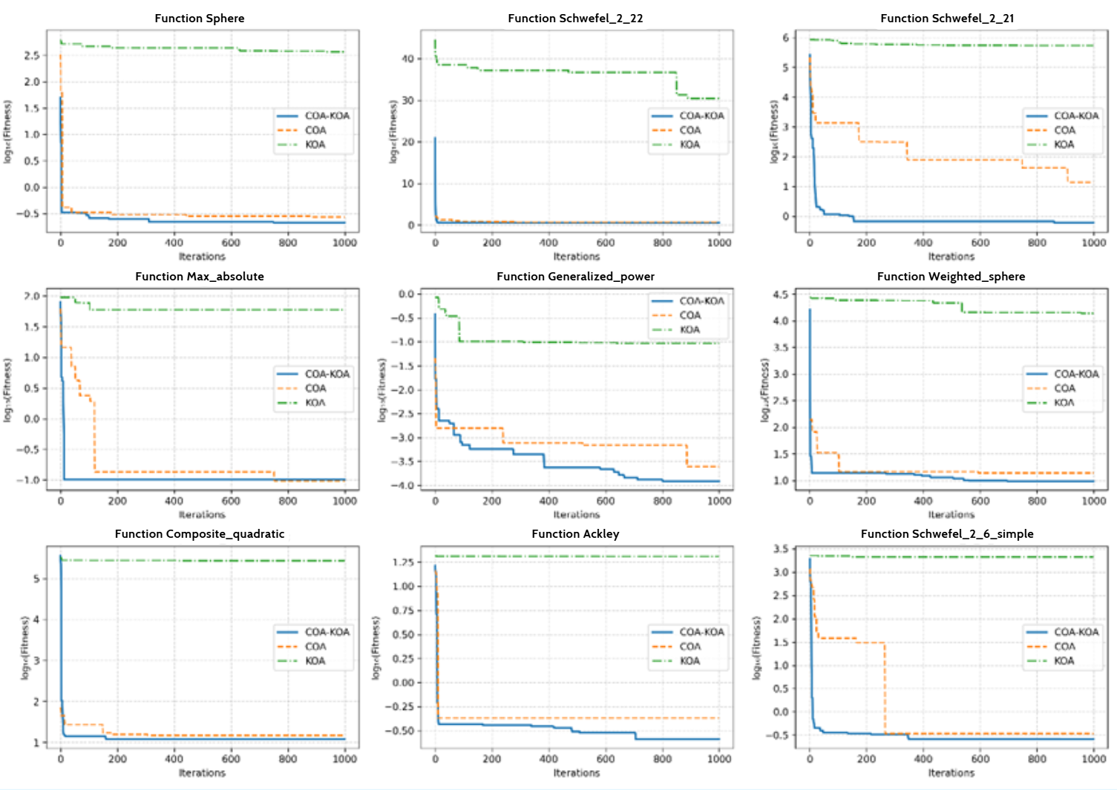
Figure 3. Experimental results with 100 dimensions
Figure 3 illustrates the comparison of convergence capabilities among the three algorithms—COA-KOA, COA, and KOA—on nine benchmark functions (F1–F9) in a 100-dimensional space. Observations indicate that as the number of dimensions increases, the efficiency of the hybrid COA-KOA algorithm is maintained stably and becomes even more pronounced compared to the two original algorithms. For functions F1, F2, and F3, COA-KOA achieves the lowest log-fitness value and converges rapidly after only about 100–200 iterations, while COA, and particularly KOA, tend to decrease more slowly and stop early at higher fitness levels. For functions F4, F5, and F6, the convergence curve of COA-KOA drops sharply in the initial phase and quickly stabilizes, demonstrating the ability to exploit the optimal solution even when the search space expands significantly. For complex functions such as F7, F8, and F9, the hybrid algorithm continues to affirm its advantage by achieving the smallest log-fitness value while maintaining stability throughout the testing process, whereas COA improves only moderately and KOA shows clear signs of inefficiency. In summary, when the number of dimensions increases to 100, COA-KOA maintains the balance between exploration and exploitation, facilitating rapid convergence without compromising accuracy. This proves that the hybrid model not only adapts well to high-complexity problems but also ensures scalability, serving as a potential basis for application to large-scale real-world optimization problems.
2.6. Experiment on Recommender Problem
2.6.1. Data and Preprocessing
The experiment in this study was conducted to evaluate the effectiveness of the product recommendation model based on the Hybrid COA-KOA algorithm. The dataset used was Amazon Product Reviews, comprising 1,464 users and product data records. Each record contains multi-dimensional descriptive attributes of the product, including: product ID, product name, category, price, discount rate, rating score, number of product reviews, and stock quantity. Data was preprocessed by removing duplicate records, normalizing text, and encoding categorical attributes to ensure consistency.
2.6.2. Model Setup and Parameters
In the multi-criteria recommendation problem, defining weights plays a role in orienting the search space. Instead of focusing on optimizing weight parameters (which falls under the scope of Multi-objective Optimization), this study established a fixed evaluation scenario based on recommendations from pioneering works in the field.^{12,13}
Specifically, the weight set was configured as follows: the coefficient $α = 0.4$ was given the highest priority to emphasize personalization (similarity); the two weights $β = 0.3$ and $γ = 0.3$ were distributed evenly for commercial value and popularity. Fixing this parameter set helps eliminate variations caused by changes in the objective function, thereby ensuring fairness when comparing pure convergence performance and stability between the proposed algorithm (Hybrid COA-KOA) and the control algorithms.
Concurrently, two soft constraints regarding diversity ($P_{div}$) and supply capacity ($P_{cap}$) were integrated with experimental penalty coefficients of $λ =0.1$ and $δ=0.05$.¹⁵ This setup $(λ >δ)$was applied intentionally to address the asymmetry in data scales: while $P_{div}$ (limited to the [0,1] range) requires a sufficiently large weight to create a regulatory impact, $P_{cap}$ (a cumulative integer quantity) requires a smaller scaling factor to prevent excessive distortion of the overall fitness value.
2.6.3. Comparative Experiment Setup
To objectively evaluate the effectiveness of the proposed model, the performance of Hybrid COA-KOA was compared not only with its two component algorithms (COA, KOA) but also with classic meta-heuristic algorithms such as GA, PSO, and ACO. This comparison clarifies the ability to balance local exploitation and global exploration, as well as determining the suitability of Hybrid COA–KOA in relation to other common optimization methods. Specifically, to exclude random factors, each algorithm was executed for 20 independent runs under the same initialization conditions. Based on this dataset, the study applied non-parametric statistical tests, including the Friedman test (to assess overall differences) and the Wilcoxon signed-rank test (for pairwise comparisons) with a statistical significance threshold of 0.05 (corresponding to a 95% confidence level).
2.6.4. Algorithm Parameters and Experimental Configuration
To ensure reproducibility and eliminate hardware-specific latency variations (e.g., thread context switching overhead), all algorithms were deployed in a simulated parallel environment using single-thread execution on an Intel Core i7.
In the context of this study, the term "Parallel" refers to the algorithmic topology (Parallel Population / Island Model), where the COA and KOA sub-populations are logically separated and evolve simultaneously in terms of generation count, exchanging information only at synchronized intervals ($k=3$). This distinction clarifies that the contribution lies in the collaborative parallel strategy of the metaheuristic design, rather than High-Performance Computing (HPC) hardware acceleration.
For the control algorithms (GA, PSO, ACO), operational parameters were kept at standard values recommended in the original works. This approach helped establish an objective baseline, eliminating variations due to subjective parameter tuning, thereby highlighting the self-adaptive capability of the proposed algorithm.^{3,4,5}
The cycle for exchanging elite individuals was determined based on preliminary tests. Observations indicated that small $k$ values (e.g., $k=1$) increased convergence speed but reduced population diversity, while large $k$ values (e.g., $k≥5$) slowed down the information propagation process between sub-populations. Based on the trade-off between convergence speed and solution stability, the value $k=3$ was selected to achieve balanced performance for the hybrid COA–KOA model.
Details of the parameters are presented in Table 2.
Table 2. Experimental Configuration
Algorithm | Parameter | Value | Description
COA | - | - | Uses the algorithm's default mechanism
KOA | $$e_{i}$$ | [0,1] | Orbital eccentricity (random)
KOA | $$T_{i}$$ | Normal Dist | Orbital period (normal distribution)
KOA | $$μ_{0}$$ | 0.1 | Primary attraction coefficient
KOA | $$γ_{KOA}$$ | 15 | Attraction decay coefficient
COA-KOA | - | Parallel | Combines mechanisms of KOA and COA
COA-KOA | $$t_{exchange}$$ | 3 | Elite individual exchange cycle
GA | $$p_{m}$$ | 0.1 | Mutation rate
PSO | $$ω$$ | 0.5 | Inertia weight
PSO | $$ϕ_{1}$$ | 2.0 | Cognitive acceleration coefficient
PSO | $$ϕ_{2}$$ | 2.0 | Social acceleration coefficient
ACO | ρ | 0.95 | Pheromone evaporation rate
ACO | $$α_{ACO}$$ | 1 | Pheromone trail weight
ACO | $$β_{ACO}$$ | 2 | Local information weight
In the scope of this study, the term "parallel hybrid architecture" is defined as a simultaneous evolutionary strategy at the algorithmic level, where operators of COA and KOA operate independently on sub-populations before executing the information exchange mechanism. This concept must be clearly distinguished from hardware parallelism. Accordingly, to ensure consistency and fairness in execution time comparison (Table 3), all algorithms were programmed and deployed in single-thread execution mode to eliminate potential deviations caused by the multi-core hardware architecture.
Performance Evaluation Metrics: To quantify algorithm quality and efficiency, the following metrics were used:
- Best Fitness Value: Reflects the optimality of the final solution. Higher values are better, indicating the solution is closer to the global optimum. Ideally, fitness reaches a maximum when all constraints are satisfied and the objective function is fully optimized.
- Convergence Iterations: Measures the number of rounds or generations required for the algorithm to reach a stable solution without further improvement.
- Average Execution Time: Evaluates computational efficiency and speed, measured in seconds from the start of the run until convergence or the iteration limit is reached.
2.7. Results and Discussion
2.7.1. Convergence and Performance Analysis

Table 3. Summary of experimental performance

Criteria | COA-KOA | COA | KOA | GA | PSO | ACO
Best Fitness | 0.512938 | 0.501669 | 0.488520 | 0.497763 | 0.45567 | 0.383048
Average Fitness | 0.501454 | 0.492270 | 0.484024 | 0.481820 | 0.455679 | 0.383048
Execution Time (s) | 0.81 | 2.09 | 1.86 | 0.96 | 0.92 | 1.13
Convergence Iterations | 10 | 20 | 17 | 18 | 10 | 10
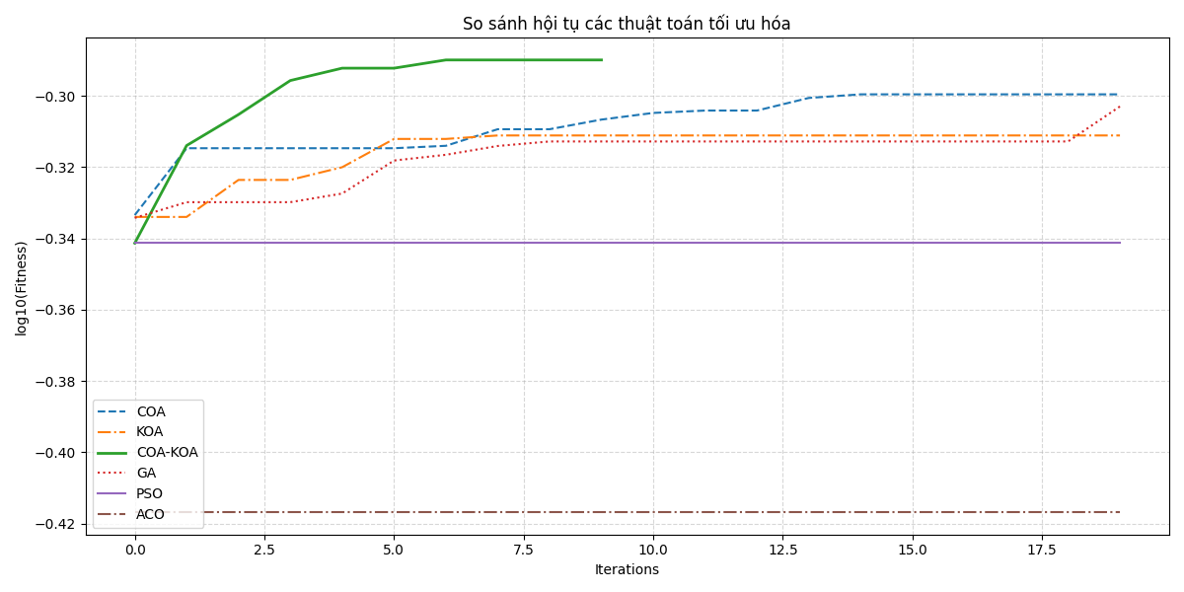
Figure 4: Fitness comparison chart across algorithms
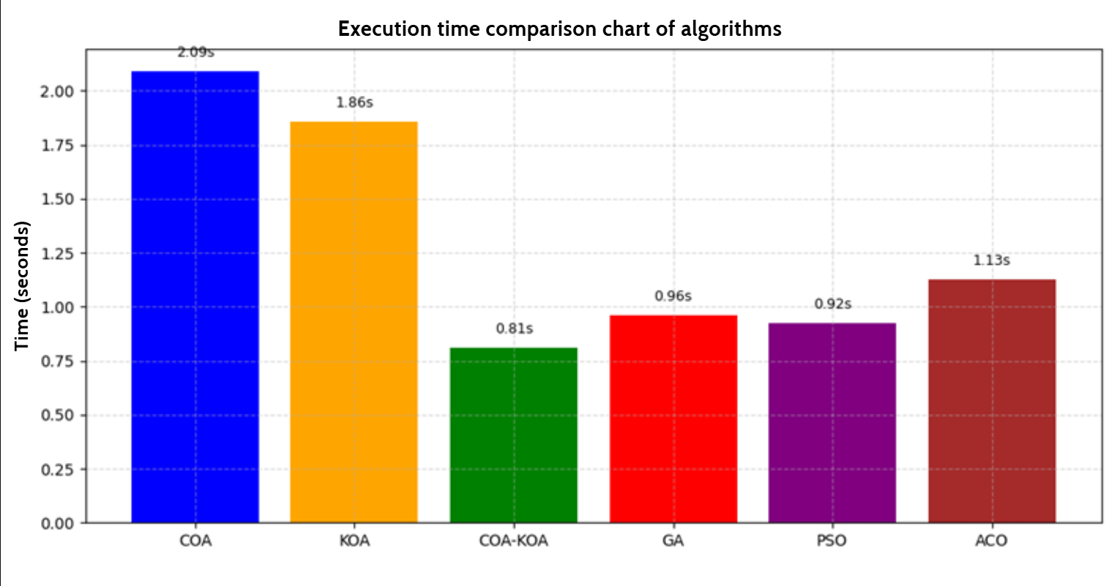
Figure 5: Execution time comparison chart of algorithms

Analysis of Solution Quality: Table 3 and Figures 4-5 summarize the comparative performance of the hybrid COA-KOA against its component algorithms and classic metaheuristics. Regarding solution quality, older generation algorithms (PSO, ACO) exhibited premature convergence, stagnating at local optima with significantly lower fitness values (0.4557 and 0.3830, respectively) within the first 10 iterations. While single-population methods like COA and KOA maintained a longer search duration and achieved moderate fitness (0.488–0.501), their improvement rates were notably sluggish. In contrast, COA-KOA achieved the highest best fitness (0.5129), demonstrating an effective balance between exploration and exploitation to reach a superior global optimum rapidly.
Analysis of Computational Efficiency and Complexity: In terms of computational efficiency, COA-KOA recorded the lowest average execution time (0.81s), significantly outperforming COA (2.09s) and KOA (1.86s). It is crucial to clarify the complexity mechanics underlying this result. Contrary to the assumption that a hybrid model doubles the computational load, the proposed architecture maintains a constant total population size ($N=50$), which is split equally between the two sub-algorithms $\left(N_{COA}=N_{KOA}=25\right)$. Consequently, the asymptotic time complexity per iteration remains $O\left(T⋅ N⋅ D\right)$, equivalent to standard single-population algorithms. The observed reduction in total execution time is, therefore, driven by accelerated convergence (stabilizing in ~10 iterations vs. ~20 for standalone methods). Furthermore, this result theoretically validates the necessity of the elite exchange mechanism. Without this exchange, the model would degrade into isolated algorithms operating with reduced population sizes ($N=25$), which would inevitably perform worse than the standalone full-population versions ($N=50$) shown in Table 3. Thus, the exchange mechanism is confirmed as the primary driver of performance, acting as a "genetic bridge" that minimizes redundant search operations.
2.7.2. Statistical Analysis
The Friedman test yielded $a χ^{2}$ of 86.94 ($p < 0.05$), confirming significant performance differences among the algorithms. Furthermore, pairwise Wilcoxon signed-rank tests (Table 4) demonstrate that the proposed COA–KOA approach consistently outperformed the comparison methods under the tested experimental conditions. The hybrid model showed statistically significant improvements over all baselines ($p < 0.05$), including the competitive GA $\left(p = 1.34× {10}^{-5}\right)$ . Additionally, COA-KOA maintained a low standard deviation (0.0055), indicating high stability compared to the fluctuating results of GA.
Table 4. Performance Statistics and Wilcoxon Test Results (20 runs)
Algorithm | Average Fitness | Std Dev | Wilcoxon p-value
COA-KOA | 0.5071 | 0.0055 | -
COA | 0.4847 | 0.0042 | $$9.54× {10}^{-7}$$
KOA | 0.4858 | 0.0036 | $$9.54× {10}^{-7}$$
GA | 0.4815 | 0.0135 | $$1.34× {10}^{-5}$$
PSO | 0.4589 | 0.0000 | $$9.54× {10}^{-7}$$
ACO | 0.3830 | 0.0000 | $$9.54× {10}^{-7}$$
Note: Wilcoxon test p-values are compared against COA-KOA. All p-values < 0.05 indicate statistical significance.
Statistical Significance and Improvement Analysis:
As shown in Table 4, COA-KOA achieved the highest Average Fitness (0.5071), far surpassing the two original algorithms, KOA (0.4858) and COA (0.4847). These results provide strong statistical evidence supporting the effectiveness of the proposed method, with all p-values smaller than the 0.05 threshold. Specifically, for the group of COA, KOA, PSO, and ACO, the p-value reached a minimal level $\left(9.54× {10}^{-7}\right)$, indicating the statistically significant improvement of the proposed model. Even for GA—the most competitive algorithm in the control group—the test result $(p = 1.34× 10^-5)$ still affirmed a significant difference favoring COA-KOA.
Population Dynamics and Stability Analysis: Beyond statistical significance, the Standard Deviation (Std Dev) serves as a crucial proxy for analyzing population dynamics. PSO and ACO recorded a Std Dev of 0.0000 alongside low fitness scores, indicating a "premature collapse" of diversity where all agents became trapped in identical local optima early in the search. Conversely, GA exhibited the highest Std Dev (0.0135), suggesting that excessive stochasticity prevented stable convergence. COA-KOA, however, maintained a moderate Std Dev (0.0055), reflecting a state of "Dynamic Equilibrium." This confirms that the hybrid architecture retains sufficient diversity (via KOA’s orbital variance) to escape local traps while exerting enough selection pressure (via COA’s exploitation) to converge reliably, avoiding both stagnation and chaos.
In conclusion, the statistical analyses from Table 4 serve as solid quantitative evidence, affirming that COA-KOA not only finds the highest quality solution but also operates most stably and reliably in the experimental scenarios.
2.7.3. Limitations and Scope
While the proposed model demonstrates superior optimization capability, certain limitations are acknowledged within the study's scope. Primarily, the Amazon Product Reviews dataset (1,464 records) serves as a proof-of-concept to validate the algorithmic logic on complex constraints rather than verifying system load capacity. This subset was intentionally selected for its rich commercial attributes such as price, stock, and promotions which are required to activate the multi-objective fitness function. Furthermore, the evaluation metrics focus on the fitness value, representing the effective satisfaction of business constraints, rather than traditional prediction metrics like Precision or Recall, as the primary goal of this study is list-wise optimization/re-ranking. Finally, regarding computational latency, the average execution time of 0.81s indicates that the model is best suited for offline periodic re-ranking pipelines (batch processing) to pre-calculate recommendations, rather than for synchronous real-time inference. Future work will address scalability on larger datasets and incorporate dynamic weight learning mechanisms.
3. CONCLUSION
This study proposed, developed, and evaluated a parallel hybrid co-evolutionary optimization model (COA-KOA), aimed at enhancing the performance of personalized product recommendation systems. By synergizing the robust local exploitation capability of COA with the effective global exploration capability of KOA, the model demonstrated distinct improvements in solution quality, convergence speed, and stability compared to single algorithms. Benchmark results against GA, PSO, and ACO confirmed that COA-KOA effectively balances the search process, violating fewer constraints while achieving higher fitness values. These findings validate the potential of the island-model topology in solving complex constrained optimization problems within e-commerce pipelines.

Beyond algorithmic improvements, the research supports businesses in harmonizing conflicting goals such as optimizing user relevance, maximizing revenue, and managing inventory thereby enhancing both user experience and operational efficiency.
Based on the current findings, future development will focus on three key directions to address scalability and adaptability. First, the model will evolve towards self-adaptation, where key parameters, especially the elite exchange cycle, are dynamically adjusted based on population diversity. Second, the framework will be expanded to Multi-objective Optimization (Pareto) to automatically determine optimal weight configurations instead of using fixed settings. Finally, to verify sustainability, the model will be integrated with Deep Learning techniques to model non-linear user interactions and evaluated on large-scale Big Data platforms for continual learning.
Acknowledgement
This work was supported by Ho Chi Minh City University of Industry and Trade (HUIT) under the 2025 University-level Student Scientific Research Project.
REFERENCES
- S. Zhang, L. Yao, A. Sun, Y. Tay. Deep learning-based recommender system: A survey and new perspectives, ACM Computing Surveys, 2023, 55(8), 1–38.
- Y. Liu, S. Wang, M. S. Khan, J. He. A novel deep hybrid recommender system based on auto-encoder with neural collaborative filtering, Big Data Mining and Analytics, 2018, 1(3), 211–221.
- K. A. De Jong. Analysis of the behavior of a class of genetic adaptive systems, Doctoral thesis, University of Michigan, 1975.
- J. Kennedy, R. Eberhart. Particle swarm optimization, Proceedings of ICNN'95 - International Conference on Neural Networks, 1995, 4, 1942–1948.
- M. Dorigo, V. Maniezzo, A. Colorni. Ant system: optimization by a colony of cooperating agents, IEEE Transactions on Systems, Man, and Cybernetics, Part B (Cybernetics), 1996, 26(1), 29–41.
- A. Maqbool, A. Rehman, A. Arshad, K. Mahmoud, M. Lehtonen. Hybrid metaheuristic optimization based DSM approach towards effective energy recommender system, Electric Power Systems Research, 2025, 246, 111645.
- A. Kumar, D. K. Tayal, S. Jain. Recommender system with Grey Wolf Optimizer and Fuzzy C-means clustering, Neural Computing and Applications, 2018, 30(7), 2111–2120.
- X. Wang, X. He, T.-S. Chua. Graph-based recommender systems: A review and new directions, ACM Transactions on Information Systems, 2024, 42(3), 25–78.
- M. Dehghani, Z. Montazeri, E. Trojovská, P. Trojovský. Coati optimization algorithm: A new bio-inspired metaheuristic algorithm for solving optimization problems, Knowledge-Based Systems, 2023, 259, 110011.
- M. Abdel-Basset, G. Hu, Y. Song, L. Zhang. Kepler optimization algorithm: A new metaheuristic algorithm inspired by Kepler’s laws of planetary motion, Knowledge-Based Systems, 2023, 268, 110454.
- M. Z. Ali, M. Pant. Benchmark functions for global optimization: A review, International Journal of Mathematical Modelling and Numerical Optimisation, 2011, 1(4), 273–295.
- Y. Zheng, D. Wang. Multi-Objective Recommendations: A Tutorial, arXiv preprint, 2021, arXiv:2108.06367.
- R. Pelissari, et al. A systematic review of the use of multiple criteria decision aiding methods in recommender systems, CEUR Workshop Proceedings, 2022, 3268, 1–12.

