Fabrication of dissolving microneedle patches based on polyvinyl pyrrolidone (PVP) and polyvinyl alcohol (PVA) matrices for the hyaluronic acid (HA) transdermal administration

Cao Luu Ngoc Hanh^{1,2,*}, Nguyen Thi Nhu Ha³, Pham Nguyen Loi², Nguyen Thi Bich Thuyen¹, Nguyen Tuong Vy², Nguyen Tiep Khac²

¹Faculty of Chemical Engineering, Can Tho University, Can Tho 900000, Vietnam
²Composite Materials Lab, Faculty of Chemical Engineering, Can Tho University, Can Tho 900000, Vietnam
³Faculty of Seafood Science and Technology, Can Tho University, Can Tho 94000, Vietnam

*Corresponding author: Cao Luu Ngoc Hanh (email: clnhanh@ctu.edu.vn)

Received: dd/mm/yyyy; Revised: dd/mm/yyyy;
Accepted: dd/mm/yyyy; Published: dd/mm/yyyy

ABSTRACT
Dissolving microneedle (DMN) patches based on polyvinyl pyrrolidone (PVP) and polyvinyl alcohol (PVA) containing hyaluronic acid (HA) were effectively fabricated using a micro-molding technique in conjunction with vacuum technology. The characteristics of the microneedles were assessed using advanced techniques. The average needle length was found to be 544.1 ± 20.7 µm via SEM imaging. The microneedles were found to dissolve quickly in the interstitial fluid environment, with a dissolution time of 2.82 ± 0.02 mins in PBS solution (pH 7.4). The microneedles had an average compressive strength of 40 ± 8 N/mm, according to compression analysis, suggesting that they have enough mechanical strength to pierce the skin. Ultimately, 113 needle holes on the pig skin out of a total of 130 microneedles on the control panel following testing, indicating an 86.9% penetration effectiveness of the microneedles through pig skin determined by methylene blue dye. In brief, preliminary progress has been obtained in the development of soluble microneedle patches to improve the effectiveness of hydrating the skin.
Keywords: Dissolving microneedle patches, polyvinyl alcohol, polyvinyl pyrrolidone, transdermal drug delivery system

INTRODUCTION
Skincare has become essential as people's quality of life has increased and their concern for aesthetic health has grown. There are various restrictions with traditional skincare techniques including oral, topical, and injectable treatments [1]. Because of first-pass metabolism, oral dosing may have an impact on the liver. In addition to causing discomfort and edema, injections carry a risk of infection. Although topical therapies are safe, there is frequently limited absorption of active substances, particularly big molecules. Therefore, one of the challenges in the realm of aesthetics is successfully transporting active substances to the appropriate region of action. The effectiveness, invasiveness, and risk of adverse effects of current approaches, such as oral, intravenous, and topical treatment, are all limited. Microneedle technology has been studied and developed as a potential remedy to these problems. Using micrometer-sized needles that can pierce the epidermis, dissolve, and release the active chemical, this technique combines the benefits of topical treatment with the penetrating strength of needles [2].
Microneedling has been investigated by scientists all over the world, and their findings have been largely good. MNs containing hyaluronic acid (HA) cross-linked with acetyl hexapeptide-8 (AHP-8) and epidermal growth factor (EGF) were investigated by An et al. (2019) [3]. On days 1, 3, and 5 of the investigation, the HA/AHP-8 microneedling reduced deep wrinkles surrounding the eyes by roughly 12.3%, 15.2%, and 13.6%. On days 1, 3, and 5 of the investigation, the HA/EGF microneedling reduced wrinkles by 12.6%, 11.3%, and 12.9%. DMN was created by Aung et al. (2019) to deliver alpha-arbutin, which has the ability to lighten skin [4]. DMN is produced by combining various polymer solutions (8% HPMC: 40% PVP K90 in a 1:1 ratio with alpha-arbutin, w/w). The alpha-arbutin-containing HPMC/PVP microneedle patch has a compressive strength of 0.089 N/needle (32 N/piece), and the needles dissolve entirely in 45 mins. The HPMC/PVP microneedle patch provides more alpha-arbutin to the skin than commercial lotions, according to in vivo experiments. Additionally, after the DMN is removed, the skin might heal on its own without showing any symptoms of infection. This DMN penetrates pig skin 100% of the time. Using solution molding, Fonseca et al. (2020) created DMN with hyaluronic acid (HA) and bacterial nanocellulose [5]. Bacterial nanocellulose is a high molecular weight substance that supports the combination of active substances, specifically rutin, and HA is used as an ingredient in cosmetics. Because of rutin's antioxidant properties, the combination may be used for skin care while also broadening the variety of possible combinations and uses for other active substances. Using reusable polydimethylsiloxane (PDMS) molds and solvent casting, Lee et al. (2020) created MNs with glutathione in the deglutathione state (GSH) aqueous solutions with varying glutathione concentrations (0%, 1.0%, 2.5%, and 5.0% by weight) and 10% hyaluronic acid (HA) [6]. GSH concentrations at 1 mg/mL are safe for the body and have a whitening impact on the skin, according to research on cytotoxicity and tyrosinase inhibition. HA also aids in getting rid of GSH's smell. Kitsongsermthon et al. (2021) used micro-molding to create DMNs from collagen, sodium hyaluronate (HYA), and polyvinyl alcohol (PVA) [7]. The HYA/PVA microneedles are able to hold onto moisture in the skin because PVA makes DMNs more elastic, which enables the microneedles to pierce the skin. Hyaluronic acid (HA)-based DMNs were examined by Saha et al. (2021), who also assessed DMNs' current uses in transdermal medication administration and cosmetics [8]. Bleomycin-containing HA-based DMNs were created by Xie et al. (2019) to treat hypertrophic scars [9]. The bleomycin-containing microneedles were able to reach the intended location and were strong enough to pierce the skin down to a depth of 330 μm before dissolving in ten mins. Erythematous areas emerge after 5 mins, go away after an hour, and the skin heals normally after another hour. Using an active ingredient solution method, Xing et al. (2022) created DMN containing complex polypeptide (CP-DMN) [10]. Acetyl hexapeptide-8, palmitoyl pentapeptide-4, hyaluronic acid (HA) base solution, and other substances were utilized. CP-DMN was made using a polydimethylsiloxane (PDMS) mold. The 230 μm-tall soluble microneedles had enough mechanical qualities to pierce the stratum corneum and reduce skin injury. The 230μm-DMN group array dissolved in 30 mins in an in vivo skin recovery test, demonstrating the quick healing of the injured epidermis. It has been demonstrated that pentapeptide-4, palmitoyl tetrapeptide-7, and other compounds stimulate collagen synthesis in the dermis, reversing skin aging through internal regeneration, thickening the dermis, and reducing wrinkles. Acetyl hexapeptide-8 reduces face muscle contraction and stops the development of new wrinkles by inhibiting nerve impulse transmission from contracting. In the field of skincare, studies have created, produced, and used a variety of microneedle types (such as solid, hollow, coated, etc.). Nevertheless, because hard microneedles have a low nutrient content, these microneedles can harm the skin's surface and are unable to efficiently deliver active ingredients.
Dissolvable microneedles are a significant advancement in skincare technology since they minimize skin injury and directly distribute active chemicals [11]. Because they are made of biodegradable polymers, they can dissolve into the subcutaneous layer and reach deeper than the epidermis. Crucially, the components of these microneedles are also skincare compounds. The nutrients are released when the polymer dissolves after being applied to the skin. As a result, the active substances can be fully absorbed by the skin without creating discomfort.
The research and development of a novel active ingredient delivery system based on micrometer-sized, biodegradable microneedles made of polyvinyl pyrrolidone (PVP), polyvinyl alcohol (PVA), and hyaluronic acid (HA) that can effectively release nutrients by penetrating the epidermis is the main goal of this project. The microneedles were made using a micro-molding technique because of its ease of usage, affordability, and mold reusability. The microneedles' important characterizations were methodically examined. Scanning electron microscopy (SEM) imaging and ImageJ software analysis were used to establish the microneedles' shape and size, especially their length. The microneedles' solubility was assessed in a pH 7.4 PBS solution. A Texture Analyzer (TA.XTplus) was used to test the microneedle structure's compressive strength, which is important for skin penetration. Lastly, the dissolving microneedles' ability to penetrate the skin was confirmed ex vivo using a pig skin model. In order to optimize fabrication settings and assess their impact on product qualities, the study used an alternating variable approach.

MATERIALS AND METHODS

Materials
The chemicals used included polyvinyl pyrrolidone (PVP K90, MW 360,000 Da, China), hyaluronic acid (HA, 99%, Xi'an Haoze Biotechnology, China), polyvinyl alcohol (PVA, hydrolysis degree 87-89%, Shanghai Zhanyun Chemical Co., Ltd, China), phosphate-buffered saline (PBS, Himedia, India), and silicone putty (plastic clay form, Vietnam). All chemicals were used directly without any further purification methods.

Preparation of silicone mold
In order to create dissolving microneedle patches from the original microneedle template (solid form), silicone molds are essential. The molds in this investigation were made using silicone putty. The two primary ingredients of silicone putty are a peroxide catalyst (B) and a silicone matrix (A).
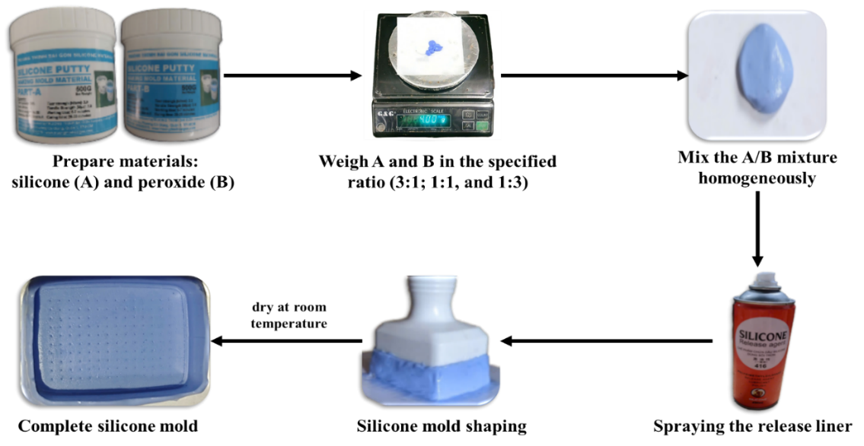
Figure 1. Silicone mold fabrication process

Figure 1 illustrates the steps involved in the silicone mold fabrication process. The molds were produced by the micro-molding method, and an adjustable-height derma stamp was utilized as a master mold. It had a conical microneedle shape with a density of 130 (10 × 13), a base diameter of 300 µm and a height of 750 µm. The silicon molds were produced by exactly inversely replicating the master structures and adjusting fabrication parameters to align with practical conditions. To this end, a certain amount of silicon monomer and its curing agent with a weight ratio of 3A:1B, 1A:1B, and 1A:3B were prepared by mixing for 1 min. Then, the mixture was pressed by the master mold, and the polymer was allowed to cure at room temperature after covering with dimethyl polysiloxane, a silicone release agent. The silicone mold is kept at room temperature until it has fully dried. The original microneedle template was separated manually, and silicon molds were obtained. These molds were repeatedly employed to make dissolving microneedle patches [12].

Fabrication of dissolving microneedle patches
The fabrication process for soluble microneedles is shown in Figure 2. Initially, solutions containing polyvinylpyrrolidone K90 (PVP K90), hyaluronic acid (HA), and polyvinyl alcohol (PVA) were prepared according to the different concentrations. In particular, PVP (5, 10, and 15%)/HA (2%) mixtures were stirred at room temperature for 30 mins at a stirring speed of 200 rpm. PVA (0, 2.5, 5, and 10%) solutions were stirred at 100°C for 60 mins at a stirring speed of 200 rpm. A homogenous PVP/HA/PVA solution was then created by magnetically stirring the PVP/HA and PVA solutions in a 1:1 volume ratio. In the second step, the microneedle structures were shaped by pouring this solution into silicone molds that had already been constructed. The molding process requires strict control over volume and speed to ensure uniformity among the microneedles and avoid air bubbles, which are one of the factors affecting the quality and dissolution efficiency of the microneedle patch. A vacuum procedure is used to fully eliminate trapped air in order to guarantee that the solution can fill the microneedle gaps inside the mold. By examining vacuum pressure at -40, -50, and -60 cmHg and vacuuming for an hour, the high-viscosity solution is able to deeply penetrate the mold's microstructures, guaranteeing even and thorough filling. The solution in the mold is then dried for 12 hours at the tested temperatures (40, 45, 50, and 60°C) to form the microneedles and produce a fully dissolved microneedle patches [13].
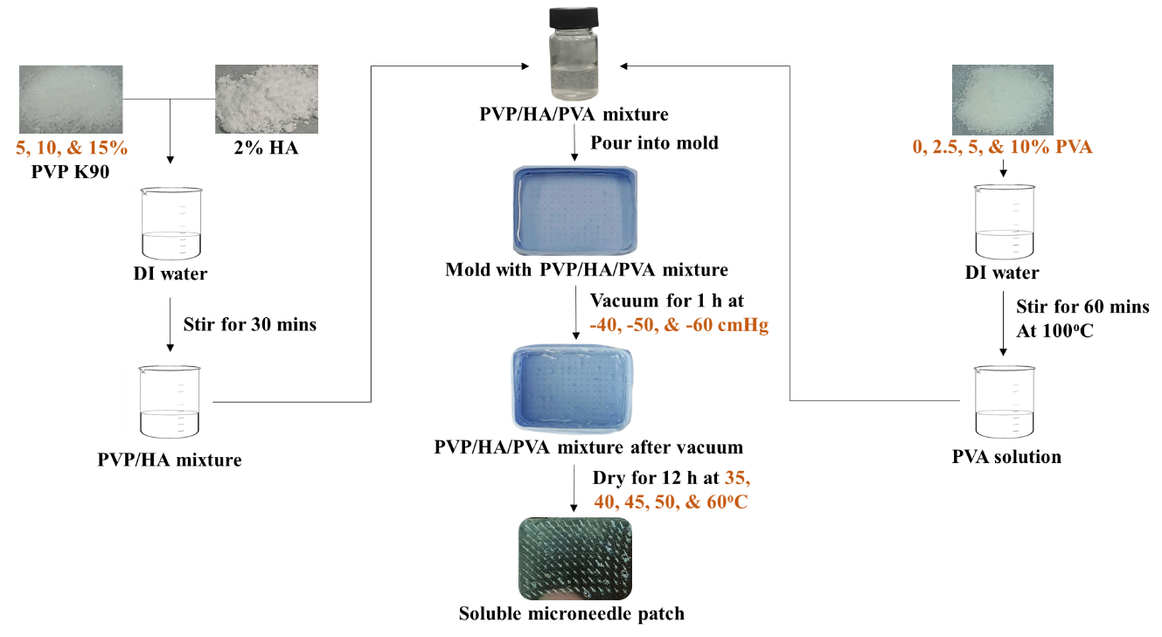
Figure 2. Fabrication process of soluble microneedle patch

Characterizations of soluble microneedle patches

2.4.1. Investigation of the dissolution time of soluble microneedle patches before and after the addition of polyvinyl alcohol (PVA)
Investigating the dissolution time of soluble microneedles before and after adding PVA is a crucial step in developing an effective soluble microneedling device for aesthetic applications. When using soluble microneedles made from PVP and HA, the dissolution time is very fast due to PVP concentrations below 20%, which allow for good water solubility. This device is unsuitable for aesthetic applications, such as targeted wrinkle reduction, as it requires some times for the user to precisely align the microneedles with the treatment area. PVA was added to the microneedles to improve their mechanical strength and lengthen their dissolving time in order to solve this problem. The mass ratios of PVA:PVP selected for investigation were 0:1; 1:4; 1:2, and 1:1, with a fixed PVP concentration of K90 based on the optimal results obtained.
Direct immersion in PBS solution, an environment that can replicate the subcutaneous conditions, osmolarity, and pH of human interstitial fluid, was applied to measure the microneedles' dissolving time. The microneedles were submerged in the PBS solution, and the dissolution time was recorded by a stopwatch. The outcomes of this process aided in determining the suitable PVA:PVP mass ratios.

2.4.2. Investigating the characteristics of microneedle patches via SEM imaging
The geometry and morphology of the resulting microneedles were assessed using an optical microscope (Nikon EPIPHOT 200, Japan) and a scanning electron microscope (SEM, JCM 7000, JEOL, Japan). The ImageJ sorfware was used to examine the microneedles' dimensions. Height, width, tip and base interspacing, were among the parameters that were measured.

2.4.3. Compressive strength test of soluble microneedle patches
The TA.Xtplus texture analyzer (Stable Micro Systems, YL, UK) was used to measure the compressive strength of a single microneedle. The prepared micro-metal plates were placed on a stainless steel base with the needle tip pointing up that was fastened with double-sided tape, with the needle tip facing upward. After contact with the support housing, a trigger force of 0.001 N was applied, and the TA began data
collection. The pre-test, and post-test speech of probe was 1 mm s⁻¹ and 10 mm.s⁻¹, respectively. The probe was then lowered vertically at a rate of 0.1 mm s⁻¹ until each plate received a maximum force of 0.5 N. This represents the standard maximum force exerted by an individual during manual microneedle administration.
By measuring the dissolved microneedle patch's compressive force and distance parameters, the structural analyzer makes it possible to assess the DMN's compressive strength. The compressive strength k (N/μm) will be determined using Hooke's law formula once these parameters have been gathered. The connection between a material's compressive force and distance is expressed mathematically by Hooke's law.
F = k $×\left|∆l\right|$ (1)
Where: F is the force, k is the compressive strength, and ∆l is the microneedle deformation. This formula can be used to determine the dissolved micro-needle patch's compressive strength and assess DMN's effectiveness.

2.4.4. Transdermal testing of dissolving microneedles
Compression strength measures are used to assess the microneedle patch's ability to penetrate the skin. The following compression test was performed on pig skin: before being used, pig skin was kept at -18°C after being stripped of hair and subcutaneous fat. The pig skin was then allowed to defrost at room temperature for 12 hours while soaking in PBS. The needles were also dried at 40°C for 10 mins after being coated with a methylene blue solution. After positioning the microneedle patch with the needles face down on the pig skin, the thumb was used to provide pressure. The microneedle patch was held in place for 30 seconds after its base made contact with the skin before the material was removed. Lastly, the puncture rate of microneedle patches was calculated by counting the stained holes in relation to the actual number of needles on the microneedle plate and is calculated according to formula (2) [14].
Puncture rate (%) =$\frac{Number of stained holes}{Number of total DMN tips}×100\%$ (2)

RESULTS AND DISCUSSION
3.1. Results of silicone mold fabrication for microneedle patches
3.1.1. The effect of silicone component ratio on mold curing time
The effect of the mass ratio between silicone substrate (A) and peroxide catalyst (B) on the curing time of silicone molds was investigated at mass ratios of A and B of 3:1, 1:1, and 1:3, respectively, as shown in Figure 3.
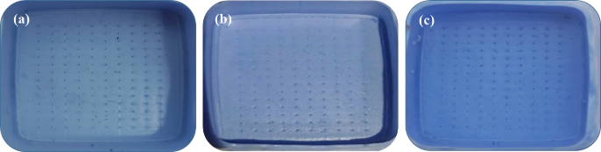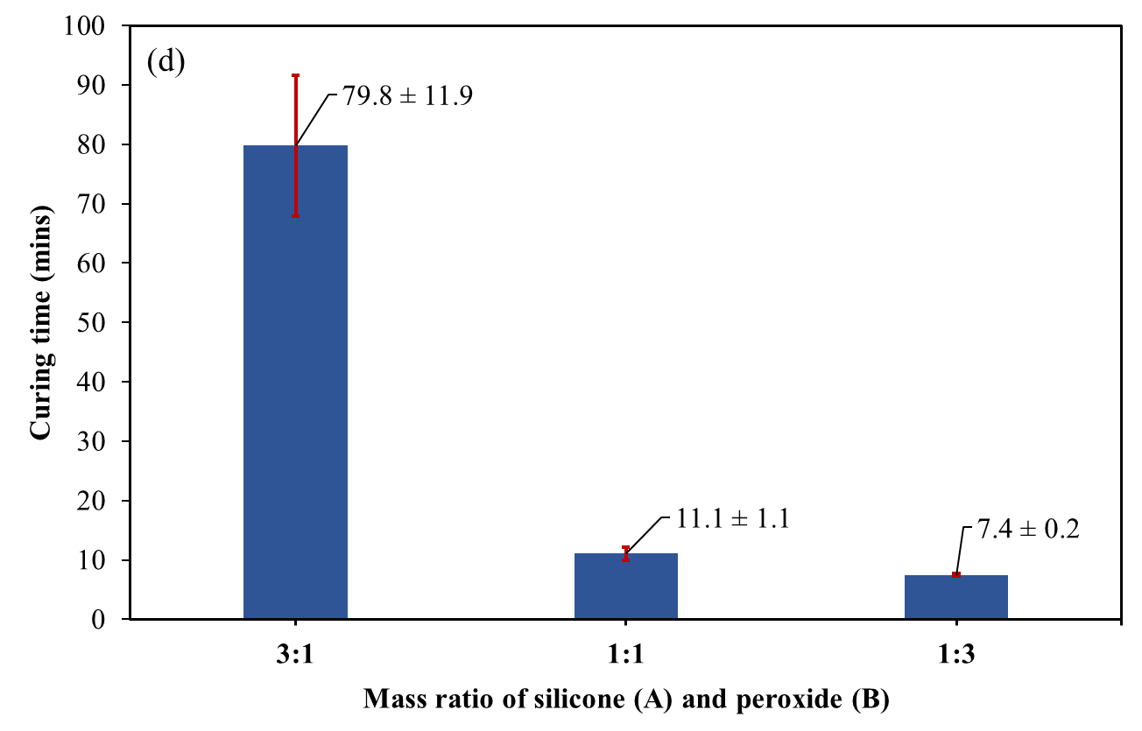
Figure 3. Silicone molds with mixing ratios A:B of (a) 3:1, (b) 1:1, (c) 1:3, and (d) a curing time chart for silicone molds
Figure 3d demonstrates that the curing time might reach 80 mins when a low peroxide curing agent ratio (A:B = 3:1) was utilized. The curing period of the A:B = 1:1 sample (11 mins) was eight times shorter than that of the A:B = 3:1 sample (80 mins) when the peroxide ratio was raised. This can be explained by the fact that adding more curing agent causes a stronger chemical reaction with the silicone substrate, which speeds up the curing process. When the curing agent ratio increased (A:B = 1:3), the average curing time decreased slightly to 7.4 ± 0.2 mins. However, an excessive amount of curing agent compared to the amount of resin could continue to react or interfere with other chemical processes, producing by-products or destroying the silicon structure. Thus, the survey results show that a ratio of 1:1 between the silicone substrate component (A) and peroxide catalyst (B) is favorable for the mold fabrication process for processing microneedle patches.
3.1.2. The effect of silicone component ratio on compressive strength
Figure 4 reveals that as peroxide concentration increases, the silicone mold's compressive strength (Shore A) gradually declines, corresponding to A:B ratios of 3:1, 1:1, and 1:3. The substantial variation in compressive strength between these mixing ratios shows how important material composition is in determining the micro-metal mold's ability to support loads and maintain its shape throughout production and use.
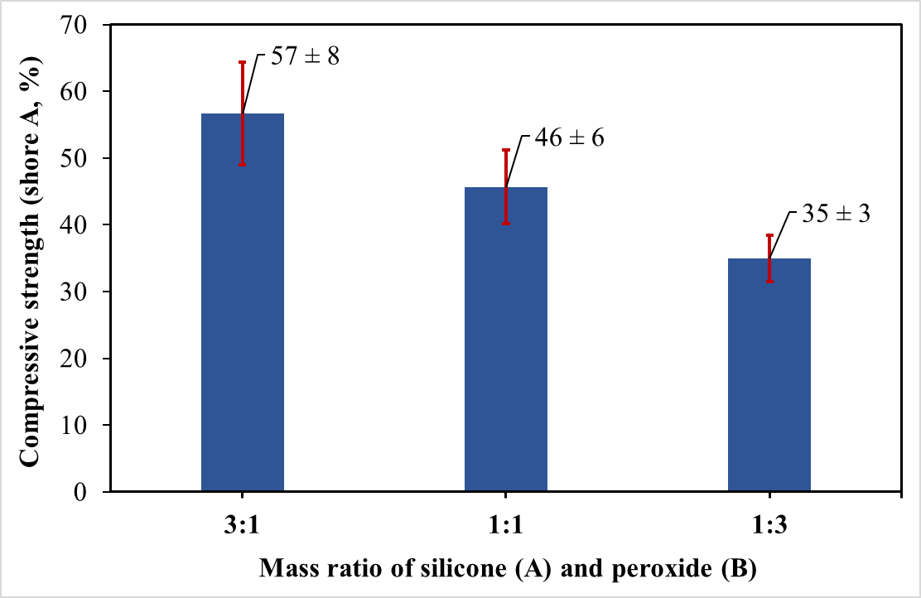
Figure 4. Results of the compressive strength test of silicone molds
The aforementioned findings demonstrate that the silicone mold's mechanical compressive strength will rise if the silicone matrix component (A) predominates over the peroxide catalyst component (B). This can be explained by the fact that when the silicone content rises, internal bonding within the silicone mixture increases. On the other hand, a low silicone content causes the bonds to weaken and the mold to soften, which lowers the silicone mold's mechanical compressive strength [15]. Furthermore, tests reveal that an excessively soft silicone mold will break when the microneedle is removed from it, whereas an excessively hard silicone mold will prevent the microneedle from being released after drying. Therefore, compared to a silicon:peroxide ratio of 3:1, the silicon mold has an average curing time and compressive strength that is not too low at a silicon:peroxide ratio of 1:1. In particular, the product formation efficiency will be faster. This indicates that a silicon:peroxide ratio of 1:1 is the optimal choice for mold manufacturing, as it provides a balance between curing time and compressive strength, while also increasing product formation efficiency.
3.2. Effects of variables on microneedle patch fabrication
One of the shortcomings of microneedle patches is the creation of air bubbles during vacuum processing, which affects the qualities of the finished product, diminishes microneedle manufacturing efficiency, and limits its application potential. The concentration of polymers, processing pressure, and drying temperature were all evaluated in this study as elements that influence air bubble production.
3.2.1. Effect of PVP K90 concentration
The concentration of PVP K90 directly affects the foaming process, so the study was conducted with different PVP K90 concentrations: 15%, 10%, and 5% PVP K90. Factors such as HA 2%, vacuum pressure -60 cmHg, and drying temperature 40°C remained constant. Figure 5 shows that the concentration of air bubbles was highest at 15% PVP K90 (Figure 5a) and lowest at 5% PVP K90 (Figure 5c), and this phenomenon was consistent with previous study [16]. Degassing was problematic at the high polymer concentration (15% PVP K90) due to excessive viscosity. The high viscosity impeded the diffusion and complete elimination of dissolved air bubbles in the solution during vacuuming. These air bubbles may become trapped in the high-viscosity fluid and expand due to polymer-polymer interactions. Conversely, with a low polymer ratio (5% PVP K90), the low viscosity caused poor air retention. The dilute solution was less likely to retain air bubbles produced by vacuuming or initial solvent evaporation. Smaller air bubbles joined readily to form larger bubbles, which moved more freely in the solution before being fixed in the mold. As a result, a concentration of 15% PVP K90 was selected for future testing.
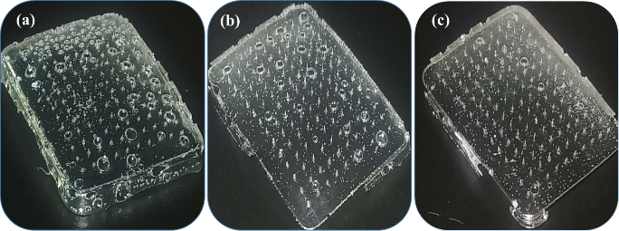
Figure 5. Microneedle patches with different PVP K90 concentrations: (a) 15%, (b) 10%, and (c) 5%
3.2.2. The effect of vacuum pressure
Vacuum pressure is important because it affects the production of microneedles and the amount of gas bubbles produced during the investigation. To assess the effects of pressure, vacuum pressures of -40 cmHg, -50 cmHg, and -60 cmHg were investigated. All samples in the investigation were kept under a fixed vacuum for one hour. The findings of the investigation on the effect of vacuum pressure on microneedle production are presented in Table 1.

Table 1. Results of the effect of vacuum pressure on microneedle formation

Vacuum pressure (cmHg) | Number of microneedles in reference sample (needles) | Number of microneedles formed (needles) | Microneedle formation efficiency (%)
-40 | 140 | 0 | 0
-50 | 140 | 70 | 50
-60 | 140 | 130 | 92.9

Specifically, as the pressure decreased, the microneedle formation efficiency tended to increase. The efficiency of microneedle production increased dramatically from 0% to 50% when the pressure was dropped from -40 cmHg to -50 cmHg. This implies that at high pressures, the force applied was insufficient to overcome the barrier generated by the PVP/HA solution's high viscosity and surface tension, preventing the solution from efficiently penetrating the micropore structures within the silicone mold. However, as pressure was reduced further, the efficiency of microneedle creation rose dramatically, reaching 92.9%. This rise can be attributed to the decreased pressure exerting a stronger compressive force, forcing the high-viscosity PVP/HA solution further into the silicone mold's micropore cavities. This suggests that determining the ideal pressure level is critical for getting the best microneedle production efficiency.
Furthermore, the survey findings indicate that vacuum pressure has a considerable effect on the bubbling of the soluble micro-needle patch. Specifically, the lower the vacuum pressure, the more bubbles form. This can be explained by the pressure's suction force, which compresses the sample solution into the micro-needle holes of the silicone mold, causing gas to ascend to the surface. However, the higher the pressure, the faster the bubbles rise to the surface, and large bubbles do not break down into numerous smaller bubbles. This suggests that pressure influences the bubbling of the soluble microneedle patch. In fact, when the vacuum pressure is kept between -40 and -50 cmHg, the number of bubbles generated on the surface of the microneedle patch increases. Conversely, when the vacuum pressure is dropped to -60 cmHg, it tends to diminish, as illustrated in Figure 6. Based on the experimental results, a vacuum pressure of -60 cmHg was shown to be the best condition for this survey. At this pressure, microneedle creation efficiency reached its peak (92.9%), indicating efficient mold filling. Simultaneously, the smallest air bubble generation was seen when compared to other pressure situations, maintaining the aesthetic quality and homogeneity of the microneedle product. As a result, a pressure of -60 cmHg will be selected for further research and experimentation to optimize the production process of soluble microneedles from PVP/HA solution.
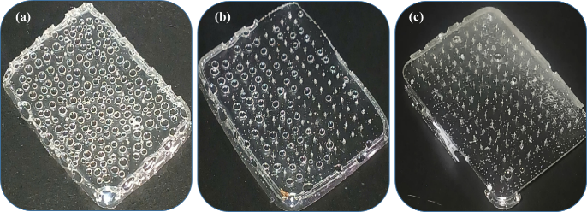
Figure 6. Microneedle plates at different vacuum pressures (a) -40 cmHg, (b) -50 cmHg, and (c) -60 cmHg
3.2.3. Effect of drying temperature
The impact of drying temperature on the residual solvent evaporation and gelation generation of dissolving microneedle patches after 12 hours of drying at various temperatures of 35°C, 40°C, 45°C, 50°C, and 60°C. Figure 7 shows photos of samples after 12 hours of drying at these temperatures. These photos demonstrate the changes in morphology, air bubble creation, and microneedle formation capabilities of microneedle patches under various drying temperatures.

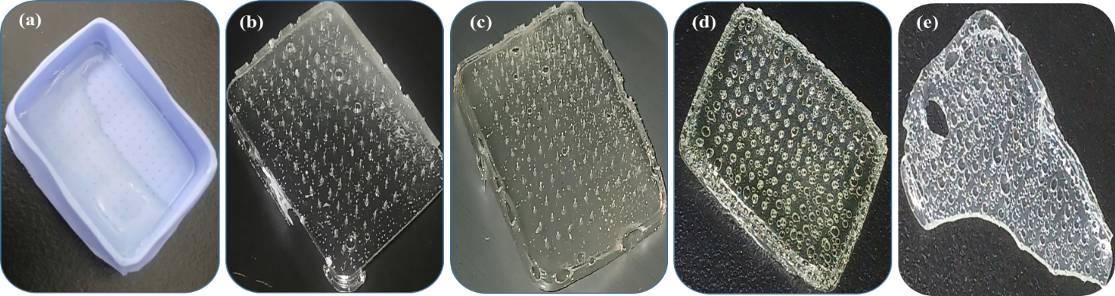
Figure 7. Microneedle patches at different drying temperatures: (a) 35°C, (b) 40°C, (c) 45°C, (d) 50°C, and (e) 60°C

The results demonstrate that even after 12 hours of drying at 35°C (Figure 7a), the fluid in the mold had not entirely solidified. This is due to slow evaporation of the polymer solutions at low temperatures. At temperatures of 40°C (Figure 7b), 45°C (Figure 7c), 50°C (Figure 7d), and 60°C (Figure 7e), the solution in the mold had completely solidified, indicating that higher temperatures promoted more efficient water evaporation, facilitating the formation of the micro-needle structure. Specifically, at a drying temperature of 40°C (Figure 7b), the microneedle patch developed with less foaming than the others. This shows that at 40°C, the evaporation rate was moderate, allowing for solidification without creating significant foaming. At 45°C (Figure 7c), the solution had entirely solidified, and foaming was minimal, but the microneedle shape was irregular due to some microneedle breakage. This phenomenon is explained by the greater drying temperature (relative to 40°C), which accelerates water evaporation and results in a rise in brittleness of these patches, increasing the likelihood of fracture during production or processing. Although the solution had completely dried at 50°C (Figure 7d) and 60°C (Figure 7e), there was a lot of foaming, making the creation of microneedles practically impossible to detect. According to the investigation results, samples dried at 40°C outperformed other temperatures in the uniform morphology, the number of air bubbles was low, ensuring the microneedle structure remained intact.
3.2.4. Evaluation of the morphology and geometric dimensions of the soluble microneedle patch
The morphological characteristics and dimensions of the dissolving microneedles under optimal conditions were determined by scanning electron microscopy (SEM) at different random locations on the microneedle plate shown in Figure 8. ImageJ software was used to perform direct measurements on the SEM images, allowing the height of each microneedle structure to be determined. From these measurements, the average microneedle height was determined to be 544.1 ± 20.7 μm. This height is optimal for these microneedles to effectively penetrate the stratum corneum and reach the dermis, thereby facilitating the transdermal delivery of HA.
Several factors can lead to differences between the mold's design size (750 µm) and the actual size of the microneedle. First, there is material shrinkage; the material used to manufacture the microneedle may shrink during drying or curing after being shaped in the mold. The degree of shrinkage depends on the material type, solution concentration, and processing conditions. Second, there is the viscosity of the solution; the viscosity of the material solution can affect the ability to completely fill the small cavities of the mold during fabrication. High-viscosity solutions may result in incomplete microneedle formation. As a result, these underlying causes contribute to the height variation observed between the master mold and the fabricated microneedles.
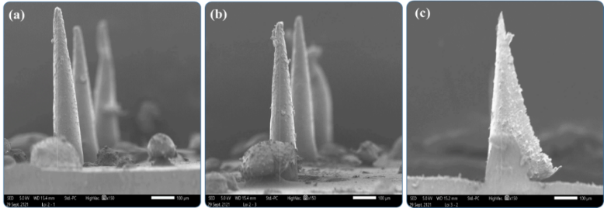
Figure 8. Microneedle morphology fabricated under optimal conditions at random locations

3.2.5. Investigation of the dissolution time of microneedle patches
PVP is a synthetic polymer with high water solubility due to its polar carbonyl group (-C=O). This group strongly interacts with water molecules via hydrogen bonds, resulting in fast swelling when in contact with water. HA is a naturally occurring glycosaminoglycan with strong hydrophilicity due to its many ionized hydroxyl (-OH) and carboxyl (-COOH) groups. These groups promote significant interaction with water and swelling, resulting in HA gel with a very high water retention capacity. When PVP/HA microneedle patches are produced, these two polymers can interact with each other through hydrogen bonds between their polar functional groups. Both PVP and HA absorb water strongly, causing the microneedle structure to inflate quickly and then dissolve. The dissolving times for the examined PVP/HA microneedle patches were approximately 1 min, respectively. This shows that the microneedle patch can dissolve quickly in a humid environment, making it have shortcomings when using in real-world conditions. To address this issue, it is necessary to find ways to increase the dissolution time of the microneedle patch. One approach could be to combine with additional polymer such as PVA to the microneedle patch. Adding PVA to the microneedle patch formulation is expected to increase dissolution time through several mechanisms. PVA has the ability to form strong hydrogen bonds between polymer chains, contributing to increased mechanical strength of the microneedle structure. This increases the microneedle's rigidity and resistance to quick breakdown when exposed to moisture on the skin [17]. Specific application levels are defined by the PVA:PVP mass ratios of 1:4, 1:2, and 1:1. The results showed a significant change in dissolution rate corresponding to the different PVA concentrations investigated. Initially, the average dissolution time of the PVP/HA microneedle patch before adding PVA was 1.02 ± 0.02 mins. The dissolution time of the PVP/HA microneedle patch after adding PVA showed a significant increase. Especially, the average dissolution time of the microneedle patch after adding PVA was 1.73 ± 0.04 mins for the PVA:PVP K90 = 1:4 sample, 2.82 ± 0.02 mins for the PVA:PVP K90 = 1:2 sample, and 5.56 ± 0.04 mins for the PVA:PVP K90 = 1:1 sample, respectively. According to the previous research, the dissolution time of the microneedle patch is neither too long nor too short, usually ranging from 2-5 mins for microneedles used in the cosmetic field [18]. Therefore, a PVA:PVP K90 ratio of 1:2 was suitable in subsequent studies.
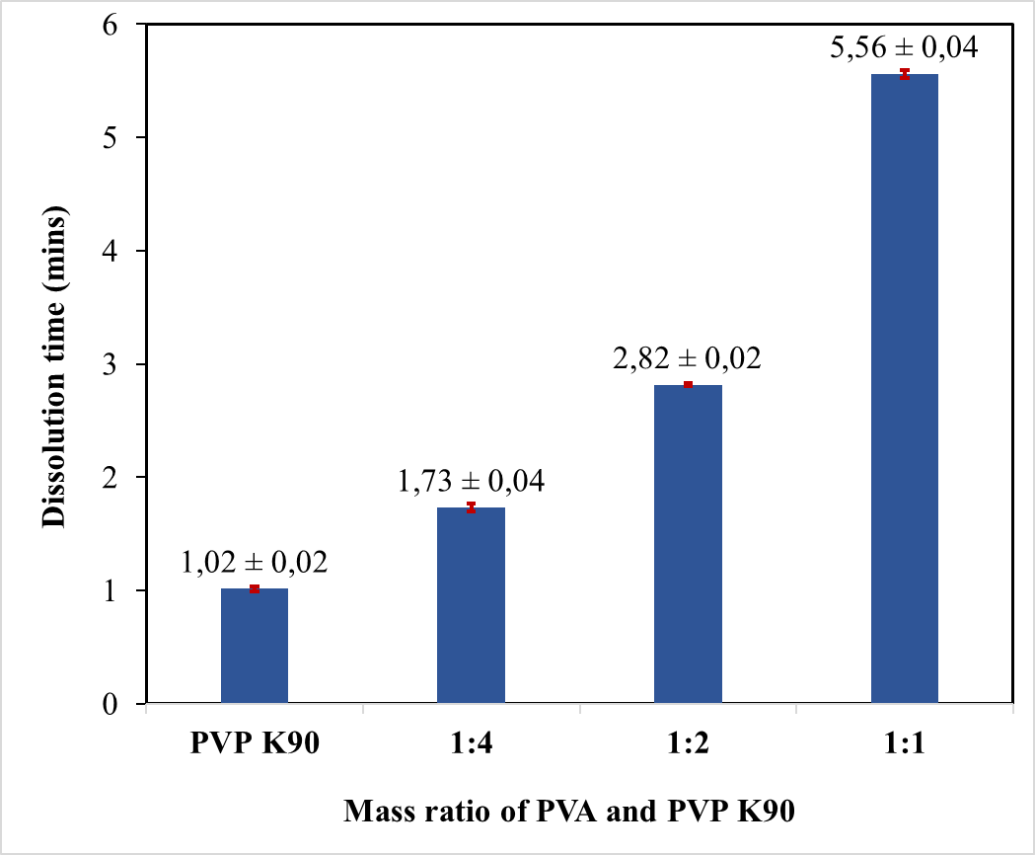
Figure 9. Dissolution time of PVP K90/HA and PVP K90/HA/PVA microneedle patches
3.2.6. Testing the mechanical strength of microneedle patches
The compressive strength of dissolving microneedle patches is an important characterization in transdermal applications. To this end, the TA.XTplus Texture Analyser was used to provide force and compression distance parameters for the product being measured. Table 2 shows the mechanical strength testing results for dissolving microneedle patches, including maximum compressive force and compression distance data from four tests. These data are used to calculate the compressive strength of microneedles using Hooke's law.

Table 2. Compressive strength measurement results of the dissolved microneedle patches
Experiment number | Compressive force (N) | Initial height (µm) | Distance  (µm) | Remaining height (µm) | Compressive strength (N/µm)
1 | 22.20 | 544.05 | 446 | 98.05 | 0.05
2 | 15.91 | 544.05 | 447 | 97.05 | 0.04
3 | 21.95 | 544.05 | 441 | 103.05 | 0.05
4 | 15.75 | 544.05 | 444 | 100.05 | 0.04
Average value | 18.95 ± 3.61 | 544.05 | 444.50 ± 2.65 | 99.55 ± 2.65 | 0.045 ± 0.006

The microneedle patch has an average compressive strength of 18.95 ± 9.39 N, and each micrometer unit area of ​​the micrometal patch can withstand approximately 0.05 N. This result displays good compressive strength, which opens up new applications for great mechanical strength [19]. The measurement results (15.75 - 22.20 N) indicate mechanical strength differences between microneedles or areas on the patch. This could serve as a foundation for future study into controlling and optimizing the uniformity of the microneedle structure. In actual applications, the production method might be refined to preserve high compressive strength while minimizing variability, enhancing the potential of the microneedle patch in applications needing high mechanical strength. These first findings suggest that soluble microneedle patches could be used in fields that require a specific level of mechanical strength. However, more study and optimization of the fabrication process are required to assure uniformity and improve the mechanical strength of the product, thereby meeting actual application requirements.
3.2.7. Testing the penetration performance of soluble microneedle patches through pig skin
Figure 10 depicts the surface of pig skin after being treated with the soluble microneedle patch and stained with methylene blue solution to demonstrate the skin penetration efficiency of the microneedle patch. The spots on the skin's surface correspond to where the microneedles entered the stratum corneum. Observing and counting these dots helps us to quantify the microneedle patch's skin penetration efficiency. Pig skin is a popular ex vivo model for investigating skin penetration because it has many structural and physical similarities to human skin, particularly the stratum corneum [20]. The use of PBS solution pH 7.4 to moisten the pig skin surface prior to placing the microneedle patch is intended to imitate the physiological conditions of human skin, which includes sweat and other extracellular fluids.
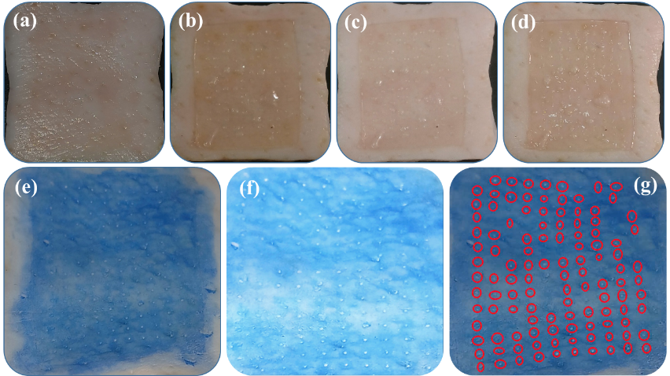
Figure 10. Pig skin surface: (a) before microneedling, (b) 5 mins after microneedling, (c) 10 mins after microneedling, (d) 15 mins after microneedling, and (e, f, g) after skin penetration test with methylene blue

In this experiment, the microneedle plate had 130 microneedles. The skin penetration and staining technique revealed 113 dots on the pig skin surface. The penetration effectiveness of 86.9% implies that the bulk of the microneedles on the patch successfully penetrated the pig skin's stratum corneum. The excellent penetration efficiency attained in this test demonstrates the dissolving microneedle patch's potential to efficiently transfer active substances through the skin. These results confirm that the fabricated microneedle patches were successfully inserted into pig skin and effectively created microchannels facilitating the delivery of cosmetic agents into the dermis, and are a new promising approach for skincare products.

CONCLUSIONS
The microcasting technique was effectively used to create the microneedles. The optimal casting solution concentration was found to be 10% PVP/2% HA mixed with 5% PVA at a volume ratio of 1:1, resulting in an average microneedle dissolution time of 2.82 ± 0.02 mins. Additional ideal parameters were a drying temperature of 40°C and a vacuum pressure of -60 cmHg. Scanning electron microscopy (SEM) morphological analysis showed an average microneedle length of 544.1 ± 20.7 µm, a size suitable for penetration into the stratum corneum of the skin. Mechanical properties analysis using a structural analyzer showed an average compressive strength of 18.95 ± 3.61 N. This value falls within the target range, indicating that the microneedles have sufficient mechanical strength to penetrate the skin. More importantly, ex vivo testing on pig skin demonstrated high skin penetration efficiency, reaching 86.9%, showing great potential for delivering active ingredients through the skin. In summary, the development of a micro-molding process to create dissoving microneedles with rapid dissolution, required compressive strength, and high skin penetration efficiency is promising. The overall findings demonstrate the promising potential of dissolving microneedles in the realm of aesthetics, particularly in the efficient and minimally invasive delivery of skin-tightening active ingredients.
DECLARATION OF CONFLICTS OF INTEREST
The authors declare that this research has no conflicts of interest.
ACKNOWLEDGEMENTS
This research was funded by the Vietnam Ministry of Education and Training under Grant number B2025-TCT-71.

REFERENCES
[1] Z. Sartawi, C. Blackshields, and W. Faisal. "Dissolving microneedles: applications and growing therapeutic potential," Journal of Controlled Release, vol. 348, Aug., pp. 186-205, 2022.
[2] M. R. Prausnitz. "Microneedles for transdermal drug delivery," Advanced drug delivery reviews, vol. 56, no. 5, Mar., pp. 581-587, 2004.
[3] J. H. An, H. J. Lee, M. S. Yoon, and D. H. Kim. "Anti-wrinkle efficacy of cross-linked hyaluronic acid-based microneedle patch with acetyl hexapeptide-8 and epidermal growth factor on Korean skin," Annals of dermatology, vol. 31, no. 3, Jun., pp. 263-271, 2019.
[4] N. N. Aung, T. Ngawhirunpat, T. Rojanarata, P. Patrojanasophon, P. Opanasopit, and B. Pamornpathomkul. "HPMC/PVP dissolving microneedles: a promising delivery platform to promote trans-epidermal delivery of alpha-arbutin for skin lightening," Aaps Pharmscitech, vol. 21, no. 1, Dec., pp. 25, 2019.
[5] D. F. Fonseca, C. Vilela, R. J. Pinto, V. Bastos, H. Oliveira, and J. Catarino, et al. "Bacterial nanocellulose-hyaluronic acid microneedle patches for skin applications: In vitro and in vivo evaluation," Materials Science and Engineering: C, vol. 118, Jan., pp. 111350, 2021.
[6] Y. Lee, S. Kumar, S. H. Kim, K. Y. Seong, H. Lee, and C. Kim, et al. "Odorless glutathione microneedle patches for skin whitening," Pharmaceutics, vol. 12, no. 2, Jan., pp. 100, 2020.
[7] J. Kitsongsermthon, N. Kumboonlert, and N. Saksumolrat. "Dissolving microneedle arrays that compensated for skin water loss due to microporation," Journal of Pharmaceutical Investigation, vol. 51, no. 5, May., pp. 571-577, 2021.
[8] I. Saha, and V. K. Rai. "Hyaluronic acid based microneedle array: Recent applications in drug delivery and cosmetology," Carbohydrate Polymers, vol. 267, Sep., pp. 118168, 2021.
[9] Y. Xie, H. Wang, J. Mao, Y. Li, M. Hussain, and J. Zhu, et al. "Enhanced in vitro efficacy for inhibiting hypertrophic scar by bleomycin-loaded dissolving hyaluronic acid microneedles," Journal of Materials Chemistry B, vol. 7, no. 42, Sep., pp. 6604-6611, 2019.
[10] M. Xing, H. Liu, F. Meng, Y. Ma, S. Zhang, and Y. Gao. "Design and evaluation of complex polypeptide-loaded dissolving microneedles for improving facial wrinkles in different areas," Polymers, vol. 14, no. 21, Oct., pp. 4475, 2022.
[11] K. Ita. "Transdermal delivery of drugs with microneedles—potential and challenges," Pharmaceutics, 7, no. 3, Jun., pp. 90-105, 2015.
[12] Q. Wang, G. Yao, P. Dong, Z. Gong, G. Li, and K. Zhang, et al. "Investigation on fabrication process of dissolving microneedle arrays to improve effective needle drug distribution," European Journal of Pharmaceutical Sciences, vol. 66, Jan., pp. 148-56, 2015.
[13] X. Pan, Y. Li, W. Pang, Y. Xue, Z. Wang, and C. Jiang, et al. "Preparation, characterisation and comparison of glabridin-loaded hydrogel-forming microneedles by chemical and physical cross-linking," International Journal of Pharmaceutics, vol. 617, Apr., pp. 121612, 2022.
[14] B. Chanabodeechalermrung, T. Chaiwarit, S. Udomsom, P. Rachtanapun, P. Piboon, and P. Jantrawut. "Determination of vat-photopolymerization parameters for microneedles fabrication and characterization of HPMC/PVP K90 dissolving microneedles utilizing 3D-printed mold," Scientific Reports, vol. 14, no. 1, Jul., pp. 16174, 2024.
[15] M. Azevedo, A. M. Monks, R. Kerschbaumer, S. Schlögl, K. Saalwächter, and M. Walluch, et al. "Peroxide‐based crosslinking of solid silicone rubber, part II: The counter‐intuitive influence of dicumylperoxide concentration on crosslink effectiveness and related network structure," Journal of Applied Polymer Science, vol. 140, no. 31, May., pp. e54111, 2023.
[16] M. Huang, Y. Hou, Y. Li, D. Wang, and L. Zhang. "High performances of dual network PVA hydrogel modified by PVP using borax as the structure-forming accelerator," Designed monomers and polymers, vol. 20, no. 1, Sep., pp. 505-513, 2017.
[17] M. Wang, L. Hu, and C. Xu. "Recent advances in the design of polymeric microneedles for transdermal drug delivery and biosensing," Lab on a Chip, vol. 17, no. 8, Mar., pp. 1373-1387, 2017.
[18] W. S. Shim, Y. M. Hwang, S. G. Park, C. K. Lee, and N. G. Kang. "Role of polyvinylpyrrolidone in dissolving microneedle for efficient transdermal drug delivery: in vitro and clinical studies," Bulletin of the Korean Chemical Society, vol. 39, no. 6, May., pp. 789-793, 2018.
[19] Q. L. Wang, D. D. Zhu, X. B. Liu, B. Z. Chen, and X. D. Guo. "Microneedles with controlled bubble sizes and drug distributions for efficient transdermal drug delivery," Scientific reports, vol. 6, no. 1, Dec., pp. 38755, 2016.
[20] S. Indermun, Y. E. Choonara, P. Kumar, L. C. du Toit, G. Modi, and S. van Vuuren, et al. "Ex vivo evaluation of a microneedle array device for transdermal application," International journal of pharmaceutics, vol. 496, no. 2, Dec., pp. 351-359, 2015.

Chế tạo tấm dán vi kim hòa tan dựa trên nền polyvinyl pyrrolidone (PVP) và polyvinyl alcohol (PVA) dẫn truyền hyaluronic acid (HA) qua da

Cao Lưu Ngọc Hạnh^{1,2,*}, Nguyễn Thị Như Hạ³, Phạm Nguyên Lợi², Nguyễn Thị Bích Thuyền¹, Nguyễn Tường Vy², Nguyễn Tiệp Khắc²

¹Khoa Kỹ Thuật Hoá Học, Đại Học Cần Thơ, Cần Thơ 900000, Việt Nam
²Phòng thí nghiệm Vật Liệu Composite, Khoa Kỹ Thuật Hoá Học, Đại Học Cần Thơ, Cần Thơ 900000, Việt Nam
³Khoa Khoa Học và Công Nghệ Chế biến Thủy sản, Đại Học Cần Thơ, Cần Thơ 900000, Việt Nam

*Corresponding author: Cao Lưu Ngọc Hạnh (email: clnhanh@ctu.edu.vn)

TÓM TẮT
Tấm dán vi kim hòa tan (DMN) dựa trên nền polyvinyl pyrrolidone (PVP) và polyvinyl alcohol (PVA) chứa hyaluronic acid (HA) đã được chế tạo thành công bằng kỹ thuật tạo khuôn chứa vi kim kết hợp với công nghệ hút chân không. Đặc tính của các vi kim được đánh giá bằng các kỹ thuật tiên tiến. Chiều dài vi kim trung bình được xác định là 544,1 ± 20,7 µm thông qua ảnh SEM. Các vi kim được chế tạo tan nhanh trong môi trường dịch kẽ, với thời gian tan là 2,82 ± 0,02 phút trong dung dịch đệm PBS (pH 7,4). Theo phân tích cơ tính nén, các vi kim có độ bền nén trung bình là 40 ± 8 N/mm, cho thấy chúng có đủ độ bền cơ học để xuyên qua da. Cuối cùng, sau khi thử nghiệm trên da lợn, 113 lỗ kim trong tổng số 130 vi kim trên tấm đối chứng cho thấy hiệu quả xuyên thấu của vi kim qua da lợn đạt 86,9%, được xác định bằng thuốc nhuộm xanh methylene. Như vậy, bước đầu thành công trong việc chế tạo tấm vi kim hòa tan để nâng cao hiệu quả cung cấp chất dưỡng ẩm cho da.
Từ khoá: Tấm dán vi kim hòa tan, polyvinyl alcohol, polyvinyl pyrrolidone, hệ thống phân phối thuốc qua da

