Hệ thống hỏi đáp tuyển sinh dựa trên GraphRAG: Trường hợp nghiên cứu tại Trường Đại học Quy Nhơn

Trần Thiên Thành*, Nguyễn Đông Dương, Hà Nhật Đoan, Nguyễn Thiên Phú, Nguyễn Duy
Khánh, Trương Văn Khôi

Khoa Công nghệ thông tin, Trường Đại học Quy Nhơn

* Email: tranthienthanh@qnu.edu.vn

TÓM TẮT
Thông tin tuyển sinh đại học thường phân tán trên nhiều nguồn và thay đổi liên tục, gây khó khăn cho việc tra cứu chính xác. Mặc dù các mô hình ngôn ngữ lớn (LLMs) có khả năng tương tác tự nhiên, việc ứng dụng trực tiếp vào các miền tri thức hẹp thường vấp phải rào cản nghiêm trọng về hiện tượng "ảo giác" (hallucination) và thiếu tính cập nhật. Bài báo này đề xuất một hệ thống hỏi đáp tuyển sinh tự động cho Trường Đại học Quy Nhơn, dựa trên kiến trúc tiên tiến GraphRAG (Retrieval-Augmented Generation kết hợp đồ thị tri thức) được điều phối bởi tác tử LangChain ReAct. Hệ thống tích hợp mô hình ngôn ngữ DeepSeek với thiết lập nhiệt độ triệt tiêu (temperature=0), vận hành song song hai luồng xử lý: truy xuất ngữ nghĩa (vector search) cho các quy chế dạng văn bản, và tự động sinh truy vấn đồ thị (Text-to-Cypher) để trích xuất dữ liệu có cấu trúc như điểm chuẩn, học phí và chỉ tiêu. Kết quả thực nghiệm trên bộ dữ liệu 314 câu hỏi độc lập cho thấy hệ thống đạt tỷ lệ phản hồi hữu ích 80,3%. Đặc biệt, hệ thống thể hiện khả năng phòng vệ xuất sắc với 19,7% các truy vấn ngoài dữ liệu được "từ chối có kiểm soát" thay vì tự bịa đặt thông tin, đồng thời duy trì tỷ lệ lỗi vận hành ở mức 0%. Kết quả này khẳng định tính khả thi và độ tin cậy vượt trội của kiến trúc GraphRAG trong việc giải quyết bài toán hỏi đáp đặc thù đòi hỏi tính chính xác tuyệt đối.
Từ khóa: RAG, GraphRAG, đồ thị tri thức, hỏi đáp, tuyển sinh đại học.

An Admission Question Answering System Based on GraphRAG: A Case Study at Quy Nhon University

Tran Thien Thanh*, Nguyen Dong Duong, Ha Nhat Doan, Nguyen Thien Phu, Nguyen Duy Khanh, Truong Van Khoi

Faculty of Information Technology, Quy Nhon University

* Email: tranthienthanh@qnu.edu.vn

ABSTRACT
University admission information is often scattered across multiple sources and constantly changing, making accurate retrieval difficult. Although Large Language Models (LLMs) demonstrate strong natural language interaction capabilities, their direct application in narrow knowledge domains often encounters severe barriers regarding "hallucination" and a lack of updates. This paper proposes an automated admission question-answering system for Quy Nhon University, based on the advanced GraphRAG (Retrieval-Augmented Generation combined with knowledge graph) architecture orchestrated by the LangChain ReAct agent. The system integrates the DeepSeek language model with a zero temperature setting (temperature=0), operating through two parallel processing pipelines: semantic retrieval (vector search) for text-based regulations, and automated graph query generation (Text-to-Cypher) to extract structured data such as admission scores, tuition fees, and quotas. Experimental results on an independent dataset of 314 questions show that the system achieves a useful response accuracy of 80.3%. Notably, the system demonstrates excellent defense capabilities with 19.7% of out-of-domain queries being "controllably rejected" instead of fabricating information, while maintaining an operational error rate of 0%. These results confirm the feasibility and superior reliability of the GraphRAG architecture in solving specific question-answering problems that require absolute accuracy.
Keywords: RAG, GraphRAG, knowledge graph, question answering, university admission.

- INTRODUCTION
University admission information plays a crucial role for candidates and parents in the process of choosing majors and educational institutions. However, this information is often published in a scattered manner across multiple sources and in various formats such as websites, fan pages, and admission documents for each academic year. This causes difficulties in searching and synthesizing information, especially for queries requiring specific details such as admission scores, tuition fees, and enrollment quotas by major and year.
Large Language Models (LLMs) have demonstrated their effectiveness in understanding and generating natural language. However, when applied directly to narrow-domain question-answering systems, they still exhibit significant limitations, including hallucination and the inability to update new information [1-3]. These limitations particularly affect the reliability of admission question-answering systems, where data changes every academic year.
Retrieval-Augmented Generation (RAG) was proposed to combine information retrieval from external data sources with the text generation capabilities of LLMs, thereby mitigating hallucinations and enhancing timeliness [2,3]. Nevertheless, traditional RAG systems primarily rely on semantic similarity-based text retrieval, thus facing challenges when handling queries that require reasoning or precise extraction from structured data.
To overcome this limitation, integrating knowledge graphs into the RAG architecture allows data to be represented as entities and relationships with explicit semantics, effectively supporting precise and explainable queries [4,5]. In the university admission domain, entities such as majors, admission methods, enrollment years, admission scores, and tuition fees are closely interlinked, making them highly suitable for modeling as a knowledge graph.
Based on this premise, this paper proposes an admission question-answering system for Quy Nhon University utilizing an architecture that combines Retrieval-Augmented Generation and knowledge graphs. This system aims to simultaneously process general questions regarding admission regulations and specific queries requiring information categorized by major and year. The remainder of the paper is organized as follows: Section 2 presents the background knowledge; Section 3 describes the proposed system; Section 4 presents the experimental evaluation; and Section 5 concludes the paper and outlines future development directions.
- RAG AND KNOWLEDGE GRAPHS IN QUESTION-ANSWERING SYSTEMS
2.1. The RAG Method
The RAG method, first introduced by Lewis et al. in 2020, is an advanced architecture aimed at addressing the inherent limitations of traditional LLMs in knowledge intensive tasks [3]. Fundamentally, RAG is a hybrid approach that combines the generative power of pre-trained language models with the capability to retrieve information from an external knowledge base. This mechanism allows the system to expand its scope of understanding beyond the initial training data without the need for resource intensive fine-tuning processes.
The operational workflow of a standard RAG system consists of two sequential phases: retrieval and generation. During the retrieval phase, upon receiving a user query, the system encodes the question into a vector representation and performs a similarity search within a vector database to identify the top-k most relevant text chunks [2]. In the generation phase, these retrieved text chunks serve as supplementary context, which is concatenated with the original question and fed into a large language model (such as GPT). Consequently, the model can synthesize and generate a natural, accurate answer based on the newly provided information source. The general architecture and data flow of a typical RAG system are illustrated in Figure 1.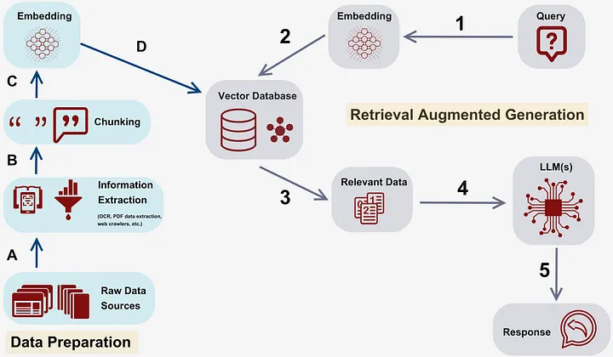
Figure 1. RAG architecture
The application of RAG plays a particularly important role in question-answering systems within the admissions domain, where data frequently changes from year to year. According to recent studies, RAG significantly reduces the phenomenon of “hallucination” - where models fabricate incorrect information - while ensuring data remains up to date without requiring retraining of the underlying foundation model. However, traditional RAG approaches based purely on text matching still exhibit certain limitations when handling complex queries that require multi-step reasoning or the integration of fragmented pieces of information, thereby motivating the need to incorporate more explicit data structures such as knowledge graphs.
2.2. Knowledge Graph
Knowledge Graph (KG) is defined as a network-structured data model in which information is represented as nodes corresponding to entities and edges describing the semantic relationships between them. According to the definition by Hogan et al., a KG is a collection of interlinked descriptions of entities - objects, events, or concepts in the real world - connected through abstract relationships [6]. In contrast to traditional relational databases and unstructured text repositories, knowledge graphs emphasize the preservation of semantic meaning and data interconnectivity, thereby enabling machines not only to store information but also to comprehend and perform reasoning over such relationships.
In the context of intelligent question-answering systems, knowledge graphs offer a significant advantage over vector similarity-based retrieval methods used in traditional RAG approaches. While vector databases often struggle to capture explicit relationships or perform multi-step logical reasoning, KGs provide an explicit structure that enables the system to accurately locate the required information.⁵ For example, to answer a question comparing tuition fees between two specific programs, a KG-based system can directly traverse the connecting edges instead of searching and probabilistically aggregating information from disparate text passages, thereby substantially improving both the accuracy and interpretability of the response [4].
For the admissions question-answering task at Quy Nhon University, the domain-specific data comprises closely linked entities such as academic programs, admission methods, subject combinations, and yearly admission scores. Modeling this data as a knowledge graph enables the transformation of regulatory texts into a dynamic knowledge network. Specifically, quantitative information such as scores, quotas, or tuition fees is directly associated with the corresponding program entities through identifying relationships, allowing the GraphRAG system to perform complex queries such as filtering, comparison, and data aggregation with high precision, effectively overcoming the information ambiguity commonly observed in pure LLMs.¹
- DEVELOPING AN ADMISSIONS QUESTION AND
3.1. System architecture
The admissions question-answering system is built upon a RAG architecture enhanced with a knowledge graph, as illustrated in Figure 2. At its core, the system utilizes a Neo4j graph database, which supports both the storage and querying of vector data and graph structures simultaneously, enabling efficient and unified access to unstructured and structured information.
In terms of the overall architecture and core deep learning models, the system is designed with a tightly layered structure that combines the capabilities of Vietnamese-specialized models with state-of-the-art large language models. Specifically, the system’s processing workflow passes through the following functional layers:
First, when a user submits a question in natural language, the query is received via the REST API gateway (implemented using FastAPI) at the Presentation Layer. The query is then immediately forwarded to the Orchestration Layer, where the Session Manager module is responsible for storing and retrieving the conversation history to maintain context for follow-up questions. At this stage, the ReAct Agent functions as a semantic router, evaluating the characteristics of the query to determine the branching path to the Hybrid Retrieval Layer along one of two possible streams:
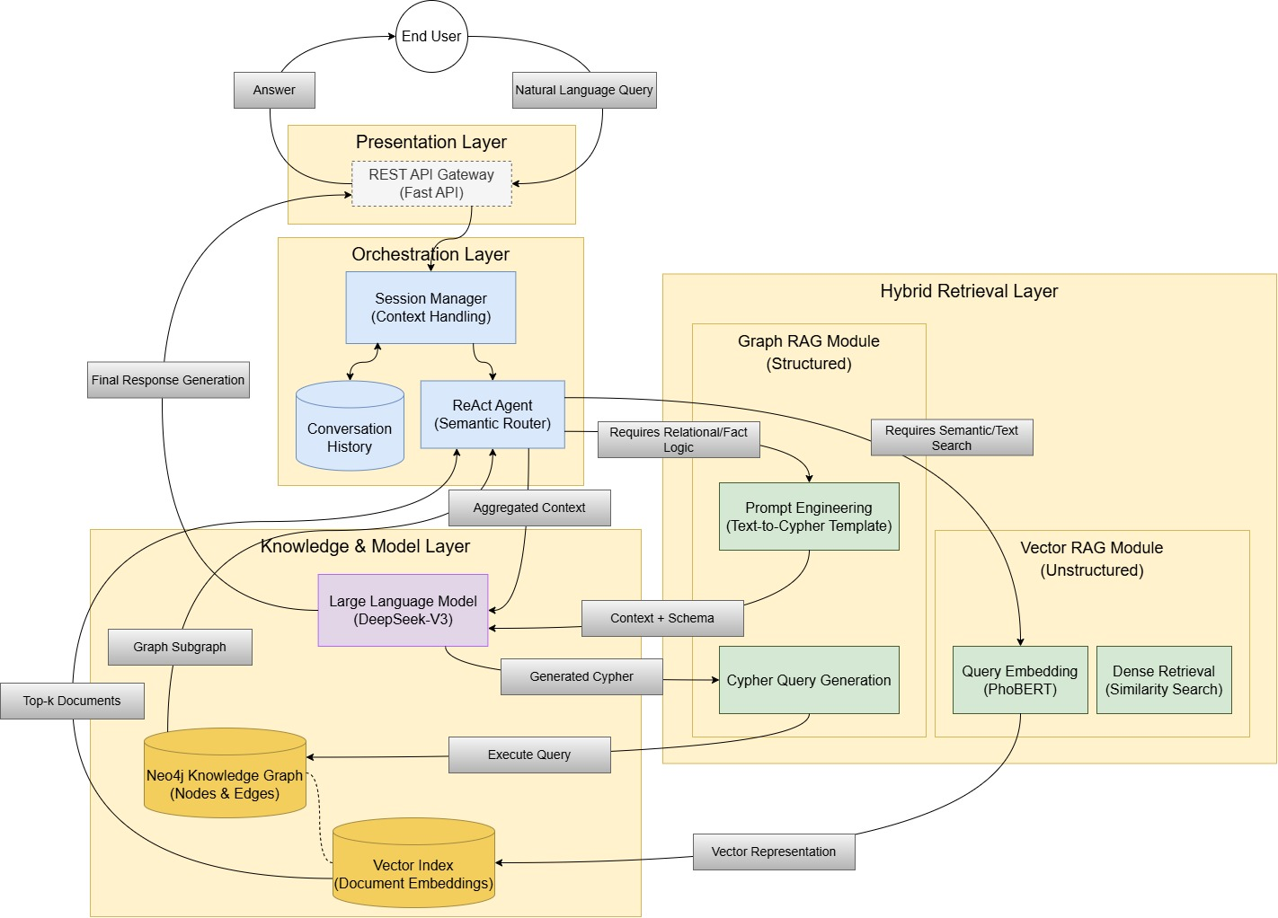
The first stream (Vector RAG Module) is activated for queries requiring semantic search or unstructured text retrieval (Requires Semantic/Text Search), such as regulations or official guidelines. In this phase, the system employs a locally deployed PhoBERT embedding model to encode the query into vector representations. The choice of PhoBERT over multilingual models is crucial, as it is a pretrained model specifically designed for Vietnamese, enabling the system to accurately capture both the semantic nuances of the vocabulary and the complex grammatical structures of the language. After embedding, the system performs Dense Retrieval on Neo4j’s Vector Index to retrieve the top-k documents most semantically similar to the input query.
Figure 2. Architecture of the admissions question-answering system
The second stream (Graph RAG Module) is activated for queries that require logical reasoning, structured factual data, or multidimensional relationships (Requires Relational/Fact Logic), such as looking up admission scores, tuition fees, or yearly quotas. This process leverages Prompt Engineering techniques (Text-to-Cypher Template), wherein the knowledge graph schema along with the query context is directly fed into the large language model DeepSeek-V3 at the Knowledge & Model Layer. In this mechanism, DeepSeek-V3 functions as an intermediate reasoning engine, responsible for analyzing natural language questions, identifying entities and implicit relationships within the query, and automatically generating the corresponding graph query scripts in Cypher. Thanks to its advanced contextual understanding and code generation capabilities, the model can flexibly map between natural language structures and the knowledge graph schema, enabling the system to automate data retrieval without the need for manually constructed query rules.
The selection of DeepSeek-V3 for the system was made based on several technical and practical considerations. First, the model demonstrates strong capabilities in semantic reasoning and code generation tasks, making it particularly suitable for translating natural language queries into database queries. Second, DeepSeek-V3 offers competitive processing performance compared to widely used large language models such as GPT-4 or Gemini, while incurring significantly lower API costs, thereby reducing operational expenses when the system must handle a large volume of queries in real-world deployments. This aspect is especially critical for automated advisory systems in the education domain, where maintaining scalability and stable long-term operation is essential.
Once the query generation process is complete, the generated Cypher commands are executed directly on the Neo4j knowledge graph to retrieve the relevant data. The returned result is not the entire graph but a subgraph containing precisely the entities, attributes, and relationships necessary to answer the user’s question. This subgraph is then used as the knowledge input for the language model’s answer synthesis stage, ensuring that the generated information is based on structured and reliable data from the knowledge system.
Finally, the results from the two retrieval streams are merged into an aggregated context block. This context block, together with the original question, is fed back into the DeepSeek-V3 model to perform the final response generation, which is then delivered to the user.
Throughout the entire interaction with DeepSeek-V3 (from intent analysis and Cypher query generation to answer synthesis), a core technical constraint rigorously enforced by the system is the setting of the temperature parameter to zero (temperature = 0). This configuration eliminates randomness, compelling the model to reason deterministically and produce results solely based on the data retrieved from Neo4j, without autonomously “generating” additional information. This approach maximizes the mitigation of hallucinations, ensuring reliability and absolute accuracy - an essential requirement for domain-specific applications such as admissions advisory.
3.2. Data collection and standardization
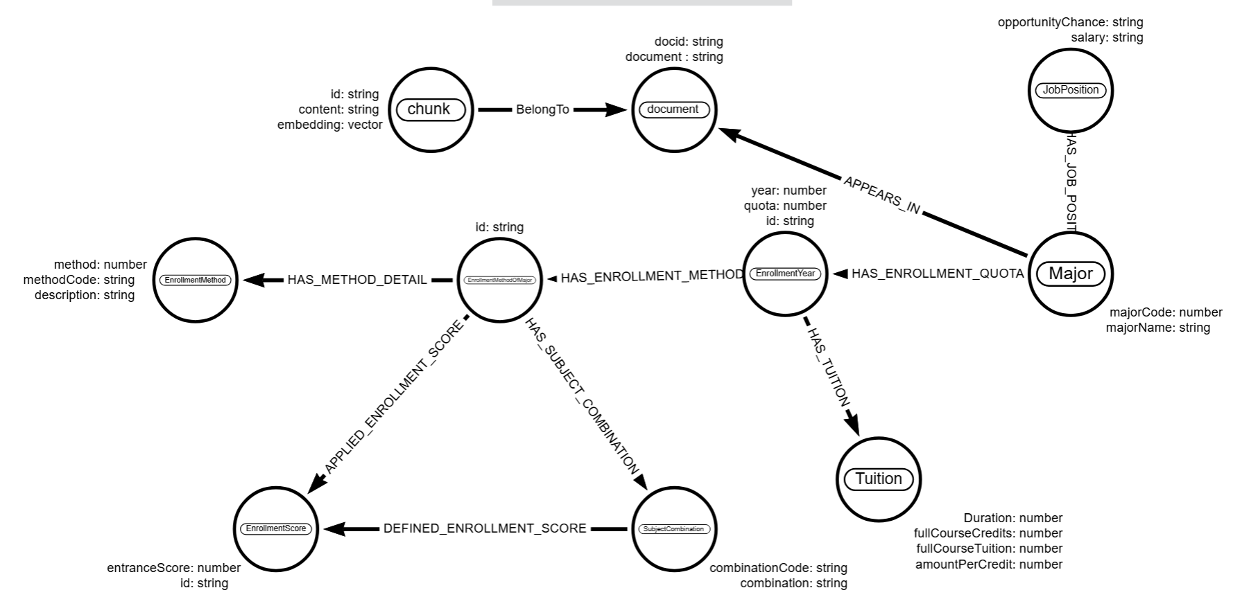
3.2.1. Data Collection:
Figure 3. Knowledge database schema for Quy Nhon University admissions
The data were collected from the admissions website of Quy Nhon University (tuyensinh.qnu.edu.vn). After collection, information such as program names, admission methods, subject combinations, quotas, and annual admission scores was standardized and converted into CSV format for insertion into the graph database. For textual data such as regulations, policies, and official guidelines, the content was segmented into chunks and embedded into vectors for storage in the vector database. The processed dataset includes: three admissions regulations issued by the Ministry of Education and Training and Quy Nhon University; documents introducing the university’s academic programs and employment positions updated through 2025; admission methods and scores for the years 2024 and 2025; and tuition regulations for programs during the 2024 and 2025 admissions cycles.
3.2.2. Data Storage Organization:
After preprocessing, the data were directly extracted and transformed into a knowledge graph stored in a Neo4j database, comprising entities, relationships, and attributes as illustrated in Figure 3.
Entities:
- Document (9 nodes): Regulations and official guidelines related to admissions.
- Chunk (278 nodes): Small segments of documents.
- Major (52 nodes): Academic programs.
- SubjectCombination (105 nodes): Admission subject combinations.
- EnrollmentMethod (21 nodes): Admission methods.
- EnrollmentYear (99 nodes): Information on admission years.
- EnrollmentScore (834 nodes): Admission scores by year, program, and method.
- Tuition (99 nodes): Tuition information by program and year.
- JobPosition (50 nodes): Employment positions after graduation for each program.
- EnrollmentMethodOfMajor (241 nodes): Intermediate nodes linking Program – Method – Year – Score.
Relationships: The database comprises eight main types of relationships, forming a complex and multi-dimensional information network:
- PART_OF: Indicates which document a given chunk belongs to.
- HAS_ENROLLMENT_QUOTA (97 connections): Specifies the admission quota of a program in a particular year.
- HAS_ENROLLMENT_METHOD (241 connections): Indicates the admission methods associated with a given program.
- HAS_METHOD_DETAIL (241 connections): Provides detailed information for each admission method.
- HAS_SUBJECT_COMBINATION (886 connections): Specifies the subject combinations used for admission to each program.
- DEFINED_ENROLLMENT_SCORE (834 connections): Indicates the admission scores of each program by year and admission method.
- HAS_TUITION (99 connections): Provides tuition information for each program by year.
- HAS_JOB_POSITION (50 connections): Specifies the job positions associated with each program.
3.3. Functional Modules
Based on the overall architecture proposed in Figure 2, the system’s processing workflow is divided into three core functional modules, corresponding to the processes of data intake, routing, and aggregation across the system layers.
At the Orchestration Layer, the question classification module functions as a semantic router, orchestrated by the ReAct Agent. Based on the input question and the historical context stored in the Session Manager module, the agent leverages the DeepSeek model to evaluate the user’s intent. The system automatically classifies queries into two main branches: general regulatory questions (Type A) and queries requiring the extraction of specific numerical data (Type B). This process is executed using prompt templates to enforce the large language model to return results in a standardized JSON format:
"""You are an admissions question classification system for Quy Nhon University. Your task is to classify the input question into ONE of the following TWO categories:
Type A – Questions about regulations and general issues:
- Inquire about rules, principles, conditions, or admission methods
- General in nature, not requiring specific numerical data
- Not associated with a specific program, year, score, or cost
Type B – Questions about specific admissions information:
- Inquire about admission scores, tuition fees, quotas, programs, or career opportunities
- Related to numerical data, admission year, or a specific program
- Information may change from year to year
Return the result only in the following JSON format (no additional explanations):
{
"label": "A" or "B",
"reason": "A brief explanation of the classification (1 sentence)"
}
Question to classify:
"{question}"
"""
Based on the routing signal from the Semantic Router, the system continues operation at the Hybrid Retrieval Layer. If the question belongs to Type A, the unstructured retrieval module (Vector RAG Module) is activated. Here, the query is encoded into a vector using the PhoBERT embedding model. The system then performs a dense retrieval algorithm on Neo4j’s Vector Index to extract the top-3 text chunks with the highest semantic relevance. The Cypher command used for vector search is defined as follows:
WITH $questionEmbedding AS queryEmbedding CALL db.index.vector.queryNodes( 'chunk_embedding_index',3, queryEmbedding)
YIELD node AS chunk, score
MATCH (chunk)-[:PART_OF]>(doc:Document)
RETURN score, chunk.text AS chunk_content, doc.doc_id AS document_id, doc.title AS document_title, doc.source AS document_source ORDER BY score DESC
Conversely, for Type B questions that require logical reasoning and structured data extraction, the system branches to the graph retrieval module (Graph RAG Module). To perform this task, the system employs a Text-to-Cypher technique combined with the DeepSeek model. To ensure the absolute accuracy of the generated graph query code, the database schema (defined and visually illustrated in Figure 3) is extracted and directly supplied to the {schema} variable in the prompt. Explicitly providing the entity and relationship structures compels the LLM to generate queries that strictly conform to Neo4j’s actual network format rather than fabricating information. The Text-to-Cypher prompt template is designed with strict constraints to safeguard the graph database:
"""You are a Neo4j and Graph Question Answering expert. Your task is to convert the user’s question into an EXACT Cypher query based on the provided graph schema.
GRAPH SCHEMA: {schema}
GENERAL PRINCIPLES:
- Use only nodes, properties, and relationships present in the provided schema.
- DO NOT use any data-modifying commands: CREATE, SET, DELETE, MERGE.
- DO NOT return node objects or embeddings.
- Always return data as text or a compact object suitable as context for an LLM.
- If there is insufficient information for precise filtering, broaden the query (do NOT speculate).
Always RETURN data in one of the following formats:
- Context from text:
RETURN { type: "text", content: <text>, source: <document_title or null> } AS context
- Context from structured data:
RETURN { type: "<data_type>", content: <value>, metadata: { major: <if applicable>, year: <if applicable>, method: <if applicable> } } AS context
"""
The final processing stage occurs at the Knowledge & Model Layer. Results collected from the retrieval streams - whether text chunks or JSON data from the graph - are merged and formatted into an Aggregated Context block. The Final Response Generation module is responsible for taking this context along with the original question and feeding it into the large language model. To rigorously prevent hallucinations, the prompt at this stage incorporates a mandatory Semantic Check mechanism. This mechanism directs the model to structure its response solely based on the reference data within the given context and to proactively decline to answer if the information does not exist:
""" You are a virtual assistant tasked with answering questions based on the given context.
STEP 1: SEMANTIC CHECK (MANDATORY)
Before answering, you MUST verify:
- Is the context DIRECTLY RELEVANT to the question?
- Does the context contain the INFORMATION NEEDED to answer the question?
- Does the context address the SAME TOPIC as the question?
- If the context is NOT relevant or cannot answer: "Sorry, I could not find any information related to your question."
STEP 2: ANSWERING RULES
- Use only the information provided in the context
- Respond concisely, clearly, and naturally in Vietnamese
- Do NOT infer or add any external knowledge
Context: {context}
Question: {input}
Answer:
"""
3.4. Development of the Application Interface
To assess feasibility and deploy the model in practice, we developed a web application serving as a virtual admissions advisory assistant for Quy Nhon University. The application features a modern, user-friendly conversational (chatbot) interface, enabling real-time interaction in natural language.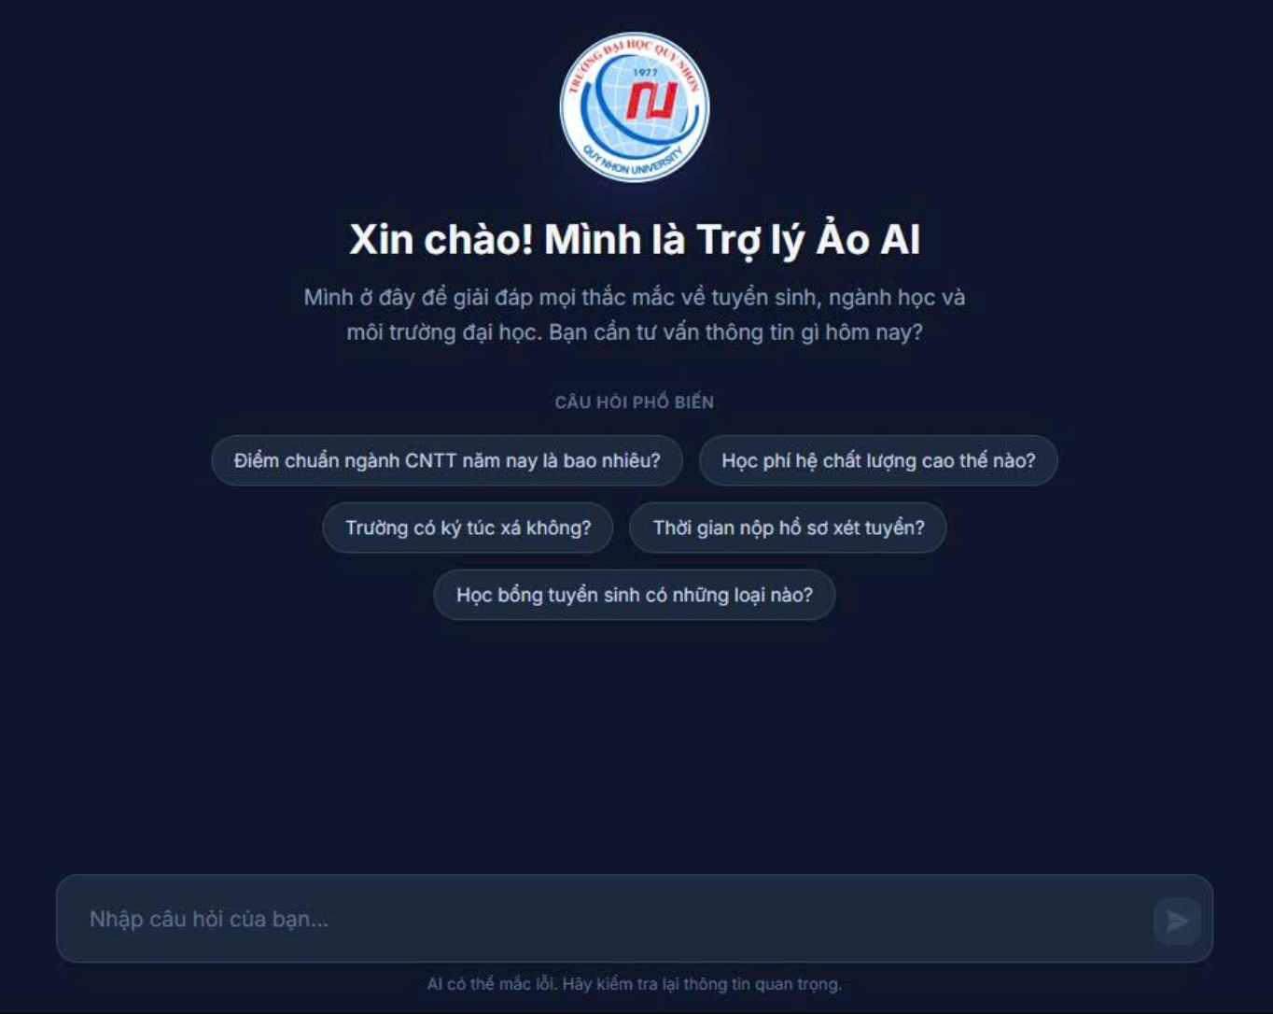
(a) Home screen upon initializing the conversation
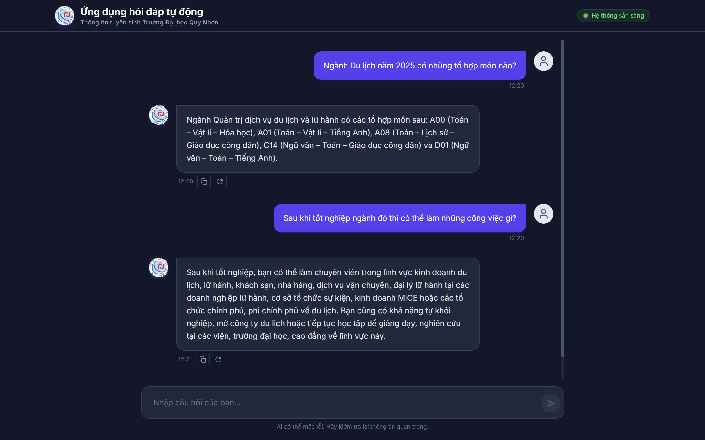
(b) Context retention and conversational handling capabilities
Figure 4. Interface of the Quy Nhon University admissions question-answering application
On the homepage interface (Figure 4a), to address the difficulty faced by new users when initiating a conversation, the system provides a pre-populated list of “Popular Questions” to quickly guide users toward key information streams (such as admission scores, tuition fees, and dormitory details). Simultaneously, a clear warning message regarding the limitations of AI is displayed at the bottom of the page, ensuring transparency and ethical responsibility in real-world deployment.
The system’s most notable feature is demonstrated through direct conversational interactions (Figure 4b). Real-world operation shows that the system can effectively handle complex, multi-turn reasoning queries thanks to the Session Manager module. For example, when a user initially queries with the abbreviated keyword “Tourism program,” the agent automatically maps it to the canonical entity name in the graph database, “Tourism and Hospitality Management Program,” to retrieve the corresponding subject combinations for admission. Notably, in the immediate subsequent turn, when the user employs a pronoun reference (“After graduating from that program…”), the system seamlessly inherits the context from the conversation history to correctly interpret the intent and extract accurate information about employment positions, without requiring the user to repeat the program name.
In addition, the interface provides utility features such as a copy button, answer refresh, and system status display. Notably, thanks to the underlying GraphRAG architecture, all responses generated by the system are configured to include explicit source references (e.g., the name of the regulatory document or a URL link). This traceability mechanism plays a crucial role, not only preventing the model from fabricating information but also providing a solid basis for students and parents to independently verify the authenticity of the advisory data.
- SYSTEM EVALUATION
Due to the specific nature of the university admissions advisory domain and the lack of publicly available standardized Vietnamese datasets, this study constructed an independent test dataset comprising 314 questions. The dataset was designed to comprehensively evaluate the two core processing streams of the system architecture, including 114 questions related to regulations and procedures (requiring retrieval of unstructured text via vector and full-text search) and 200 questions involving specific program information such as admission scores, tuition fees, and quotas (requiring the generation of Cypher queries to extract structured data from the knowledge graph).
To accurately measure the performance and information safety of the RAG system, the evaluation process focused not only on the accuracy of responses but also particularly on the system’s ability to control the hallucination phenomenon commonly observed in large language models. Accordingly, system responses were categorized into three states: (1) Useful Response, when the system correctly extracts the key information and provides accurate data compared to the original text; (2) Safely Declined, when the system detects missing data and returns a standardized message such as “Sorry, I could not find the information...” instead of generating inferences; and (3) System Error, when the agent becomes unresponsive or encounters exceptions during execution. The experimental results are summarized in Table 1.
The experimental results demonstrate that the system achieves high stability and reliability during operation. The rate of useful responses was consistently high across both types of queries, reaching 78.9% for regulatory text data and 81.0% for questions requiring direct extraction from the knowledge graph (GraphRAG). Notably, the system error rate remained at an absolute 0% across all 314 test cases, confirming the robustness of the layered architecture design and the effective exception handling capabilities of the LangChain ReAct Agent.
Table 1. System evaluation results on the two test datasets
Question Type | Quantity | Useful | Safely Declined | System Error
Regulation | 114 | 90(78.9%) | 24(21.1%) | 0
Program lookup | 200 | 162(81.0%) | 38(19.0%) | 0
Total | 314 | 252 (80.3%) | 62(19.7%) | 0
A notable highlight of this study lies in the defense mechanism against information hallucination. All queries for which no answer could be found (accounting for approximately 19.7%) were proactively categorized by the system as “Safely Declined.” Error analysis indicates that these cases largely involved questions beyond the scope of the knowledge already loaded into the database (e.g., queries about subject combinations for programs without available data or requests for data from years not yet updated). The system’s behavior of declining to answer rather than attempting to infer external knowledge demonstrates that setting the DeepSeek model’s temperature parameter to zero (temperature = 0), combined with strict constraints in prompt engineering, effectively safeguards the system, ensuring the integrity and transparency of admissions information.
Although the system achieved promising accuracy results, it still exhibits certain limitations in response time. In some cases, the agent may enter repeated tool-calling loops, resulting in prolonged response times. This technical issue represents a key focus for future development, where the research team plans to address it through optimization of the agent’s early stopping mechanism during reasoning and enhancement of the buffer management strategy.
- CONCLUSION
This study successfully proposes and develops an automated admissions question-answering system for Quy Nhon University, leveraging the advanced GraphRAG architecture integrated with the LangChain ReAct orchestration agent and the DeepSeek large language model. Unlike conventional text-based retrieval approaches, the system effectively addresses complex and multi-dimensional information retrieval tasks by flexibly switching between semantic search (for regulations and textual documents) and Cypher-based graph queries (for structured data such as admission scores and tuition fees). Experimental evaluation on a dataset of 314 questions demonstrates that the system operates reliably, achieving a useful response rate of 80.3%. Notably, the application of strict content constraints effectively eliminates hallucinations, as evidenced by 19.7% of out-of-scope queries being “safely declined” rather than generating incorrect or fabricated information.
These results confirm the superior feasibility and reliability of the GraphRAG approach for building question-answering systems within narrow knowledge domains. The model is fully capable of being deployed as a practical virtual assistant, contributing to improved admissions advisory services and promoting the university’s digital transformation efforts. In future research, we will focus on addressing latency issues arising from the multi-step reasoning process of the agent through early stopping mechanisms and buffer optimization. Additionally, the graph database will continue to be enriched to provide more comprehensive coverage of scholarship policies, specialized training content, and the latest regulations issued by the Ministry of Education and Training.
DECLARATION OF CONFLICTS OF INTEREST
The author(s) declare that this research has no conflicts of interest.
ACKNOWLEDGMENTS
We would like to express our gratitude to Quy Nhon University for providing financial support for this research under the Student Scientific Research Project, code 2025.1144.94.
REFERENCES
[1] Z. Ji et al., “Survey of hallucination in natural language generation,” ACM Computing Surveys, vol. 56, no. 12, pp. 1–38, 2023.
[2] H. Yu, A. Gan, K. Zhang, S. Tong, Q. Liu, and Z. Liu, “Evaluation of retrieval-augmented generation: A survey,” in Proceedings of Springer Nature Singapore, 2025, pp. 102–120.
[3] P. Lewis et al., “Retrieval-augmented generation for knowledge-intensive NLP tasks,” in Advances in Neural Information Processing Systems (NeurIPS), vol. 33, pp. 9459–9474, 2020.
[4] B. Peng et al., “Graph retrieval-augmented generation: A survey,” Journal of the ACM, vol. 37, no. 4, pp. 1–41, 2024.
[5] A. Hogan et al., “Knowledge graphs,” ACM Computing Surveys, vol. 54, no. 4, pp. 1–37, 2021.

