Developing an AI-assisted model for self-directed learning of English academic writing: a case study of fourth-year English language students at Quy Nhon University
Nguyen Tran Y Nhi*, Truong Van Dinh

Department of Foreign Language, Quy Nhon University, Binh Dinh, Vietnam

*Corresponding author. Email: nhi4557510173@st.qnu.edu.vn

ABSTRACT
This research investigates the integration of Artificial Intelligence (AI) tools in the self-directed English academic writing of 60 senior English majors at Quy Nhon University. Utilizing a mixed-methods approach, the study examines current practices, perceptions, and the dual nature of AI tools—highlighting benefits such as enhanced linguistic accuracy and efficiency alongside challenges like over-reliance and ethical concerns. The primary contribution of this study is the proposal of an AI-assisted Self-Regulated Writing Model (SRWM), a four-stage cyclical framework (Planning, Monitoring, Evaluating, and Reflecting) designed to foster learner autonomy and ethical AI literacy. Ultimately, the findings advocate for a strategic pedagogical shift toward integrating AI as a cognitive scaffold in higher education writing contexts.
Keywords: AI-assisted writing, self-regulated learning, learner autonomy, pedagogical implications, academic integrity.
1. INTRODUCTION

The rapid advancement of Artificial Intelligence (AI), particularly generative large language models, has sparked a paradigm shift in higher education. In the field of English as a Foreign Language (EFL), AI-powered writing tools have evolved from providing simple rule-based feedback on grammar to assisting in complex cognitive tasks such as idea generation, rhetorical structuring, and discourse coherence [1], [2]. Unlike traditional Computer-Assisted Language Learning (CALL) [3], contemporary AI systems function as sophisticated partners in the writing process. This technological leap necessitates a fundamental re-examination of how academic writing competence is developed and regulated in increasingly AI-mediated learning environments [4].
English academic writing remains one of the most cognitively demanding challenges for EFL learners, requiring not only linguistic precision but also a mastery of "socially situated" discourse norms [5]. Developing this competence is an iterative process involving planning, drafting, and constant monitoring. Theoretical foundations in Self-Directed Learning (SDL) and Self-Regulated Learning (SRL) emphasize that successful writers are those who take proactive initiative in diagnosing their needs and implementing strategic interventions [6], [7]. In the context of technology-enhanced learning, digital tools have long been recognized for their potential to foster learner autonomy [8]. Recent studies suggest that AI can provide personalized scaffolding that strengthens these metacognitive processes [1], [9].
However, the integration of generative AI presents a complex duality. On one hand, AI tools serve as cognitive scaffolds that reduce the burden of lower-level linguistic mechanics, allowing students to focus on higher-order synthesis [10]. On the other hand, significant concerns have been raised regarding academic integrity, the potential for diminished critical thinking, and an over-reliance that may stifle the development of an independent academic voice [11], [12]. The pedagogical challenge, therefore, lies not in the prohibition of AI, but in its strategic alignment with self-regulated learning principles to preserve learner agency [4].
In the Vietnamese higher education context, while technology adoption has expanded, there is a paucity of systematic research on how senior English majors—who are expected to demonstrate advanced professional autonomy—integrate AI into their self-study writing practices. This study seeks to address a critical conceptual gap by situating AI usage within Zimmerman’s cyclical model of self-regulation [7]. By investigating the practices of fourth-year students at a regional university, the research aims to propose a principled, AI-assisted Self-Regulated Writing Model (SRWM) that promotes ethical and autonomous academic writing in the digital age.
Research questions
Based on the issues and research gap identified in the preceding sections, this study addresses the following research questions:
- How do fourth-year English Language students at QNU currently use AI tools in their self-directed learning of English academic writing?
- What are the perceptions, benefits, and challenges experienced by fourth-year English Language students at QNU when using AI for self-directed learning of English academic writing?
- What key components should be included in a practical AI-assisted self-directed learning model to effectively enhance EFL learners’ English academic writing competence?
2. THEORETICAL BACKGROUND
2.1. Theoretical framework
2.1.1. Self-directed learning (SDL) and self-regulated learning (SRL)
Self-Directed Learning (SDL) has emerged as a pivotal concept in adult education and language pedagogy. According to Knowles [3], SDL is a process in which individuals take the initiative, with or without assistance, in diagnosing needs, formulating goals, and evaluating outcomes. In EFL contexts, this reflects a pedagogical shift toward learner-centered autonomy, emphasizing agency in language acquisition [13]. Benson further conceptualizes autonomy as the capacity to take control over decisions regarding objectives and methods [13].
Expanding this, Garrison [14] proposed a model integrating self-management, self-monitoring, and motivation, which are essential in managing complex tasks like academic writing. This perspective aligns with Zimmerman’s [4] social cognitive model of Self-Regulated Learning (SRL), viewing learning as a cyclical process of forethought (task analysis), performance (monitoring), and self-reflection (evaluation). In AI-mediated environments, these phases are recontextualized: learners may consult AI for structural guidance in the forethought stage, use AI feedback for accuracy during performance, and critically judge both their output and AI suggestions during reflection [15].
2.1.2. Technology-enhanced language learning (TELL)
TELL represents the integration of technological affordances into the linguistic and cognitive aspects of acquisition. Historically, Computer-Assisted Language Learning (CALL) provided the foundation for digital integration [3]. From an ecological perspective, van Lier [16] argues that digital environments provide "affordances"—relational opportunities for action that become meaningful when learners engage purposefully. This aligns with Vygotsky’s Zone of Proximal Development (ZPD), where AI-based scaffolding enables learners to achieve complex compositions beyond their independent capabilities [17]. Empirical studies confirm that TELL environments reduce writing anxiety and enhance "noticing" through iterative feedback cycles [18], [19].
2.1.3. Artificial intelligence in education (AIEd)
AIEd moves beyond static tools toward adaptive systems functioning as "augmented intelligence" [9]. In writing, AI acts as a digitally mediated scaffold, providing individualized feedback [1]. Through the lens of Cognitive Load Theory [10], AI can reduce extraneous cognitive load—low-level mechanics like syntax—allowing learners to allocate more germane resources to higher-order processes such as argument synthesis and genre awareness [5]. However, the "black box" nature of AI poses risks of over-reliance, necessitating critical AI literacy and evaluative judgment to preserve learner agency [2], [20].
2.2. AI tools in English academic writing
2.2.1. Classification and functions
The writing landscape is now a hybrid human–AI ecology [6], categorized into three functional groups:
- Automated Writing Evaluation (AWE): Systems like Grammarly or QuillBot use NLP to detect grammatical and stylistic issues, promoting self-correction [21], [22].
- Machine Translation (MT): Tools like Google Translate or DeepL act as cognitive supports, allowing EFL writers to refine L1 ideas into L2 academic discourse [23], [24].
- Generative AI (GenAI): LLMs like ChatGPT provide macro-level support, including brainstorming and structural organization [12].
2.2.2. Pedagogical implications
The integration of AI necessitates a shift from product-oriented to process-oriented pedagogy [5]. As AI provides real-time feedback, the focus moves toward developing evaluative judgment—the capacity to assess quality and make informed decisions about AI suggestions [27]. Furthermore, AI challenges traditional notions of authorship, shifting academic integrity from punitive enforcement toward ethical dialogue and transparency [12].
2.3. Previous studies
2.3.1. International perspectives
International discourse has shifted from grammar-checkers to the implications of GenAI. Dwivedi et al. [6] highlight that while AI enhances productivity, its effectiveness is contingent upon institutional governance. Research underscores that AI feedback is most effective when embedded within metacognitive training [22]. However, scholars caution against "cognitive offloading," where over-reliance on opaque systems may diminish critical engagement [2], [25].
2.3.2. The Vietnamese context
In Vietnam, empirical research specifically examining AI tools in English academic writing remains limited. While Vietnamese students are generally receptive to digital tools, most local scholarship has focused on policy and general perceptions rather than controlled writing performance or structured integration. There is a scarcity of research exploring how AI facilitates higher-order skills within the Vietnamese EFL setting, marking a significant gap that this study seeks to address by situating AI usage within Zimmerman’s SRL framework at Quy Nhon University.
3. METHODOLOGY
3.1. Research design
This study adopts a mixed-methods research design, integrating both quantitative and qualitative approaches. The rationale for employing a mixed-methods design lies in the complex and multidimensional nature of AI-assisted self-directed learning in academic writing [14], [4]. This phenomenon involves not only observable patterns of AI tool usage but also learners’ perceptions, motivations, and decision-making processes. A single-method design would risk providing either breadth without depth or depth without generalizability [13].
The quantitative component consists of a structured questionnaire to identify general patterns of AI tool usage, frequency, purposes, and perceived challenges among fourth-year English Language students. Descriptive statistics are used to capture trends and central tendencies. The qualitative component involves semi-structured interviews with a subset of participants to explore how students integrate AI tools into the stages of their self-directed writing process—planning, monitoring, and reflecting. This design is non-experimental and exploratory, aimed at generating empirically grounded insights [26].
3.2. Research setting and participants
3.2.1. Research setting
The research is conducted at the Faculty of Foreign Languages, Quy Nhon University (QNU), Vietnam. At this advanced academic stage, students are required to complete research projects and graduation theses, necessitating a high degree of writing competence [5]. Given the absence of a standardized institutional policy on AI, students' engagement remains largely self-initiated, providing a suitable context for examining autonomous AI integration.
3.2.2. Participants
The study involves approximately 60 fourth-year English Language majors selected via purposive sampling, ensuring all participants have prior
experience with at least one AI writing tool [6]. For the qualitative phase, 10 participants are selected based on their usage frequency and perceived confidence, ensuring heterogeneity in perspectives [13]. Participation is voluntary, and no academic incentives are provided to ensure unbiased data.
3.3. Research instruments
3.3.1 Questionnaire design
The questionnaire is structured into three sections: demographic information, writing practices/perceptions, and potential model components, aligned with Zimmerman’s (2000) cyclical model [7]. Items 1–6 cover the forethought and performance phases; items 7–12 address affective and cognitive dimensions; and items 13–18 inform the proposed model [7]. Responses are measured using a five-point Likert scale.
3.3.2 Semi-structured interview guide
The interview protocol is designed to deepen the understanding of students' regulatory decision-making, covering:
- Sequential AI integration in writing tasks [12].
- Criteria for evaluating AI suggestions [25].
- Perceived cognitive impact and ethical concerns [11], [12].
3.4. Data collection procedures
Data collection is conducted between September 2025 and June 2026. The questionnaire is distributed electronically, accompanied by an informed consent form. Following preliminary analysis, interview participants are contacted for 10–20 minute audio-recorded sessions. All transcripts are anonymized to ensure confidentiality [11].
3.5. Data analysis
3.5.1 Quantitative analysis
Quantitative data are analyzed using descriptive statistics (frequency distributions, percentages, mean scores) to identify dominant usage patterns and perceptions [21], [22].
3.5.2 Qualitative analysis
Qualitative data undergo thematic analysis, involving repeated reading, initial coding, and mapping themes onto self-regulated learning (SRL) phases [7]. Triangulation between survey and interview data enhances interpretive credibility [25].
3.6. Validity and reliability
Content validity is ensured by aligning items with Zimmerman’s (2000) theoretical constructs [7]. Reliability is examined through internal consistency analysis of Likert-scale items, while qualitative credibility is strengthened through member confirmation of thematic interpretations [13].
3.7. Ethical considerations
Ethical integrity is prioritized: participation is voluntary, withdrawal is possible at any time, and all data are anonymized [11]. No writing samples are assessed to prevent academic risk.
3.8. Pilot study
A pilot study was conducted with five fourth-year students to ensure clarity, suitability, and time management. Based on their feedback, minor adjustments were made to the phrasing of Likert-scale items to improve student-friendliness, confirming the reliability of the instruments before full-scale implementation [6].
4. RESULT AND DISCUSSION
4.1. Current use of AI tools in academic writing self-study
4.1.1. Demographic distribution and frequency of ai engagement
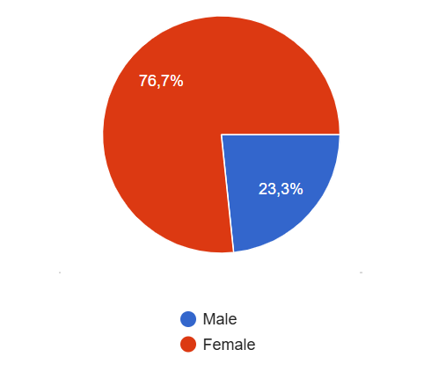
Figure 1. Participants' gender

Among the 60 respondents, 76.7% were female (n = 46) and 23.3% were male (n = 14). Although gender differences were not statistically examined, the distribution reflects the gender composition typical of English-major cohorts.
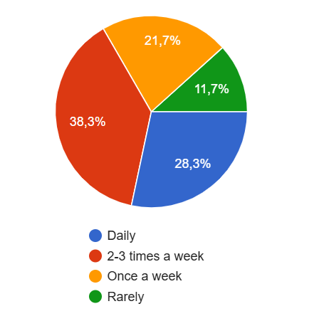
Figure 2. Frequency of AI tool usage for academic writing
Quantitative findings show that AI is deeply embedded in students’ academic routines, with 66.6% of respondents using it regularly (daily to thrice weekly). While this signals the normalization of AI within the learning ecology, frequency metrics alone do not capture the pedagogical nuances of its use. Qualitative data reveal significant variations in regulatory patterns, indicating that high exposure does not inherently equate to cognitive dependency.
Contrasting student perspectives highlight this stratification. For instance, Participant 4 engages in "cognitive outsourcing," delegating higher-order processes—such as ideation and drafting—to AI. From the perspective of cognitive load theory, this practice risks bypassing essential schema construction and rhetorical internalization, effectively positioning AI as a surrogate writer rather than a scaffold. In contrast, Participant 5 demonstrates higher metacognitive control by using AI strictly for post-drafting feedback. By retaining ownership of argument development and using the tool primarily to refine linguistic accuracy, this approach aligns with self-regulated learning principles.
These findings suggest that identical usage frequencies conceal distinct modes of engagement. Because the same frequency category can encompass both creative delegation and selective revision, the critical variable is the locus of cognitive control. Future research should therefore move beyond simple frequency metrics and instead prioritize analyzing regulatory depth, task delegation patterns, and metacognitive awareness to better assess the pedagogical value of AI integration.
4.1.2. Platform preference and functional orientation

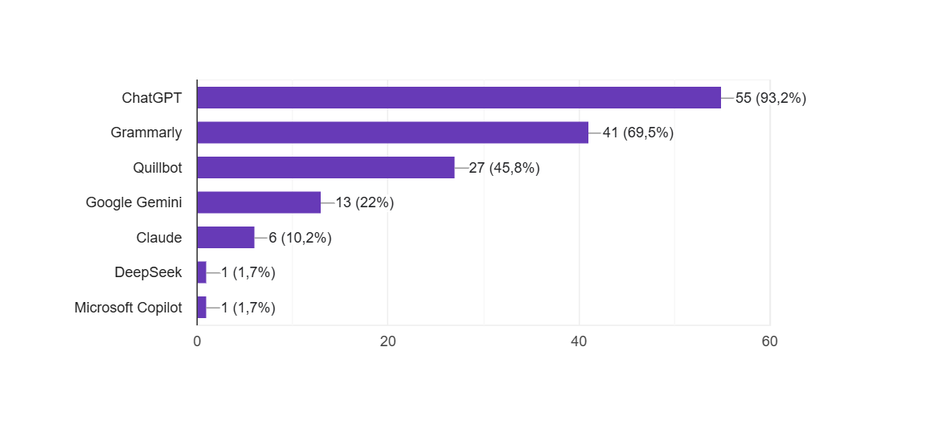
Figure 3. Distribution of AI tools used by participants

Usage patterns are dominated by ChatGPT (93.2%), followed by Grammarly (69.5%), QuillBot (45.8%), Gemini (22%), and Claude (10.2%). This preference for multi-functional generative AI over single-purpose tools indicates that students seek comprehensive support—including ideation and restructuring—rather than mere linguistic correction.
However, the dominance of a single platform fosters "habitualization," potentially reducing critical cross-verification. Qualitative insights confirm a clear gap between awareness and action: despite acknowledging risks like AI-generated hallucinations (Participant 7), students lack systematic verification habits. These findings suggest that while ChatGPT has become central to academic routines, reliance on a single, default system does not guarantee responsible engagement. Consequently, there is a pressing need for structured pedagogical guidance to transition students from convenient, passive reliance toward critical and deliberate AI use.
4.1.3. AI across the writing process

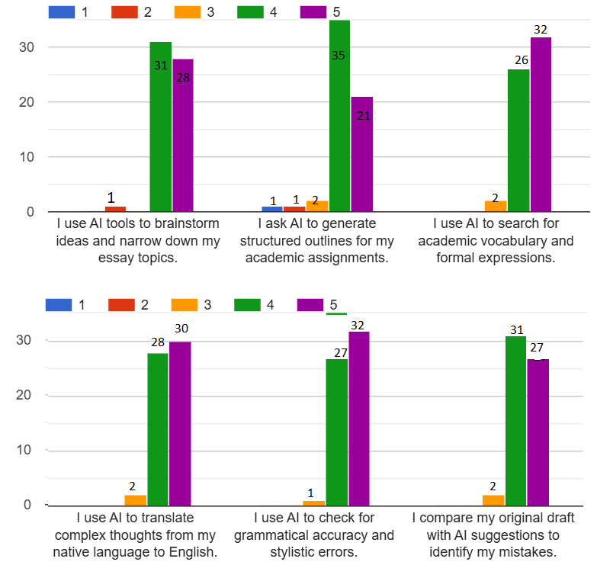
Figure 4. Current Writing Practices

The Likert-scale responses reveal particularly strong integration during the planning and revision phases.
For brainstorming (Item 1), 98.4% of students agreed or strongly agreed (31 agree; 28 strongly agree). For outline generation (Item 2), 93.3% expressed positive agreement. These findings suggest that AI has become a pre-writing scaffold.
From a self-regulated learning perspective, this may reduce initial cognitive anxiety. However, it may also limit productive struggle, which is essential for long-term writing development.
Grammar correction (Item 5) received 98.3% positive agreement (32 strongly agree; 27 agree). Vocabulary enhancement (Item 3) and translation of complex thoughts (Item 4) each reached 96.7%.
These results show that AI functions most strongly at the micro-linguistic level. Students appear to trust AI most when dealing with surface-level accuracy.
Yet, revision behavior (Item 6) reveals important nuance. While 96.7% agreed that they compare their drafts with AI suggestions, interviews reveal two patterns:
Participant 7 explained:
“If the suggestion changes my argument, I don’t accept it.”
This indicates evaluative filtering, characteristic of higher-level metacognitive regulation.
Conversely, Participant 9 admitted:
“I usually accept it because it sounds more academic than mine.”
Here, linguistic sophistication becomes equated with correctness, potentially suppressing authorial voice.
Thus, AI is simultaneously a revision scaffold and a voice modifier.
4.2. Students’ perceptions, benefits, and challenges
4.2.1. Psychological and academic benefits

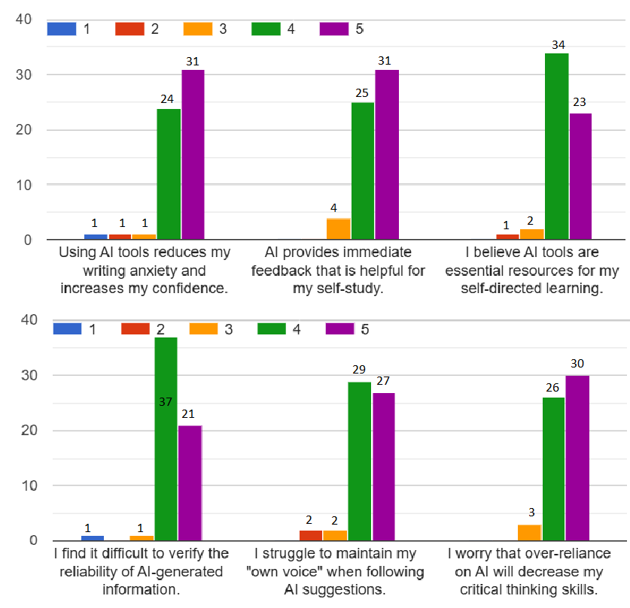
Figure 5. Psychological and Academic Benefits

For anxiety reduction (Item 7), 91.7% expressed agreement (24 agree; 31 strongly agree). Immediate feedback (Item 8) reached 93.3%. These figures indicate that AI plays an affective and temporal support role.
Participant 1 stated:
“It makes me feel more confident because my writing sounds more native-like.”
This highlights performance enhancement.
However, confidence appears partially AI-dependent. Participant 9 reflected:
“It improves my short-term confidence but makes me worry about my long-term ability.”
This statement introduces a critical tension between performance gains and competence development.
Similarly, 95% of students agreed that AI is essential in their writing process (Item 9). Yet interviews suggest that “essential” may mean “efficient” rather than “indispensable.”
Participant 2 clarified:
“AI should be a co-editor, not a ghostwriter.”
This distinction demonstrates conceptual awareness of ethical boundaries.
4.2.2. Cognitive and ethical tensions

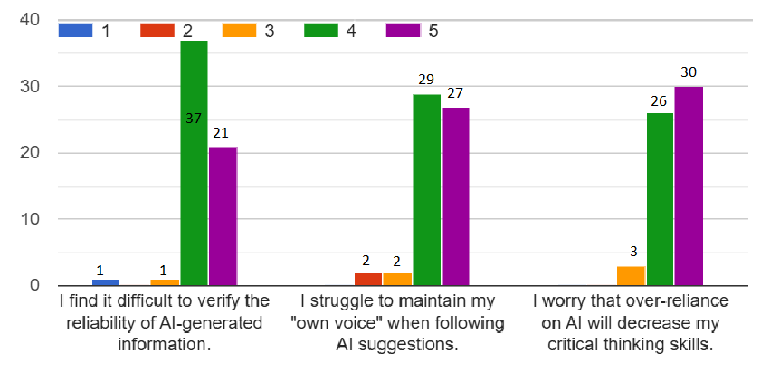
Figure 6. Cognitive and Ethical Tensions

High agreement levels also appeared in concern-related items.
For difficulty verifying AI reliability (Item 10), 96.7% agreed. Maintaining personal voice (Item 11) reached 93.3%. Concern about weakening critical thinking (Item 12) also reached 93.3%.
Such consistently high concern percentages indicate that students are not blindly dependent. Rather, they experience cognitive dissonance: they benefit from AI yet fear its consequences.
Participant 4 admitted:
“If AI is banned, I cannot write independently.”
This suggests emerging dependency.
In contrast, Participant 5 asserted:
“AI should only be used in the revision stage.”
This represents strategic containment of AI influence.
The coexistence of high usage and high concern suggests transitional adaptation rather than stabilized integration.
4.3. A proposed AI-assisted self-directed learning model
Given the high agreement levels for structured guidance (over 96% support for ethical checklists, verification practices, and critical AI literacy), a systematic framework is clearly needed.
The proposed model is the AI-Supported Self-Regulated Writing Model (SRWM), structured around four cyclical stages.
4.3.1 Model components
The SRWM is grounded in four iterative stages of Self-Regulated Learning:
1. Planning
In this stage, students set goals, brainstorm ideas, and create outlines.
AI Role: ChatGPT supports idea expansion and structural suggestions.
However, students must first define their own thesis and learning objectives before consulting AI. This preserves cognitive ownership.
2. Monitoring
Students draft essays and monitor language accuracy.
AI Role: Grammarly and QuillBot assist with grammar correction, paraphrasing, and clarity.
At this stage, students compare AI feedback with their intended meaning rather than accepting suggestions automatically.
3. Evaluating
Students evaluate coherence, argument strength, and factual accuracy.
AI Role: AI feedback tools help identify structural weaknesses.
Students must verify all references and claims independently. This addresses the 96.7% concern regarding reliability.
4. Reflecting
Students engage in reflective journaling.
AI Role: ChatGPT can assist by prompting reflection questions such as:
• What improvements did AI suggest?
• Which suggestions were accepted or rejected?
• Why?
This stage strengthens metacognitive awareness and reduces passive dependence.
The cyclical structure ensures that AI supports, rather than replaces, learner agency.
4.3.2. Practical applications
The Self-Regulated Writing Model (SRWM) proposed in this study is not merely a theoretical construct but a pedagogically actionable framework grounded in empirical findings from both quantitative and qualitative data. Given the high frequency of AI tool usage reported among participants and the unanimous agreement (100%) on the necessity of AI literacy training, the institutional implementation of this model is both feasible and pedagogically justified.
First, the integration of faculty-provided AI ethics guidelines is essential to establish normative boundaries for responsible AI usage. Survey findings revealed that while students frequently use AI for idea generation, paraphrasing, and grammar correction, many demonstrated uncertainty regarding appropriate attribution practices and the risks of over-reliance. This suggests that without explicit institutional guidance, AI usage may drift toward dependency rather than skill development. Therefore, formalized ethical frameworks can function as regulatory scaffolding, ensuring AI remains a supplementary tool rather than a substitute for cognitive engagement.
Second, the adoption of structured prompting templates can help transform AI interaction from passive content reception into strategic academic inquiry. Interview data indicated that students who used more specific prompts (e.g., requesting feedback on coherence or argument structure rather than full essay generation) perceived greater improvement in writing ability. This aligns with self-regulated learning theory, which emphasizes planning and monitoring as core components of skill development. Structured prompts, therefore, operationalize metacognitive awareness in AI-assisted writing.
Third, mandatory reference verification exercises directly address concerns related to AI hallucination and fabricated citations, a risk acknowledged by several participants. Instead of prohibiting AI use, embedding verification tasks into coursework encourages students to critically evaluate AI-generated content. This approach fosters epistemic vigilance and strengthens academic integrity while maintaining technological integration.
Fourth, the inclusion of reflective learning journals enables learners to document how AI was used, what revisions were made independently, and what learning gains were achieved. Such reflective practices are particularly important given that qualitative findings revealed an internal tension among students between grade optimization and genuine competence development. Reflection serves as a mechanism to reconcile this tension by re-centering learning objectives.
Finally, workshops on AI hallucination detection and critical AI literacy should be institutionalized. Given that all participants expressed support for training in verification skills, there is strong learner readiness for structured intervention. Rather than framing AI as a threat to academic integrity, these workshops reposition it as a literacy domain requiring instruction, similar to information literacy or digital literacy.
Importantly, the SRWM emphasizes gradual independence. The goal is not to eliminate AI assistance but to progressively reduce cognitive outsourcing. As one participant insightfully stated:
“AI improves my grades, but I want to improve my real ability.”
This statement encapsulates the central pedagogical tension identified in this research. The SRWM responds to this gap by shifting AI from a generative shortcut to a regulated learning assistant embedded within a metacognitive framework. In doing so, the model supports both performance outcomes and sustainable skill development, thereby aligning technological affordances with long-term academic growth.
5. CONCLUSION AND RECOMMENDATIONS
5.1. Conclusion
5.1.1. Findings on AI integration
AI tools have become structurally embedded in the writing processes of fourth-year English majors at QNU, with 66.6% reporting regular use and 93.2% favoring ChatGPT. AI engagement spans the entire writing cycle—from planning (brainstorming, outlining) to performance (drafting, editing) and evaluation (revision). Theoretically, AI acts as a mediational artifact within the SRL cycle; however, usage is stratified by "regulatory depth." The critical distinction among students is not frequency of use, but the level of metacognitive control maintained over the writing process.
5.1.2. Ambivalent empowerment
The study identifies a paradox: students experience significant psychological and academic benefits, such as reduced anxiety and improved efficiency, alongside intense concerns regarding AI reliability, authenticity, and the potential erosion of critical thinking. This tension reflects a transitional stage of "ambivalent empowerment," where students recognize AI as a powerful scaffold yet remain anxious about potential cognitive dependency. The need for evaluative judgment—deciding when to accept or reject algorithmic suggestions—emerges as a core competence in this AI-mediated landscape.
5.1.3. The SRWM framework
Given the high demand for structured guidance (100% of participants supported literacy training), this study proposes the AI-Supported Self-Regulated Writing Model (SRWM). By mapping AI interaction onto the four stages of Planning, Monitoring, Evaluating, and Reflecting, the SRWM reconceptualizes AI from a potential authorial substitute into a regulated scaffold that supports metacognitive development.
5.2. Pedagogical implications
5.2.1. For educators and curriculum designers
Institutions should shift from reactive prohibitions to structured integration. Lecturers should embed AI literacy workshops, require transparency in AI-assisted work, and design assessments that focus on process accountability—such as revision logs and justification of AI-generated suggestions—rather than solely on the final product.
5.2.2. For students
Students must cultivate "evaluative judgment" to treat AI as a dialogue partner rather than an authoritative source. Essential practices include independent thesis formulation, rigorous cross-verification of facts, and the use of reflective journals to document learning. Developing these metacognitive skills is critical for distinguishing autonomous, professional writers from passive, AI-dependent users.
5.3. Limitations
This study is subject to several constraints: the sample size ($N=60$) is limited to a single cohort; the descriptive, non-experimental design precludes establishing causal relationships; and reliance on self-reported data may not fully capture objective interaction patterns. Furthermore, the SRWM remains a conceptual framework that requires future empirical testing.
5.4. Suggestions for further studies
Future research should employ experimental designs to test the efficacy of the SRWM through structured interventions. Longitudinal studies are needed to track the evolution of AI-assisted self-regulation over time, while interdisciplinary approaches incorporating textual analysis of
Conflict of interest
The author(s) declare no competing interests.

REFERENCES
- O. Zawacki-Richter, V. I. Marín, M. Bond, and F. Gouverneur, “Systematic review of research on artificial intelligence applications in higher education – Where are the educators?” International Journal of Educational Technology in Higher Education, vol. 16, no. 39, pp. 1-27, 2019.
- M. Bearman and R. Ajjawi, “Learning to work with the black box: Pedagogy for a world with generative AI,” British Journal of Educational Technology, vol. 54, no. 5, Sep., pp. 1160–1173, 2023.
- K. Beatty, Teaching & Researching Computer-Assisted Language Learning, 2nd edition. London: Routledge, 2010.
- W. M. Lim et al., “Generative AI and the future of education: Ragnarök or reformation?” Interactive Learning Environments, pp. 1-22, 2023.
- K. Hyland, Second Language Writing, 2nd edition. Cambridge: Cambridge University Press, 2019.
- M. S. Knowles, Self-Directed Learning: A Guide for Learners and Teachers. Chicago: Association Press, 1975.
- B. J. Zimmerman, “Attaining self-regulation: A social cognitive perspective,” in Handbook of Self-Regulation, M. Boekaerts, P. R. Pintrich, and M. Zeidner, Eds. San Diego: Academic Press, 2000, pp. 13-39.
- M. Warschauer, “Computer-Assisted Language Learning: An Introduction,” in Multimedia Language Teaching, S. Fotos, Ed. Tokyo: Logos International, 1996, pp. 3-20.
- R. Luckin, W. Holmes, M. Griffiths, and L. B. Forcier, Intelligence Unleashed: An Argument for AI in Education. London: Pearson, 2016.
- J. Sweller, “Cognitive load during problem solving: Effects on learning,” Cognitive Science, vol. 12, no. 2, pp. 257–285, 1988.
- D. R. E. Cotton, P. A. Cotton, and J. R. Shipway, “Chatting and cheating: Ensuring academic integrity in the era of ChatGPT,” Innovations in Education and Teaching International, vol. 60, no. 6, pp. 1–11, 2023.
- M. Sullivan, A. Kelly, and P. McLaughlan, “ChatGPT in higher education: Considerations for academic integrity and student learning,” Journal of Applied Learning & Teaching, vol. 6, no. 1, pp. 1–10, 2023.
- P. Benson, Teaching and Researching Autonomy, 2nd edition. London: Routledge, 2011.
- D. R. Garrison, “Self-directed learning: Toward a comprehensive model,” Adult Education Quarterly, vol. 48, no. 1, pp. 18–33, 1997.
- N. Selwyn, Education and Technology: Key Issues and Debates, 3rd edition. London: Bloomsbury Academic, 2021.
- L. van Lier, The Ecology and Semiotics of Language Learning: A Sociocultural Perspective. Kluwer Academic Publishers, 2004.
- L. S. Vygotsky, Mind in Society: The Development of Higher Psychological Processes. Harvard University Press, 1978.
- E. M. Golonka, A. R. Bowles, V. M. Frank, D. L. Richardson, and S. Freynik, “Technologies for foreign language learning: A review of technology types and their effectiveness,” Computer Assisted Language Learning, vol. 27, no. 1, pp. 70–105, 2014.
- R. W. Schmidt, “The role of consciousness in second language learning,” Applied Linguistics, vol. 11, no. 2, pp. 129–158, 1990.
- N. Hockly, “Artificial intelligence in English language teaching: The good, the bad and the ugly,” Modern English Teacher, vol. 32, no. 2, pp. 21–25, 2023.
- M. Stevenson and A. Phakiti, “The effects of computer-generated feedback on the quality of writing,” Assessing Writing, vol. 19, pp. 51–65, 2014.
- J. Ranalli, “Automated written corrective feedback: How well can students make use of it?” Computer Assisted Language Learning, vol. 31, no. 7, pp. 653–674, 2018.
- M. Groves and K. Mundt, “Friend or foe? Google Translate in language for academic purposes,” English for Specific Purposes, vol. 37, pp. 112–121, 2015.
- E. M. O’Neill, “Training students to use online translators and dictionaries: The impact on second language writing scores,” International Journal of Research Studies in Language Learning, vol. 8, no. 2, pp. 47–65, 2019.
- J. Tai, R. Ajjawi, D. Boud, P. Dawson, and E. Panadero, “Developing evaluative judgement: Enabling students to make decisions about the quality of work,” Higher Education, vol. 76, no. 3, pp. 467–481, 2018.
- Grassini, S. (2023), “Shaping the future of education: Exploring the potential and consequences of AI and ChatGPT in educational settings”, Education Sciences, 13(7), 692.

Phát triển mô hình ứng dụng AI trong tự học viết học thuật tiếng Anh: Khảo sát tại Trường Đại học Quy Nhơn đối với sinh viên năm cuối ngành Ngôn ngữ Anh
Nguyễn Trần Ý Nhi*, Trương Văn Định

Khoa Ngoại ngữ, Trường Đại học Quy Nhơn, Bình Định, Việt Nam

*Tác giả liên hệ chính. Email: nhi4557510173@st.qnu.edu.vn

TÓM TẮT
Nghiên cứu này khảo sát việc tích hợp các công cụ Trí tuệ nhân tạo (AI) trong quá trình tự học viết học thuật tiếng Anh của 60 sinh viên năm cuối ngành Ngôn ngữ Anh tại Trường Đại học Quy Nhơn. Bằng phương pháp nghiên cứu hỗn hợp (mixed-methods), nghiên cứu phân tích các thực trạng, quan điểm và tính hai mặt của các công cụ AI—nhấn mạnh vào những lợi ích như cải thiện độ chính xác về ngôn ngữ và hiệu quả công việc, song song với đó là các thách thức như sự phụ thuộc quá mức và những lo ngại về đạo đức. Đóng góp chính của nghiên cứu là đề xuất Mô hình Viết tự chủ có hỗ trợ bởi AI (SRWM)—một khung quy trình bốn giai đoạn tuần hoàn (Lập kế hoạch, Giám sát, Đánh giá và Phản tư) được thiết kế nhằm thúc đẩy sự tự chủ của người học và năng lực sử dụng AI có đạo đức. Kết quả nghiên cứu khẳng định sự cần thiết của một chiến lược sư phạm chuyển đổi, hướng tới việc tích hợp AI như một công cụ hỗ trợ tư duy trong bối cảnh giảng dạy kỹ năng viết ở bậc đại học.
Keywords: Viết có hỗ trợ bởi AI, học tập tự điều chỉnh, sự tự chủ của người học, hàm ý sư phạm, liêm chính học thuật.

