Sàng lọc môi trường Zarrouk cải tiến trong nuôi tảo
Spirulina platensis

TÓM TẮT
Nghiên cứu này hướng tới cải tiến môi trường nuôi cấy tảo Spirulina platensis, nhằm xác định môi trường dinh dưỡng rẻ tiền phù hợp với việc nuôi cấy loài tảo này. Nghiên cứu được thực hiện trên 4 loại môi trường gồm môi trường Zarrouk cơ bản (M1), môi trường Zarrouk (75%) bổ sung muối NaCl (M2), môi trường Zarrouk (50%) bổ sung muối NaCl (M3), môi trường Zarrouk (25%) bổ sung muối NaCl (M4). Các loại môi trường này được hòa tan bằng nước lọc RO. Định kỳ đo các giá trị pH, độ mặn của các loại môi trường và mật độ sinh khối tảo tại bước sóng 560 nm (OD560). Kết quả cho thấy môi trường M3 có mật độ sinh khối tảo cao nhất sau 22 ngày nuôi (OD560 = 1,448). Giá trị pH và độ mặn của các loại môi trường đều nằm trong khoảng thích hợp cho tảo phát triển. Riêng đối với môi trường M4 thì ngày thứ 21 trở đi có giá trị pH >11 nên mật độ tảo giảm mạnh. Tiếp tục khảo sát 2 loại dung môi để hòa tan môi trường M3 là nước lọc RO và nước khoáng thiên nhiên tại Phước Mỹ, Bình Định. Kết quả cho thấy môi trường M3 được hòa tan bằng nước lọc RO có mật độ sinh khối tảo cao hơn so với hòa tan bằng nước khoáng. Vì vậy, môi trường M3 hòa tan bằng nước lọc RO được lựa chọn để nuôi tảo ở quy mô thí điểm nhằm tiết kiệm chi phí cũng như thu được lượng tảo nhiều nhất.
Từ khóa: Spirulina platensis, Zarrouk, OD560, mật độ sinh khối tảo.

Screening of the modified Zarrouk medium for
Spirulina platensis cultivation

ABSTRACT
This study aimed to improve the cultivation medium for Spirulina platensis, with the goal of identifying a cost-effective nutrient medium suitable for cultivating this alga. The research was conducted on 4 types of media, including basic Zarrouk medium (M1), Zarrouk medium (75%) supplemented with sodium chloride (M2), Zarrouk medium (50%) supplemented with sodium chloride (M3), Zarrouk medium (25%) supplemented with sodium chloride (M4). These media were prepared with RO water. The pH values, salinity values of the media and the biomass density of the algae were periodically measured at a wavelength of 560 nm (OD560). The results showed that M3 medium had the maximum biomass density after 22 days of cultivation with OD560 = 1.448. The pH and salinity values of all media remained within a suitable range for algae growth. However, for the M4 medium, the pH value exceeded 11 after the 21st day, resulting in a significant decline in algae density. Further investigation was conducted on two solvents used to dissolve the M3 medium: RO water and natural mineral water from Phuoc My commune, Binh Dinh province. The results indicated that the M3 medium dissolved in RO water had a higher algae biomass density compared to being dissolved in mineral water. Therefore, the M3 medium dissolved in RO water was chosen for pilot-scale algae cultivation to reduce costs while obtaining the highest possible algae yield.
Keywords: Spirulina platensis, Zarrouk, OD560, algae density.

INTRODUCTION
Spirulina platensis (Arthrospira platensis) is regarded as a superfood due to its exceptional nutritional value and broad potential applications in nutrition and medicine. Spirulina contains protein of 60-70%, which is three times higher than beef and more than double that of soybeans, making it one of the most ideal sources of plant- based protein. Additionally, Spirulina is rich in essential amino acids such as lysine, methionine, phenylalanine, tryptophan, along with vital minerals like copper, zinc, magnesium and iron, effectively meeting the micronutrient requirements of the human body. Its high vitamin content further enhances the biological value of this alga.
Beyond its nutritional benefits, Spirulina has also been proven to boost the immune system and aid in preventing serious conditions such as cancer, hepatitis and diabetes. With its scientifically verified advantages, the World Health Organization (WHO) has recognized Spirulina as a safe food source and an effective tool for disease prevention and treatment in the 21st century.
However, the Zarrouk medium used for cultivating algae facilitates optimal Spirulina
growth but is relatively expensive, limiting its scalability for production. Therefore, researching and developing cost-effective alternative culture media is an urgent requirement. This solution would significantly reduce the production costs of Spirulina, enhance its accessibility to the community and create new opportunities for the functional food and modern biomedical industries.

MATERIALS AND RESEARCH METHODS

Materials
Algae Culture Medium: Zarrouk medium, sodium chloride salt, RO water, natural mineral water from Phuoc My commune, Binh Dinh province.
The chemicals used to prepare the Zarrouk medium were purchased from Viet My Chemical Company, Binh Dinh.
Spirulina platensis strain: The algae strain was sourced from Minh Thien algae aupply facility in Bac Ninh, Viet Nam. The morphological characteristics of the Spirulina strain (observed under a MicroBlue optical microscope with a 40X objective) include a helical filamentous shape and a distinctive blue- green color.

Research methods
    - Experimental design
The experiment was conducted in the Plant Cell Tissue Culture Laboratory, Faculty of Natural Sciences, Quy Nhon University (Figure 1).
- Experiment 1: Investigation of optimal nutritional medium for cultivating Spirulina
Investigation of the influence of four types of nutritional media on the biomass increase of algae. The media used included:
M1: Basic Zarrouk medium.
M2: Zarrouk medium (75%) supplemented with sodium chloride.
M3: Zarrouk medium (50%) supplemented with sodium chloride.
M4: Zarrouk medium (25%) supplemented with sodium chloride.
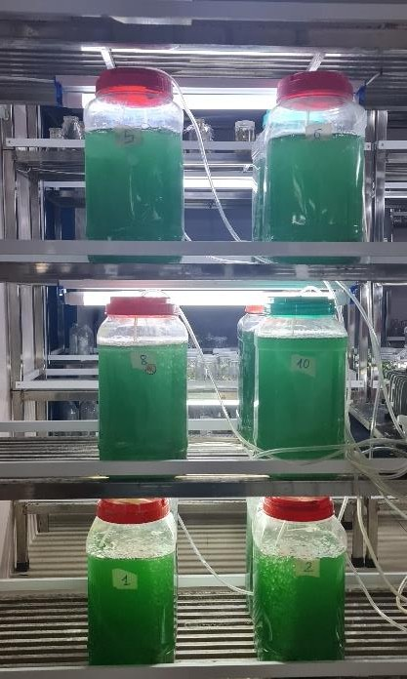
Figure 1. Experimental design.

Each treatment was conducted in a 5-Liter plastic jars. The Spirulina strain was inoculated into each jar to achieve an initial cell density of
0.061 OD. Continuous aeration at a flow rate of 5 L/min was maintained throughout the cultivation process, with a temperature set at 28 °C and continuous lighting provided by LED lamps at an intensity of 1100 lux.
Monitored parameters included optical density (OD), pH levels and salinity of the medium, with measurements taken daily throughout the cultivation process. The biomass density of the algae in each treatment was compared to select the optimal nutritional medium for cultivating Spirulina.
- Experiment 2: Investigation of Solvent Selection for Preparing the Optimal Nutritional Medium for Algae Cultivation based on Experiment 1
Investigation of two types of solvents for preparing the nutritional medium chosen in experiment 1, including RO water and natural mineral water from Phuoc My commune, Binh Dinh province. The treatments were performed under the same conditions as those in experiment 1.
Monitored parameters included optical density (OD), pH levels and salinity of the medium, with measurements taken daily throughout the cultivation process. The biomass density of Spirulina in each treatment was compared to select the most appropriate solvent.
    - Analysis and evaluation methodology
- Determination of biomass density
Growth of Spirulina was monitored daily by determining the biomass density using the optical density (OD) measurement method. The OD was measured using a spectrophotometer (Aurius CE- 2011) at a wavelength of 560 nm. This method facilitates the quantification of algal biomass, providing a reliable indicator of growth performance over the cultivation period.
- Determination of pH value
Assessment of pH in the Spirulina cultivation medium: The pH of the algal cultivation medium was monitored daily and measured using a pH meter (Winlab W06-614310025). This measurement to ensure that the pH remains within the optimal range for Spirulina growth, as pH fluctuations can significantly affect algal growth and metabolic activity.
- Determination of salinity
Assessment of salinity in the Spirulina cultivation medium: The salinity of the algal cultivation medium was monitored daily and measured using a refractometer (Alla ALL35540). This measurement is crucial for ensuring that the salinity levels remain appropriate for the growth of Spirulina, as variations in salinity can impact algal health and productivity.
- Determination of protein content
The algae samples are filtered using a mesh filter and dried at 55 °C for 8 hours. The protein content is analyzed according to TCVN 8125:2009.
- Determination of acid insoluble ash content
The algae samples are filtered using a mesh filter and dried at 55 °C for 8 hours.

The acid insoluble ash content is analyzed according to TCVN 7765:2007.
    - Data processing methodology
The recorded data were processed using Excel and Minitab 16 software. Each experiment was repeated three times and the data were presented as means and underwent statistical analysis to indicate significant differences.

RESULTS AND DISCUSSION

Survey for selecting optimal nutrient media for cultivating Spirulina
The basic Zarrouk medium (M1) is formulated with the following components:
Table 1. Composition of basic Zarrouk medium (M1).

No. | Component | Concentration (g/L)
1 | NaHCO3 | 16.8
2 | K2HPO4 | 0.5
3 | FeSO4.7H2O | 0.01
4 | CaCl2.2H2O | 0.04
5 | MgSO4.7H2O | 0.2
6 | NaCl | 1.0
7 | K2SO4 | 1.0
8 | NaNO3 | 2.5
9 | EDTA | 0.08
10 | H3BO4 | 0.00286
11 | MnCl2.4H2O | 0.00181
12 | ZnSO4.7H2O | 0.00022
13 | MoO3 | 0.00001
14 | CuSO4.5H2O | 0.00008

Table 2. Composition of nutrient media M2, M3, and M4.

No. | Medium | Composition Description
1 | M2 | 75% Basic Zarrouk medium (M1)  + 15 mL/L of Sodium Chloride Salt solution with 100‰ salinity
2 | M3 | 50% Basic Zarrouk medium (M1)  + 15 mL/L of Sodium Chloride Salt solution with 100‰ salinity
3 | M4 | 25% Basic Zarrouk medium (M1)  + 15 mL/L of Sodium Chloride Salt solution with 100‰ salinity
The Spirulina was cultivated in four types of media (M1, M2, M3, M4), dissolved in RO water, at a temperature of 28 °C, with continuous aeration and lighting. The following parameters were monitored: biomass density measured at a
wavelength of 560 nm, pH and salinity of the cultivation medium. The results obtained are as follows.
    - Changes in algal biomass density during the algal cultivation process
The changes in biomass density of Spirulina across the four nutrient media are illustrated in Figure 2 and detailed in Table 3.
The results indicate that the biomass density increased in all four nutrient media. From Day 1 to Day 15, the increase in biomass density was minimal, corresponding to the lag phase, which is the period required for the algae to acclimate to the culture environment. From Day 16 to Day 20, a significant increase in biomass density was observed, corresponding to the logarithmic phase. Day 22, biomass density for media M1, M2, and M3 showed negligible increases, indicating the stationary phase. However, in medium M4, there was a sharp decline in biomass density due to the pH of the environment rising above 11. Thus, after 22 days of cultivation, the highest biomass density was recorded in medium M3, which was statistically significant (p < 0.05).
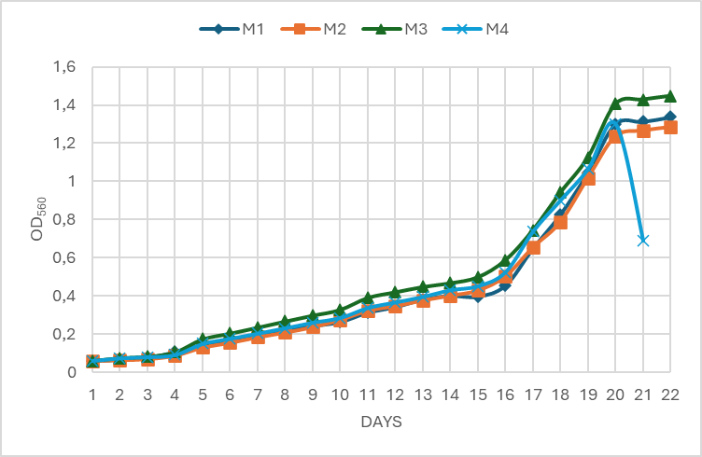
Figure 2. Development of biomass density of
Spirulina in different nutrient media.

According to previous research,² it is possible to substitute the sodium bicarbonate (NaHCO₃) content with sodium chloride (NaCl) in the cultivation medium for Spirulina. Reducing NaHCO₃ to a certain level, or fully replacing it, could result in lower productivity for the algae. Therefore, the author suggests investigating an appropriate concentration of NaCl as a replacement to ensure optimal growth of the algae.
Thus, it is feasible to reduce the components in the basic Zarrouk medium by 50% and incorporate sodium chloride salt. This adjustment not only facilitates the healthy growth and development of the algae but also results in cost savings.

    - Changes in the pH of the media during the algal cultivation process
The change in pH of four types of media during the algal cultivation process is illustrated in Figure 3.
During algal growth and development, the pH of the medium gradually increases as algae assimilate essential compounds such as carbon, nitrogen and minerals for their metabolic processes. Additionally, algae may utilize EDTA as a nitrogen source, which further contributes to the increase in pH. The findings of this study indicate that from Day 1 to Day 16, pH increases at a slow rate, corresponding to the initial slow growth of the algae. However, from Day 17 to Day 22, the pH rises more rapidly, reflecting the accelerated growth and increased consumption of available nutrient sources by the algae.
Furthermore, the marked increase in pH observed in media M4 can likely be attributed to the depletion of the medium’s buffering capacity. This effect becomes more pronounced as the algae rapidly deplete the available nutrients, causing a significant shift in pH levels. These observations emphasize the critical importance of maintaining pH within an optimal range to sustain both algal health and the stability of the culture system. Notably, the sedimentation observed in M4 suggests that excessively high pH may compromise algal cell integrity, leading to cell aggregation and precipitation rather than remaining uniformly dispersed in the medium.
Previous research has identified the optimal pH range for Spirulina growth as 8.3 to
Table 3. Biomass Density Changes Over Time.
11.5 The pH values in media M1, M2, and M3 (9.29–10.38) fall within this optimal range, supporting robust algal growth and a steady increase in algal density during cultivation. In contrast, in media M4, where the pH exceeds 11 on Days 21 and 22, significant algal mortality is observed, accompanied by sedimentation at the bottom of the culture flask, leading to a sharp decline in algal density.
These results underscore the importance of selecting an appropriate cultivation medium and carefully monitoring pH levels to optimize algal productivity. Maintaining a stable pH environment is essential for maximizing algal biomass yield and ensuring efficient nutrient utilization. Such control is crucial for scaling up algal cultivation for industrial applications. Therefore, understanding the intricate relationship between pH and algal growth is vital for refining cultivation strategies and achieving optimal yields.
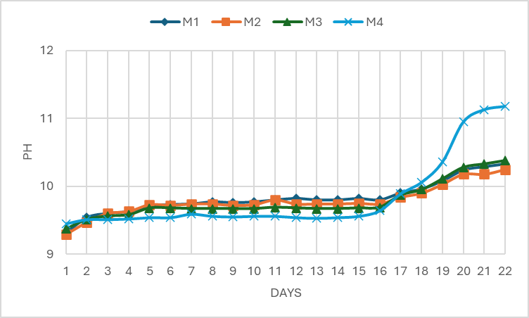
Figure 3. pH values of different algal cultivation media over the days.

Days | Biomass Density (OD560)
Days | M1 | M2 | M3 | M4
1 | 0.061 ± 0.002ª | 0.061 ± 0.001ª | 0.061 ± 0.001ª | 0.061 ± 0.002ª
2 | 0.067 ± 0.003^{b} | 0.065 ± 0.001^{b} | 0.076 ± 0.001ª | 0.075 ± 0.002ª
3 | 0.078 ± 0.001^{b} | 0.071 ± 0.002^{c} | 0.083 ± 0.003ª | 0.081 ± 0.002^{a.b}
4 | 0.107 ± 0.004ª | 0.089 ± 0.003^{b} | 0.106 ± 0.001ª | 0.092 ± 0.002^{b}
5 | 0.145 ± 0.002^{c} | 0.131 ± 0.002^{d} | 0.174 ± 0.001ª | 0.15 ± 0.003^{b}
6 | 0.164 ± 0.001^{c} | 0.156 ± 0.001^{d} | 0.204 ± 0.003ª | 0.177 ± 0.002^{b}
7 | 0.198 ± 0.001^{c} | 0.185 ± 0.003^{d} | 0.235 ± 0.003ª | 0.204 ± 0.001^{b}
8 | 0.222 ± 0.001^{c} | 0.21 ± 0.001^{d} | 0.267 ± 0.001ª | 0.232 ± 0.002^{b}
9 | 0.244 ± 0.008^{c} | 0.238 ± 0.004^{c} | 0.298 ± 0.002ª | 0.261 ± 0.003^{b}
10 | 0.265 ± 0.001^{d} | 0.276 ± 0.002^{c} | 0.328 ± 0.001ª | 0.286 ± 0.002^{b}
11 | 0.314 ± 0.005^{d} | 0.324 ± 0.002^{c} | 0.391 ± 0.002ª | 0.338 ± 0.002^{b}
12 | 0.343 ± 0.003^{d} | 0.348 ± 0.002^{c} | 0.42 ± 0.004ª | 0.367 ± 0.004^{b}
13 | 0.382 ± 0.002^{c} | 0.378 ± 0.003^{c} | 0.448 ± 0.003ª | 0.396 ± 0.005^{b}
14 | 0.402 ± 0.008^{c} | 0.403 ± 0.004^{c} | 0.468 ± 0.001ª | 0.431 ± 0.007^{b}
15 | 0.398 ± 0.003^{d} | 0.43 ± 0.002^{c} | 0.499 ± 0.003ª | 0.452 ± 0.001^{b}
16 | 0.455 ± 0.003^{d} | 0.504 ± 0.002^{c} | 0.588 ± 0.004ª | 0.525 ± 0.002^{b}
17 | 0.648 ± 0.004^{d} | 0.655 ± 0.001^{c} | 0.745 ± 0.001ª | 0.738 ± 0.001^{b}
18 | 0.826 ± 0.002^{c} | 0.789 ± 0.007^{d} | 0.942 ± 0.009ª | 0.901 ± 0.006^{b}

19 | 1.045 ± 0.001^{c} | 1.019 ± 0.002^{d} | 1.126 ± 0.002ª | 1.065 ± 0.001^{b}
20 | 1.301 ± 0.008^{b} | 1.236 ± 0.002^{c} | 1.405 ± 0.003ª | 1.3 ± 0.009^{b}
21 | 1.313 ± 0.005^{b} | 1.267 ± 0.047^{c} | 1.429 ± 0.001ª | 0.69 ± 0.003^{d}
22 | 1.337 ± 0.006^{b} | 1.285 ± 0.013^{d} | 1.448 ± 0.010ª | -
In the same row, the superscript letters indicate statistically significant differences (p < 0.05).

    - Changes in salinity of the media during the algal cultivation process
The change in salinity of four types of media during the algal cultivation process is illustrated in Figure 4.

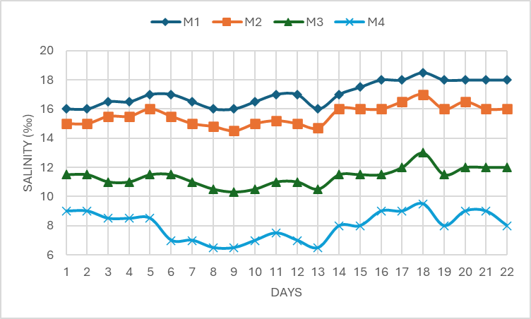
Figure 4. Salinity of different algal cultivation media over the days.

Based on Figure 4, the salinity in the media shows slight fluctuations over the days. During growth and development, Spirulina has the ability to absorb salts while releasing certain byproducts of metabolic processes, which leads to changes in the salinity of the medium.
Previous research has shown that when the salinity of the medium reaches 20‰, Spirulina growth slows significantly and cells die within 5–
6 days.^{8,9} This is attributed to the detrimental effects of high salinity on cellular osmotic pressure, which disrupts essential physiological processes such as photosynthesis and respiration, ultimately reducing the cell growth rate.
Experimental findings indicate that the salinity levels in all tested media remain within the permissible range for Spirulina growth and development, specifically between 9‰ and
18.5‰. Notably, medium M3 maintains a salinity range of 10.3‰ to 13‰, supporting a higher algal density compared to the other media. These results highlight the importance of maintaining optimal salinity conditions to enhance algal productivity and ensure the stability of cultivation systems.

Survey on the selection of solvents for preparing the optimal nutrient medium
The cultivation of Spirulina was performed using the M3 medium selected from Experiment 1, with two solvent types include RO water and
natural mineral water sourced from Phuoc My commune, Binh Dinh province. The cultivation conditions were maintained consistent with those of Experiment 1. The results detailing changes in pH, salinity and algal biomass density across the media are presented in the following Tables 4 and Figures 5, 6, 7.
Table 4. OD values of the two types of algal cultivation media over the days.

Days | OD560
Days | M3 | M3’
1 | 0.061 ± 0.001ª | 0.061 ± 0.002ª
2 | 0.076 ± 0.001ª | 0.074 ± 0.003ª
3 | 0.083 ± 0.003ª | 0.083 ± 0.005ª
4 | 0.106 ± 0.001ª | 0.097 ± 0.005^{b}
5 | 0.174 ± 0.001ª | 0.168 ± 0.002^{b}
6 | 0.204 ± 0.003ª | 0.194 ± 0.003^{b}
7 | 0.235 ± 0.003ª | 0.217 ± 0.002^{b}
8 | 0.267 ± 0.001ª | 0.257 ± 0.001^{b}
9 | 0.298 ± 0.002ª | 0.283 ± 0.002^{b}
10 | 0.328 ± 0.001ª | 0.313 ± 0.006^{b}
11 | 0.391 ± 0.002ª | 0.365 ± 0.011^{b}
12 | 0.42 ± 0.004ª | 0.398 ± 0.010^{b}
13 | 0.448 ± 0.003ª | 0.422 ± 0.002^{b}
14 | 0.468 ± 0.001ª | 0.443 ± 0.003^{b}
15 | 0.499 ± 0.003ª | 0.472 ± 0.003^{b}
16 | 0.588 ± 0.004ª | 0.565 ± 0.004^{b}
17 | 0.745 ± 0.001ª | 0.727 ± 0.004^{b}
18 | 0.942 ± 0.009ª | 0.912 ± 0.019ª
19 | 1.126 ± 0.002ª | 0.985 ± 0.009^{b}
20 | 1.405 ± 0.003ª | 1.304 ± 0.002^{b}
21 | 1.429 ± 0.001ª | 1.324 ± 0.004^{b}
22 | 1.448 ± 0.010ª | 1.356 ± 0.003^{b}
M3 (M3 medium dissolved in RO water); M3’(M3 medium dissolved in natural mineral water).
Experimental findings reveal that the pH levels of media M3 and M3’, range between 9.37 and 10.38, while salinity fluctuates from 10.3‰ to 14‰, which is suitable for the growth and development of Spirulina. The algal biomass density in both media exhibits an upward trend over the cultivation period. During the initial phase (Day 1 to Day 3), the algal density is comparable in both media. However, from Day 4 onward, medium M3 demonstrates a consistently higher biomass density compared to medium M3’.
The observed difference in algal density can be attributed to the elevated salinity levels in medium M3’, which likely impose osmotic stress, thereby slowing algal growth. These results suggest that using RO water as the solvent

for preparing the cultivation medium provides more favorable conditions for algal growth compared to natural mineral water. This highlights the importance of controlling salinity levels in the medium to optimize algal productivity.

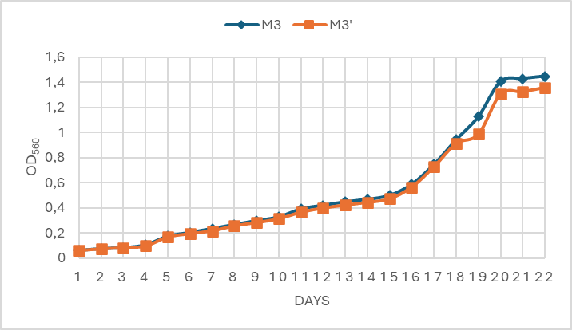
Figure 5. Growth of algal biomass density in two types of media over the days.
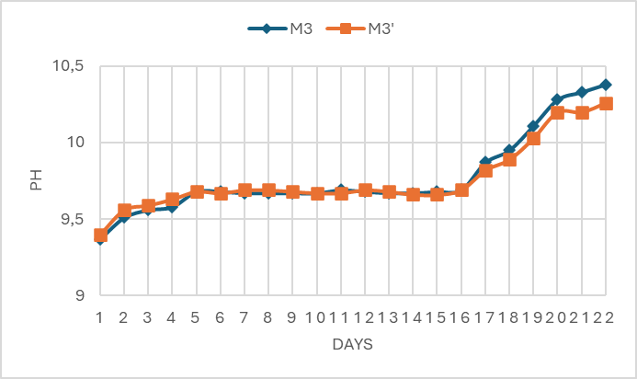
Figure 6. pH values of the two types of algal cultivation media over the days.
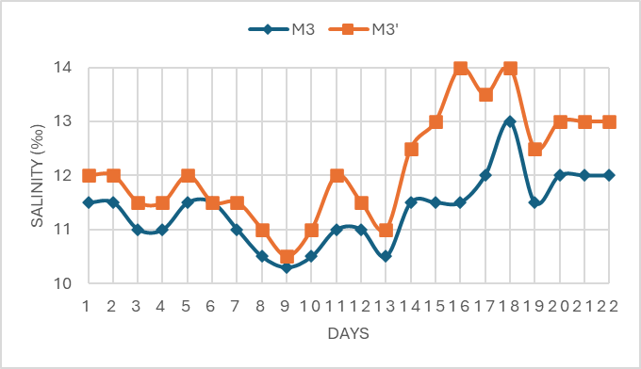
Figure 7. Salinity of two types of algal cultivation media over the days.

Protein content and acid insoluble ash content of Spirulina
The analysis results show that the protein content of Spirulina reached 64.7%, which is consistent with previous studies, where the protein content of the algae ranged from 60% to 70%.¹⁰⁻¹² Compared to another study, which reported a protein content of 51.98% to 54.53%,¹⁵ the algae obtained in this study have a significantly higher protein content. This demonstrates that
cultivating algae in M3 medium not only yields algae with high protein content but also provides economic benefits, while offering a valuable source of nutrition for humans.
The measured acid insoluble ash content is very low, at 0.11%, indicating a high degree of purity and quality of the Spirulina biomass. This low level of insoluble ash suggests that the algae are free from contaminants such as heavy metals, sand, or dust, which are potential concerns for the safety and applicability of the product.
Previous studies have reported an insoluble ash content of 0.28% and 2.09%,^{17,18} which was still considered acceptable for use in medical, functional, and therapeutic foods. Therefore, the Spirulina obtained in this study demonstrates superior purity, offering enhanced product quality compared to the Spirulina from earlier research.
  - Observing the morphology of Spirulina

using an optical microscope
The algae were cultivated using the selected nutrient medium and solvent to harvest biomass. The algal samples were then observed under an optical microscope using a 40X objective lens. Spirulina has a filamentous structure, a blue- green color, and exhibits movement, with many evenly spaced helical turns and numerous vacuoles containing air.
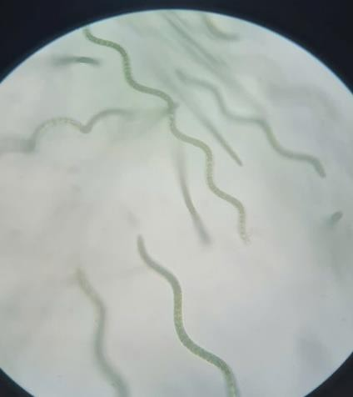
Figure 8. Morphology of Spirulina observed under a microscope.

CONCLUSION
The optimized algal cultivation medium is the Zarrouk medium at a 50% ratio, supplemented with sodium chloride at a salinity of 100‰ and a concentration of 15 mL/L, using RO water to prepare the medium. The maximum algal biomass density was achieved on Day 22 (OD560 = 1.448). Spirulina exhibits a blue-green color and a twisted filamentous structure, with a high protein content (64.7%) and low acid-insoluble

ash content (0.11%). Therefore, the use of this medium is recommended for further research to enhance the efficiency of algal cultivation while reducing costs.

REFERENCES
- Nguyen Thi Bich Ngoc. Research on the use of mineral water sources to establish a production process for Spirulina platensis to ensure quality as raw material for food processing for humans and aquaculture, Research project under the Biotechnology program, Institute of aquaculture research 3, 2010.
- Le Quynh Hoa. Survey on replacing NaHCO3 content with NaCl in the cultivation medium of Spirulina platensis, Research on biotechnology, Ho Chi Minh City college of economics and technology, 2013.
- Pham Thi Kim Ngoc. Cultivation of Spirulina platensis in seawater at laboratory scale and its application in food processing, Scientific and Technological information, Union of Science and Technology associations of Ba Ria – Vung Tau province, 2013, 3, 11-13.
- Tran Anh Tuan. Research on optimization of Athrospira platensis growth in pilot scale, The Journal of Science and Technology of Hung Vuong university, 2020, 19, 69-75.
- C. Zarrouk. Influence de divers facteurs physiquest et chimiques sur la croissance et la photsynthese de Spirulina maxima, Ph.D. Thesis, University of Pais, France, 1966.
- Godia. Culture of Spirulina platensis in human urine for biomass production and O2 evolution, Journal of Zhejiang University Science, 2006, 7, 34-37.
- Goksan. The growth of Spirulina platensis in different culture systems under greenhouse condition, Turkish Journal of Biology, 2007, 31, 47-52.
- M. T. Zeng, A. Vonshak. Adaptation of Spirulina platensis to sailnity stress, Comparative Biochemistry and Physiology, 1998, 120, 113-118.
- A. Vonshak, L. Tomaselli. Arthrospira (Spirulina): systematics and ecophysiology,
The Ecology of Cyanobacteria, Kluwer Academic Publisher, Italy, 2000.
- A. Belay, T. Kato, Y. Ota. The potential application of Spirulina (Arthrospira) as a nutritional and therapeutic supplement in Health Management, The Journal of the American Nutraceutical Association, 2002, 5,
27-45.
- G. Tang, M. Suter Paolo. Vitamin A, nutrition and health values of algae: Spirulina, Chlorella and Dunaliella, Journal of Pharmacy and Nutrition Sciences, 2011, 1, 111-118.
- S. M. Hosseini, K. Khosravi Darani, M. R. Mozafari. Nutritional and medical applications of Spirulina microalgae, Mini Review in Medicinal Chemistry, 2013, 13,
1231-1237.
- M. Hultberg, H. L. Jonsson, K. J. Bergstrand,
A. S. Carlsson. Impact of light quality on biomass production and fatty acid content in the microalga Chlorella vulgaris, Bioresource Technology, 2014, 159, 465-467.
- L. H. Pelizer, I. O. Moraes. A method to estimate the biomass of Spirulina platensis cultivated on a solid medium, Brazilian Journal of Microbiology, 2014, 45, 933-936.
- Denise da Fontoura Prates, Elisângela Martha Radmann. Spirulina cultivated under different light emitting diodes: Enhanced cell growth and phycocyanin production, Bioresource Technology, 2018, 256, 38-43.
- A. El-Shall, S. Jiang, R. Mayada Farag. Potential of Spirulina platensis as a feed supplement for poultry to enhance growth performance and immune modulation, Frontiers in Immunology, 2023, 14, 25-37.
- Maulana, L. Mulqie, K. M. Yuliawati, Y. Sukarman, N. A. Suhara, R. Safira. Phycochemical screening and standard parameter determination of Spirulina plantesis, Chlorella vulgaris and Euchema spinosum that cultivated in Indonesia, Medical Technology and Environmental Health, 2020, 37, 230-236.
- K. Manjula, M. Alpha Raj, Ramya Krishna. Feed efficiency and serobiochemical profile of wistar rats fed with Spirulina as functional food, Nutrition and Food Science, 2016, 4, 230-236.

