A study on the effectiveness of Shadowing technique to enhance speaking performance in terms of fluency for freshmen English majors at Quy Nhon University

ABSTRACT
This study aims to evaluate the effectiveness of the Shadowing technique in improving the speaking fluency of first-year English majors at Quy Nhon University, especially those who are trained to be English teachers. The study involved 80 first-year English majors at Quy Nhon University, divided equally into two groups: a control group and an experimental group. The experimental group utilized the Shadowing technique over six weeks. Data were collected through pre-test, post-test, survey, and interview and analyzed statistically. Analysis results show that learners have made significant progress in fluency in speaking skills. The data also showed that neither group had a substantial score difference before the experiment, and the scores of the experimental group outscored the control group in the post-test. Analytical findings prove that the Shadowing technique has a positive and effective impact on improving English majors' speaking fluency.
Keywords: Shadowing, speaking skills, fluency.

Nghiên cứu hiệu quả của kỹ thuật Shadowing trong việc nâng cao khả năng nói lưu loát của sinh viên năm nhất chuyên ngành Tiếng Anh tại trường Đại học Quy Nhơn

TÓM TẮT
Nghiên cứu này nhằm đánh giá hiệu quả của kỹ thuật Shadowing trong việc nâng cao khả năng nói trôi chảy của sinh viên năm thứ nhất chuyên ngành tiếng Anh tại Đại học Quy Nhơn, đặc biệt là sinh viên ngành Sư phạm. Nghiên cứu có sự tham gia của 80 sinh viên năm nhất ngành Sư phạm Tiếng Anh tại Đại học Quy Nhơn. Những người tham gia được chia đều thành hai nhóm: nhóm đối chứng và nhóm thực nghiệm. Nhóm thử nghiệm đã sử dụng kỹ thuật Shadowing trong sáu tuần. Dữ liệu được thu thập thông qua bài kiểm tra trước và sau thực nghiệm, khảo sát, phỏng vấn và sau đó được phân tích thống kê. Kết quả phân tích cho thấy các sinh viên trong nhóm thực nghiệm đã có tiến bộ rõ rệt về khả năng nói trôi chảy. Điều này cho thấy kỹ thuật Shadowing có tác động tích cực và hiệu quả trong việc cải thiện khả năng nói trôi chảy của người học tiếng Anh.
Từ khoá: Shadowing (phương pháp nghe và lặp lại), kỹ năng nói, sự lưu loát.

INTRODUCTION
In recent years, English has become a global language, serving as a means of communication across many different fields such as business, academia, technology, and everyday conversation. The popularity of English emphasizes the importance of mastering four basic skills in learning English: speaking, listening, reading, and writing. Among these, speaking skills are of particular importance because “success is measured in terms of the ability to carry out a conversation in the target language” as Nunan¹.
Despite the increased importance of speaking skills, learners in Vietnam often prioritize reading and writing over speaking. This trend is reflected in educational practice, where mastery of grammar and written assessment are prioritized, leaving little time for speaking practice. Therefore, many students have difficulty speaking fluently and confidently.
According to Nguyen Hoai Dung et al.,² “It is a fact that the speaking skill in terms of fluency and naturalness and pronunciation in particular of English majors at Quy Nhon University has still been far from satisfaction”. This study aims to address the challenge of developing speaking fluency of first-year English majors at Quy Nhon University. Specifically, it focuses on the effectiveness of shadowing - a technique in which learners imitate English speaking to improve fluency. Despite the potential benefits of this technique, its application and impact remain underexplored in the context of English teaching.
This study aims to contribute valuable insights into effective pedagogical strategies to improve speaking fluency, thereby addressing the urgent need for English education at Quy Nhon University. The research questions are:
Question 1: How do first-year English majors perceive improvements in their speaking fluency during the Shadowing intervention?

Question 2: How does the Shadowing technique influence fluency development in first- year English majors?

THEORECAL BACKGROUND
  - Shadowing technique
    - What is the "Shadowing" technique?
Shadowing is a language learning technique developed by American Professor Alexander Arguelles. In foreign language learning, shadowing is a form of listening and repeating the text you heard immediately afterward.
According to Lambert³, “shadowing is a paced, auditory tracking task which involves the immediate vocalization of auditorily presented stimuli, i.e word-for-word repetition, in the same language, parrot-style, of a message resented through headphone.”
Tamai⁴ suggests that Shadowing as “an act or task of listening in which the learner tracks the heard speech and repeats it as exactly as possible while listening attentively to the incoming information”.
In addition, Luster⁵ emphasizes shadowing, which comes from "shadow," as an influential English teaching technique that repeats what the original voice said.
In short, shadowing helps students imitate and immediately repeat what they hear, a great technique to improve speaking skills. This method is one of the most straightforward and accessible methods.
    - Types of Shadowing
Tim Murphey (2001)⁶ suggests three kinds of Shadowing:
      - Complete Shadowing: Repeat everything the speaker says.
      - Selective Shadowing: Repeat only certain words and phrases.
      - Interactive Shadowing: Combines selective shadowing with questions and comments to create natural interaction.
Alternatively, Tamai⁴ offers five categories for Shadowing:
      - Full Shadowing: Listen and repeat at the same time.
      - Delayed Shadowing: Repeats after about one second.
      - Silent Shadowing: Imitate spoken words silently.
      - Parallel Reading: Read aloud while looking at the written text and listening to the corresponding sound.
      - Speed Reading: Babbling when skimming a text. Reading quickly does not focus on understanding, only focuses on speed.
    - Steps to carry out the Shadowing Technique
According to Hamada⁷, the Shadowing implementation process includes the following six steps:
- Step 1: Listening
Listen to the conversation without subtitles, focusing on the context of the conversation.
- Step 2: Mumbling
Listen without a script, focusing on the sound.
- Step 3: Synchronized reading (content understanding)
Use the script for shadowing, focusing on the meaning of the script.
- Step 4: Prosody Shadowing
Focus on intonation features such as emphasis, rhythm, intonation, rate, and pauses.
- Step 5: Synchronized reading (difficult
point)
Shadowing the script, focusing on confusing parts.
- Step 6: Content Shadowing
Once the practitioners clearly understand the audio, they begin shadowing without a script.

Fluency in Speaking
    - Definitions of Fluency
The term "fluency" in language learning does not have a clear origin from a specific researcher. However, this concept has been developed and used by many linguists and educators through various studies.
Fluency in second language acquisition is determined by the ability to speak or read quickly, accurately, and without hesitation. Skehan⁸ suggests that fluency is improved when components such as word recognition, grammatical processing, and pronunciation are

performed automatically. Besides, Faerch et al.⁹ divide fluency into three types: phonological (clear pronunciation), lexical and syntactic (fluent use of language), and semantic (free communication of ideas). Additionally, Brumfit¹⁰ suggested that fluency includes both language perception and production, while Sajavaara¹¹ emphasized the influence of social and cultural context on fluency. Furthermore, Fillmore¹² focused on fluency in spoken language production, identifying four important factors: fluency, correctness, flexibility, and creativity. Skehan¹³ argues that fluency should not be separated from sentence meaning, as it demonstrates the ability to communicate effectively in real-life situations.
    - Factors Affecting Oral Fluency
      - Anxiety
Public speaking anxiety can reduce students' confidence, making them less likely to engage in speaking activities and creating a vicious cycle where anxiety leads to less speaking, and less speaking leads to less ability to speak. learning ability.
      - Fear of making mistakes
Fear of making mistakes makes students worry about being judged and laughed at, leading to avoidance of participating in speaking exercises. Understanding that errors are a natural part of the learning process can help reduce this anxiety.
      - Preparation time
Giving students more time to prepare before a task helps them speak more fluently and express more complex ideas. Time pressure can reduce students' speaking performance.
      - Topical knowledge
Topical knowledge is an understanding of information related to a specific topic. Students with rich subject knowledge will have an easier time using language related to real-life experiences.
      - Vocabulary range
Lack of vocabulary is the main cause of difficulty in communication. A wide range of vocabulary helps students express ideas more clearly and effectively.
      - Grammar proficiency
Understanding grammar helps students construct more correct and fluent sentences,
while fear of making grammatical mistakes can reduce speaking confidence.
    - How Shadowing Enhances Oral Fluency
Shadowing is one of the most effective methods to improve speaking skills. Zakeri¹⁴ found that there is a relationship between shadowing and speaking fluency of EFL learners. Similarly, “many studies have highlighted the effective role of using shadowing and tracking techniques in the process of speaking development” according to Yavari and Shafiee.¹⁵
Luster⁵ points out that shadowing offers many benefits for improving English proficiency, including providing opportunities for speaking practice, improving listening skills, and practicing phonetics, intonation, and rhythm. of English, promoting faster speaking, developing vocabulary and grammar, and improving discourse and pragmatic skills.
According to Manseur¹⁶, shadowing helps students self-correct their pronunciation errors. Similarly, Miyake¹⁷ and Mori¹⁸ suggest that shadowing helps improve pronunciation with native-like intonation and speed. They highlight that repeating sounds can improve speaking fluency by automating the way sounds are heard and pronounced.
Kadota¹⁹⁻²³ suggests that regular shadowing practice can significantly improve listening and speaking skills, learn new language elements, and develop the ability to perform tasks. fluently. This is consistent with the concepts of Schmidt²⁴ and Towell et al.²⁵ on the importance of continuous practice to achieve fluency.
In general, the Shadowing technique is considered very important in improving students' speaking fluency, contributing to overall language acquisition.

METHODOLOGY
  - Research design
The study will employ a mixed-methods approach, utilizing both qualitative and quantitative methods based on its objectives and research questions. The purpose is to investigate students' awareness and speaking skills, and the data collection process will utilize the survey questionnaire method divided into a pre-and a post-survey, alongside a pre- and a post-test reflecting their fluency skill in speaking. Interviews were also carried out to gather data on students’ perceptions of the shadowing method. Afterward, statistical analysis will be conducted

using SPSS software to determine the performance difference between the control and experimental groups.

Participants
The research subjects include 80 pedagogical students who are currently first-year English majors at Quy Nhon University. They were divided equally into a control group and an experimental group. The 40 students in the treatment group had extra shadowing exercises to record and received teacher feedback on weekly performances while the 40 students in the control group did not. Levene's Test for Equality of Variances revealed that there was no statistically significant difference between the two groups in terms of fluency investigated prior to the experiment (p > 0.05).

Data Collection Instruments
    - Pre/Post-test
The study used pre-test and post-test designs to evaluate participants' speaking proficiency before and after Shadowing practice. The pre-and post-tests used a selection of IELTS speaking tests from Cambridge Practice Tests For IELTS 13 and 16. The IELTS test is chosen because all language students need to achieve a minimum IELTS score of 6.5 to graduate. Therefore, selecting the IELTS test is appropriate to the student's future needs. While tested, students’ answers are recorded for subsequent analysis.
    - Students Survey Questionnaire
This study used pre- and post-survey questionnaires administered through Google Forms, a user-friendly platform. The questionnaires take only 3 and 5 minutes to
complete, making it a time-saving tool for data collection.
    - Interview
In this study, interviews were conducted with a lecturer teaching Speaking 1 at Quy Nhon University and five participants from the experimental group. More specifically, the interviewed students were expected to clearly describe their progress in speaking fluency after applying the shadowing technique and the difficulties they experienced when practicing shadowing. In addition, an interview with the Speaking 1 lecturer accumulated data about students' current fluency levels as well as the practicality of Shadowing.

Material Selection
During six weeks, six dialogues from the Basic IELTS Speaking textbook (from Unit 1 to Unit 6) were chosen as weekly supplementary exercises for students in the Shadowing treatment group because they were appropriate for the level of the participants' vocabulary and the audio files were all high-quality recordings of native English speakers and were clear enough. The first three dialogues range from 98-130 words and the last three dialogues range from 150-197 words.

Data Collection Procedures
The experimental research was conducted over 8 weeks during the semester, including one week for a pre-test and pre-survey, six weeks for shadowing practices applied for the experimental group, and one week for a post-test, post-survey, and interview.

FINDINGS AND DISCUSSION
  - Participants' Perceptions of the Effects of the Shadowing Technique on Fluency Enhancement

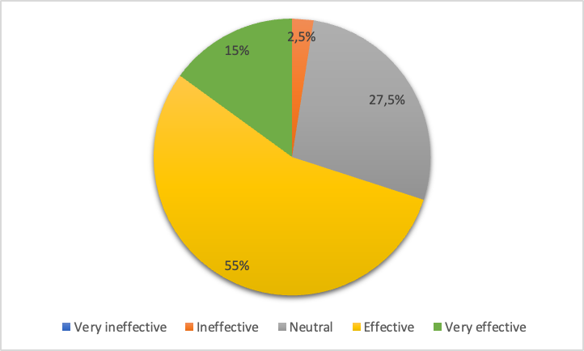

Figure 1. Participants' Perceptions of the Effects of the Shadowing Technique on Fluency Enhancement

The pie chart presents data from students who applied the Shadowing technique and rated its effectiveness on a 5-point Likert scale. The most notable observation is that the majority of experimental students, accounting for 55%, rated the Shadowing technique as effective. Additionally, 15% of respondents rated the method as very effective, indicating a strong positive perception of its impact on fluency. Approximately 27.5% of students provided a neutral rating for the technique. Lastly, a small proportion, 2.5%, rated the technique as
ineffective. Although this group was the smallest in the survey, it still represents college students who did not find the shadowing helpful in improving their speaking fluency. By and large, the pie chart illustrates the overall positive perception of the Shadowing technique's effectiveness in improving students' speaking fluency.

Participants’ Difficulties in Implementing the Shadowing Technique to Enhance Their Fluency

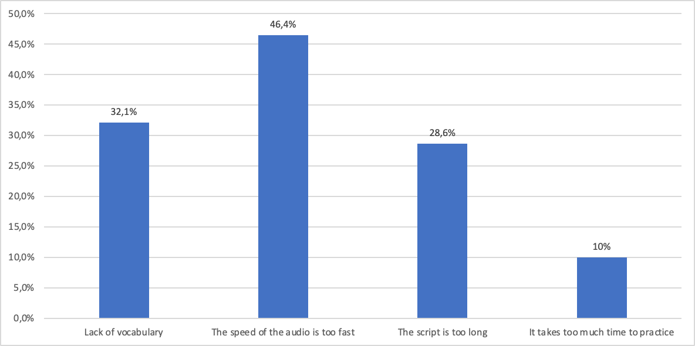

Figure 2. Types of Difficulties Encountered by Participants When Practicing the Shadowing Technique

During the practice of the shadowing technique, students encountered several difficulties. When students were asked to select factors that influence the process of applying Shadowing from among the factors listed, nearly half of the students (46,4%) reported that the speed of the audio is too fast is the most significant difficulty, making it difficult for them to keep up and accurately reproduce the sounds they hear. Approximately 32.1% of students have difficulty due to a lack of vocabulary necessary to understand and reproduce conversations accurately. The script is too long was considered by 28.6% of students to be a hindering factor in
the Shadowing practice process. Only a small number of students (10%) think that practicing Shadowing takes too much time, but they realize that the benefits gained from this practice far outweigh the time investment. Understanding students' difficulties in shadowing can help educators devise solutions and implement strategies to help students improve their shadowing skills and enhance their language learning experience.

Participants' Intentions to Use Shadowing in the Future

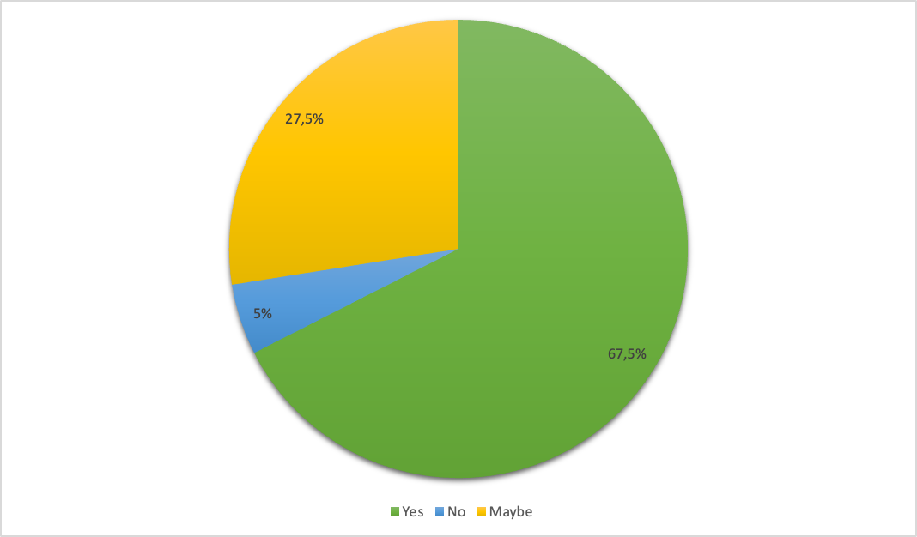
Figure 3. Participants' Intentions to Use Shadowing in the Future

The majority of students (67.5%) expressed their desire to continue applying Shadowing techniques to their learning process in the future. Students noted that practicing the Shadowing technique is very flexible and effective, helping them significantly improve their speaking and listening skills. Positive feedback from students includes improved pronunciation, increased language response speed, expanded vocabulary, and increased confidence when communicating. This proves that the Shadowing technique is not only useful in the short term but also brings long-term benefits.

The Influences of the Shadowing Technique on ELF Learners’ Speaking Performance in terms of Fluency
This study aims to determine the impact of the Shadowing method on the English-speaking fluency of first-year English major students. To this end, pre-and post-tests were performed with both the experimental group and the control group. The mean scores before and after practice Shadowing are summarized in the following table.

Table 1. Pre and Post-test scores of the experimental and control group

 |  | Mean | SD | Min | Max | Mean | SD | Min | Max
Experimental | 40 | 6.35 | 1.110555 | 5 | 8.5 | 7.39 | 1.00949 | 6 | 9
Control | 40 | 6.41 | 0.986365 | 5 | 8.5 | 6.74 | 0.973939 | 5.5 | 9

After applying the Shadowing technique, the mean score of the experimental group was 7.39, higher than the mean score of the control group which was 6.74. This shows that there was an improvement in speaking fluency in the experimental group. However, the experimental group and the control group had the highest scores, both of 9, which indicates the possibility that students in the control group may have been influenced by extraneous factors such as other learning methods, motivation to learn, level of

prior knowledge, ability to absorb information, or level of interest in learning, confirming the reliability from the random selection of participants.
After obtaining the results of the post-test, the Independent T-test analysis was conducted to compare the scores between the experimental and the control groups. To gain more insights into the mean scores of both groups in the post-test, let us have a look at Table 2.

Table 2. Comparison of Experimental and Control Groups on the Post-test

Group Statistics

Group |  | N | Mean | Std. Deviation | Std. Error Mean
Score | Experimental | 40 | 7.39 | 1.00949 | 0.15961
Score | Control | 40 | 6.74 | 0.97394 | 0.15399

Independent Samples Test

 |  | Levene's Test for Equality of Variances |  | t-test for Equality of Means
 |  | F | Sig. | t | df | Sig. (2-  tailed) | Mean Difference | Std. Error Difference | 95% Confidence Interval of the Difference
 |  |  |  |  |  |  |  |  | Lower | Upper
Score | Equal variances assumed | 0.252 | 0.617 | 2.931 | 78 | 0.004 | 0.65000 | 0.22179 | 0.20845 | 1.09155
Score | Equal variances not assumed |  |  | 2.931 | 77.900 | 0.004 | 0.65000 | 0.22179 | 0.20844 | 1.09156

T-test analysis results showed a statistically significant difference between the two groups (p=0.004<0.05) in the post-test. The mean score of the experimental group (M = 7.3875) was significantly higher than the control group (M = 6.7375). In short, after implementing the intervention, the experimental group had a higher mean score than the control group, suggesting that applying the Shadowing method had a positive effect on students' speaking fluency.

CONCLUSION
From the need to improve the ability to use English more fluently for English learners in Vietnam, efforts have been made to find solutions to achieve the goal. This study aims to (1) investigate the viability of implementing shadowing as a technique to enhance speaking performance, specifically by focusing on fluency
among freshmen, and (2) provide learners with a practical method for integrating Shadowing into independent practice to improve speaking fluency.
Of the many aspects of English, this investigation focuses exclusively on the aspect of fluency. Shadowing techniques are used as a measure to promote autonomy in addition to the formal classes of the course of Speaking 1. The experiment lasted for 8 weeks for first-year students, at the Faculty of Education, Quy Nhon University. The data were collected via pre-test, post-test, survey, and interview.
Analysis results showed that the experimental group had significantly improved speaking fluency compared to the control group. This confirms that the Shadowing technique has a positive and effective impact on improving English speaking skills.

Surveys and interviews also showed that most students appreciated the shadowing technique, and many are planning to continue applying this method in the future. Although there are some difficulties, such as the speed of the audio being too fast or the length of the exercise, the benefits that the Shadowing technique brings outweigh these challenges, such as improving pronunciation, enhancing vocabulary, and confidence when communicating.
In summary, this study not only confirms the effectiveness of the Shadowing technique in improving speaking fluency but also suggests that teachers should consider integrating this method into the English curriculum. The study certainly does not include all the applications of Shadowing. If possible, future research could expand further by exploring the long-term effectiveness of the Shadowing technique and its influence on other language skills, such as listening skills and reading skills.

REFERENCES
- Nunan, D. Language Teaching Methodology: A Textbook for Teachers, Prentice Hall International English Language Teaching, New York, 1991.
- Nguyen Hoai Dung, Bui Thi Minh Nguyet, Le Thi Thanh Tam. A study on improving the pronunciation of first-year English majors during a speech training course at Quy Nhon University, Quy Nhon University Journal Of Science, 2019, 13(6), 33-42.
- Hamada, Y. Shadowing: What is It? How to Use It. Where Will It Go?, RELC Journal, 2018, 50(3), 386-393.
- Tamai, K. Listening shidouhotoshite no shadowing no koukani kansuru kenkyu [Research on the effectiveness of shadowing as a listening teaching method], Kazama Shobo, Tokyo, 2005.
- Hamzar. The Implementation Of Shadowing Technique To Improve Students’ Speaking Performance, Master's thesis, State University Of Makassar, 2014.
- Murphey, T. Exploring the role of shadowing in the development of EFL learners’ speaking skill: A case study of third-year students of English , Unpublished MA Thesis, Mohamed Kheider University of Biskra, 2001.
- Hamada, Y. The role of shadowing in L2 listening skills development. The Language Teacher, 2019, 45(6), 3-10.
- Skehan, P. A cognitive approach to language learning, Oxford University Press, New York, 1998.
- Claus Faerch, Kirsten Haastrup, Robert Phillipson. The role of input, interaction, and output in the development of oral fluency, CCSE, 1984, 2(4), 91-100.
- Brumfit, C. Communicative Methodology In Language Teaching, Cambridge University Press, New York, 1984.
- Sajavaara, K. Applications of Cross-language Analysis, Jyväskylä cross-language studies, Department of English, University of Jyväskylä, Jyväskylä, 1987.
- Fillmore, C. J. On Fluency: Individual Differences In Language Ability & Language Behavior, Academic Press, Inc, New York, 1979.
- Skehan, P. A framework for the implementation of task-based instruction, Applied Linguistics, 1996, 17(1), 38-62.
- Zakeri, E. The Effect Of Shadowing On Efl Learners’ Oral Performance In Terms Of Fluency, EA Journals, 2014, 2(1).
- Fereshteh Yavari, Sajad Shafiee. Effects of Shadowing and Tracking on Intermediate EFL Learners’ Oral Fluency, International Journal of Instruction, 2019, 12(1), 869-884.
- Manseur, R. Exploring the role of shadowing in the development of EFL learners' speaking skill, Master's thesis, Mohamed Kheider University of Biskra, 2015.
- Miyake, S. Cognitive processes in phrase shadowing: Focusing on articulation rate and shadowing latency, JACET Bulletin, 2009, 48, 15-28.
- Mori, Y. Shadowing with oral reading: Effects of combined training on the improvement of Japanese EFL learners' prosody, Language Education & Technology, 2011, 48, 1-22.
- Kadota, S. Shadowing to ondoku no kagaku [Science of shadowing, oral reading, and English acquisition], CosmoPier, Tokyo, 2007.
- Kadota, S. Inputo to autoputo o tsunagu shadowing: Riron to Jissen no Renkei [Shadowing connecting input and output: Association of theory and practice], JACET Chubu Bulletin, 2011, 9, 41-55.
- Kadota, S. Shadowing to ondoku to eigoshutoku no kagaku [Science of shadowing, oral reading, and English acquisition], CosmoPier, Tokyo, 2012.
- Kadota, S. Eigo jotatsu 12 no pointo [12 points for improving English], CosmoPier, Tokyo, 2014.

- Kadota, S. Shadowing ondoku to eigo comyunikesyon no kagaku [Science of shadowing, oral reading, and English communication], CosmoPier, Tokyo, 2015.
- Schmidt, R. Psychological mechanisms underlying second language fluency. Studies in
Second Language Acquisition, 2012, 14(4), 357-
385.
- R. Towell, R. Hawkins, N. Bazergui. (1996). The development of fluency in advanced learners of French. Applied Linguistics, 1996, 17(1), 84-119.

